Center for States Webinar Registration Form
Fields marked with an asterisk (*) are required.
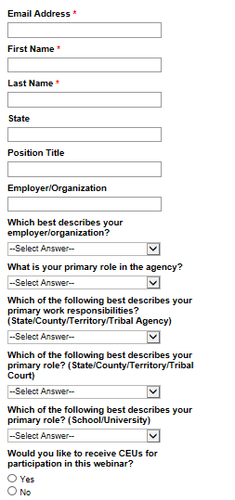
Public reporting burden for this collection of information is estimated to be 2 minutes per response to complete this questionnaire. An agency may not conduct or sponsor, and a person is not required to respond to, a collection of information unless it displays a currently valid OMB control number.

