Public Comments Received During the 60-day Comment Period –
December 2016
State Longitudinal Data System (SLDS) Survey 2017 – 2019
ED-2016-ICCD-0107 Comments on FR Doc # 2016-24298

Comment Number 5
Document: ED-2016-ICCD-0107-0005
Name: Joshua Jones
In 2016, education as a whole should be making data-driven decisions. The SLDS survey will continue to provide helpful information and will enhance the program's reach and overall impact.

Response
Dear Mr. Jones,
Thank you for your feedback posted on October 17, 2016 responding to a 60-day request for comments on the proposed Statewide Longitudinal Data System (SLDS) Survey 2017. The National Center for Education Statistics appreciates your interest in the SLDS Program.
Sincerely Yours,

Nancy S. Sharkey
Statistician, National Center for Education Statistics
United States Department of Education
Institute of Education Sciences
550 12th Street, SW, Room 4162
Washington, DC 20202

Comments 7 and 8
Comment Number 7
Document: ED-2016-ICCD-0107-0007
Name: Catherine Imperatore (on behalf of LeAnn Wilson and Kimberly Green)
Thank you for this opportunity to provide comments in response to the State Longitudinal Data System (SLDS) Survey 2017-2019 (Docket No. ED-2016-ICCD-0107). The Association for Career and Technical Education (ACTE) and Advance CTE appreciate NCESs commitment to collecting information on state longitudinal data systems (SLDS), which perform a vital function in many states by linking data across education and workforce systems. While this survey has great potential to facilitate understanding of SLDS capabilities, we recommend the attached edits pertaining to the CTE section of the survey.

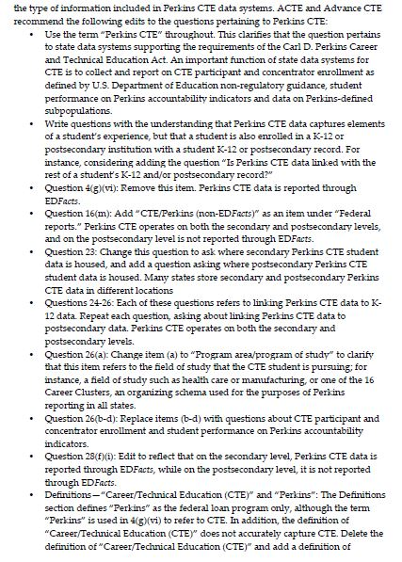
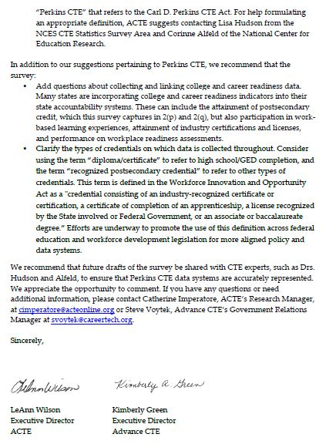

Comment Number 8
Document: ED-2016-ICCD-0107-0008
Name: Jenna Leventoff (on behalf of Rachel Zinn)

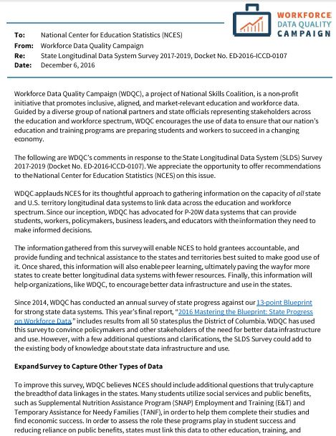
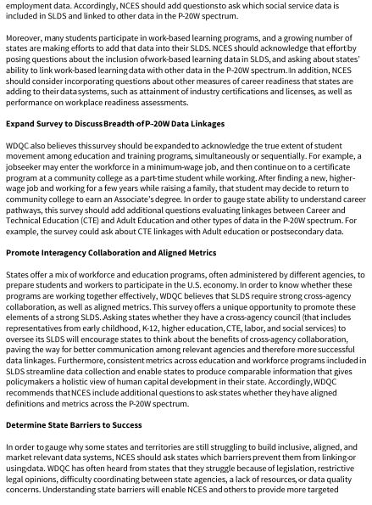
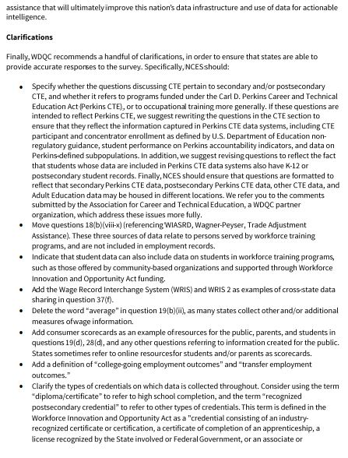
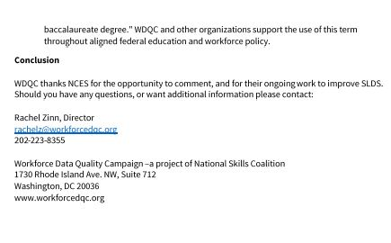

Response
Dear Ms. Wilson, Ms. Green, and Ms. Zinn,
Thank you for your feedback posted on December 7, 2016 responding to a 60-day request for comments on the proposed Statewide Longitudinal Data System (SLDS) Survey 2017. The National Center for Education Statistics (NCES) appreciates your interest in the SLDS Program, and your commitment to the SLDS initiative.
We have incorporated many of your thoughtful suggestions into the SLDS Survey:
- All references have been changed to “Perkins CTE” as opposed to “CTE”. We have included the following definition to clarify reference to state data systems supporting the requirements of the Carl D. Perkins Career and Technical Education Act. Additionally, the following definition was added to the “Definitions” section:
“The Carl D. Perkins Career and Technical Education Act of 2006 (Perkins) provides federal support for CTE programs in all 50 states, the District of Columbia, and the territories. The law focuses on the academic and technical achievement of CTE students, strengthening the connections between secondary and postsecondary education, and improving accountability.”
- Question 4(g) has been removed from the survey; Perkins CTE data is reported through EDFacts.
- Perkins CTE (non-EDFacts) was added as a sub-question to Question 16(m) to distinguish from “Other federal reports”, similar to IPEDS.
- Question 26(a) was changed to “Program area/program of study” to clarify that this item refers to the field of study that the CTE student is pursuing.
- WRIS and WRIS 2 were added as examples of cross-state data sharing in Question 37(f).
- The word “Average” was removed in Question 19(b)(ii) to be inclusive of all state wage measures.
- “Consumer scorecards” was added as an example to all questions relating to resources for the public, parents and students.
- Questions 22a.i. through 22.a.iv have been amended to be clearer.
- There were two instances where credential language was edited to state “diploma/certificate” and “recognized postsecondary credential”. The definition provided was also added to the “Definitions” section of the Survey.
- Questions 18.b.viii. through 18b.x. were not moved because the root question refers to workforce data or other employment data, and not to data specifically in employment systems.
Because the scope of this survey focuses on K12 education outcomes, Questions pertaining to Perkins CTE will remain only slightly modified under the presumption that references are intended to result in the data collection of linkages to K12 (secondary) Perkins CTE student data, as opposed to data from other sectors. The U.S. Department of Education strives to remain cognizant of the fact that its purview and efforts focus on education, despite the exploratory efforts to better gauge how education is linked to other sectors. While more information is always useful to the variety of stakeholders that the SLDS initiative impacts, we want to guarantee that we are capturing education data in its own right and as linked to other federal programmatic initiatives. Striking the needed balance poses challenges, so we welcome ongoing feedback on the content and structure of the survey. At a later time, we might consider broadening the scope of the survey and/or revisiting the survey questions to begin collecting information more inclusive of data from other sectors.
Additionally, as part of its development, the SLDS Survey was piloted with and vetted by a sample of states that provided feedback and suggestions for improvement. This process resulted in many changes to the Survey to ensure that our key stakeholders were able to understand and respond to survey questions appropriately. The pilot states provided favorable feedback when comparing the SLDS Survey to past similar surveys in the field.
A significant amount of time was also spent balancing the Survey’s length and comprehensiveness. This resulted in shortening the Survey in breadth to remain committed to a K12 student outcome survey emphasis. The survey has been expanded to include many other sources of data, and we remain confident that this is a valuable starting point to a data collection of this nature.
Your thought-provoking and informative feedback will definitely be considered if we decide to expand the Survey’s scope in the future.
Sincerely Yours,

Nancy S. Sharkey
Statistician, National Center for Education Statistics
United States Department of Education
Institute of Education Sciences
550 12th Street, SW, Room 4162
Washington, DC 20202

