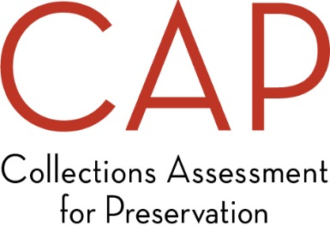
Application Feedback Form

Thank you for applying for the Collections Assessment for Preservation Program! In order to help us improve the application process, we ask that you take 5-10 minutes to let us know how you heard about CAP and provide feedback about the application process. Your responses will be anonymous and will not affect your application.
We thank you in advance for your feedback!

Where did you get the information that prompted your interest in applying for the CAP Program? Check all that apply.
FAIC website
CAP printed material
From a colleague/word of mouth
Professional association meeting
(please specify):
LISTSERV posting
Discussion with CAP staff person
Discussion with an IMLS staff person
IMLS website
IMLS publications
FAIC email/newsletter
FAIC social media
Other: ________________________________________

If more than one, which was most influential in encouraging you to apply? ___________________

Rate the CAP application package by placing an “X” in the appropriate column below.
 | Excellent |  |  |  | Poor
 | 5 | 4 | 3 | 2 | 1
Easy to complete.
Useful as a self-study document.

Did you contact FAIC staff while completing the application? Yes No
If yes, please answer the question in the chart below.
 | Completely satisfied |  |  |  | Complete unsatisfied
 | 5 | 4 | 3 | 2 | 1
How satisfied were you with the assistance you received?

What could we have done to better assist you (optional)?

Approximately how many hours did it take you to complete this application? ___ hours
How many staff members participated in gathering all of the information? ___________________
Did you need to contact FAIC staff while completing the application? Yes No
If yes, was FAIC staff able to assist to your satisfaction? Yes No
If they were not able to assist to your satisfaction, please explain.

Please share any additional comments on the application process below (optional).

