**Appendix AA.3**

**Additional Authorizing Statutes**

Section 28 of the Richard B Russel National School Lunch Act as Amended by HHFKA of 2010

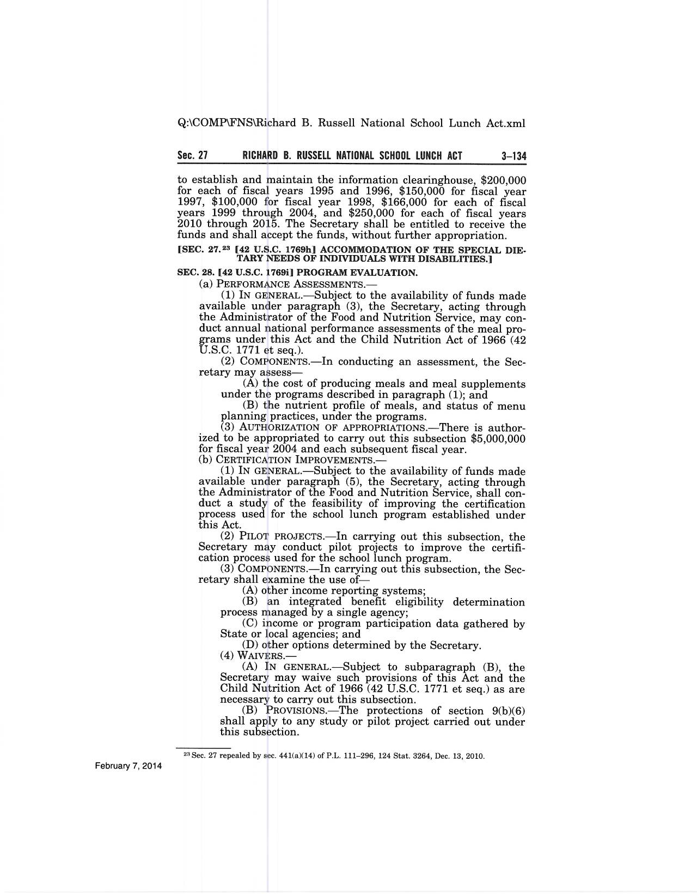

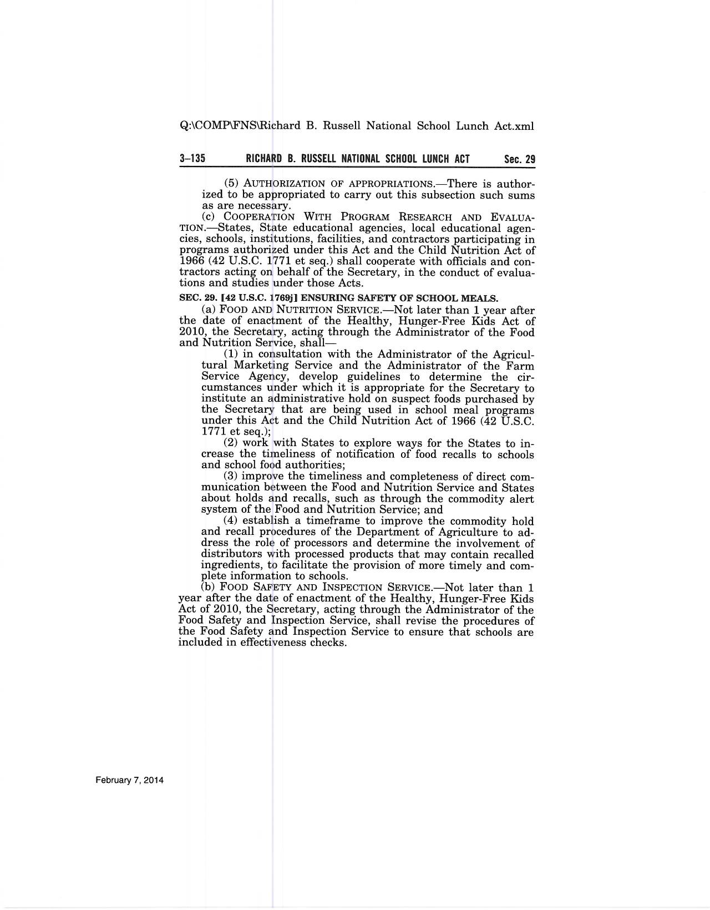

Section 17 (7 U.S.C.) (a)(1) of the Food and Nutrition Act of 2008

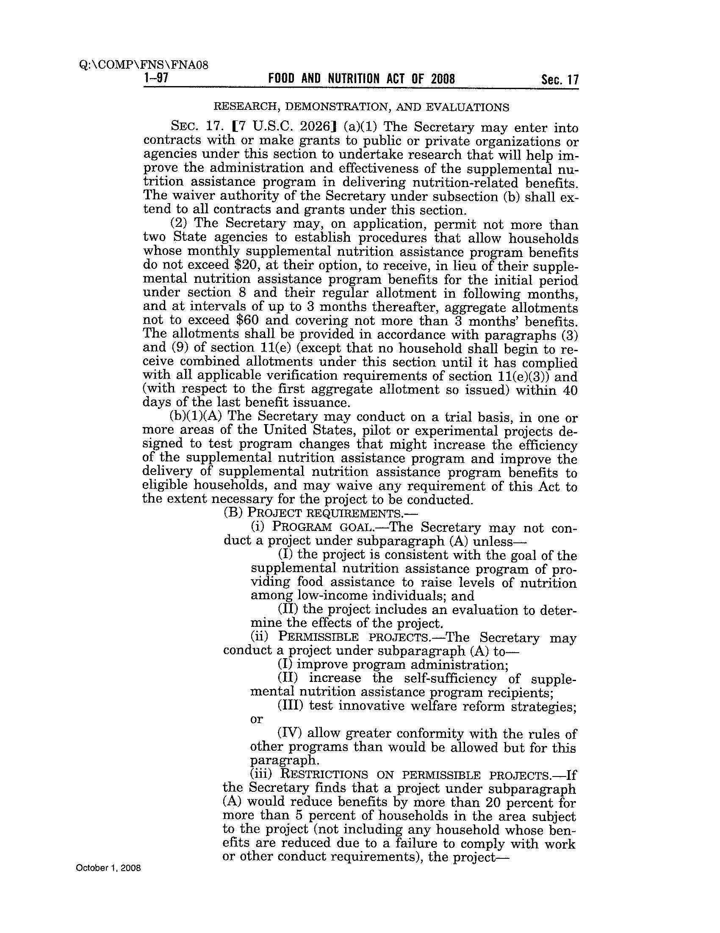

Copy of 7 CFR 246.25(a)(2)

