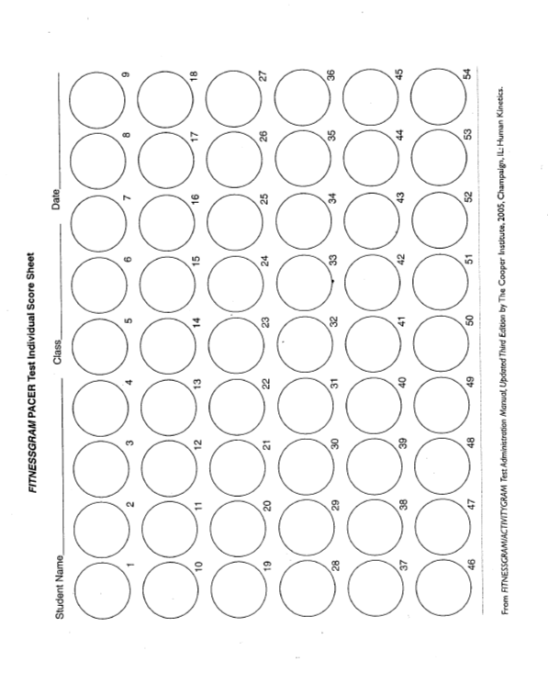
Pacer Test Individual Score Sheet

