ACCELEROMETRY BELT INSTRUCTIONS

Belt Instructions

The activity meter records general movement and allows us to get a better idea of the child’s overall activity level. It is extremely important for our evaluation that the children wear the belts properly. Please follow these instructions carefully:

- The belt should be worn around the waist, with the device just above the right hipbone (with black button and number facing up). The belt can wear either underneath or on top of the child’s clothing.

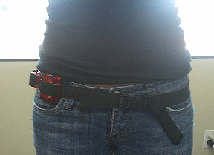
- Make sure the belt is snug against the child’s body so that the device does not move.
- The meters are NOT waterproof!
- Remind the students not let anyone else wear their belt.
- There is no “ON” or “OFF” switch. The devices run on a battery and will run continuously without you needing to turn them on.

If you have any questions please contact Isabela Lucas at
404-592-2155 or Isabela.Lucas@icf.com

