99.3 Letters of Reference (must be submitted electronically through the eRA Commons)

IMPORTANT NOTE: This section contains instructions for both the Fellowship Applicant (Part A) and the Referees (Part B). Applicants are urged to read both sections carefully so they are able to provide accurate instructions to the Referees. Failure to submit all of the required references may result in the application being returned to you without review.

Part A. Instructions for Fellowship Applicants:

Within the application, the list of referees (including name, departmental affiliation, and institution) is included in Other Attachments on the Other Project Information Form (see special instructions in Section 99.4.3). In addition, applicants must include the same list and information on the SF424 (R&R) Form in the Cover Letter Attachment.

At least three (but no more than 5) Letters of Reference are required for all applications defined as New and Resubmissions (see Note below) for mentored support. The letters should be from individuals not directly involved in the application, but who are familiar with the applicant’s qualifications, training, and interests. The mentor/co-mentor(s) of the application cannot be counted toward the three required references.

Your referees should be carefully selected. Only those individuals who can make the most meaningful comments about your qualifications for a research career should be used. Whenever possible, select at least one referee who is not in your current department. For postdoctoral applications, if not submitting a reference from your dissertation advisor or chief of service, provide an explanation in Item 12 – Other Attachments on the SF424 (R&R) Other Project Information Form. Also for postdoctoral applications, references from graduate or medical school are preferred over those from undergraduate school.

Note: For resubmission applications, it is critical that NEW (updated) Letters of Reference be submitted providing an up-to-date evaluation of the Fellowship applicant’s potential to develop as an independent and productive researcher, and the continued need for additional supervised research experience.

Electronic submission of a letter of reference is a separate process from submitting an application electronically. Reference letters are submitted directly through the eRA Commons and do not use Grants.gov. Therefore, this process requires that the referee be provided information including (a) the PI’s (candidate’s) eRA Commons user name, (b) the PI’s first and last name as they appear on the PI’s eRA Commons account, and (c) the number assigned to this Funding Opportunity Announcement.

Confirmation e-mails will be sent to both the referee and the candidate following reference letter submission. The confirmation sent to the candidate will include the referee’s name and the date the letter was submitted. The confirmation sent to the referee will include the referee and applicant’s names, a confirmation number, and the date the letter was submitted.

The candidate may check the status of submitted letters by logging into their Commons account and accessing the “check status” screen for this application. The candidate is responsible for reviewing the status of submitted reference letters and contacting referees to ensure that letters are submitted by the receipt deadline. While the candidate is able to check on the status of the submitted letters, the letters are confidential and he/she will not have access to the letters themselves. Note: Because e-mail can be unreliable, it is the candidate’s responsibility to check the status of his/her letters of reference in the Commons.

Part B. Instructions for Referees:

Important Note: If this is a new application, Reference Letters should NOT refer to the applicant’s previous, unsuccessful submissions, previous scores, summary statements, etc., since current policy prohibits any reference to previous submissions or reviews.

The fellowship applicant is applying for an individual fellowship award. The purpose of this award is to provide support to promising applicants with the potential to become productive, independent investigators in scientific health-related research fields relevant to the missions of participating NIH Institutes and Centers, and AHRQ.

Please put the name of the fellowship applicant at the top of the letter. Also, be sure to include your name and title in the letter.

Name of the Fellowship Applicant (First & Last Name as shown in the eRA Commons):
Fellowship applicant’s eRA Commons Username:
Funding Opportunity Announcement (FOA) Number:

In two pages or less (PDF format), describe the qualities and potential of the fellowship applicant for the research training for which support is being requested (predoctoral, postdoctoral, or senior fellow). This should include your evaluation with special reference to:

• Research ability and potential to become an independent researcher

• Adequacy of scientific and technical background

• Written and verbal communication abilities including ability to organize scientific data

• Quality of research endeavors or publications to date, if applicable

• Perseverance in pursuing goals

• Evidence of originality

• Need for further research experience and training

• Familiarity with research literature

Referees may provide any additional, related comments that they believe will help reviewers evaluate the merit of the candidate’s application.

Submitting Reference Letters

Letters must be submitted directly to the eRA Commons at: https://public.era.nih.gov/commons/public/reference/submitReferenceLetter.do?mode=new and must be submitted by the application receipt deadline date. Although previously NIH provided a 5 business days grace period for the receipt of letters of reference after the application receipt due date, the new policy eliminates the grace period. More information can be found in NIH Guide Notice NOT-OD-11-047.

Applications that are missing the required letters of reference will not be reviewed.

Once you have accessed the letters of reference submission site, the following information must be entered before uploading the PDF reference letter attachment:

Referee Information:

• Referee First Name (Required)

• Referee Last Name Required)

• Referee MI Name (Not Required)

• Referee e-mail (Required)

• Referee Institution/Affiliation (Required)

• Referee Department (Required)

Fellowship Application Information:

• PD/PI (Fellowship applicant) Commons User ID (Required)

• PD/PI’s Last Name, as it appears on the PI’s Commons account (Required) (will be validated to ensure they match)

• Funding Opportunity Announcement (FOA) Number (Required and must match the number of the FOA under which the application is being submitted)

• Reference Letter Confirmation Number (Required only if resubmitting a letter; not required otherwise)

• Fellowship Letter of Reference – two pages maximum. Complete the letter using word processing software and then convert to PDF using PDF generating software. Avoid scanning text attachments to convert to PDF since that causes problems for the agency handling the application. Additional tips for creating PDF files can be found
at http://grants.nih.gov/grants/ElectronicReceipt/pdf_guidelines.htm.

Note that the Letter of Reference can be submitted at any time prior to the receipt deadline. It is not necessary to wait until after the application is submitted before the Letter of Reference is submitted; the two submissions are distinct. After you have submitted your Letter of Reference, both you and the applicant will receive a confirmation of receipt by e-mail. Your e-mail confirmation will include a Reference Letter Confirmation Number. The Confirmation Number will be required when resubmitting reference letters. Please print the confirmation e-mail for your records.

Revised reference letters may be submitted at the time of the application receipt date.

99.5 PHS Fellowship Supplemental Form

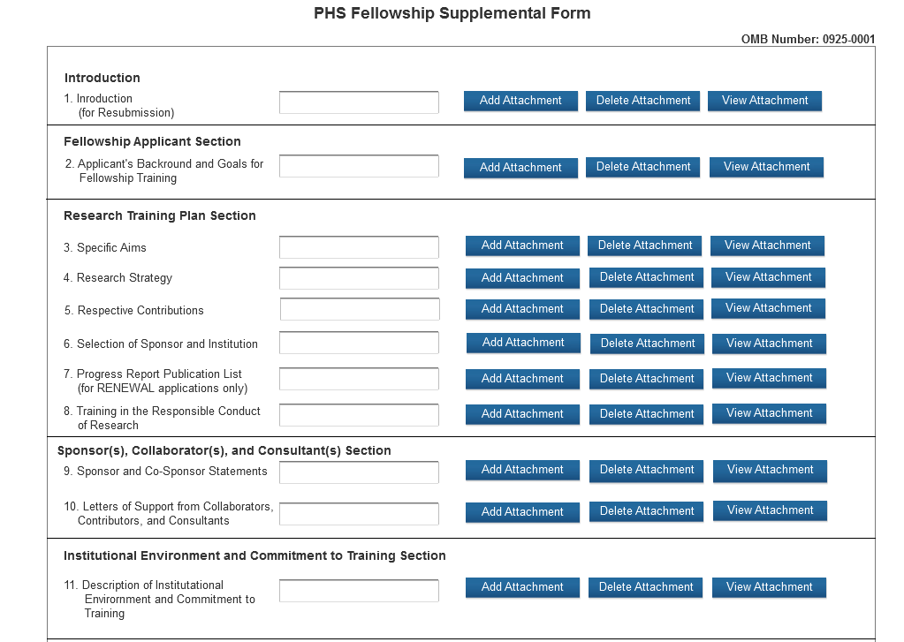

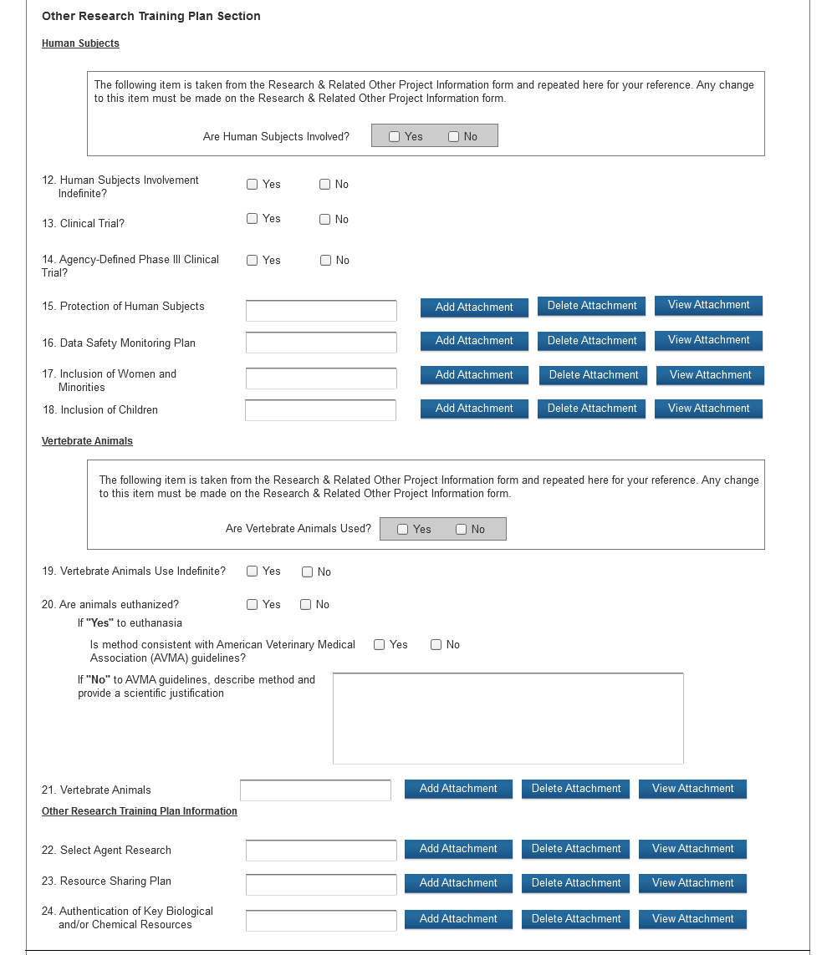

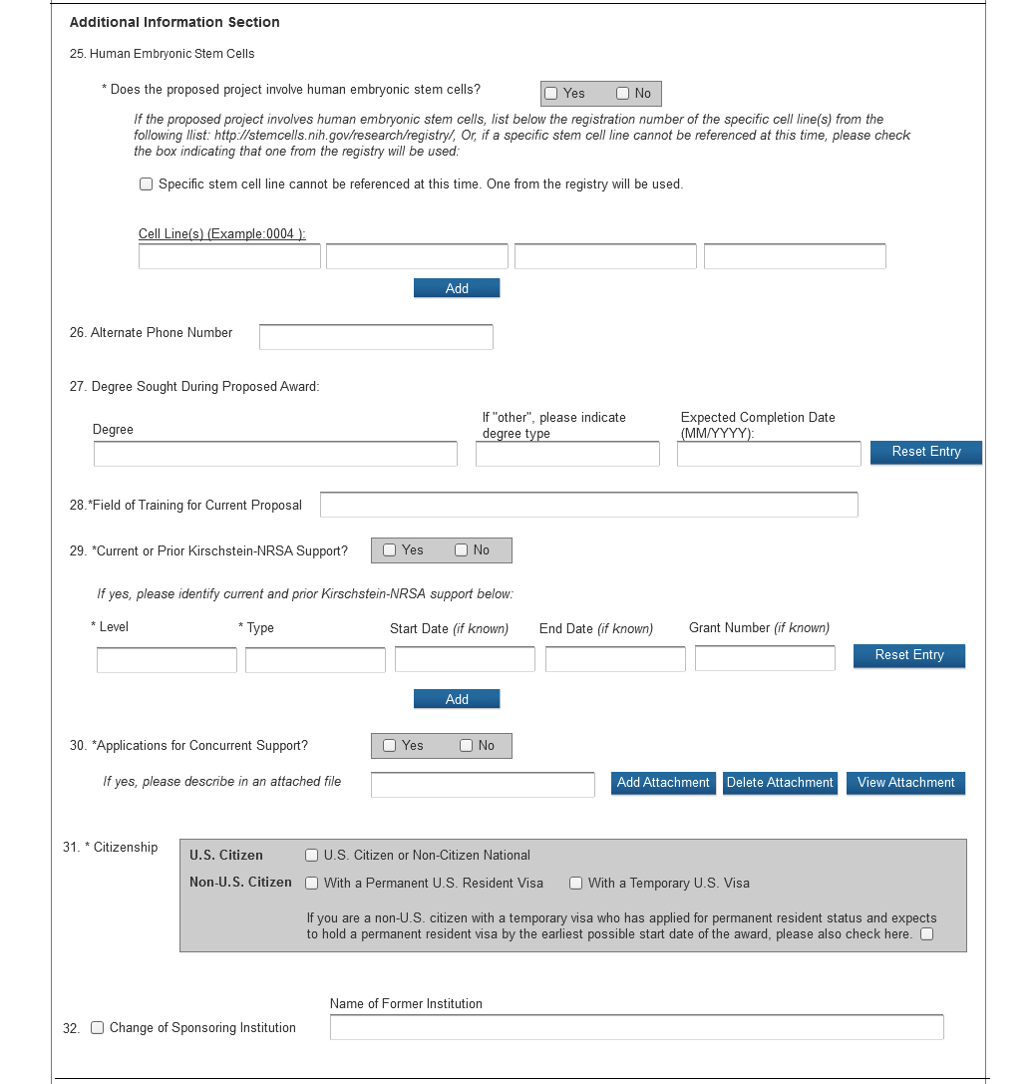

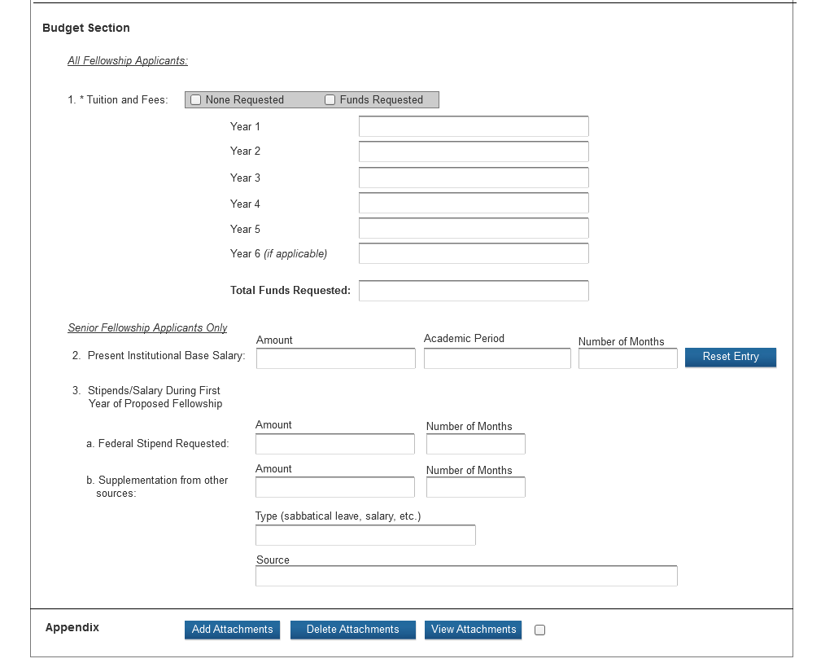
It is strongly recommended that fellowship applicants and sponsors speak with a PHS Program Official for Institute or Center (IC)-specific guidance before preparing this application. These contacts are identified in tables associated with each FOA. In addition, a list of contacts specifically for extramural training at the NIH ICs can be found at http://grants.nih.gov/training/tac_training_contacts.doc. For AHRQ, see http://www.ahrq.gov/funding/training-grants/contacts.html. Individuals always are encouraged to check these Web sites for the most current contact information.

Note: Required fields on the PHS Fellowship Supplemental Form are noted with an asterisk (*).

The PHS Fellowship Supplemental Form should include sufficient information needed for evaluation of the project, independent of any other document (e.g., previous application). Be specific and informative, and avoid redundancies. This section should be well-formulated and presented in sufficient detail that it can be evaluated for both its research training potential and scientific merit. It is important that it be developed in collaboration with your sponsor, but it should be written by you, the fellowship applicant.

Fellowship Attachments (See also Section 2.3.2 Creating PDFs for Text Attachments)

Although many of the sections of this application are separate PDF attachments, page limitations referenced in the instructions and/or funding opportunity announcement must still be followed. Agency validations will include checks for page limits (and use of appropriate font). Some accommodation will be made for sections that, when combined, must fit within a specified limitation.

NIH and other PHS agencies require all text attachments to the SF424(R&R) application forms to be submitted as PDF files. Text attachments should be generated using word processing software and then converted to PDF using PDF generating software. Avoid scanning text attachments to convert to PDF since that causes problems for the agency handling the application. Scanning paper documents, without the proper Optical Character Recognition (OCR) process, will hamper automated processing of your application for NIH analysis and reporting.

Do not include any information in a header or footer of the attachments. A header will be system-generated that references the name of the PD/PI. Page numbers for the footer will be system-generated in the complete application, with all pages sequentially numbered.

Since a number of reviewers will be reviewing applications as an electronic document and not a paper version, fellowship applicants are strongly encouraged to use only a standard, single-column format for the text. Avoid using a two-column format since it can cause difficulties when reviewing the document electronically.

Full-sized glossy photographs of material such as electron micrographs or gels must only be included within the page limitations of the Research Strategy section. The maximum size of images to be included should be approximately 1200 x 1500 pixels using 256 colors. Figures must be readable as printed on an 8.5 x 11 inch page at normal (100%) scale.

Investigators must use image compression such as JPEG or PMG. Do not include figures or photographs as separate attachments either in the Appendix or elsewhere in the application.

Separate Attachments

Separate attachments have been designed for the Fellowship Supplemental Form sections to maximize automatic validations conducted by the eRA system. When the application is received by the agency, all of the Fellowship Supplemental Form sections will be placed in the appropriate order so that reviewers and agency staff will see a single cohesive application.

When attaching a PDF document to the actual forms, please note you are attaching an actual document, not just pointing to the location of an externally stored document. Therefore, if you revise the document after it has been attached, you must delete the previous attachment and then reattach the revised document to the application form. Use the “View Attachment” button to determine if the correct version has been attached.

Page Limits

Follow the page limits for the Fellowship (F) Applications in the Table of Page Limits at http://grants.nih.gov/grants/forms_page_limits.htm, unless specified otherwise in the FOA.

All applications and proposals for NIH funding must be self-contained within specified page limits. Agency validations will include checks for page limits. Note that while these computer validations will help minimize incomplete and/or non-compliant applications, they do not replace the validations conducted by NIH staff. Applications found not to comply with the requirements will not be reviewed. Unless otherwise specified in an NIH solicitation, internet website addresses (URLs) may not be used to provide information necessary to the review because reviewers are under no obligation to view the internet sites. Moreover, reviewers are cautioned that they should not directly access an internet site as it could compromise their anonymity.

Applicants are prohibited from using the Appendix to circumvent page limitations in any section of the application for which a page limit applies.” For additional information regarding Appendix material and page limits, please refer to the NIH Guide Notice NOT-OD-11-080, http://grants.nih.gov/grants/guide/notice-files/NOT-OD-11-080.html.

Research Training Plan

A Research Training Plan is required for all types of individual F awards. The Research Training Plan is a major part of the Fellowship award plan. It is important to relate the research to the applicant's scientific career goals. Describe how the research, coupled with related training activities, will provide the experience, knowledge, and skills necessary to achieve the stated objectives of the Fellowship award. Explain the relationship between the applicant’s research on the Fellowship award and the mentor’s ongoing research program.

For most types of research, the plan should include: a specific hypothesis; a list of the specific aims and objectives that will be used to examine the hypothesis; a description of the methods/approaches/techniques to be used in each aim; a discussion of possible problems and how they will be managed; and, when appropriate, alternative approaches that might be tried if the initial approaches do not work.

The Research Training Plan of a Fellowship award is expected to be appropriate for, and tailored to the experience level of the applicant, and allow him/her to develop the skills needed for further career advancement; reviewers will evaluate the plan accordingly. The plan should be achievable within the requested time period. Pilot or preliminary studies and routine data gathering are generally not appropriate as the focus of a Fellowship award research training plan. Although applicants for Fellowship awards are expected to write the Research Training Plan, the mentor should review a draft of the plan and discuss it in detail with the applicant. Review by other knowledgeable colleagues is also helpful. Although it is understood that Fellowship applications do not require the extensive detail usually incorporated into regular research grant applications, a fundamentally sound Research Training Plan should be provided.

The PHS Fellowship Supplemental Form is comprised of the following sections:
- Fellowship Applicant Information
- Research Training Plan
- Sponsor(s), Collaborator(s), and Consultant(s)
- Institutional Environment & Commitment to Training
- Other Research Training Plan Sections
- Additional Information
- Budget
- Appendix

Note: Begin each text section of the Fellowship Applicant Information and Research Training Plan with a section header (e.g., Introduction, Specific Aims, Research Strategy). See the specific FOA for additional information.

Introduction (if applicable)
Field Name | Instructions
1.  Introduction  to  Application  (for RESUBMISSION Applications Only) | NIH policy allows a thirty-seven month window for resubmissions (A1 applications) following the submission of a New, Renewal, or Revision application (A0 application).  See NIH Notice NOT-OD-12-128 for additional information/clarification of NIH policy.  Use only if Type of Application is Resubmission. Resubmission applications must include an Introduction to Resubmission Application, not to exceed one page. The Introduction must include responses to the criticisms and issues raised in the Summary Statement. Summarize the substantial additions, deletions, and changes.  Save this information in a single file in a location you remember. Click Add  Attachments, browse to where you saved the file, select the file, and then click Open.
Fellowship Applicant Section
Field Name | Instructions
2. Applicant’s Background and Goals for Fellowship Training | This attachment is required. Follow the page limits for Fellowship (F) Applications in the Table of Page Limits at http://grants.nih.gov/grants/forms_page_limits.htm, unless specified otherwise in the FOA.  - Doctoral Dissertation and Research Experience: Summarize your research experience in chronological order.  Advanced graduate students, who have (or will have) completed their comprehensive examinations by the time of award, must also include a narrative of their doctoral dissertation (may be preliminary). If you have no research experience, list other scientific experience. Do not list academic courses.  In summarizing their research experience, Postdoctoral and Senior Fellowship applicants should include the areas studied and conclusions drawn.  Postdoctoral fellowship applicants should also specify which areas of research were part of their thesis or dissertation and which, if any, were part of a previous postdoctoral project.  - Training Goals and Objectives: The fellowship applicant must describe his/her overall training goals for the duration of the fellowship, and explain how the proposed fellowship will enable the attainment of these goals. Identify the skills, theories, conceptual approaches, etc. to be learned or enhanced during the award.  - Activities Planned Under This Award: The fellowship applicant must describe by year the activities (research, coursework, etc.) he/she will be involved in during the proposed award and estimate the percentage of time to be devoted to each activity, based on a normal working day for a full-time fellow as defined by the sponsoring institution. Also, briefly explain activities other than research and relate them to the proposed research training. Include any courses that you plan to take to support the research training experience. The percentage should total 100 for each year. Also, briefly explain activities other than research and relate them to the proposed research training. Include any courses that you plan to take to support the research training experience.  Save this information in a single file in a location you remember. Click Add Attachment, browse to where you saved the file, select the file, and then click Open.

Research Training Plan
Field Name | Instructions
3. Specific  Aims | This attachment is required. Follow the page limits for Fellowship (F) Applications in the Table of Page Limits at http://grants.nih.gov/grants/forms_page_limits.htm, unless specified otherwise in the FOA.  State precisely the goals of the proposed research and summarize the expected outcome(s), including the impact that the results of the proposed research will exert on the research field(s) involved.  List succinctly the specific objectives of the research proposed, e.g., to test a stated hypothesis, create a novel design, solve a specific problem, challenge an existing paradigm or clinical practice, address a critical barrier to progress in the field, or develop new technology.  Save this information in a single file in a location you remember. Click Add Attachment, browse to where you saved the file, select the file, and then click Open.
4. Research Strategy | This attachment is required. Follow the page limits for Fellowship (F) Applications in the Table of Page Limits at http://grants.nih.gov/grants/forms_page_limits.htm, unless specified otherwise in the FOA.  Organize the Research Strategy section using the instructions provided below as guidance. Cite published experimental details within the text and provide the full reference in the Bibliography and References Cited section (Part I Section 4.4.9).  - Explain the importance of the problem or critical barrier to progress in the field that the proposed project addresses.  - Describe the scientific rationale for the proposed project, including consideration of strengths and weaknesses of any prior research or preliminary data.  - Explain how the proposed project will improve scientific knowledge, technical capability, and/or clinical practice in one or more broad fields.  - Describe how the concepts, methods, technologies, treatments, services, or preventative interventions that drive this field will be changed if the proposed aims are achieved.  - Describe the overall strategy, methodology, and analyses to be used to accomplish the specific aims of the project. Unless addressed separately in Item 20 (Resource Sharing Plan), include how the data will be collected, analyzed, and interpreted as well as any resource sharing plans as appropriate.  - Describe how the experimental design and methods proposed will achieve robust and unbiased results.  - Discuss potential problems, alternative strategies, and benchmarks for success anticipated to achieve the aims.
4. Research Strategy (cont.) | - If the project is in the early stages of development, describe any strategy to establish feasibility, and address the management of any high risk aspects of the proposed work.  - Explain how relevant biological variables, such as sex, are factored into research designs and analyses in vertebrate animal and human studies.  - Strong justification e.g. scientific literature, preliminary data, or other relevant considerations must be provided for application proposing to study only one sex. Please refer to NOT-OD-xxx for further consideration of NIH expectations about sex as a biological variable.  - Point out any procedures, situations, or materials that may be hazardous to personnel and precautions to be exercised. A full discussion on the use of select agents should appear in Item 19, below.  - If research on Human Embryonic Stem Cells (hESCs) is proposed but an approved cell line from the NIH hESC Registry cannot be identified, provide a strong justification for why an appropriate cell line cannot be chosen from the Registry at this time.  As applicable, also include the following information as part of the Research Strategy..  Preliminary Studies for New Applications: For new applications, include information on preliminary studies (including data collected by others in the lab), if any. Discuss the applicant's preliminary studies, data and/or experience pertinent to this application.  Progress Report for Renewal Applications: Renewal applications for individual fellowships are rare. You should consult with your program official before preparing such an application. In the rare instance that you are submitting a renewal application, provide a Progress Report. Provide the beginning and ending dates for the period covered since the last competitive review. Summarize the specific aims of the previous project period and the importance of the findings, and emphasize the progress made toward their achievement. Explain any significant changes to the specific aims and any new directions including changes resulting from significant budget reductions. A list of publications, manuscripts accepted for publication, patents, and other printed materials should be included in the Progress Report Publication List); do not include that information here.  Save this information in a single file in a location you remember. Click Add Attachment, browse to where you saved the file, select the file, and then click Open.
5. Respective Contributions | This attachment is required. Follow the page limits for Fellowship (F) Applications in the Table of Page Limits at http://grants.nih.gov/grants/forms_page_limits.htm, unless specified otherwise in the FOA.  Describe the collaborative process between you and your sponsor/co-sponsor in the development, review, and editing of this research training plan. Discuss the respective roles in accomplishing the proposed research.  Save this information in a single file in a location you remember. Click Add Attachment, browse to where you saved the file, select the file, and then click Open.
6. Selection of Sponsor and Institution | This attachment is required. Follow the page limits for Fellowship (F) Applications in the Table of Page Limits at http://grants.nih.gov/grants/forms_page_limits.htm, unless specified otherwise in the FOA.  Describe the rationale/justification for the selection of the sponsor and institution.  1. Explain why the sponsor, co-sponsor (if any), and institution were selected to accomplish the research training goals. If the proposed research training is to take place at a site other than the sponsoring organization, provide an explanation here.  2. Doctorate or Current Institution (for postdoctoral and senior fellows only). Since training is expected to broaden a fellow's perspective, postdoctoral fellowship applicants requesting training at either their doctorate institution or at the institution where they have been training for more than a year must explain why further training at that institution would be valuable. Individuals applying for Senior Fellowships who are requesting training at the institution at which they are employed should provide a similar explanation.  3. Foreign Institution. If you are proposing a research training experience at a foreign institution, describe the nature of the special opportunities offered by the foreign institution and sponsor for training that are not currently available in the United States. Key factors in the selection of a foreign institution should be described. If applicable, the need for and level of proficiency in reading, speaking, and comprehending the foreign language should be addressed.  Save this information in a single file in a location you remember. Click Add Attachment, browse to where you saved the file, select the file, and then click Open.
7. Progress Report Publication List (for RENEWAL applications only) | In the rare instance that you are submitting a renewal application, list the titles and complete references to all appropriate publications, manuscripts accepted for publication, patents, and other printed materials that have resulted from the project since it was last reviewed competitively. For NIH applications only, when citing articles that fall under the NIH Public Access Policy, http://publicaccess.nih.gov/, were authored or co-authored by the fellowship applicant and arose from NIH support, provide the NIH Manuscript Submission reference number (e.g., NIHMS97531) or the PubMed Central (PMC) reference number (e.g., PMCID234567) for each article. If the PMCID is not yet available because the Journal submits articles directly to PMC on behalf of their authors, indicate “PMC Journal – In Process.” A list of these journals is posted at: http://publicaccess.nih.gov/submit_process_journals.htm.  Citations that are not covered by the NIH Public Access Policy, but are publicly available in a free, online format may include URLs or PMCID numbers along with the full reference (note that copies of these publications are not accepted as appendix material, see Appendix below).
8. Training in Responsible Conduct of Research | Provide an itemized plan for Instruction in the Responsible Conduct of Research (RCR) that addresses each of the five instructional components individually in the following order: 1) Format; 2) Subject Matter; 3) Faculty Participation; 4) Duration of Instruction; and 5) Frequency of Instruction.  A sample RCR plan for fellowships is available at NIH Forms and Applications: http://grants.nih.gov/grants/funding/424/index.htm. See Part III, 1.16 for additional information.  Note: An application will not be reviewed if it lacks this attachment.

Sponsor(s), Collaborator(s), and Consultant(s) Section
Field Name | Instructions
9. Sponsor and Co-Sponsor Statements | This attachment is required. Follow the page limits for Fellowship (F) Applications in the Table of Page Limits at http://grants.nih.gov/grants/forms_page_limits.htm, unless specified otherwise in the FOA.  This section is to be completed by the sponsor and co-sponsor(s), as appropriate. Complete these items as comprehensively as possible so that a meaningful evaluation of the training environment can be made by the reviewers.  a. Research Support Available  In a table, list all current and pending research and research training support specifically available to the applicant for this particular training experience. Include funding source, complete identifying number, title of the research or training program, and name of the principal investigator, dates, and amount of the award. If the sponsor’s research support will end prior to the end of the proposed training period, the sponsor should provide a plan for how the fellow’s research will be supported. Include this information for any co-sponsor as well.  b. Sponsor's/Co-Sponsor’s Previous Fellows/Trainees  Give the total number of predoctoral and postdoctoral individuals previously sponsored. Select up to five that are representative and, for those five, provide information on time spent in the lab., their present employing organizations and position titles or occupations. Include this information for any co-sponsor as well.  c. Training Plan, Environment, Research Facilities  Describe the research training plan that you have developed specifically for the Fellowship applicant. Include items such as classes, seminars, and opportunities for interaction with other groups and scientists, and any professional skills development opportunities. Describe the research environment and available research facilities and equipment. Indicate the relationship of the proposed research training to the applicant's career goals. Describe the skills and techniques that the applicant will learn. Relate these to the applicant's career goals. This information should be coordinated with information provided under Description of Institutional Environment and Commitment to Training.  d. Number of Fellows/Trainees to be Supervised During the Fellowship  Indicate whether pre- or postdoctoral. Include this information for any co-sponsor as well.  e. Applicant's Qualifications and Potential for a Research Career  Describe how the Fellowship applicant is suited for this research training opportunity  based on his/her academic record and research experience level, including how the  research training plan, and your own expertise as the sponsor will assist in transitioning the applicant to the next career stage (e.g., postdoctoral fellow to independent researcher).  Save this information in a single file in a location you remember. Click Add Attachment, browse to where you saved the file, select the file, and then click Open.
10. Letters of Support from Collaborators, Contributors, and Consultants | Attachments may be provided (if applicable) by collaborators, consultants, advisors, etc. Relevant information applicable to the fellow’s planned research training and future goals may be provided by any contributor or advisor via an attachment.

Institutional Environment and Commitment to Training
Field Name | Instructions
11. Description of Institutional Environment and Commitment to Training | This attachment is required. Follow the page limits for Fellowship (F) Applications in the Table of Page Limits at http://grants.nih.gov/grants/forms_page_limits.htm, unless specified otherwise in the FOA.  The sponsoring institution must document a strong, well-established research program related to the candidate's area of interest, including the names of key faculty members relevant to the candidate's proposed developmental plan. Referring to the resources description (See Section 4.4.10 Facilities and Other Resources), indicate how the necessary facilities and other resources will be made available for career enhancement as well as the research proposed in this application. Describe opportunities for intellectual interactions with other investigators, including courses offered, journal clubs, seminars, and presentations. This information should be coordinated with information provided under Sponsor and Co-Sponsor Statements, Training Plan, Environment, Research Facilities.  Additional Educational Information (required for F30 and F31 applications): Describe the institution’s dual-degree (F30) or graduate (F31) program in which the applicant is enrolled, e.g. the structure of the program, required milestones and their usual timing (number of courses, any teaching commitments, qualifying exams, etc.) and the average time to degree over the past 10 years. Describe the progress/status of the applicant in relation to the program’s timeline. Describe when the applicant matriculated into the program and when the applicant is likely to transition to the clinical years of the dual-degree program.  Save this information in a single file in a location you remember. Click Add Attachment, browse to where you saved the file, and the click Open.

Other Research Training Plan Section
Field Name | Instructions
Human  Subjects | Prefilled from the Research and Related Other Project Information form. If activities involving human subjects are not planned at any time during the proposed project at any performance site, skip the remainder of the block and continue to Other Research Training Plan Sections. If you have indicated “Yes” for Human Subjects involvement, consult with your Sponsor and Administrative Officials at the Sponsoring Institution before completing this section, and refer to Part II Supplemental Instructions for Preparing the Human Subjects Section of the Research Training Plan. Human subjects requirements may apply even if you are obtaining specimens/data from collaborators or if you are subcontracting the human research to another organization. For all research involving human subjects, a part of the peer review process will include careful consideration of protections from research risks, as well as the appropriate inclusion of women, minorities, and children. The Scientific Review Group (SRG) will assess the adequacy of safeguards of the rights and welfare of research participants,  and the appropriate inclusion of women, minorities, and children, based on the information in the application. The evaluation of the inclusion plans will be factored into the overall score that the SRGs award for scientific and technical merit of the application. Much of the information on the protection of human subjects that you are required to provide in the Fellowship application is identical to information that you will be required to provide for IRB review at your own institution.  Do not use the protection of human subjects section to circumvent the page limits of the Research Strategy.
12. Human Subjects Involvement Indefinite? | Check “Yes” if at the time of application plans to involve human subjects are unknown. If an award is made, the fellow may not participate in human subjects research until an updated research training plan is submitted and approved by the awarding component. Such a plan must be developed in consultation with the sponsor. Certification of the date of IRB approval must also be submitted before the fellow can participate in human subjects research.
13. Clinical  Trial | Check “Yes” or “No” to indicate whether the project includes a clinical trial.
14. Agency- Defined Phase III Clinical Trial? | Check the “Yes” or “No” box to indicate whether the project is an NIH-defined Phase III clinical trial. An NIH-defined Phase III clinical trial is a broadly based prospective Phase III clinical investigation, usually involving several hundred or more human subjects, for the purpose of either evaluating an experimental intervention in comparison with a standard or control intervention or of comparing two or more existing treatments. Often the aim of such investigation is to provide evidence leading to a scientific basis for consideration of a change in health policy or standard of care. The definition includes pharmacologic, non-pharmacologic, and behavioral interventions given for disease prevention, prophylaxis, diagnosis, or therapy. Community trials and other population-based intervention trials are also included.
15. Protection of Human Subjects | Refer to Part II, Supplemental Instructions for Preparing the Human Subjects Section of the Research Training Plan.  This section is required for applicants answering “yes” to the question “Are human subjects involved?” on the R&R Other Project Information form. If the answer is “No” to the question but the proposed research involves human specimens and/or data from subjects applicants must provide a justification in this section for the claim that no human subjects are involved.  Do not use the protection of human subjects section to circumvent the page limits of the Research Strategy.  Save this information in a single file in a location you remember. Click Add Attachment, browse to where you saved the file, select the file, and then click Open.
16. Data Safety Monitoring Plan | Refer to Part II, Supplemental Instructions for Preparing the Human Subjects Section of the Research Plan.  Complete this section if you answered “yes” to Item 2 Clinical Trial of the Cover Page Supplement Form. Follow the instructions provided in the Application guide and the FOA regarding the attachment.
17. Inclusion of Women and Minorities | Refer to Part II, Supplemental Instructions for Preparing the Human Subjects Section of the Research Plan. This section is required for applicants answering “yes” to the question “Are human subjects involved?” on the R&R Other Project Information form and the research does not fall under Exemption 4.  Save this information in a single file in a location you remember. Click Add Attachment, browse to where you saved the file, select the file, and then click Open.
18. Inclusion of Children | Refer to Supplemental Instructions for Preparing the Human Subjects Section of the Research Plan, Sections 4.4 and 5.7. For applicants answering “Yes” to the question “Are human subjects involved” on the R&R Other Project Information Form and the research does not fall under Exemption 4, this section is required.  Save this information in a single file in a location you remember. Click Add Attachment, browse to where you saved the file, select the file, and then click Open.
Are Vertebrate Animals Used? | Prefilled from the Research and Other Project Information form. If activities involving vertebrate animals are not planned at any time during the proposed project at any performance site, indicate no and skip items 11 and 12.
19. Vertebrate Animals Use Indefinite? | If the sponsoring institution has an approved Animal Welfare Assurance on file with the NIH Office of Laboratory Animal Welfare (OLAW) but, at the time of application, plans for the involvement of vertebrate animals are so indefinite that IACUC review and approval are not feasible, check "Yes." If an award is made, vertebrate animals may not be involved until a verification of the date of IACUC approval has been submitted to the NIH IC or AHRQ.
20. Are animals euthanized? | Check "Yes" or "No" to indicate whether animals in the project are euthanized.
If “Yes” to euthanasia  Is method consistent with AVMA Guidelines? | Check “Yes” or “No” to indicate whether the method of euthanasia is consistent with the American Veterinary Medical Association Guidelines for the Euthanasia of Animals.
If “No” to AVMA Guidelines, describe method and provide a scientific justification. | If you answered “No” to the question “Is method consistent with AVMA Guidelines?” describe the method of euthanasia and provide a scientific justification for its use. If you answered “Yes”, leave the section blank.
21. Vertebrate Animals | This section is required for applicants answering “Yes” to the question “Are vertebrate animals involved?” on the R&R Other Project Information form.  If Vertebrate Animals are involved in the project, address each of the criteria below. This section should be a concise, complete description of the animals and proposed procedures. While additional details may be included in the Research Strategy, the responses to the criteria below must be cohesive and include sufficient detail to allow evaluation by peer reviewers and NIH staff. If all or part of the proposed research involving vertebrate animals will take place at alternate sites (such as project/performance or collaborating site(s)), identify those sites and describe the activities at those locations. Although no specific page limitation applies to this section of the application, be succinct. Failure to address the following criteria will result in the application being designated as incomplete and it will not be considered.  If the involvement of animals is indefinite, provide an explanation and indicate when it is anticipated that animals will be used. If an award is made the grantee must submit to the NIH awarding office detailed information as required in points 1-5 below and verification of IACUC approval prior to the involvement of animals. If the grantee does not have an Animal Welfare Assurance, then an applicable Animal Welfare Assurance will be required (see Part III, Section 2.2 Vertebrate Animals for more information).  The criteria are as follows:  - Description of Procedures Provide a concise description of the proposed procedures to be used that involve vertebrate animals in the work outlined in the “Research Strategy” section. Identify the species, strains, ages, sex, and total numbers of animals by species, to be used in the proposed work. If dogs or cats are proposed provide the source of the animals.  - Justifications: Provide justification that the species are appropriate for the proposed research. Explain why the research goals cannot be accomplished using an alternative model (e.g. computational, human, invertebrate, in vitro).  For additional information, see http://grants.nih.gov/grants/olaw/VASchecklist.pdf. Do not use the vertebrate animal section to circumvent the page limits of the Research Strategy.  Save this information in a single file in a location you remember. Click Add Attachment, browse to where you saved the file, select the file, and then click Open. Do not use the vertebrate animals section to circumvent the page limits of the Research  Strategy.  Save this information in a single file in a location you remember. Click Add Attachment, browse to where you saved the file, select the file, and then click Open.
22. Select Agent Research | Select agents are hazardous biological agents and toxins that have been identified by DHHS or USDA as having the potential to pose a severe threat to public health and safety, to animal and plant health, or to animal and plant products. CDC maintains a list of these agents. See http://www.selectagents.gov/.  If the activities proposed in the application involve only the use of a strain(s) of select agents which has been excluded from the list of select agents and toxins as per 42 CFR  73.3, the select agent requirements do not apply. Use this section to identify the strain(s) of the select agent that will be used and note that it has been excluded from this list. The CDC maintains a list of exclusions at http://www.selectagents.gov/SelectAgentsandToxinsExclusions.html.  If the strain(s) is not currently excluded from the list of select agents and toxins but you have applied or intend to apply to DHHS for an exclusion from the list, use this section to indicate the status of your request or your intent to apply for an exclusion and provide a brief justification for the exclusion.  If any of the activities proposed in your application involve the use of select agents at any time during the proposed project period, either at the applicant organization or at any other performance site, address the following three points for each site at which select agent research will take place. Although no specific page limitation applies to this section, be succinct.  1. Identify the select agent(s) to be used in the proposed research.  2. Provide the registration status of all entities* where select agent(s) will be used.  • If the performance site(s) is a foreign institution, provide the name(s) of the country or countries where select agent research will be performed.  *An “entity” is defined in 42 CFR 73.1 as “any government agency (Federal, State, or local), academic institution, corporation, company, partnership, society, association, firm, sole proprietorship, or other legal entity.”  3. Provide a description of all facilities where the select agent(s) will be used.  • Describe the procedures that will be used to monitor possession, use and transfer of select agent(s).  • Describe plans for appropriate biosafety, biocontainment, and security of the select agent(s).  • Describe the biocontainment resources available at all performance sites.  If you are responding to a specific funding opportunity announcement, address any requirements specified by the FOA.  Reviewers will assess the information provided in this Section, and any questions associated with select agent research will need to be addressed prior to award.  Save this file in a location you remember. Click Add Attachment, browse to where you saved the file, select the file, and then click Open.
23. Resource Sharing Plan(s) | NIH considers the sharing of unique research resources developed through NIH- sponsored research an important means to enhance the value and further the advancement of the research. When resources have been developed with NIH funds and the associated research findings published or provided to NIH, it is important that they be made readily available for research purposes to qualified individuals within the scientific community. See Part III, 1.5 Sharing Research Resources.  1. Data Sharing Plan: Investigators seeking $500,000 or more in direct costs (exclusive of consortium F&A) in any year are expected to include a brief one-paragraph description of how final research data will be shared, or explain why data-sharing is  not possible. Specific Funding Opportunity Announcements may require that all applications include this information regardless of the dollar level. Applicants are encouraged to read the specific opportunity carefully and discuss their data-sharing plan with their program contact at the time they negotiate an agreement with the Institute/Center (IC) staff to accept assignment of their application. See Data-Sharing  Policy or http://grants.nih.gov/grants/guide/notice-files/NOT-OD-03-032.html.  2. Sharing Model Organisms: If the development of model organisms is anticipated, attach a description of a specific plan for sharing and distributing unique model organism research resources or state appropriate reasons why such sharing is restricted or not possible. For many individual fellowships it is anticipated that plans of this nature would have already been reported to the NIH by your sponsor in his/her  research application. When this has occurred, indicate so in this section and include the appropriate grant number. For additional information on this policy, see Sharing Model Organisms in Part III, 1.5.2.  3. Genomic Data Sharing (GDS): Applicants seeking funding for research that generates large-scale human or non-human genome data are expected to provide a plan for sharing of these data, or an appropriate explanation why sharing is not possible. Large-scale genomic data include genome-wide association studies (GWAS), single nucleotide polymorphisms (SNP) arrays, and genome sequence, transcriptomic, epigenomic, and gene expression data. Supplemental Information to the NIH GDS Policy, provides examples of genomic research projects that are subject to the Policy. For further information see the NIH GDS Policy, NIH Guide NOT-OD-14-124, and the GDS website at http://gds.nih.gov/.  Save this information in a single file in a location you remember. Click Add Attachment, browse to where you saved the file, select the file, and then click Open.
24. Authentication of Key Biological Resources | Briefly describe methods to be used in ensuring the identity and validity of key biological and/or chemical resources used in the proposed studies.  - Key biological and/or chemical resources are those that: 1) may differ from laboratory to laboratory or over time; and 2) whose qualities and/or qualifications could influence the research data. These include, but are not limited to, cell lines, antibodies and specialty chemicals.  - Standard laboratory reagents that are not expected to vary do not need to be included in the plan. Examples are buffers and other common biologicals or chemicals.  Include brief, one-paragraph descriptions of how you will ensure the identity and integrity of each class of key resources (e.g., cell lines, antibodies, etc.) you plan to use in your studies. Describe how the effects of resources known to vary in activity, such as serum used in tissue culture, will be monitored and reported in such a way that the experiments can be repeated by other researchers. If authentication of one or more key resources is not possible, explain why this is the case and how the effects on the reproducibility of the experiments and the rigor of the conclusions drawn from them will be mitigated.  If you are responding to a specific funding opportunity announcement (e.g., PA or RFA), address any requirements specified by the FOA.  Reviewers will assess the information provided in this Section. Any reviewer questions associated with key biological and/or chemical resource authentication will need to be addressed prior to award.  Save this information in a single file. Click Add Attachment, browse to where you saved the file, select the file, and then click Open.
Additional Information Section
Field Name | Instructions
25. Human Embryonic Stem Cells | Indicate “Yes” if the proposed research involves human embryonic stem cells.  See http://stemcells.nih.gov/info/basics/pages/basics3.aspx for a definition of human embryonic stem cells. If the proposed project involves human embryonic stem cells, list in this section the 4-digit NIH Registration Number of the specific cell line(s) from the NIH Human Embryonic Stem Cell Registry found at: http://grants.nih.gov/stem_cells/registry/current.htm. If a specific stem cell line cannot be referenced at the time of application submission, check the box provided to indicate that one from the registry will be used.
26. Alternate Phone Number | Enter an alternate phone number (e.g., cell phone) where the fellowship applicant can be reached on matters relating to this application for fellowship support. This should be a different number than provided in the PD/PI contact information in the SF424 (R&R) Form.
27. Degree Sought During Proposed Award | Complete if applicable. Completion of the degree requirements should be coordinated with the sponsor. The fellowship applicant must select the degree from the drop down menu and also enter the month and year of the expected completion date. If the degree is not on the drop down menu, please mark “Other” and indicate the type of degree in the space provided.
28. Field of Training for Current Proposal | Indicate the proposed area of research training according to the Fields of Training (FOT) codes listed in the drop down menu. Provide the FOT code that best describes the proposed area of research training from the FOT codes listed in the instructions. Select the subcategory descriptor, unless the broader category (in bold uppercase) fits best. If the FOT listing does not provide a good descriptor, select “Other.” (This information is used for reporting purposes only and is not used for study section assignments.)
29. Current or Prior Kirschstein- NRSA Support? | If “Yes”, identify the current and/or prior Kirschstein-NRSA support from the drop down menu, up to four entries. Define level of support as either predoctoral or postdoctoral level (not the level of experience). The type of support is either individual fellowship or institutional research training grant indicated on the drop down menu. Enter the start and end dates (if known) of the support (month, day, and year) and the grant number (if known) of the current and/or prior support (e.g., T32 GM123456 or F31 HL345678).  An individual cannot receive more than 5 years of cumulative predoctoral Kirschstein- NRSA support and 3 years cumulative postdoctoral Kirschstein-NRSA support (the total of Institutional Grants and Individual Fellowships) without a waiver from the  NIH IC. The NIH ICs have different policies on waiving the statutory limits on support. Therefore, the fellowship applicant must request a waiver from the probable funding IC before requesting a period of support that would exceed these limits. The fellow’s sponsor and a sponsoring institution official must endorse the request, and it must include justification and specify the amount of additional support for which approval is sought. Individuals seeking additional support beyond the third year of postdoctoral support are strongly advised to consult with their awarding IC Program Officer before submitting a waiver request. It is important to read carefully the applicable FOA that may have an overall approval to exceed these limits (e.g., the F30 program allows for up to 6 years of predoctoral support).  Promptly report to the NIH IC to which this application is assigned any additional  NRSA support received while this application is pending.
30. Applications for Concurrent Support? | Check the appropriate answer, indicating “Yes” if the fellowship applicant has applied or will be applying for other support that would run concurrently with the period covered by this application. Include the type, dates, source(s) and amount in the attachment document. The fellowship applicant must promptly report to the NIH IC to which this application is assigned, or AHRQ, any support resulting from other such applications.  Save this information in a single file in a location you remember. Click Add Attachment, browse to where you saved the file, select the file, and then click Open.
31. Citizenship | Fellowship applicants must check the appropriate box.  To be eligible for a Kirschstein-NRSA Individual Fellowship (F30, F31, F32, F33), the fellowship applicant must be a U.S. citizen, a non-citizen national, or have been lawfully admitted to the U.S. for permanent residence before the award is issued. Individuals on temporary student visas are not eligible for NRSA support.  If the fellowship applicant is applying for a non-NRSA fellowship program supported by the NIH, for which citizenship or permanent residency is not required (e.g., Fogarty International Center programs), the fellowship applicant must have in his/her possession a valid visa allowing him/her to remain in the U.S. (or in a foreign research training setting, if applicable) long enough to be productive on the proposed fellowship project. It is the responsibility of the sponsoring institution to determine and retain documentation indicating that the individual fellowship applicant’s visa will allow him/her to reside in the proposed research training setting for the period of time necessary to complete the proposed fellowship.  U.S. Citizen or Non-Citizen National: Check this box if the applicant is a U.S. citizen or non-citizen national. Non-citizen nationals are people, who, although not citizens of the United States, owe permanent allegiance to the United States. They generally are people born in outlying possessions of the United States (e.g., American Samoa and Swains Island).  Non-U.S. Citizen With a Permanent U.S. Resident Visa: Check this box if the applicant has been lawfully admitted for permanent residence; i.e., is in the possession of a current and valid Permanent Resident Card (USCIS Form I-551) or other legal verification of such status.  Before the award is issued, a permanent resident will be required to submit a notarized statement that a licensed notary has seen the fellowship applicant’s valid Permanent Resident Card (USCIS Form I-551) or other valid verification from the U.S. Immigration and Naturalization Service of legal admission to the U.S.  Non-U.S. Citizen With a Temporary U.S. Visa: Check this box if the fellowship applicant is a non-citizen holding a temporary U.S. visa.  If the applicant has applied for, but has not yet been granted, legal admission to the U.S. as a permanent resident, the applicant should also check the box at the bottom of the form indicating that permanent residence status is pending. A notarized statement will be required as part of the pre-award process.
32. Change  of Sponsoring  Institution | The fellowship applicant must indicate if this application is being submitted with a change of sponsoring institution. If the fellowship applicant checks the box, the name of the former sponsoring institution must be provided.
Budget Section
Field Name | Instructions
All Fellowship Applicants:  1. Tuition and Fees: | All fellowship applicants should list the estimated costs of tuition and fees. Postdoctoral and senior fellowship applicants should list the costs associated with courses planned that support the research training experience and are identified and described in the attachment for “Activities Planned Under This Award” in the Fellowship Applicant section. If no tuition and fees are being requested, check the box provided.  With the exception of senior fellowship applicants, no additional budget information is required. The final stipend and institutional allowance will be determined at the time of award.  In accordance with NIH Guide NOT-OD-10-073, funds to offset the costs of health insurance (self or family, as appropriate) are included in the standard Institutional Allowance, and not to be requested as part of Tuition and Fees.
Senior Fellowship Applicants Only:  2. Present Institutional Base Salary: | Senior fellowship applicants must provide their present base salary and indicate the period of time on which the salary is determined (e.g., academic year of 9 months, full- time 12 months, etc. The number may not be more than 12, but may include a decimal indicating partial months (e.g., 9.5).
Senior Fellowship Applicants Only:  3. Stipend/ Salary During First Year of Proposed Fellowship: | a. Federal Stipend Requested:  Fellowship applicants must insert the stipend being requested for the initial period of support and the number of months.  b. Supplementation from other sources:  Fellowship applicants should enter the anticipated amount and the length of time associated with the amount. Enter also the type of supplementation expected (e.g., salary, sabbatical leave, etc.) and the source of such funding.

Field Name | Instructions
Appendix | Do not use the appendix to circumvent the page limits of the Candidate Information and the Research Strategy or any other section of the application for which a page limit applies. For additional information regarding Appendix material and page limits, please refer to the NIH Guide Notice NOT-OD-11-080, http://grants.nih.gov/grants/guide/notice-files/NOT-OD-11-080.html.  Only one copy of appendix material is necessary. Use the Add Attachments button to the right of this field to complete this entry.  Use the Add Attachments button to complete this entry. A maximum of 10 PDF attachments is allowed in the Appendix. If more than 10 appendix attachments are needed, combine the remaining information into attachment #10. Note that this is the total number of appendix items, not the total number of publications. When allowed there is a limit of 3 publications that are not publicly available (see below for further details and check the FOA for any specific instructions), though not all grant mechanisms allow publications to be included in the appendix.  Appendix material may not appear in the assembled application in the order attached, so it is important to use filenames for attachments that are descriptive of the content. A summary sheet listing all of the items included in the appendix is also encouraged but not required. When including a summary sheet, it should be included in the first appendix attachment. Applications that do not follow the appendix requirements may be delayed in the review process.  New, resubmission, renewal, and revision applications may include the following materials in the Appendix:  - Publications – No longer allowed as appendix materials except in the circumstances noted below. Applicants may submit up to 3 of the following types of publications:  - Manuscripts and/or abstracts accepted for publication but not yet published: The entire article should be submitted as a PDF attachment.  - Manuscripts and/or abstracts published, but a free, online, publicly available journal link is not available: The entire article should be submitted as a PDF attachment.  - Patents directly relevant to the project: The entire document should be submitted as a PDF attachment.  - Do not include unpublished theses, or abstracts/manuscripts submitted (but not yet accepted) for publication.)  - Surveys, questionnaires, and other data collection instruments; clinical protocols and informed consent documents may be submitted in the Appendix as necessary.  - For materials that cannot be submitted electronically or materials that cannot be converted to PDF format (e.g., medical devices, prototypes, DVDs, CDs), fellowship applicants should contact the SRO for instructions following notification of assignment of the application to a study section. Fellowship applicants are encouraged to be as concise as possible and submit only information essential for the review of the application.
Items that must not be included in the appendix:
- Photographs or color images of gels, micrographs, etc., are no longer accepted as Appendix material. These images must be included in the Research Plan PDF. However, images embedded in publications are allowed.
- Publications that are publicly accessible. For such publications, the URL or PMC submission identification numbers along with the full reference should be included as appropriate in the Bibliography and References cited section, the Progress Report Publication List section, and/or the Biographical Sketch section.

99.6 Individual Fellowship Application Review Criteria

Overall Impact/Merit. Reviewers will provide an overall impact/priority score to reflect their assessment of the likelihood that the fellowship will enhance the applicant’s potential for, and commitment to, a productive independent scientific research career in a health-related field, in consideration of the scored and additional review criteria (as applicable for the project proposed).

Scored Review Criteria. Each application FOA will include specific criteria, under the headings listed below. Reviewers will consider each criteria detailed in the FOA in the determination of scientific and technical merit, and give a separate score for each. Please refer to the application FOA for specific information about each of the criteria.

Fellowship Applicant

Sponsor(s), Collaborator(s), and Consultant(s)

Research Training Plan

Training Potential

Institutional Environment and Commitment to Training:

As applicable for the project proposed, reviewers will consider the following additional terms in the determination of scientific and technical merit, but will not give separate scores for these items.

Protections for Human Subjects

Inclusion of Women, Minorities, and Children

Vertebrate Animals

Biohazards

Resubmission Applications

Renewal Applications

Additional Review Considerations. As applicable for the project proposed, reviewers will address each of the following items, but will not give scores for these items and should not consider them in providing an overall impact/priority score.

Training in the Responsible Conduct of Research
Applications from Foreign Organizations
Select Agent Research
Resource Sharing Plans
Authentication of Key Biological and/or Chemical Resources
Budget and Period of Support

Dual-Level Peer Review
The second level review of Fellowship applications is performed by senior staff of the potential awarding component (Institute, Center, or other unit). Fellowship applications are not required to undergo Advisory Council/Board review.

