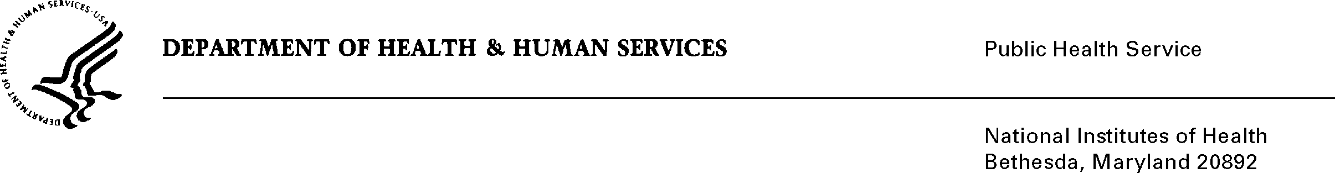
DATE: February 26, 2016

TO: Stephanie Mok
Office of Management and Budget (OMB)
Reports Clearance Officer, DHHS

FROM: Mikia P. Currie
Chief, Project Clearance Branch

SUBJECT: Change Request to a Currently Approved Form
(OMB # 0925-0001, Expiration Date 10/31/2018)

In October, 2015 NIH received approval of all pre-award application forms under OMB Collection number 0925-0001, as well as post-award forms in OMB Collection 0925-0002. NIH is requesting non-substantive changes to instructions to a form (9B) approved under 0925-0001 which do not change the approved data collection or anticipated burden hours. There is no new data collection being proposed on any of the existing forms. Details on these changes are provided in the attached change request justification document. Since the most recent approval of 0925-0001 several Federal-wide and agency-specific initiatives have begun that require modification to instructions used for completing applications currently cleared in this package. These are instruction changes only. The changes are described in a separate justification document that explains the background and natures of the changes. The other attachments show the text that will be used and/or how the changes will appear on the document.

Attachment A: Changes to SF424 (R&R) Instructions (Senior/Key Person Profile (Expanded) Form, biosketch instructions, pages 90-92)

Attachment B: Revised Biosketch Instructions

Your full consideration is appreciated.

