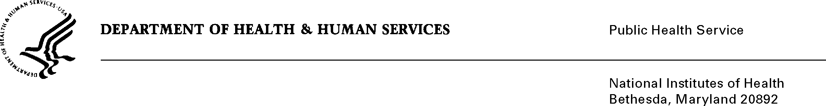

DATE: November 10, 2016

TO: Stephanie Mok, OMB

Through: Darius Taylor, DHHS

Mikia P. Currie, NIH

Celia Wolfman, FIC

FROM: Mikia Currie

Chief, Project Clearance Branch

SUBJECT: Change Request to a Currently Approved Form

(OMB # 0925-0001, Expiration Date 10/31/2018)

In October 2015, NIH received approval of all pre-award application forms under OMB Collection number 0925-0001, as well as post-award forms in OMB Collection 0925-0002. NIH is requesting non-substantive changes to (1) form (9B) approved under 0925-0001 which do not change the approved data collection or anticipated burden hours, (2) and forms 5N, 5P, 5R, and 6A which do not change the approved data collection or anticipated burden hours. Lastly, NIH is requesting non-substantive changes to prior approval requests collected under 0925-0001 which do not change the approved data collection or anticipated burden hours. There is no new data collection being proposed on any of the existing forms.

More information about the description of changes are as follows:

Biosketch instructions have been rewritten for clarity – using shorter sentences, bullet points, and shorter paragraphs. Clarification on which sections apply for which mechanisms have been updated (i.e., fellowship, career, etc.). No policy changes have been made regarding biosketch instructions.

NIH has redefined the current appendix policy for allowable appendix materials, effective for application due dates on or after January 25, 2017. Updated instructions reflect this change.

The current submission process for prior approval requests is through email or paper submission. NIH has developed an electronic submission option through the eRA Commons for applicants and grantees to submit these requests directly to the appropriate official. Review and approval will happen within this system, which is currently optional for applicants and grantees.

Examples of prior approval requests include, but are not limited to, the following:

* Withdraw an application after it has been submitted
* Request direct costs of $500,000 or more in any one year

Screen shots of how these requests will look in eRA Commons are attached separately.

**Attachment A:** Changes to biosketch instructions, which are currently located in attachment 9B of the 0925-0001 package.

**Attachment B:** Changes to the appendix instructions, which are currently located in attachments 5N, 5P, 5R, and 6A of the 0925-0001 package.

Attachment C: Screen shots of prior approval requests.

Your full consideration is appreciated.