Department of Health & Human ServiceS  Centers for Medicare & Medicaid Services  7500 Security Boulevard, Mail Stop C5-15-12  Baltimore, Maryland 21244-1850 | 

Date:

Dear [Mr./Ms./Dr. Name of Grievant]

Under contract with the Centers for Medicare & Medicaid Services (CMS), The Jackson Group, A Bivarus Company would like you to tell us about how your ESRD Network handled your facility complaint. The Jackson Group is not part of your facility and will not share your answers with
[Network #: Network Name] or your dialysis facility.

CMS works with The Jackson Group to call patients who have filed a complaint with their ESRD Network and agreed to take part in a survey. [Network #] closed your complaint on or around [Complete Date] and shared your name with us as a patient who agreed to take the survey. Someone from The Jackson Group will try to call you up to five times. If you cannot talk when you are called, you can let The Jackson Group know when it is better to call, and they will call you back then.

The Jackson Group will call you in the time noted below:

mm/dd/yyyy and mm/dd/yyyy [between 9:00 am and 7:00 pm]

The survey should take less than 15 minutes. You will be asked about how your complaint was handled by your Network. We will not ask about what happened or the result of your complaint. Your answers will be kept private. Your facility and Network will not see your answers. Your answers will not change your Medicare benefits.

You do not have to take the survey, but if you do take the survey, you will help improve the complaint process for other people like you. If you do not take the survey, the care and services you receive will not change.

To set up a survey time, ask questions, or get a copy of the survey to use during your call, please contact: The Jackson Group at 844-550-1952.

Sincerely,

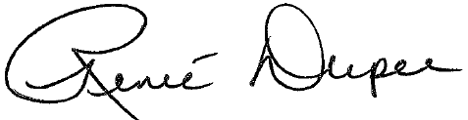
Renee Dupee, JD
CMS-ESRD Team Lead

