***Optional Share Your Story Component***

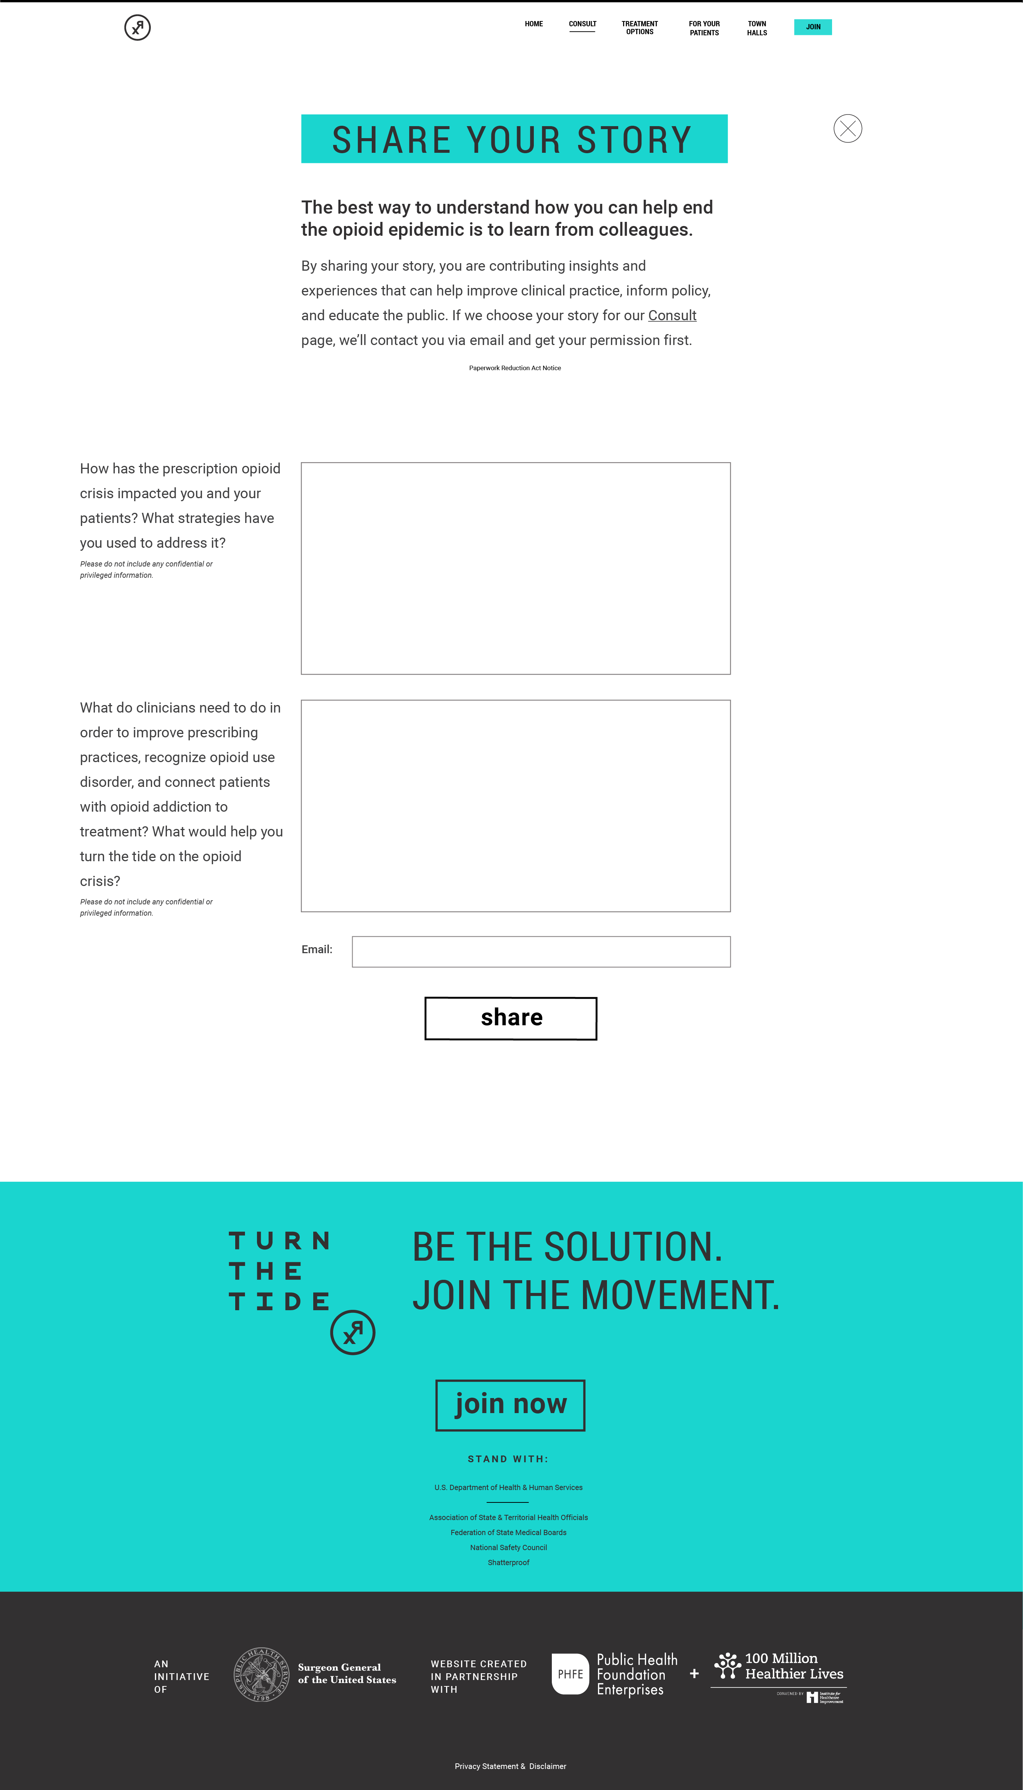***­­***

***Optional Pledge Component***

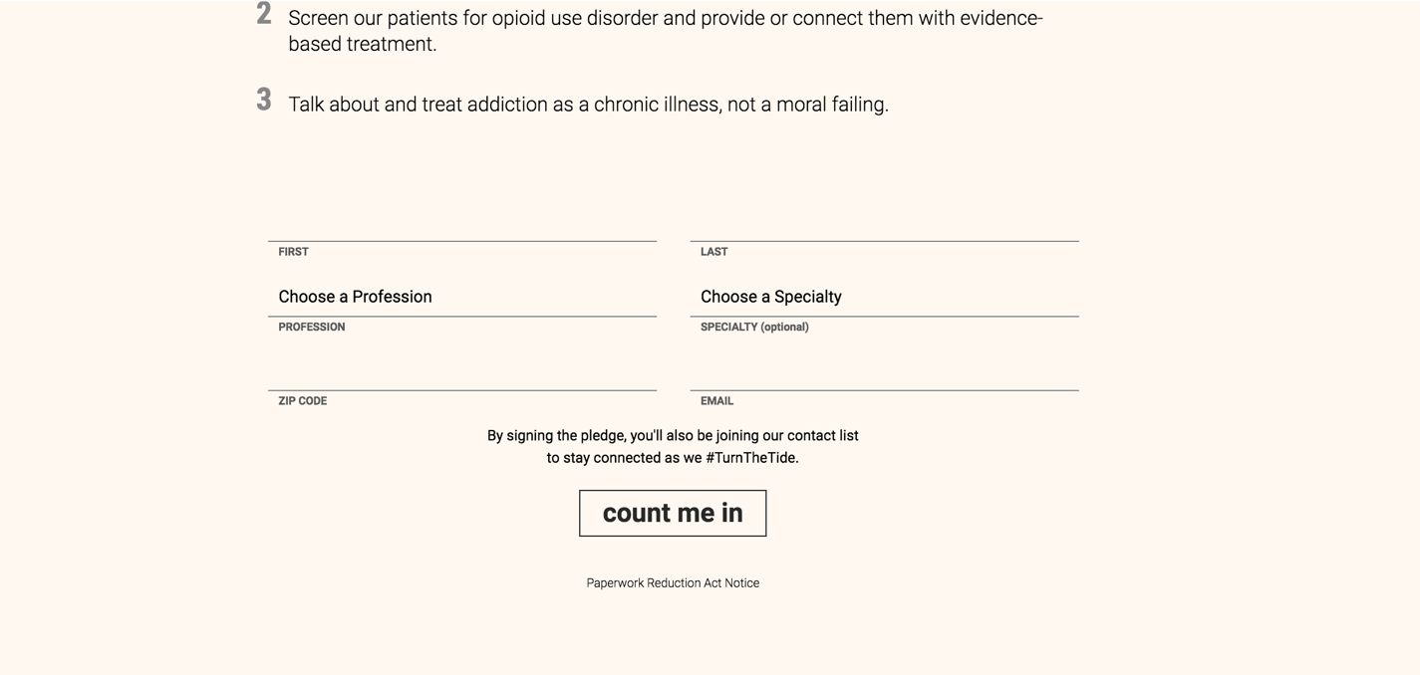

***Paperwork Reduction Act Notice (Appears on the forms)***

