**OMB No. 1240-0041**

**Notice of Final Payment or Suspension of Compensation Payments (LS-208)**

Notice to OMB Reviewer:

The Office of Workers’ Compensation Programs (OWCP) Division of Longshore and Harbor Workers’ Compensation (DLHWC) is requesting this non-material change in conjunction with the adjustment of civil monetary penalties in accordance with the Federal Civil Penalties Inflation Adjustment Act Improvements Act of 2015.

The Federal Civil Penalties Inflation Adjustment Act of 1990 as amended by the Federal Civil Penalties Inflation Adjustment Act Improvements Act of 2015 (Inflation Adjustment Act) required agencies to adjust the levels of civil monetary penalties with an initial catchup adjustment, followed by annual adjustments for inflation. To implement the Inflation Adjustment Act, on July 1, 2016 the Department of Labor published a department-wide interim final rule (IFR) adjusting its penalties for inflation for all civil penalties assessed after August 1, 2016. This IFR does not change what is collected in this information collection request (ICR), the anticipated response or any of the associated costs. The only change is to the penalty amount referenced in the Instruction section at the top of the form.

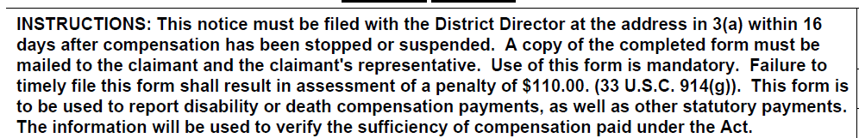

Since this penalty amount will change each year, OWCP/DLHWC proposes to remove the specific penalty amount and refer to the regulatory citation only since that is updated as each annual adjustment is implemented.

Revised Instructions:

INSTRUCTIONS: This notice must be filed with the District Director at the address in 3(a) within 16 days after compensation has been stopped or suspended. A copy of the completed form must be mailed to the claimant and the claimant's representative. Use of this form is mandatory. Failure to timely file this form shall result in assessment of a penalty as outlined in 20 CFR 702.236. This form is to be used to report disability or death compensation payments, as well as other statutory payments. The information will be used to verify the sufficiency of compensation paid under the Act.