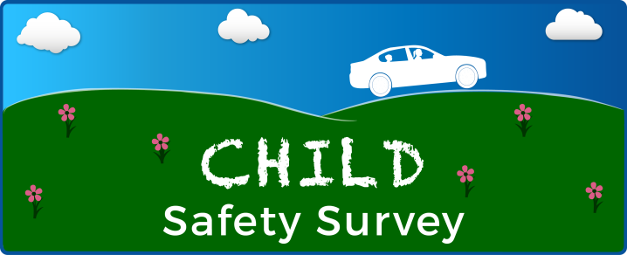

«SAMPNO»
«CITY» Resident
«ADDRESS»
«CITY», «STATE» «ZIP» «DATENOW»

Please help us improve child safety in your community.
I am writing to ask you to take part in an important Child Safety Survey that can benefit children and improve transportation safety in your community and around the country. Even if you don’t travel with children on a regular basis your responses are valuable.
This survey will be used to help:
- Make travel safer for children.
- Give caregivers better information about child safety.
- Build better child safety programs.
To help us improve child transportation safety, the National Highway Traffic Safety Administration (NHTSA) at the U.S. Department of Transportation (DOT) is asking you to complete the Child Safety Survey. Westat, a nationally recognized research firm, is conducting the survey on behalf of NHTSA.
The PIN you received is unique to your household; we care about your thoughts so please do not share the PIN with others. Participation is voluntary and you can be certain that all information you provide will be used for research purposes only. The survey will take only 15 minutes of your time. Enclosed you will find a small token of appreciation. You will also receive $5 as a thank you for completing the survey.
Here’s how you can help children in your community:
1
3
2

If you prefer to speak with a study team member or if you have any questions about the survey, please visit our website at www.ChildSafetySurvey.com or call our study team at 1-8##-###-####.
Thank you in advance for helping to improve child safety!

Sincerely,
SIGNATURE NHTSA STAFF NAME
National Highway Traffic Safety Administration
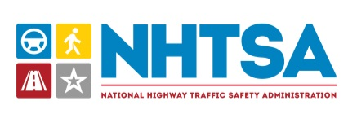

Si quiere participar en este estudio sobre la seguridad infantil, o si quiere obtener
más información, por favor llame al 800 NUMBER.

