Awareness & Availability of Child Passenger Safety Information Resources
Survey Screener

Under the Paperwork Reduction Act, a federal agency may not conduct or sponsor, and a person is not required to respond to collection of information subject to the requirements of the Paperwork Reduction Act unless that collection of information displays a current valid OMB Control number. The OMB Control Number for this information collection is XXXX-XXXX (expiration date: MM/DD/YYYY). The average amount of time to complete this survey is 5 minutes. All responses to this collection of information are voluntary. If you have comments regarding this burden estimate or any other aspect of this collection of information, including suggestions for reducing this burden send them to Information Collection Clearance Officer, National Highway Traffic Safety Administration, 1200 New Jersey Ave, S.E., Washington, DC, 20590.

Screener
S1. In a typical month, how often do you drive a vehicle with a child passenger under the age of 9?
- Daily
- At least 2 times a week
- At least 2 times a month
- Less than 2 times a month
- Never

S2. Are you the person living in your household who drives most often with a child passenger under age 9?
- Yes, I am the household member who drives most often with a child passenger (If answer to S1 is D or E and S2 is A, proceed to select demographic questions and thank you; otherwise go to S4)
- No, someone else drives most often with a child passenger (Go to S3)
- No one in our household drives with children under the age of 9 (Proceed to select demographic questions and thank you)

S3. Is the individual who drives most often with a child passenger available to participate in this survey at this time?
- Yes (Provide text asking for alternative respondent and back to introduction)
- No (If answer to S1 is D or E and S2 is B, proceed to select demographic questions and thank you; otherwise go to S4)

S4. How many children under age 9 do you drive in a vehicle at least 2 times a month?
Number (2 Digits)
[Based on the number of children reported – a roster will be presented for each child with an introduction and a series of questions S5-S16. If respondent records 0 verify response from S1 – respondent indicates that they drive with a child passenger under the age of 9 at least 2 times a month]

Introduction to Child Roster:
[Based on number of children reported, a different introduction will appear prior to the roster.]
- [For respondents that drive one child]
Please continue to provide information about the child under age 9 that you drive in a vehicle at least 2 times a month.
- [For respondents that drive 2-5 children]
For each child under age 9 you drive in a vehicle at least 2 times a month, please provide the following information. Start with the oldest child:
- [For respondents that drive more than 5 children]
For each of the 5 children under age 9 you drive in a vehicle most frequently, please provide the following information. Start with the oldest child.

S5. What is the child’s name?
NOTE: We only ask for names to help refer to the child later. You can use initials, nicknames, etc. if you prefer. We just ask that no two names are the same and that what you use is meaningful to you.
- ________ (Text)

S6. Is [child name]’s a ……?
- Boy
- Girl

S7. How old is [child name]?
- Less than 2 years old (Go to S8)
- Two years or older(Go to S9)

S8. What is [child name]’s age in months? (Go to S10)
_____ (enter number)

S9. What is [child name]’s age in years?
____ (enter number)

S10. What is [child name]’s height in feet?
- ___ (Text)
- I don’t know

S11. What is [child name]’s height in inches?
- ____ (Text)
- I don’t know

S12. What is [child name]’s weight in pounds?
- _____ lb
- I don’t know

S13. What is your relationship to [child name]?
- Parent/Stepparent
- Grandparent
- Other Relative
- Child Care Provider
- Carpool Driver
- Other, Specify:

S14. How many days per week or per month do you usually drive [child name]?
_________ (Number Field)
Per…
- Week
- Month

S15. How does [child name] usually ride with you in a vehicle? (NOTE – will use images below)
- Infant Seat
- Rear Facing Seat
- Forward Facing Seat
- High back Booster
- Low Back Booster
- Seat Belt
- Does not use child seat or wear seat belt
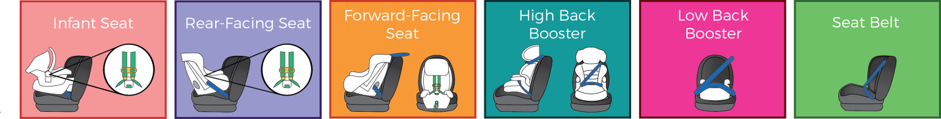
[If the response to S15 for all of the children is seat belt (F) or none (G), go to Question 1-7 followed by Section 3.]

[Questions S5-S15 repeated for number of children reported in S4]

S16. Are there any additional children under age 9 that you drive in a vehicle at least 2 times a month?
- Yes (provide additional screen for the child)
- No (continue to survey)

