Exhibit S: Final Medicare FI Assessment Letter (Top Memorandum)

Exhibit S: Findings
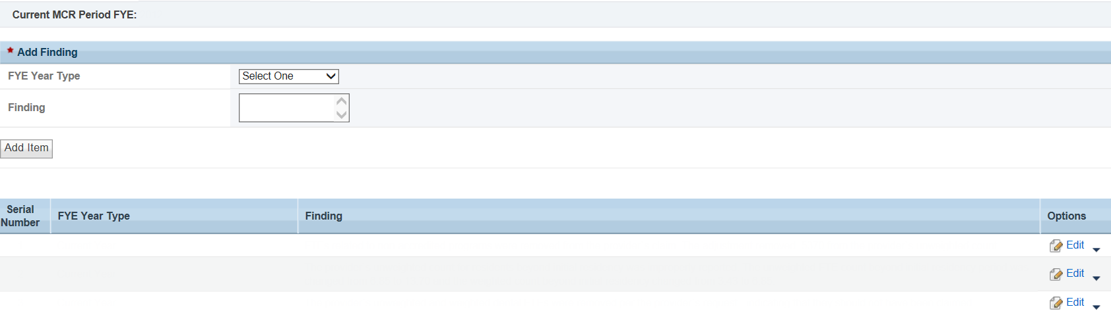

Exhibit S: Recommendations/Conditions
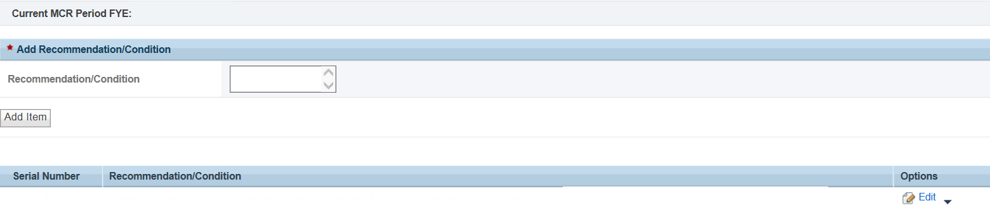

Exhibit S: Field Review Activities
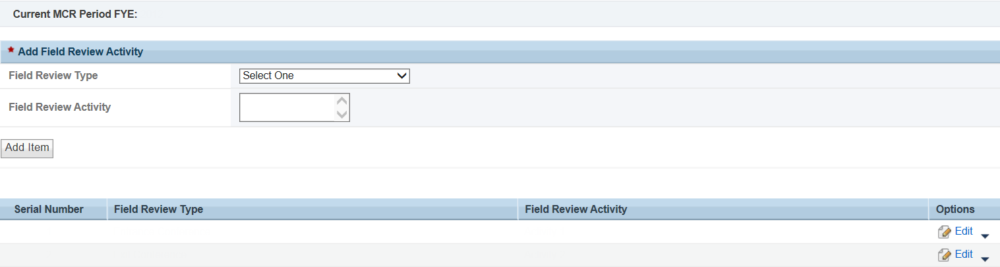

Exhibit S: Medicare Intermediary
