Change Request
March 14, 2016

Monitoring and Reporting System for the Division of Community Health’s Cooperative Agreement Programs
(OMB no. 0920-1053, exp. Date 03/31/2018)

Summary
CDC is currently approved to collect information from awardees funded through two cooperative agreements: Partnerships to Improve Community Health (PICH) and Racial and Ethnic Approaches to Community Health (REACH). Awardees are 41 state, local and tribal governmental agencies, and 52 non-governmental organizations. Each DCH awardee submits semi-annual reports to CDC through an electronic management information system, the DCH-Performance Monitoring Database (DCH-PMD), also called the DCH-Performance Monitoring and Reporting System.

CDC proposes minor changes to the DCH-PMD, effective immediately, to facilitate the production of reports due in April 2016. CDC will continue to use this monitoring system for program improvement and to respond in a timely manner to requests for information from the Department of Health and Human Services (HHS), the White House, Congress, and other sources.

Information Collection Instruments Affected by Changes
The DCH-PMD includes a section for awardees to report “Progress”; all requested changes to the system are within this section.

The following changes are proposed:

- Addition of a new screen for improved navigation and usability. No new information is collected on this screen.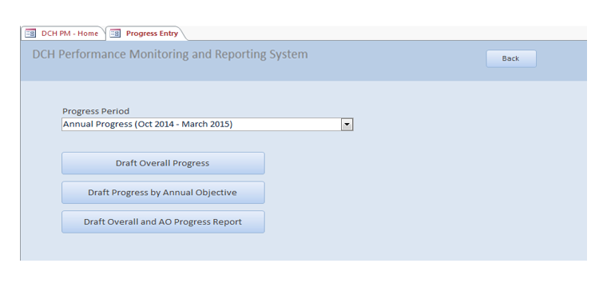

- Correction of a typographical error on six screens and addition of one new tab on each of the corrected screens. The screen shot below shows the typographical error: two items were labeled “3.” In addition, item “4.” should have been labeled “5.”

- Accomplishments. 2. Challenges 3. Overcome Challenges 3. Lessons Learned 4. Priority Populations.
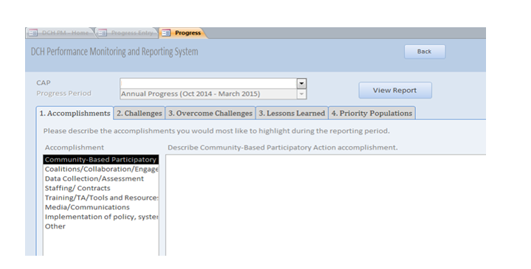

The labeling will be corrected to 1. Accomplishments 2. Challenges 3. Overcome Challenges 4. Lessons Learned 5. Priority Populations.

In addition, a new tab (6. Evaluation) will be added to each of the six screens:
1. Accomplishments 2. Challenges 3. Overcome Challenges 4. Lessons Learned
5. Priority Populations 6. Evaluation.
For example,

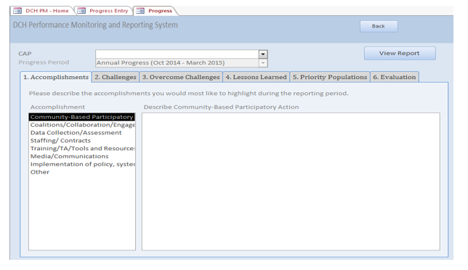

- When the “Evaluation” tab is selected, the user will be directed to a new Add Evaluation screen with the fields:

- “Select Evaluation” (from a pre-formatted drop-down list)
- “Provide a brief summary of the evaluation including progress to date and findings” (text)
- “How is evaluation being used and disseminated?” (text)

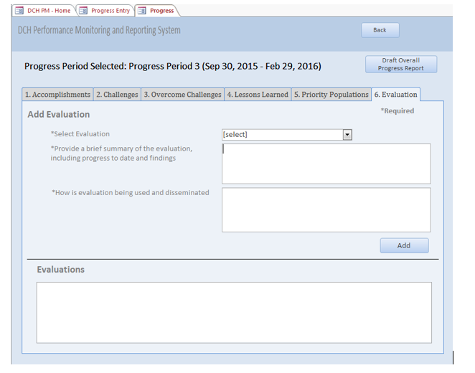

Justification for New Evaluation Tabs
The FOA requirements for both PICH and REACH stipulate that awardees must conduct at least one local evaluation that measures short-term outcomes. In addition, the FOA requires that awardees report both their evaluation progress and dissemination goals annually to the Office of Financial Resources (OFR). A minor modification of the DCH-PMD is the most convenient, user-friendly, and least burdensome method of reporting the required information to CDC. The modification is consistent with the stated information collection objectives for program monitoring and reporting.

Impact on Estimated Annualized Burden
Minimal. Awardees will not be asked to collect new information, only to provide brief descriptive summaries of activities in which they are routinely engaged on an ongoing basis. These activities include the implementation and evaluation of interventions that increase access and uptake of nutrition, physical activity, and clinical community linkages to improve population health outcomes. CDC estimates that the time to create responses can be easily absorbed in the current burden estimate.

Summary of Revised Documents

- Att3a_DCH-PMD Screen Shots_ 3 14 2016 replaces Att3a_DCH-PMD_Screen Shots_3 06 2015

The updated screen shots can be viewed on pages 8 – 11.

- The Guidance provided to awardees for entering data into the DCH-PMD will also be amended. Att3b_DCH-PMD_User Guide_ 3 10 2016 replaces Att3b_DCH-PMD_User guide_3 06 2015.

The revised guidance can be viewed on pages 41 – 45.

