November 09, 2016

Monitoring and Reporting System for the Division of Community Health’s Cooperative Agreement Programs
(OMB no. 0920-1053, exp. Date 03/31/2018)

Summary
CDC’s Division of Community Health (DCH) receives semi-annual progress reports from awardees through an electronic management information system, the DCH-Performance Monitoring Database (DCH-PMD), (in the original OMB request the DCH-DMD was also referred to as the DCH-Performance Monitoring and Reporting System). This system collects information from awardees funded by DCH through two cooperative agreements: Partnerships to Improve Community Health (PICH) and Racial and Ethnic Approaches to Community Health (REACH). Awardees are 41 state, local and tribal governmental agencies, and 52 non-governmental organizations.

CDC DCH is proposing a minor Change, effective immediately, to facilitate awardees reporting critical information in a consistent manner. Specifically, CDC DCH Requests to replace one Screen and its accompanying user guidance in the DCH-PMD with a new Screen and accompanying guidance. The new screen will allow awardees to more thoroughly and reliably report evaluation outcomes. There are no requested changes to the number of respondents, the overall purpose of the information collection, nor the estimated burden per response.

Information Collection Instrument Affected by Change
This Change Request will delete one Screen in the DCH-PMD that says “Evaluation”. This Screen and accompanying user guidance states: “Provide a brief summary of the evaluation including progress to date and plans for dissemination”. Currently, awardees provide this information in open-ended text boxes. The deleted Screen will be replaced with a new Screen that provides more structured responses options (a table) for awardees to report detailed and uniform Evaluation data. The accompanying User Guidance will provide a standardized way of reporting data using the new screen.

No other changes are requested.

Justification for Change Request:
The requirements for both PICH and REACH stipulate that awardees must conduct at least one local evaluation that measures short-term outcomes and actual use of a healthier environment. In keeping with these requirements, CDC intends that DCH-PMD include a format that will result in consistent and critical awardee information to report short-term outcomes and actual use of a healthier environments.

Awardees have requested this change to report their evaluation data and results. An improvement to the DCH-PMD and accompanying User Guide s the most convenient, user-friendly, and least burdensome method of reporting the required information to CDC. The modification is consistent with the stated information collection objectives for program monitoring and reporting.
Type of Change | Crosswalk of non-substantive changes to 2016 DCH-PMD  (Delete Screen and Add New Screen)
DELETE SCREEN  (Pg. 45 of Att3b_DCH-PMD_User Guide_03-10-2016.)  DELETE USER GUIDANCE | 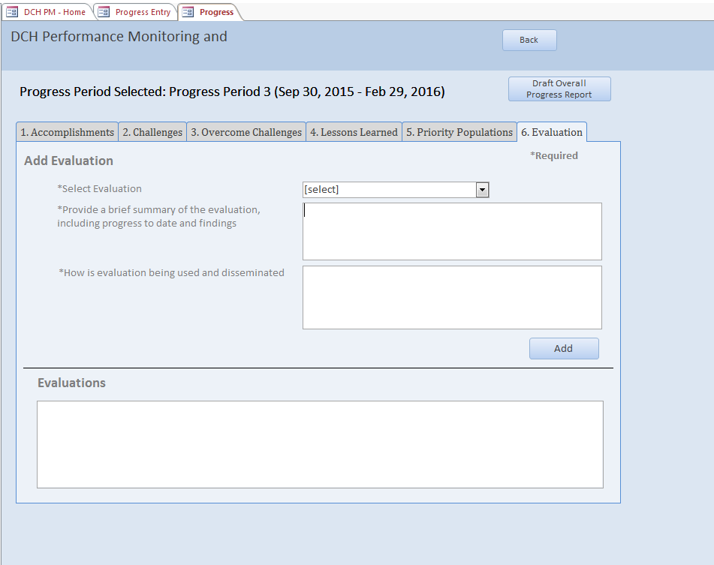  When the “Evaluation” tab is selected, the user (from a pre-formatted drop-down list) is directed to report the following:  - “Select Evaluation”  - “Provide a brief summary of the evaluation including progress to date and findings” (text)  - “How is evaluation being used and disseminated?” (text)
ADD NEW SCREEN  (Page 46 in ATT 3b_DCH-PMD User Guide_10 07 2016. | 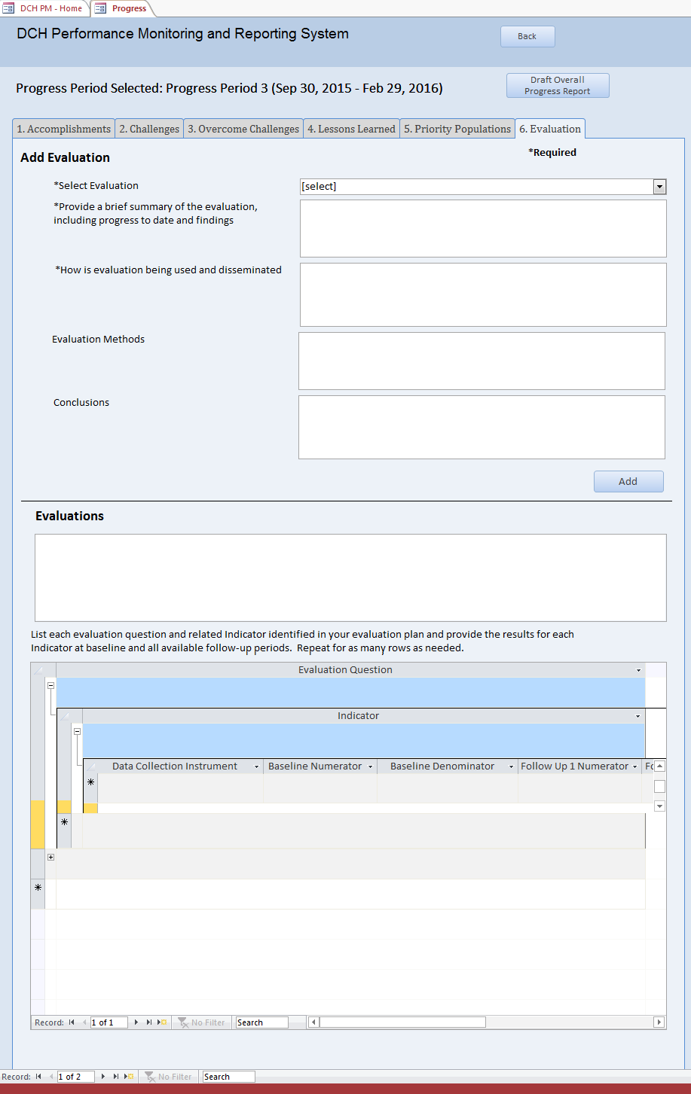
Type of Change | Crosswalk of non-substantive changes to 2016 DCH-PMD  (Delete Screen and Add New Screen)
ADD NEW GUIDANCE  Guidance for awardees to report evaluation data in ‘Evaluation’ tab. This can be found on pages 46-49 of the ATT 3b_ DCH-PMD_User Guide_10 07 2016. | - Select the “Evaluation” tab at the top of the screen (See Figure 61).  - Next, you must select the Evaluation Plan for which you wish to enter information. How you select the Evaluation Plan depends on whether the evaluation plan was entered into the Evaluation Plan database and if you previously entered data for the evaluation plan in this screen for the progress period.  - First, check to see if your evaluation plan title is in the “Select Evaluation” drop down menu. If so, highlight the evaluation plan name, click the ADD button near the middle right of the screen and proceed to Step 3. By clicking ADD, your Evaluation Plan will now appear in the “Evaluations” Box in the middle of the screen. Select the plan name in the Evaluation box. If the plan does not appear in the drop down list, proceed to Step b.  - Refer to the “Evaluations” box in the middle of the screen. If your evaluation plan is listed here, please select the evaluation plan and proceed to Step 3. If your evaluation plan is not listed here, proceed to Step c.  - Type the Evaluation Plan name in the “Select Evaluation” field. Next, click the ADD button near the middle right of the screen. By clicking ADD, your Evaluation Plan will now appear in the “Evaluations” Box at the bottom of the screen. Select the plan name in the Evaluation box. Proceed to Step 3.  - In the “Provide a brief summary of the evaluation…” box, provide a brief summary of the selected evaluation, including progress to date and findings.  - In the “How is evaluation being used…” box, provide a brief summary of how the evaluation information or data are being used and disseminated.  - In the “Evaluation Methods” Field, please include a brief description of any changes to your sample size or methodology. If there were no changes to the sampling methodology in your approved evaluation plan, please enter “NA”.  - In the “Conclusions” field, you may provide an interpretation of findings based on results of implementing the intervention, or conclusions drawn including contextual information. This is optional, and should be no more than 250 words.  - Next, you will enter information about each evaluation question and related indicators identified in your evaluation plan in the Evaluation Plan Results box at the bottom of the screen.  - In the first box, enter the evaluation question. If there is more than one evaluation question in the plan, add the first evaluation question here. Next, click on the “+” to open the Indicator line.  - Enter the indicator related to the evaluation question. If there is more than one indicator per question, add the first indicator here. Next, click on the “+” to open the Data Collection Instrument line.  - In this line, enter the data collection instrument related to the indicator. If there is more than one instrument for this indicator, add the first instrument here. Provide the baseline numerator and denominator for the data collection instrument related to the indicator for all available follow-up periods. If the indicator is a percent or proportion please provide the numerator and denominator as requested, and do not calculate the “percent” or “proportion”. If the indicator is simply a number and based on a sample (as in a survey), still provide both the numerator and the denominator. In all cases, provide a definition for the numerator and the denominator. Use the horizontal scroll bar at the bottom of the window to scroll right to view all of the fields in this row.  If there is a second data collection instrument for this indicator, add it to the row directly below the first instrument. Please note that this is a nested table, so use caution that you are entering the information in the correct level and under the appropriate header.  - Please provide numerators and denominators whenever possible. This helps us to aggregate results meaningfully.  - Please specify Not Applicable (NA) if a field not applicable to an indicator  - If data are not available, please indicate as ‘Not Available’  - When data are not amenable to reporting within the table format, please incorporate into the (optional) Conclusions section  Once you have added all of the data collection instrument information for an indicator, click the “-” on the indicator line to collapse the table to the Indicator level. If you need to add an additional Indicator for the Evaluation question, enter it in the row directly below the first Indicator. Please note that this is a nested table, so use caution that you are entering the information in the correct level and under the appropriate header.  - Next, click on the “+” to open the Data Collection Instrument line. Follow the steps outlined in step c. to enter the information about the data collection instrument(s).  - Once you have added all of the Indicator and Data Collection Instrument information for an Evaluation Question, click the “-” on the Evaluation Question line to collapse the table.  - If you need to add information for another Evaluation Question, enter the Question in the table directly below the first evaluation question. You may also select a new Evaluation Plan by returning to Step 2. To exit the Evaluation screen, click the “Back” button at the top of the screen.

Impact on Estimated Annualized Burden
Minimal. Awardees are asked to provide specific information in a more uniform manner and will not be asked to collect new information to report evaluation results. Awardees collect this information regularly to document their program efforts and progress. Awardees have asked CDC to create a template to capture meaningful results in a standardized format rather than open-ended. In an effort to document all results, awardees often include unnecessary information to ensure that all data are entered into the system. Because this new table guides awardees to only enter specific data, CDC estimates that the time spent entering information will be less than the time spent using the previous version of the screen; however, user time reading the new guidance will be increased. CDC estimates that the time gained and lost will be approximately equal and thus there is no change in the current burden estimate.

