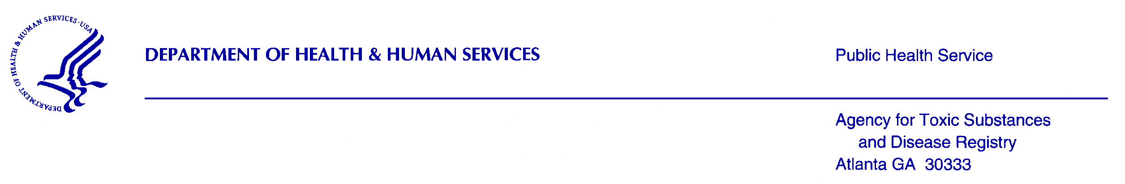

Dear (Name of survey participant),

Thank you for taking the time to participate in our survey. We truly appreciate the information you have provided. Your feedback will help us improve the timeliness and effectiveness of our activities in communities. It will also help public health staff improve what they do in a way that’s best for community members by providing valuable health information to better assess and respond to environmental health risks.

As a token of our appreciation, we are sending you the enclosed $20 gift card for completing the ATSDR Communication Activities Survey (ACAS).

Thank you again for your time and participation.

Regards,

The ATSDR Evaluation Team

