

U.S. Department of Labor
Employment and Training Administration
National Apprenticeship Education and Outreach Campaign

Survey of Apprenticeship Expansion Among U.S. Employers

INTERNAL USE ONLY:

Methodology: 15-minute online survey of n=250 employers, defined as those employed full-time with at least some decision-making authority over offering an apprenticeship program at their organization, C-Suite+ OR VP+ and in executive management role OR Director+ and in HR role), including those whose organizations do and do not currently offer apprenticeship programs

Respondent Qualifying Criteria:
- Ages 25+
- Currently reside in the U.S.
- Employed full time
- C-Suite+ OR VP+ and in executive management role OR Director+ and in HR role
- Have a great deal of influence or direct responsibility for decision-making around the types of job training that their organization offers

[BASE: ALL]
[DISPLAY TO RESPONDENT ON SEPARATE SCREEN] Thank you for your interest in our survey.

The U.S. Department of Labor’s Employment and Training Administration (ETA) is conducting a survey on job training programs. The information you provide will be critical in gaining an understanding of how organizations like yours view these job training programs and will be important for planning and policy purposes.

Completing the questionnaire will take approximately 15 minutes. The survey data collected will be used for research purposes only, and all responses you provide are voluntary, will be kept private to the extent of the law, and will be reported only in aggregate with all the responses collected. All information collected and processed will be done in accordance with local and international data protection laws. Your responses will be combined with those from other organizations like yours and shared only in the aggregate in all reports and communications with the U.S. Department of Labor.

Note: The survey is being conducted by the Employment and Training Administration (ETA) under OMB control number 1205-0346. ETA’s Division of Research and Evaluation (DRE), with input and support from the relevant program offices in ETA, is directing the survey, which is being administered by the research firm, Edelman Intelligence. The ETA, its employees and agents, will use the information you provide for statistical purposes only and will hold the information in confidence to the extent permitted by law. In accordance with the Confidential Information Protection and Statistical Efficiency Act of 2002 (title 5 of Public Law 107-347) and other applicable Federal laws, your response will not be disclosed in identifiable form without your informed consent. If you have any questions or comments regarding this survey, please contact DRE staffer, Sande Schifferes at schifferes.charlotte@dol.gov, or 202/693-3655. Please note that this survey is not hosted on U.S. Department of Labor-owned systems, so the Department cannot assure 100% privacy; therefore, please do not include any personal information.

- Based on the information above, do you agree to participate? [SINGLE SELECT]]

- Yes
- No [TERMINATE]

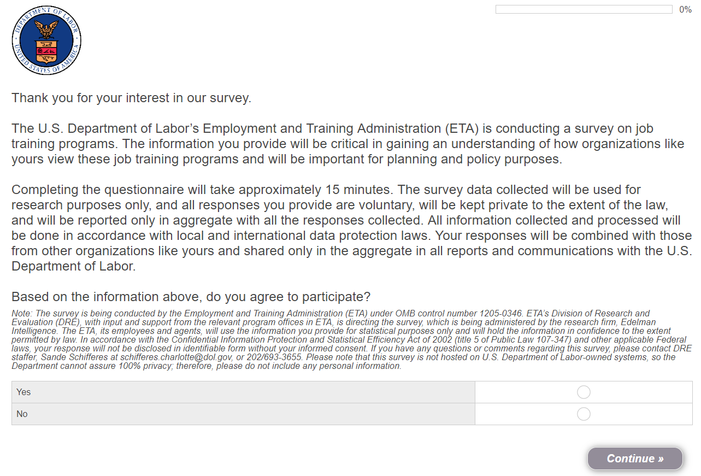

[BASE: ALL]
- What is your current age? [OPEN-END NUMERIC, MIN 1, MAX 99, TERMINATE IF UNDER 25]
[INSERT “Prefer not to answer” OPTION BELOW OPEN-END BOX AND TERMINATE IF SELECTED]

S2A. [BEHIND THE SCENES RECODE TO CENSUS AGE BREAKS]

- 25 to 29
- 30 to 34
- 35 to 39
- 40 to 44
- 45 to 49
- 50 to 54
- 55 to 59
- 60 to 64
- 65 or older

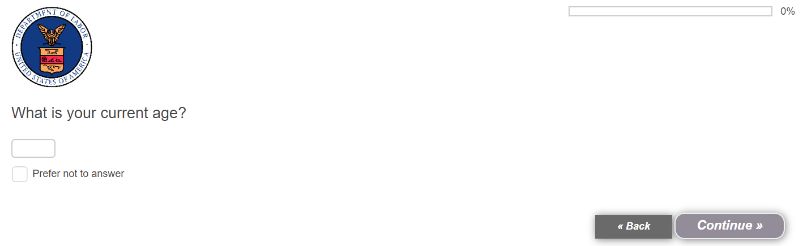

[BASE: ALL]
- What is your current employment status? [SINGLE SELECT, TERMINATE IF NOT EMPLOYED FULL-TIME – S3/01]

- Employed full-time
- Employed part-time [TERMINATE]
- Student [TERMINATE]
- Not employed [TERMINATE]
- Retired [TERMINATE]
- Homemaker/caregiver/stay-at-home parent [TERMINATE]
- Prefer not to answer [TERMINATE]

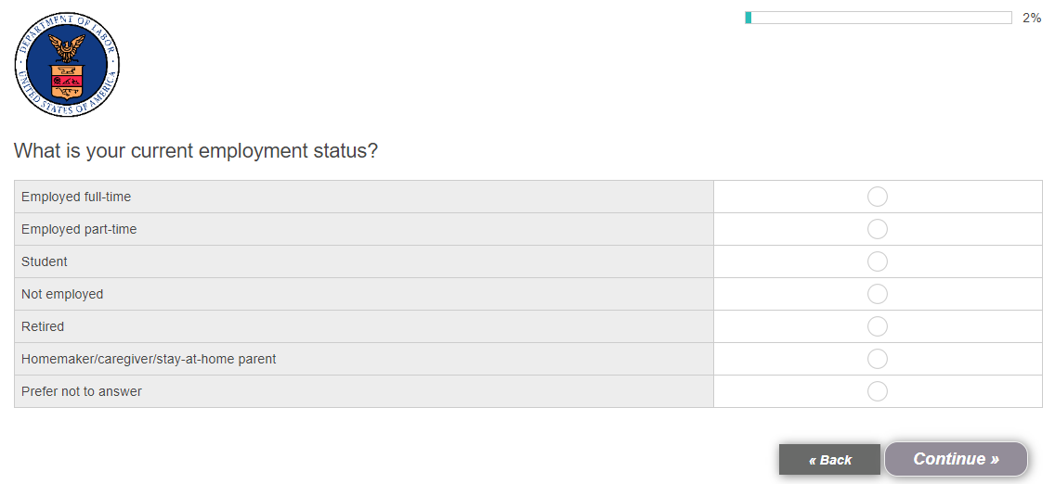

[BASE: ALL]
- In what state do you currently work? [DROPDOWN MENU OF ALL U.S. STATES INCLUDING DC, INSERT EXCLUSIVE OPTIONS “I do not work in the U.S.” AND “Prefer not to answer” BELOW THE DROPDOWN MENU AND TERMINATE IF RESPONDENT SELECTS EITHER OPTION]

S4A. [RECODE TO REGION BASED ON S4]

- Region 1 (S4/ CT, ME, MA, NH, NY, NJ, RI, VT)
- Region 2 (S4/ DE, MD, PA, VA, DC, WV)
- Region 3 (S4/ AL, FL, GA, KY, MS, NC, SC, TN)
- Region 4 (S4/ AR, CO, LA, MT, NM, ND, OK, SD, TX, UT, WY)
- Region 5 (S4/ IL, IN, IA, KS, MI, MN, MO, NE, OH, WI)
- Region 6 (S4/ AK, AZ, CA, HI, ID, NV, OR, WA)

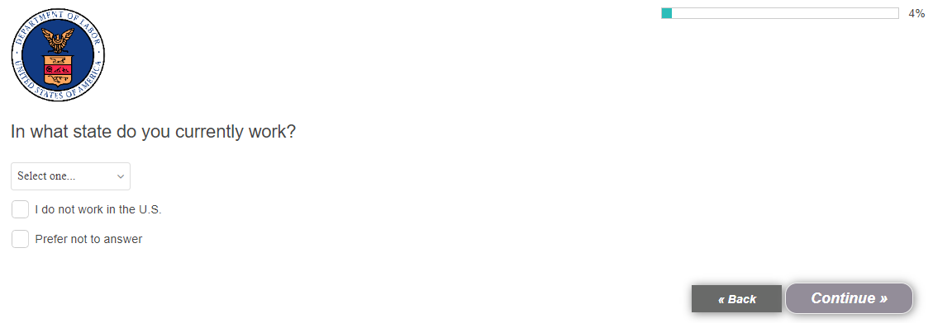

[BASE: ALL]
- Which of the following best describes your current job level at your organization? [SINGLE SELECT, TERMINATE IF NOT DIRECTOR+]

- Entry-level [TERMINATE]
- Associate [TERMINATE]
- Manager [TERMINATE]
- Director
- Vice president
- Senior vice president
- C-Suite, such as chief executive officer or chief operating officer
- Chairman or board member
- Other [TERMINATE]
- Prefer not to answer [TERMINATE]

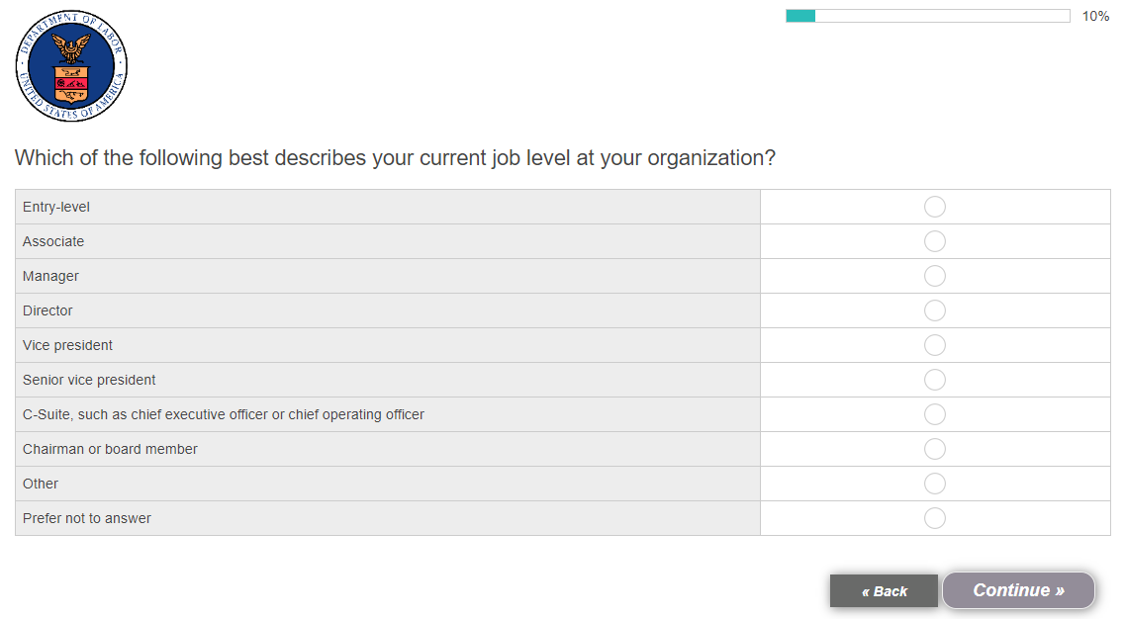

[BASE: ALL]
- Specifically, what is your current title at your organization? [OPEN-END]

- Prefer not to answer [EXCLUSIVE, TERMINATE]

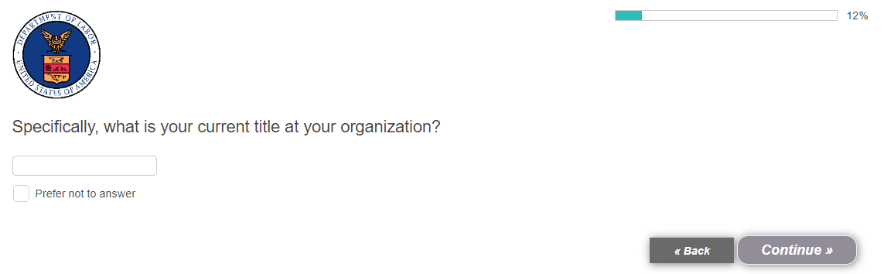

[BASE: ALL]
- Which of the following best describes your current role at your organization? [SHOW IN ALPHABETICAL ORDER, SINGLE SELECT]

- Accounting / finance
- Executive management
- General administration
- General operations
- Human resources / Recruitment
- Information technology
- Legal / general counsel
- Marketing / communications
- Research and development
- Risk management
- Sales / business development
- Other [SPECIFY]
- Prefer not to answer [TERMINATE]

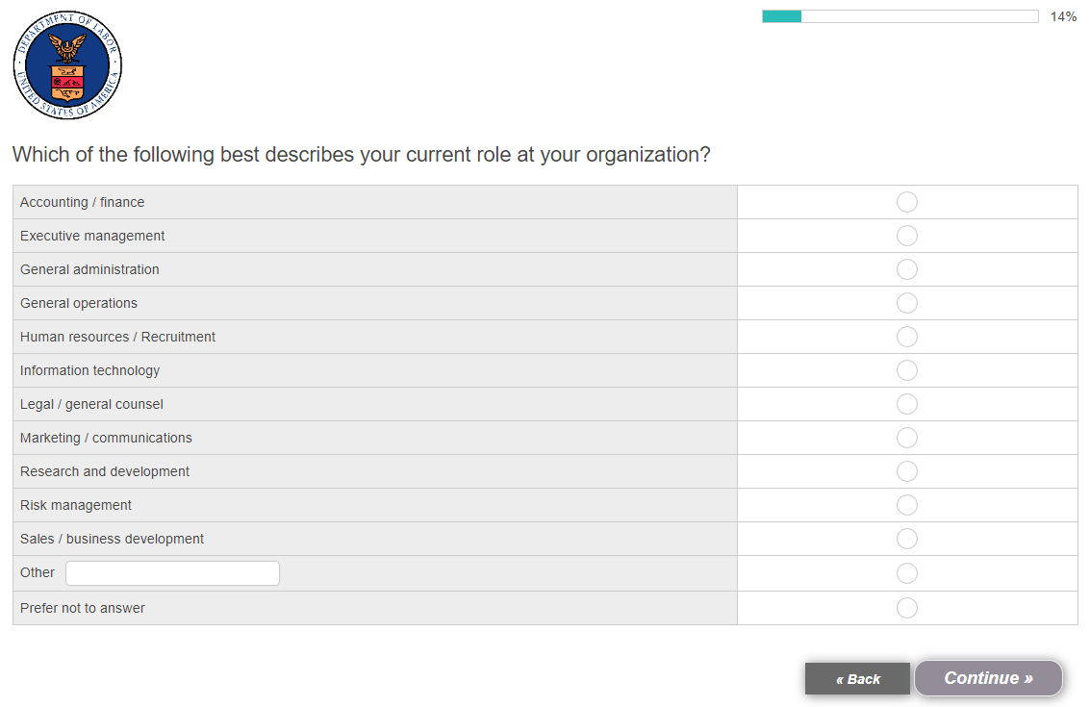

[TO CONTINUE, MUST SELECT: C-SUITE + (S5/07-08) OR EXECUTIVE MANAGEMENT AND VP+ (S5/05-08 AND S7/02) OR HR AND DIRECTOR+ (S5/04-08 AND S7/05); ALL OTHERS TERMINATE]

PN: THERE ARE THREE PATHS (LISTED BELOW) TO CONTINUE. IF A RESPONDENT DOES NOT MEET ONE OF THE THREE, TERMINATE:
- S5/7-8
- S5/5-8 AND S7/2
- S5/4-8 AND S7/5

[BASE: ALL]
- Which of the following best describes your role when it comes to decision-making around the types of professional or occupational training that your organization offers? [SINGLE SELECT]

- I am not at all responsible and have no influence [TERMINATE]
- I am not directly responsible, but I have some influence [TERMINATE]
- I am not directly responsible, but I have a great deal of influence
- I am somewhat responsible
- I am completely responsible

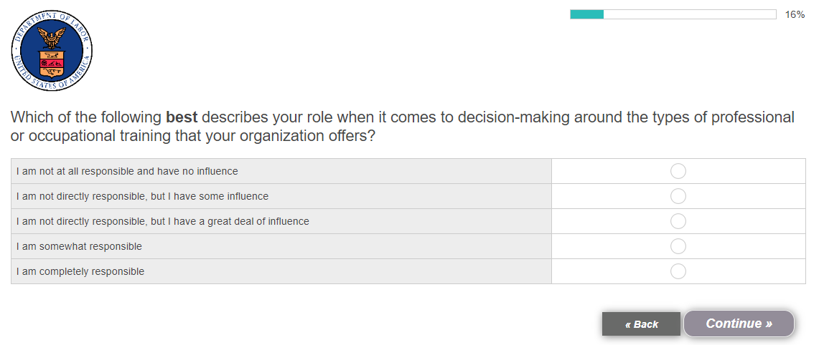

[BASE: ALL]
- Please describe your role in decision-making around the types of professional or occupational training that your organization offers. [OPEN END]

- Prefer not to answer [EXCLUSIVE, TERMINATE]

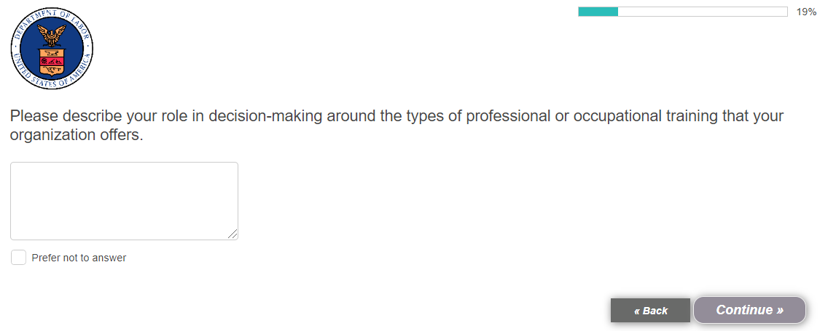

[BASE: ALL]
- Which of the following best describes your organization’s industry?

- Advanced manufacturing and engineering
- Architecture and design
- Agriculture
- Broadcast and telecommunications
- Community, household and personal services
- Construction
- Education services
- Energy
- Entertainment services
- Financial services
- Government
- Healthcare services
- Information and communication technology
- Insurance services
- Legal services
- Marketing, advertising and public relations
- Natural resources and mining
- Professional and business services
- Retail and trade services
- Science, research and development
- Tourism, hospitality and restaurant services
- Transportation and logistics
- Utilities
- Other [SPECIFY]
- Prefer not to answer [TERMINATE]

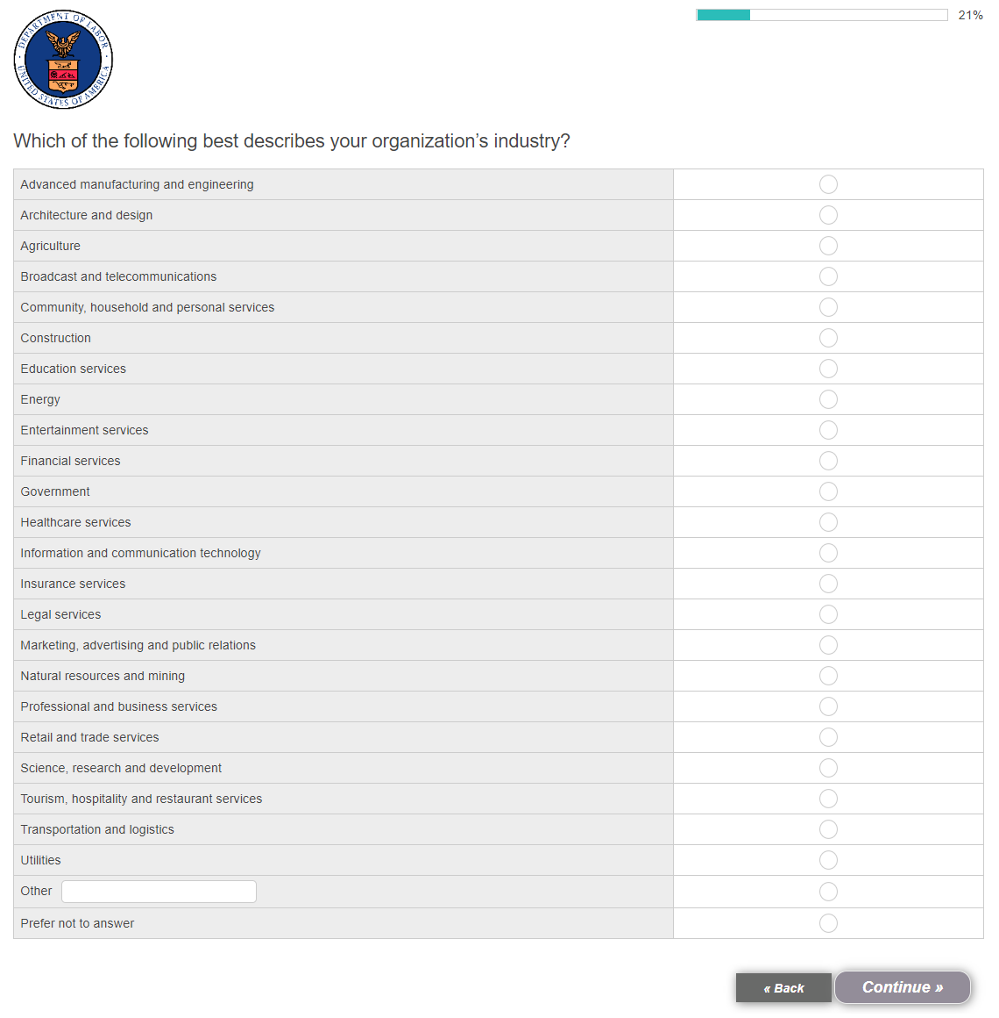

[BASE: ALL]
- Approximately how many people are employed in your organization overall? This includes all full-time, part-time, temporary, seasonal, salaried and hourly employees currently on your organization’s payroll. [SINGLE SELECT]

- Less than 50
- 50 to 99
- 100 to 499
- 500 to 999
- 1,000 to 4,999
- 5,000 to 9,999
- 10,000 to 49,999
- 50,000 to 99,999
- 100,000 or more people
- Don’t know [TERMINATE]

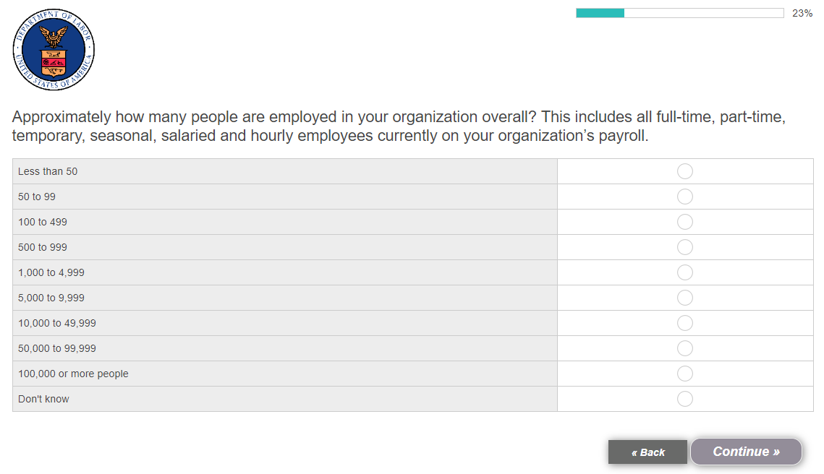

[BASE: ALL]
- Please estimate the total annual revenue of your organization overall. [SINGLE SELECT]

- Under $1 million
- $1 million to less than $10 million
- $10 million to less than $100 million
- $100 million to less than $1 billion
- $1 billion to less than $10 billion
- $10 billion or more
- Don’t know

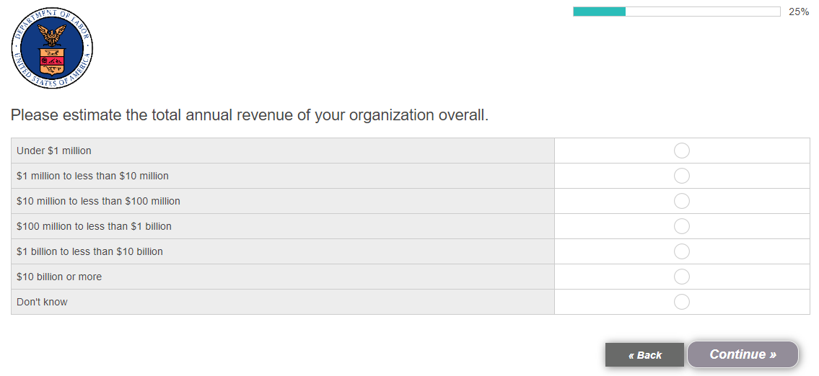

[BASE: ALL]
- Does your organization currently offer any of the following types of professional or occupational training? [RANDOMIZE, KEEP 3-4 TOGETHER, SINGLE SELECT, DISPLAY AS GRID]

[ROW]
- Mentorship program
- Internship program
- Apprenticeship program
- Pre-apprenticeship program
- In-person training courses
- Online training courses

[COLUMN]
- Yes
- No
- Don’t know [TERMINATE IF SELECTS FOR ANY ROW]

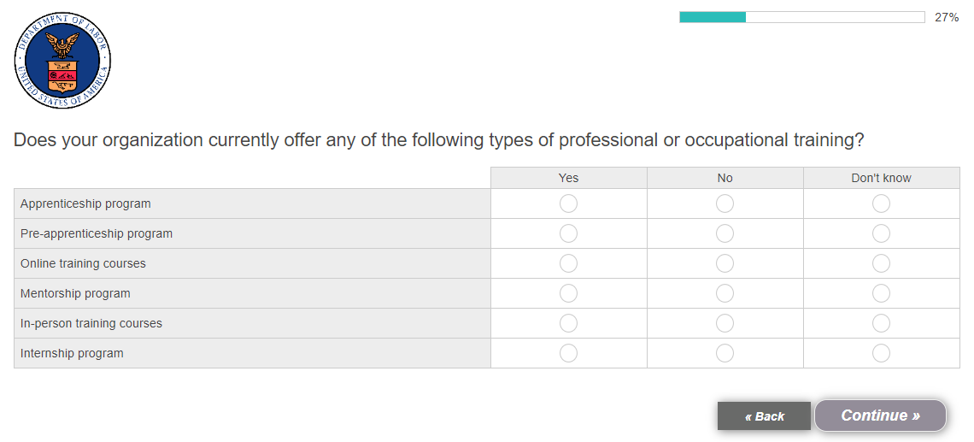

[BASE: OFFER APPRENTICESHIP, S13-3/01]
- You mentioned that your organization offers an apprenticeship program. Which of the following are true of your apprenticeship program? [MULTI-SELECT; RANDOMIZE]

- Apprentices earn wages
- The apprenticeship program provides on-the-job training
- The apprenticeship program provides related educational instruction (in a classroom or through online learning)
- Apprentices earn an industry-recognized credential once they complete the program
- None of the above [TERMINATE]

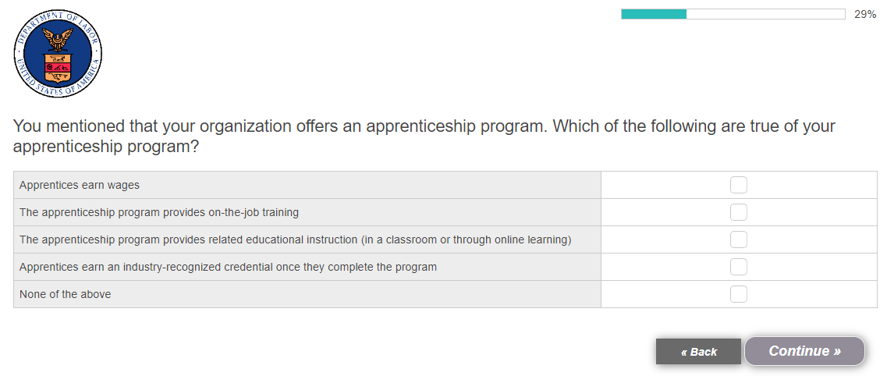

Baseline Apprenticeship Perceptions

[DISPLAY TO RESPONDENT ON SEPARATE SCREEN] Next, we’d like to ask you some questions about your organization and its current workforce, and your thoughts on various types of training programs.

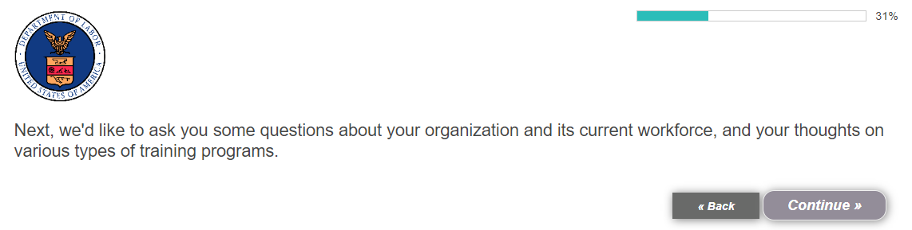

[BASE: ALL]
- Thinking specifically about your organization’s hiring needs, how strongly do you agree or disagree with each of the following statements about your organization? [RANDOMIZE, SINGLE SELECT, DISPLAY AS GRID]

[ROW]
- It attracts a diverse talent pool to its job openings
- It often struggles to find talent to apply to its job openings
- It often struggles to find talent that has the necessary skills
- Its employee training programs are behind the times
- Its employee turnover rate is above the industry average
- Hiring talent has become more difficult recently than in years past

[COLUMN]
- Strongly disagree
- Somewhat disagree
- Neither agree nor disagree
- Somewhat agree
- Strongly agree

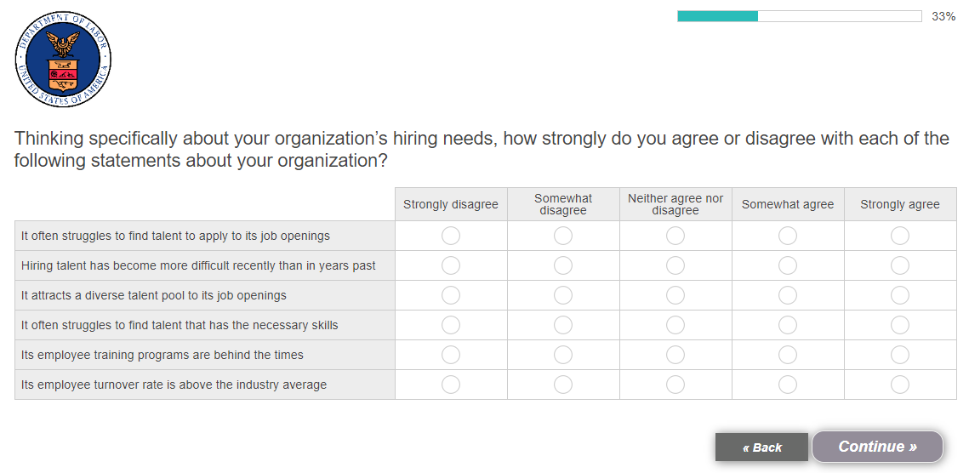

[BASE: ALL]
- Thinking about the talent shortages your organization is currently facing – or has faced in the past – why do you believe those occurred? [OPEN-END]

- My organization has not faced a talent shortage [EXCLUSIVE]

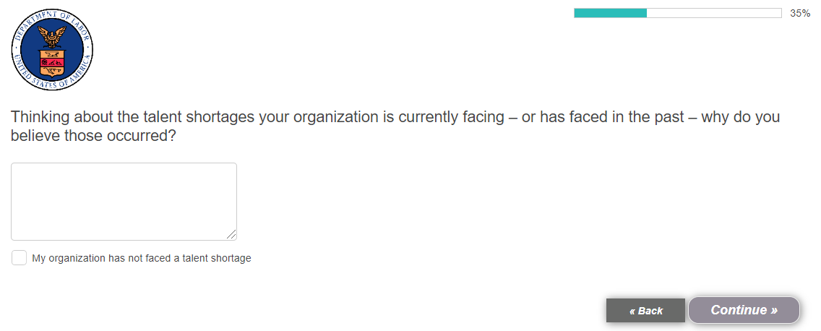

[BASE: ALL]
- Thinking about the various types of professional or occupational training that are offered today, which types of training would be effective at doing each of the following? Please select all that apply. [RANDOMIZE, MULTI SELECT, DISPLAY AS GRID] [DISPLAY AS GRID]

[ROW]
- Preparing candidates for the reality and complexities of the workplace
- Preparing candidates with unique skills that we need at my organization
- Preparing candidates with the quickly evolving skills needed in today’s economy
- Developing candidates that will stay with my organization for a long period of time
- Providing a diverse talent pool

[COLUMN]
- Technical or trade schools
- Community colleges
- Four-year colleges or universities
- Internships
- Apprenticeship programs
- Pre-apprenticeship programs
- Online certification courses
- Don’t know [ANCHOR]

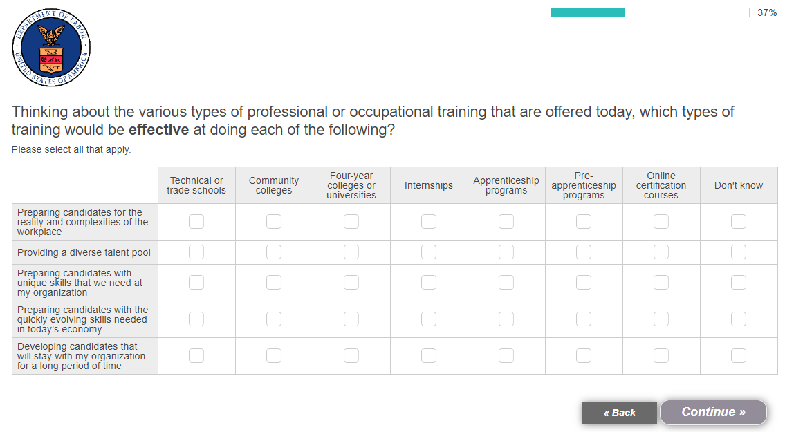

[BASE: ALL]
- How likely are you to consider starting each of the following forms of professional or occupational training at your organization? [DISPLAY AS GRID, DISPLAY ONLY OPTIONS FOR WHICH S13=02 – NO)]

[ROW]
- Mentorship program
- Internship program
- Apprenticeship program
- Pre-apprenticeship program
- In-person training courses
- Online training courses

[COLUMN]
- Not likely at all
- Somewhat unlikely
- Somewhat likely
- Very likely

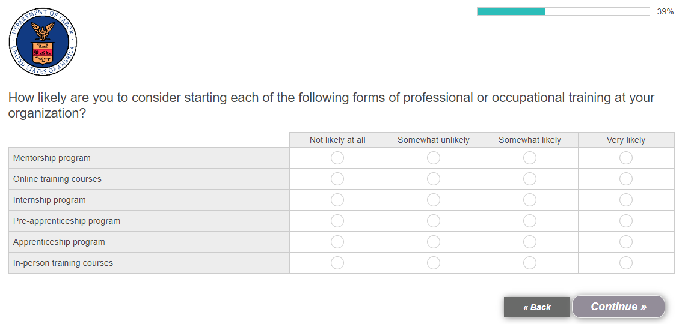

[DISPLAY TO RESPONDENT ON SEPARATE SCREEN] Next, we will ask you some questions specifically about apprenticeship programs.

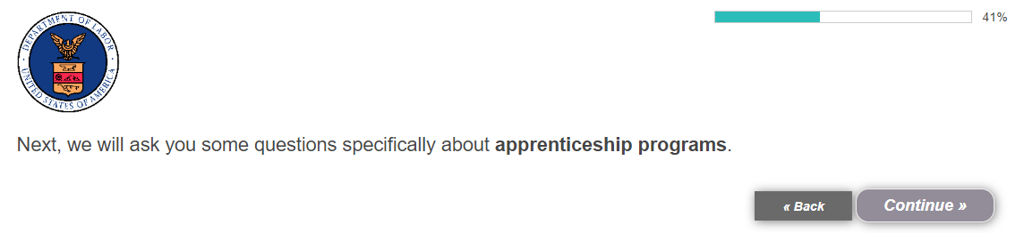

[BASE: ALL]
- When you think about apprenticeship programs specifically, what are the first words, thoughts or phrases that come to mind? Please be as specific as possible. [OPEN-END]

- Nothing/Don’t know [EXCLUSIVE]

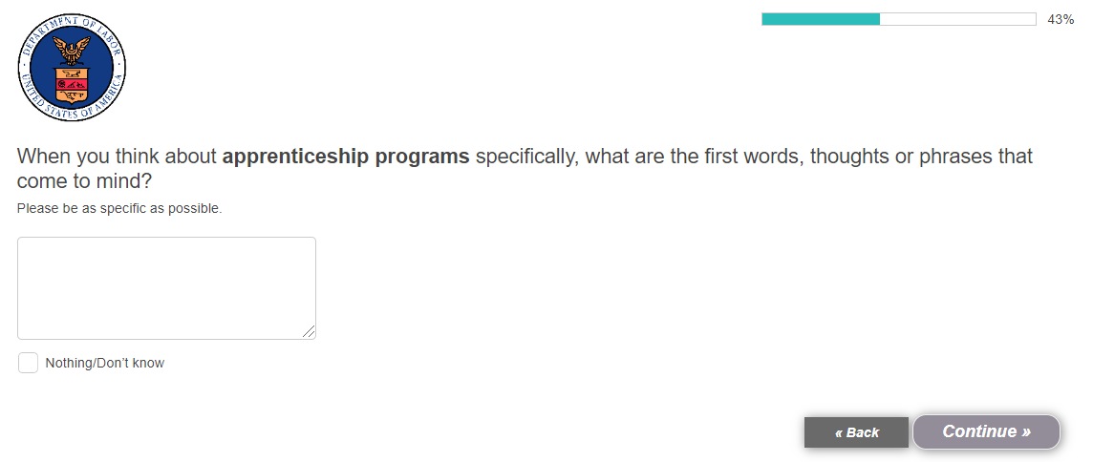

[BASE: ALL]
- What have you read, seen or heard about apprenticeship programs within the past six months? Please be as specific as possible. [OPEN-END]

- I’ve read, seen or heard something about them, but don’t remember what it was [EXCLUSIVE]
- I haven’t read, seen or heard anything about them [EXCLUSIVE]

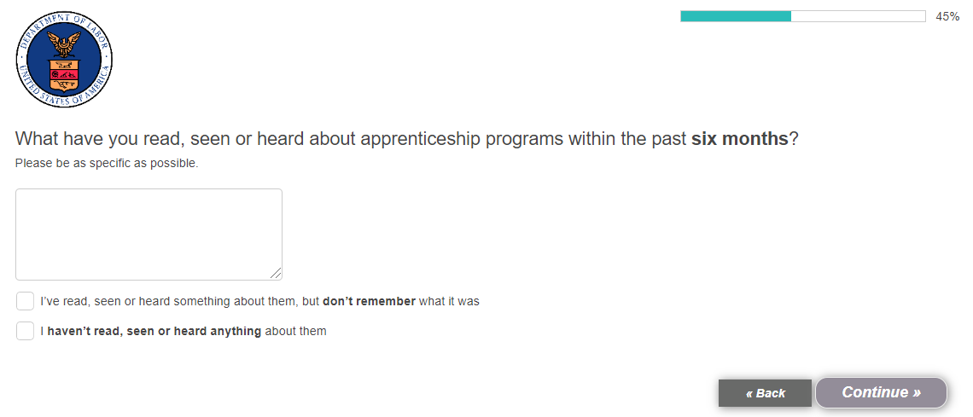

[BASE: EMPLOYERS WHO HAVE HEARD ABOUT APPRENTICESHIPS IN THE PAST SIX MONTHS]
- [ASK IF Q65=PROVIDED OE RESPONSE OR SELECTED 01] Where specifically have you read, seen or heard about apprenticeships or apprenticeship programs within the past six months? Please be as specific as possible. [OPEN-END]

- I don’t remember where I heard, read or saw anything about them [EXCLUSIVE]
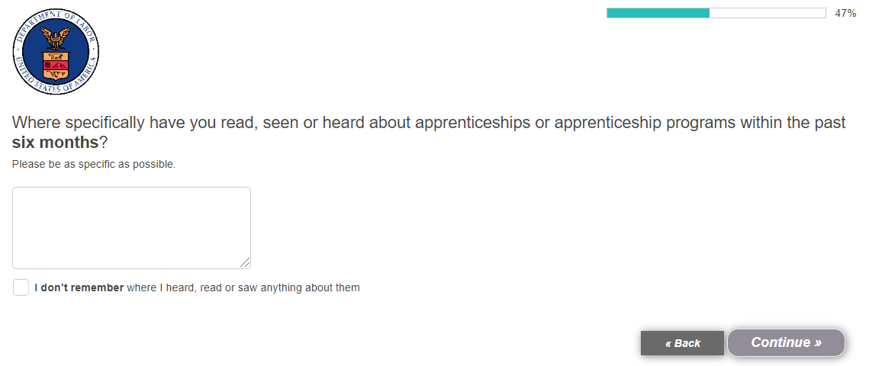

[BASE: ALL]
- To the best of your knowledge, which, if any, of the following statements do you think are TRUE about apprenticeship programs? [RANDOMIZE, MULTI-SELECT]

- Apprentices must be paid at least the applicable Federal, state or local minimum wage during their training
- [DUMMY] Apprenticeship programs do not provide on-the-job learning in the work setting
- Apprenticeship programs must provide job-related education and classroom instruction
- [DUMMY] Apprentices do not earn an industry-recognized credential after completing their program
- Organizations in any industry can offer an apprenticeship program, not just skilled trade industries (e.g., electricians, mechanics, etc.)
- [DUMMY] Apprenticeship programs cannot lead to tax credits and other incentives at the state level
- Apprenticeship programs help recruit and develop a highly skilled workforce
- [DUMMY] Apprenticeship programs are costly to establish and sustain over time
- Apprenticeship programs do not have to be registered with the U.S. Department of Labor
- [DUMMY] Apprenticeship programs take a long time to start from the ground up
- None of these statements are true [ANCHOR] [EXCLUSIVE]

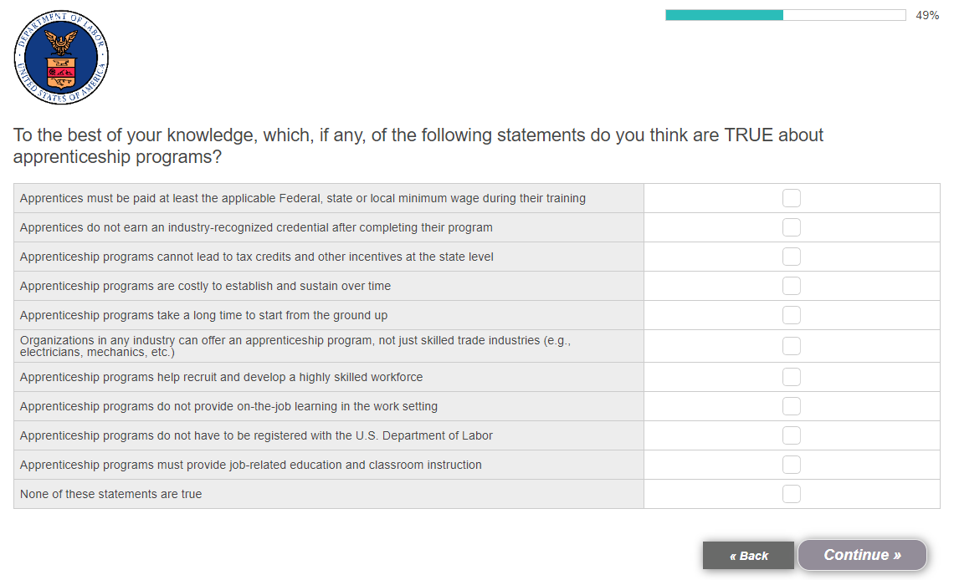

[DISPLAY TO RESPONDENT ON SEPARATE SCREEN] Please read the following definition of apprenticeship programs.

An apprenticeship program is a program in which participants earn wages from their employers while receiving on-the-job learning and job-related technical instruction in the workplace. Upon completion of their training, apprenticeship participants receive a credential – such as a specific certification – that is broadly recognized within their chosen field.

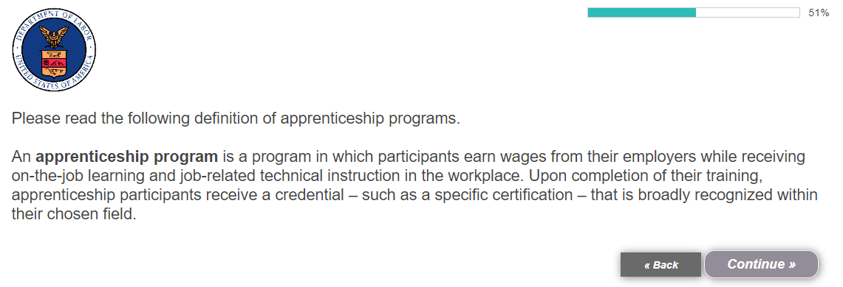

[BASE: EMPLOYERS NOT CURRENTLY OFFERING AN APPRENTICESHIP PROGRAM]
- [ASK IF S13-3=02] After reading this definition of apprenticeship programs, how likely are you to consider offering an apprenticeship program at your organization? [SINGLE SELECT]

- Not likely at all
- Somewhat unlikely
- Somewhat likely
- Very likely

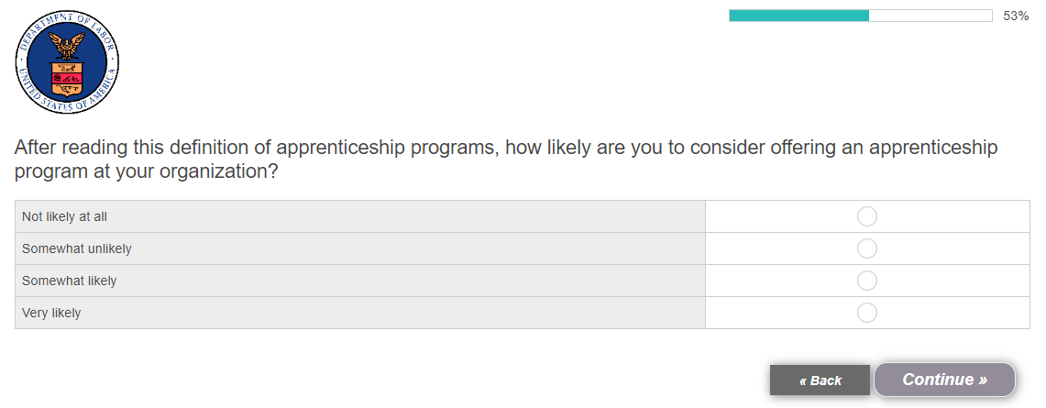

[BASE: EMPLOYERS WHO OFFER AN APPRENTICESHIP PROGRAM]
- [ASK IF S13-3/01] You mentioned that your organization currently offers an apprenticeship program. Why specifically has your organization chosen to offer an apprenticeship program? [OPEN-END]

- Don’t know [EXCLUSIVE]

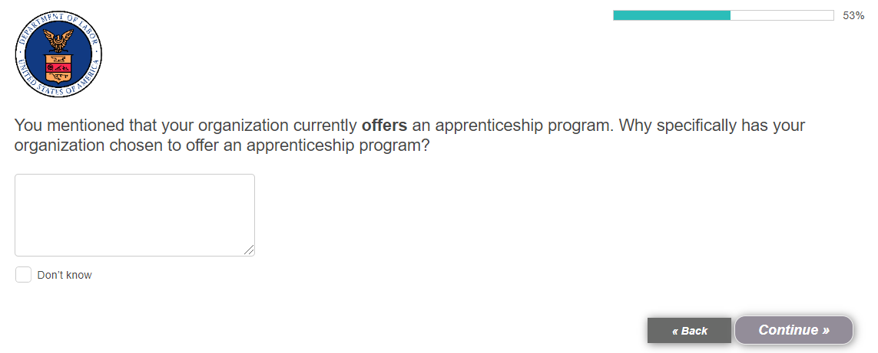

[BASE: EMPLOYERS NOT CURRENTLY OFFERING AN APPRENTICESHIP PROGRAM]
- [ASK IF S13-3/02] You mentioned that your organization does not currently offer an apprenticeship program. Why specifically does your organization not offer an apprenticeship program? [OPEN-END]

- Don’t know [EXCLUSIVE]

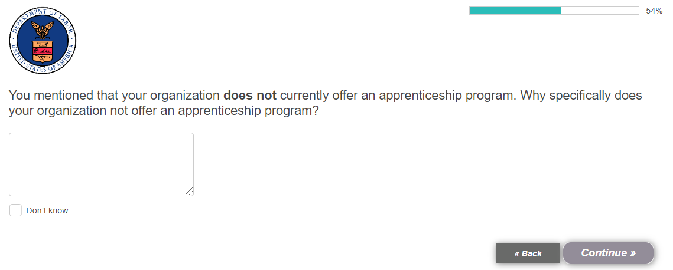
[BASE: ALL]
- What are the biggest benefits that an organization might see if it were to offer an apprenticeship program? Meaning, the reasons why an organization might offer an apprenticeship program. Please be as specific as possible. [OPEN-END]

- There are no benefits to an organization offering an apprenticeship program [EXCLUSIVE]
- Don’t know [EXCLUSIVE]

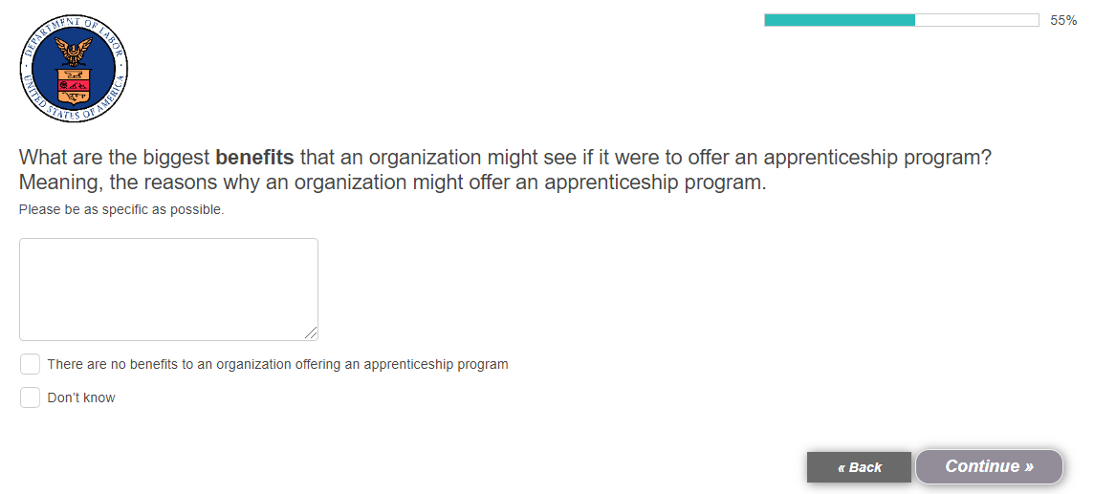

[BASE: ALL]
- To what extent do you agree or disagree that apprenticeship programs deliver each of the following benefits for organizations? [RANDOMIZE, SINGLE SELECT, DISPLAY AS GRID]

[ROW]
- They develop employees with the specific skills my organization needs
- They increase employee productivity
- They improve employee retention / reduce turnover
- They result in a safer workplace due to their emphasis on safety training
- They provide a reliable talent pipeline of qualified workers
- They lower the cost of employee recruitment
- They could make my organization eligible for tax credits
- They develop a culture of learning and mentorship
- They are a long-term solution to recruitment
- They help improve management skills by providing opportunities to train others
- They increase the diversity of an organization’s talent and thought

[COLUMN]
- Strongly disagree
- Somewhat disagree
- Neither agree nor disagree
- Somewhat agree
- Strongly agree

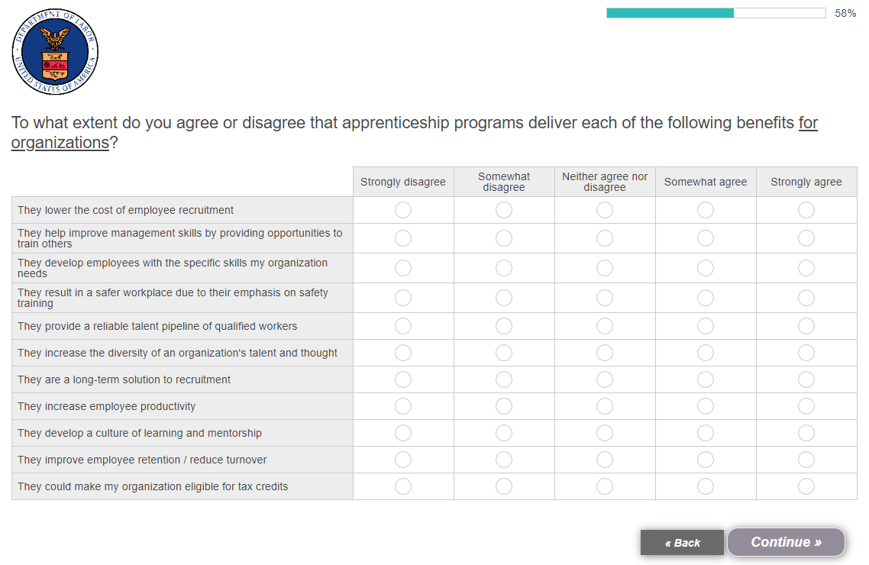

[BASE: ALL]
- How important would each of the following benefits of apprenticeship programs be to your organization when considering starting an apprenticeship program? [HOLD ORDER FROM Q13] SINGLE SELECT, DISPLAY AS GRID]

[ROW]
- They develop employees with the specific skills my organization needs
- They increase employee productivity
- They improve employee retention / reduce turnover
- They result in a safer workplace due to their emphasis on safety training
- They provide a reliable talent pipeline of qualified workers
- They lower the cost of employee recruitment
- They could make my organization eligible for tax credits
- They develop a culture of learning and mentorship
- They are a long-term solution to recruitment
- They help improve management skills by providing opportunities to train others
- They increase the diversity of an organization’s talent and thought

[COLUMN]
- Not at all important
- Not very important
- Somewhat important
- Very important
- Extremely important

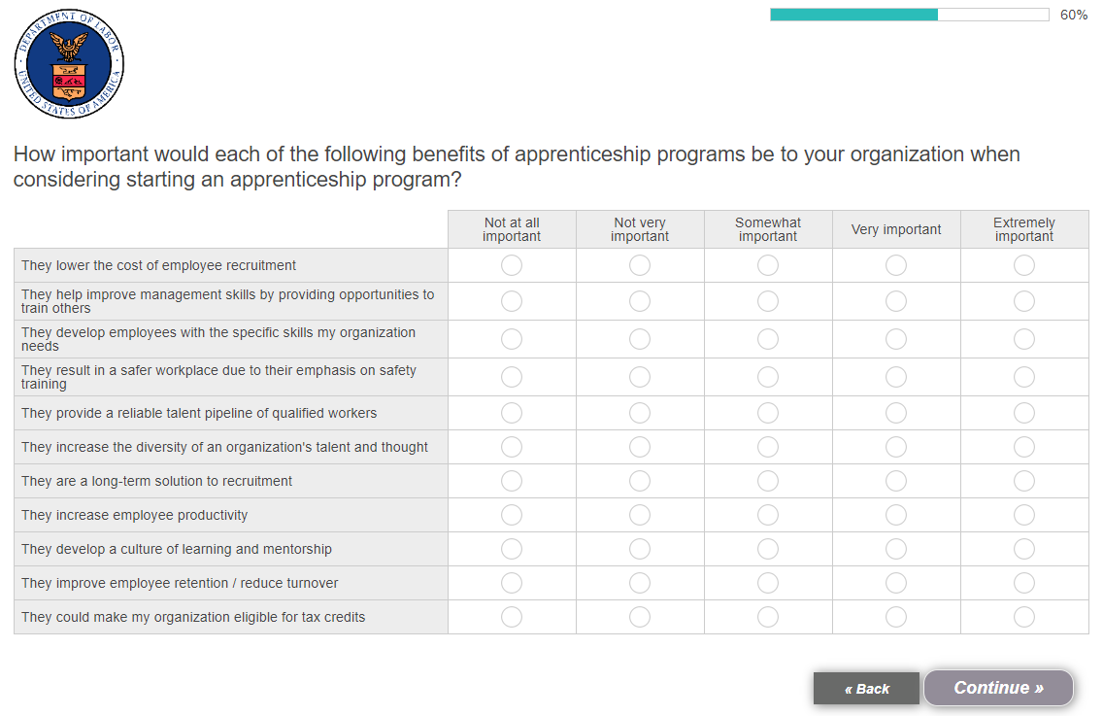

[BASE: ALL]
- What do you think [PIPE: were / would be] the biggest roadblocks or barriers to starting an apprenticeship program at your organization? Please be as specific as possible. [OPEN-END]

- There [PIPE: were / would be] no roadblocks or barriers to starting an apprenticeship programs at my organization [EXCLUSIVE]
- Don’t know [EXCLUSIVE]

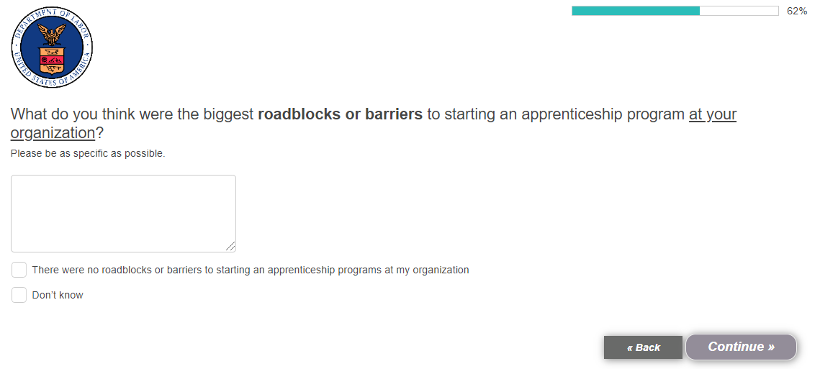

[PIPING]
- [IF CURRENTLY OFFERS APPRENTICESHIP PROGRAM – S13-3/01] were
- [IF DOES NOT CURRENTLY OFFER APPRENTICESHIP PROGRAM – S13-3/02] would be

[BASE: ALL]
- How concerned do you think your organization [PIPE: was / would be] about each of the following when considering starting an apprenticeship program? [RANDOMIZE, SINGLE SELECT, DISPLAY AS GRID]

[ROW]
- The caliber of the candidates that would enter the program
- The level of hands-on workplace training we would need to provide
- The length of time needed for apprentices to complete the program
- The specific salaries the organization would need to pay participants
- The upfront cost of starting an apprenticeship program
- The training/education costs required for apprentices to complete the program
- The quality of skills participants would gain in the program
- The potential for apprentices to leave the organization after completing the program
- Whether an apprenticeship program could be offered in my industry
- The amount of time it takes to start an apprenticeship program

[COLUMN]
- Not concerned at all
- Not very concerned
- Somewhat concerned
- Very concerned
- Extremely concerned

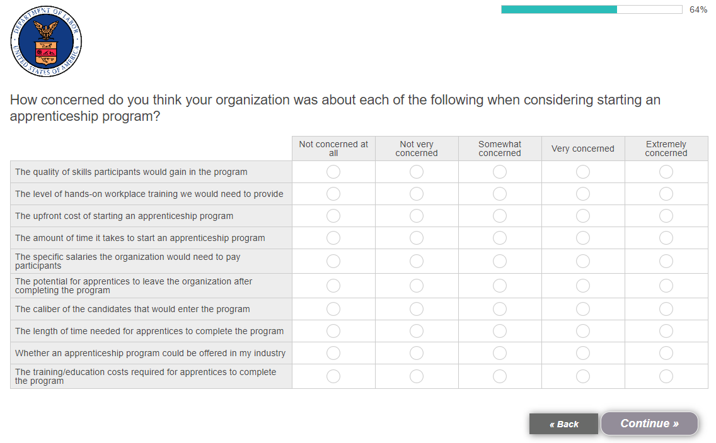

[PIPING]
- [IF S13/3=01] was
- [IF S13/3=02] would be

[BASE: ALL]
- How likely would you be to go to each of the following to get information about apprenticeship programs? [RANDOMIZE, SINGLE SELECT, DISPLAY AS GRID]

[ROW]
- My local government (city/county)
- My state government
- The federal government
- A successful business or organization currently offering an apprenticeship program
- A successful CEO or business leader whose company currently offers an apprenticeship program
- Someone who completed an apprenticeship program in my organization’s industry
- Someone who is currently an apprentice in my organization’s industry

[COLUMN]
- Not at all likely
- Not too likely
- Somewhat likely
- Very likely
- Extremely likely

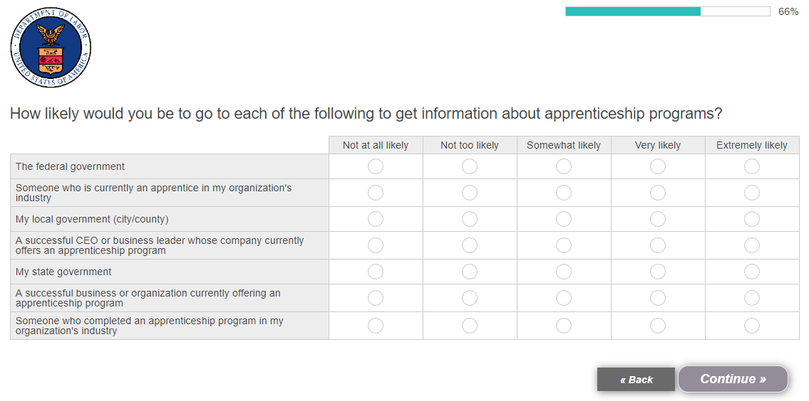

Department of Labor Perceptions

[DISPLAY] Next, we’d like to ask you some questions about a specific new web portal related to apprenticeship programs.

The U.S. Department of Labor’s new Apprenticeship web portal, Apprenticeship.gov, had a soft launch on August 30. It helps people search for apprenticeship programs by their skill set or geographic area, access information about apprenticeship opportunities, and find ways to apply their new skills.
For employers, it provides information on how apprenticeship programs can benefit their businesses, connect them with skilled talent, and helps them understand the steps needed to start apprenticeship programs at their organizations. Employers can also list apprenticeship listings through the website’s Apprenticeship Finder.

Apprenticeship.gov is part of an effort to enroll one million new apprentices over the next five years, to enable more Americans to obtain jobs that pay a family-sustaining wage through high quality, “earn-and-learn” opportunities. We would like to get your feedback on this new Apprenticeship web portal, Apprenticeship.gov.

[BASE: ALL]
- How credible is this initiative coming from the U.S. Department of Labor specifically? [SINGLE SELECT]

- Not credible at all
- Not very credible
- Somewhat credible
- Very credible
- Extremely credible

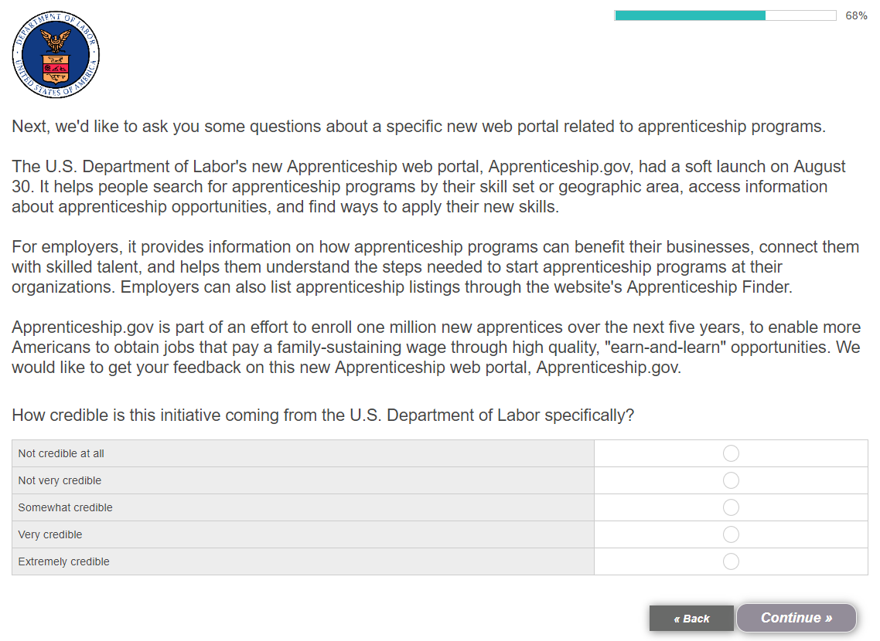

[BASE: EMPLOYERS WHO FEEL THE INITIATIVE IS NOT CREDIBLE COMING FROM DOL]
- [ASK IF Q18=01-02] Why do you feel this initiative is not credible coming from the U.S. Department of Labor? Please be as specific as possible. [OPEN-END]

- Don’t know [EXCLUSIVE]

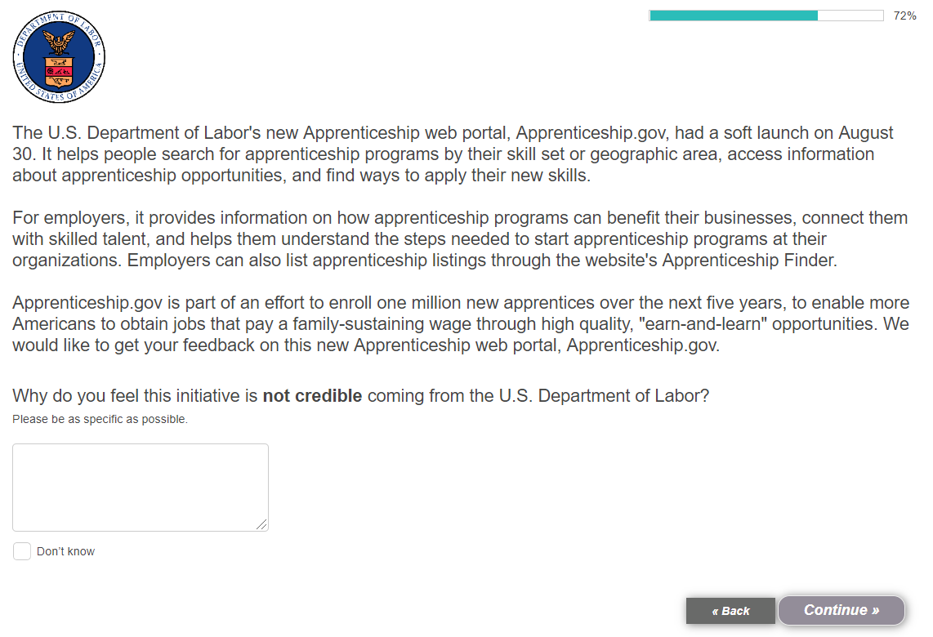

[BASE: EMPLOYERS WHO FEEL THE INITIATIVE IS CREDIBLE COMING FROM DOL]
- [ASK IF Q18=03-05] Why do you feel this initiative is credible coming from the U.S. Department of Labor? Please be as specific as possible. [OPEN-END]

- Don’t know [EXCLUSIVE]

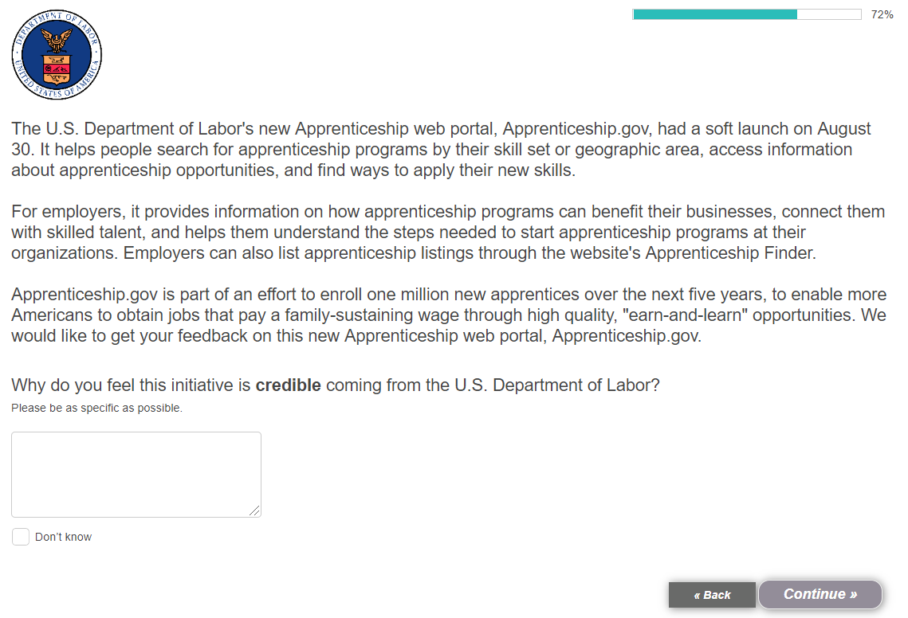

[BASE: ALL]
- How likely would you be to use this portal to search for potential apprentices for your organization, or tips on starting an apprenticeship program at your organization? [SINGLE SELECT]

- Not likely at all
- Not very likely
- Somewhat likely
- Very likely

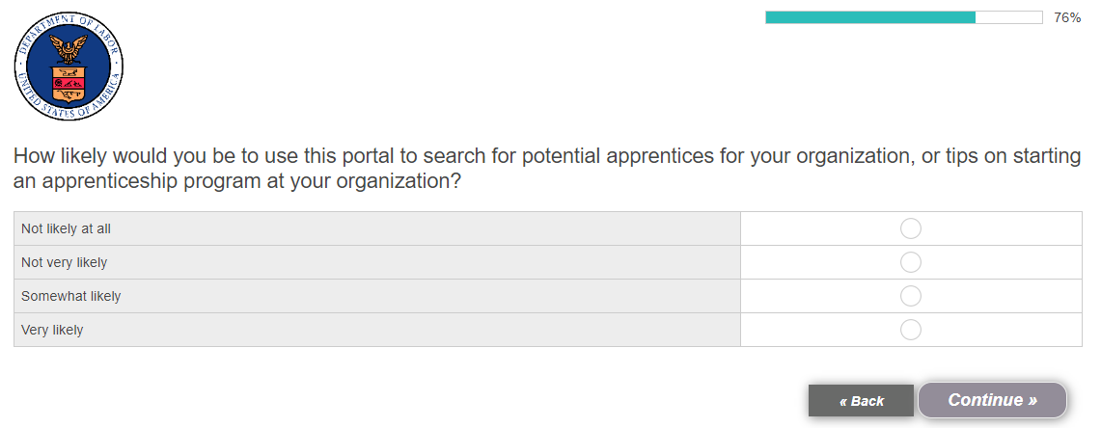

[BASE: ALL]
- Which of the following tools would you be most interested in seeing on this portal? Please select up to three responses. [RANDOMIZE, MULTI SELECT, MAX THREE RESPONSES]

- Brochures on how to start an apprenticeship program at my organization
- Videos explaining the elements of successful apprenticeship programs
- Videos on the daily lives of apprentices working for organizations like mine
- Stories on successful apprenticeship programs at organizations like mine
- Research on the specific benefits of apprenticeship programs for my organization
- A calculator to determine the return on investment for offering an apprenticeship program at my organization
- A newsletter featuring news and advice related to apprenticeship programs
- Blog posts from agency staff related to apprenticeship programs
- Other [ANCHOR, SPECIFY]

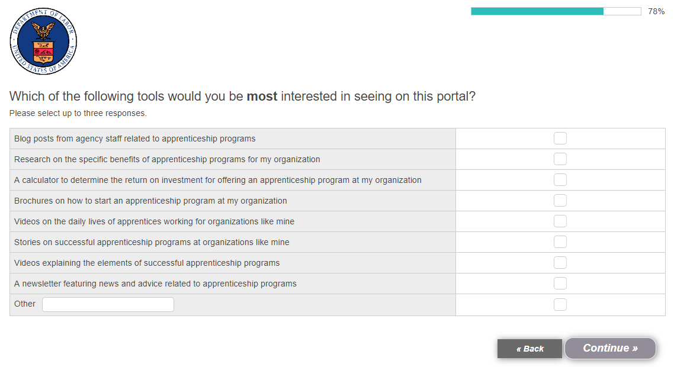

NEWS AND MEDIA QUESTIONS

[DISPLAY TO RESPONDENT ON SEPARATE SCREEN] Next, we’d like to ask you some general questions about how you get your news.

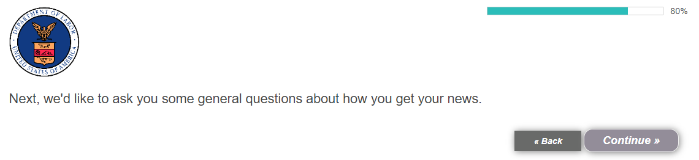

[BASE: ALL]
- From which of the following sources do you obtain most of your news? Please select all that apply. [RANDOMIZE, GROUP 01-02, MULTI SELECT]

- National cable TV news programs [SPECIFY]
- Local TV news programs
- DirectTV using a streaming app
- Talk shows, such as The Ellen DeGeneres Show [SPECIFY]
- National newspapers, in print or online [SPECIFY]
- Local newspapers, in print or online
- Business or finance online news sources [SPECIFY]
- Other online news sources, such as The Huffington Post or BuzzFeed [SPECIFY]
- Social media, such as Twitter or Facebook [SPECIFY]
- News or general interest magazines, such as People or TIME [SPECIFY]
- Blogs [SPECIFY]
- Books
- Radio
- Podcasts
- Friends or family members
- Colleagues at work
- Other [ANCHOR, SPECIFY]

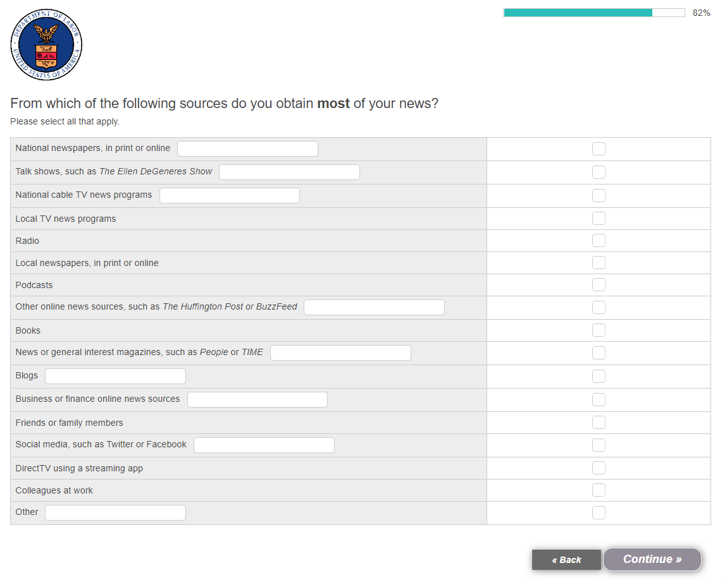

[BASE: ALL]
- On the average day, how many hours do you think you spend using each of the following types of devices? [RANDOMIZE, SINGLE SELECT]

[ROW]
- Television
- Desktop computer
- Laptop computer
- Smartphone
- Tablet or e-reader
- Gaming console

[COLUMN]
- [NUMERIC OPEN END; CANNOT EXCEED 18]
- Less than an hour
- Do not use this device

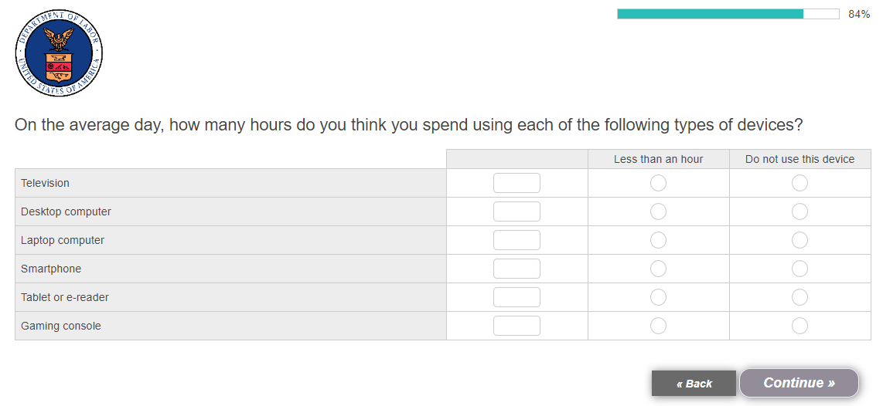

[BASE: ALL]
- Which of the following platforms, apps or sites do you regularly use? Meaning, you have an account on it and use it multiple times per week. Please select all that apply. [RANDOMIZE, MULTI SELECT]

- Facebook
- Facebook Messenger
- Twitter
- Amazon Prime Video
- Pinterest
- Tumblr
- LinkedIn
- Instagram
- IMVU
- Reddit
- Hulu
- Spotify
- Netflix
- YouTube
- Snapchat
- Meetup
- WhatsApp
- Yelp
- Other [SPECIFY, ANCHOR]
- None of these [ANCHOR, EXCLUSIVE]

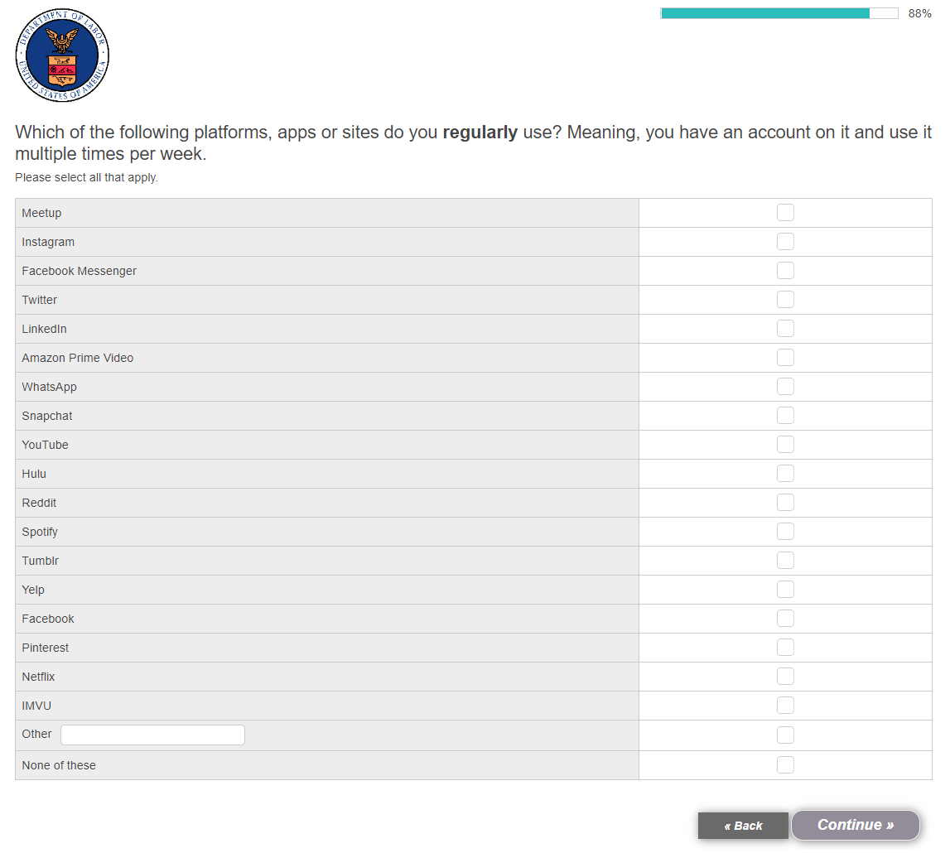

DEMOGRAPHIC QUESTIONS

[DISPLAY TO RESPONDENT ON SEPARATE SCREEN] Finally, we’d like to ask you a couple questions for classification purposes only.

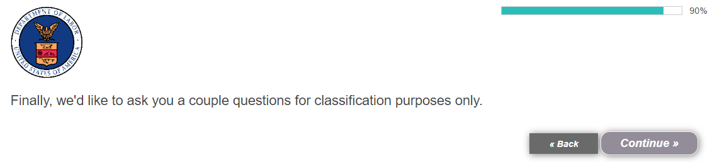

[BASE: ALL]
- What is your gender? [SINGLE SELECT]

- Male
- Female
- Other / Prefer not to answer

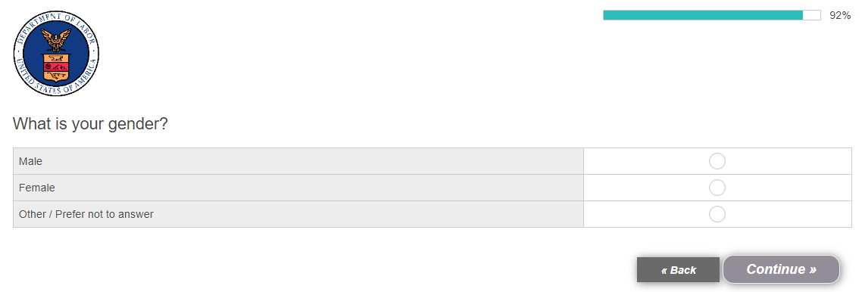

[BASE: EMPLOYERS WHOSE ORGANIZATION OFFERS AN APPRENTICESHIP PROGRAM]
- [ASK IF S13/3=01] For how long has your organization offered an apprenticeship program? Please give your answer in whole years. [OPEN-END NUMERIC, MIN 1]

- Less than one year
- Don’t know
- Prefer not to answer

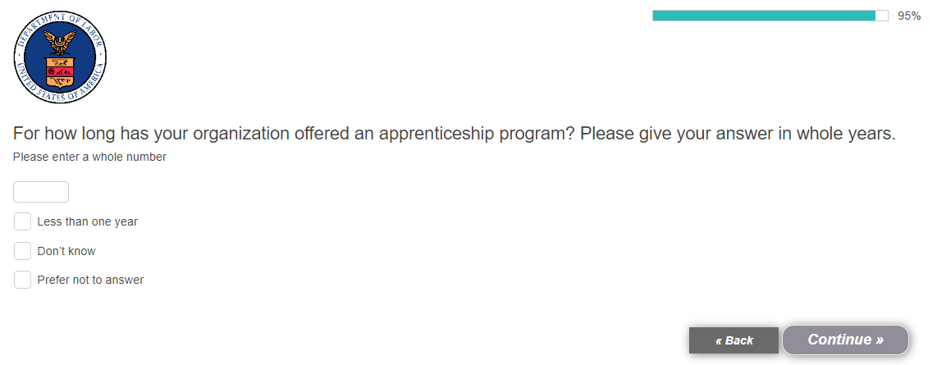

[BASE: ALL]
- Approximately how many years have you worked at your current organization? [OPEN-END NUMERIC, MIN 1, MAX S2-14]

- Less than one year [EXCLUSIVE]
- Prefer not to answer [EXCLUSIVE]

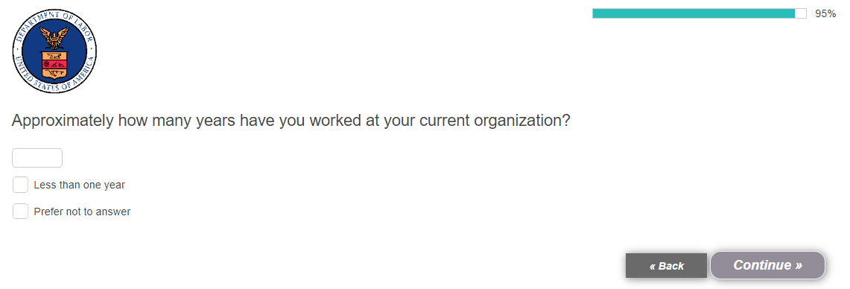

[DISPLAY TO RESPONDENT ON SEPARATE SCREEN] Those are all the questions we have for you today. Thank you for participating in this survey.

