Dear

I need your help with an important initiative I am undertaking to improve our service to America's taxpayers. I want to get feedback from taxpayers like you who have recently experienced an audit of their excise tax returns, or a review of their Form 637, Application for Registration (For Certain Excise Tax Activities).

In a few days, you will receive a survey asking your opinions about the audit with the IRS. Please direct it to the person who had the most contact with the IRS on this matter. The survey should take less than 5 minutes to complete. Your answers will be combined with others to give us an evaluation of customer satisfaction with IRS service.

The primary purpose for requesting this information is to help the IRS improve its service to taxpayers. Our authority for requesting the information is 5 USC and 26 USC 7801.

Providing information is voluntary. However, if you do not answer all or part of the survey questions, the IRS may lack information it could use to improve taxpayer service. The information you provide may be disclosed to an IRS contractor when authorized by law. The contractor is required to follow confidentiality protections required by the Privacy Act and/or Internal Revenue Code section 6103.

I am committed to improving IRS service to every taxpayer. Please help me in this effort by completing and returning the survey as soon as possible. If you do not receive a survey, please contact the Survey Helpline at
1-800-521-7177.

Sincerely,

William P. Marshall
Director, Specialty Tax

L1_13257-L

Dear

A few days ago, you received a letter from William P. Marshall, Director, Specialty Tax, asking for your help with an important research project.

We are administering a nationwide survey among people who have had contact with the Internal Revenue Service (IRS). We want to know your opinions about your recent experience with the IRS audit of your excise tax return, or review of your Form 637, Application for Registration (For Certain Excise Tax Activities). Your responses are critical to the accuracy of this research.

We are sending surveys to all taxpayers who have gone through a recent examination of an excise tax return. All responses will be anonymous to the IRS, and your participation is voluntary. We will group your responses with all the others, so that no individual reply can be traced back to any one person.

The survey is quite brief and should take less than 5 minutes to complete. Please use the postage-paid reply envelope to return your completed survey. If you have any questions about this survey, please feel free to call us toll-free at 1-800-521-7177, or email us at irssurveyhelp@forsmarshgroup.com.

The IRS is committed to improving its performance and service to the American public. A first step in this process is to gather reliable information from those who have had contact with IRS services and employees. Your honest opinions will help bring about this improvement.

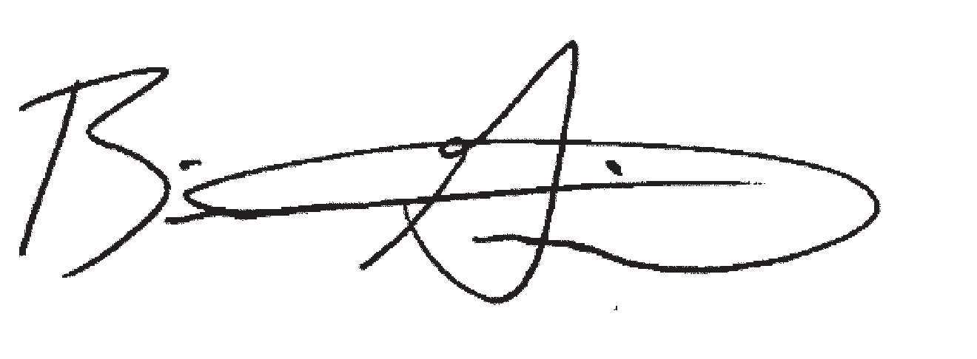
Sincerely,

Brian K. Griepentrog, Ph. D. Director of Research
Fors Marsh Group LLC

L2_13257-L
Research conducted by

P.O. Box 42048 • Arlington, VA 22204-9048

IRS SMALL BUSINESS/ SELF-EMPLOYED CUSTOMER SATISFACTION SURVEY
EXCISE TAX AUDIT
OR REGISTRATION REVIEW

P.O. BOX 42048
ARLINGTON, VA 22204-9048

Do We Have Your Input Yet?

IRS SMALL BUSINESS/ SELF-EMPLOYED CUSTOMER SATISFACTION SURVEY EXCISE TAX AUDIT
OR REGISTRATION REVIEW
Recently, you received a survey asking your opinions about the service you received from the IRS in a recent contact. If you have already completed and returned the survey, please
accept our sincere thanks. If not, please take a few minutes to complete it and return it today. We want to be sure we have your opinions and suggestions.

If you did not receive the survey, or it got misplaced, please call us at 1-800-521-7177.

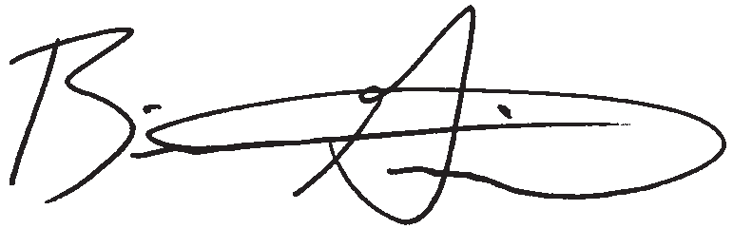
Sincerely,

Research conducted by

Brian K. Griepentrog, Ph.D. Director of Research
Fors Marsh Group

L3_13257-L

Dear

Recently you received a survey requesting your feedback about your experiences during a recent IRS audit of your excise tax return. So far, we have not received your completed survey. If you have not already completed the survey, please take a few minutes to fill in your responses. If another person was primarily responsible for dealing with the IRS on this matter, please direct the survey to that person and encourage him or her to respond.

We are administering a nationwide survey among people who had a recent IRS audit of an excise tax return or review of your Form 637, Application for Registration (For Certain Excise Tax Activities). We want to know your opinions regarding the audit process and the service you received. Your responses are critical to the accuracy of this research.

We are sending surveys to all taxpayers who have gone through a recent examination of an excise tax return. All responses will be anonymous to the IRS, and your participation is voluntary. We will group your responses with others, so that no individual reply can be traced back to any one person.

The survey is quite brief and should take less than 5 minutes to complete. Please use the postage-paid reply envelope to return your completed survey. If you have any questions about this survey, please feel free to call us toll-free at 1-800-521-7177, or email us at irssurveyhelp@forsmarshgroup.com.

The IRS is committed to improving its performance and service to the American public. A first step in this process is to gather reliable information from those who have had contact with IRS services and employees. Your honest opinions will help bring about this improvement.

Thank you in advance for your cooperation.

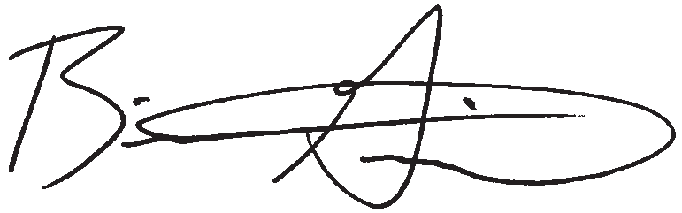
Sincerely,

Brian K. Griepentrog, Ph. D. Director of Research
Fors Marsh Group LLC

L4_13257-L
Research conducted by

P.O. Box 42048 • Arlington, VA 22204-9048

INTERNAL REVENUE SERVICE (IRS) SMALL BUSINESS/SELF-EMPLOYED CUSTOMER SATISFACTION SURVEY
EXCISE TAX AUDIT OR REGISTRATION REVIEW
OMB# 1545-1432

The IRS is trying to improve its service to the public. You can help in this important mission by providing your feedback below. This voluntary survey should take less than 5 minutes to complete. Your identity will not be provided to the IRS. If you have any questions about this survey, you may call the Survey Helpline at 1-800-521-7177.

The following questions ask your opinion regarding how the IRS handled your most recent Excise Tax audit or Form 637 registration review. For each question, regardless of whether you agree or disagree with the final outcome, please fill in the circle the best represents your opinion. Please answer the sections relevant to your situation. If a question does not apply to you, please mark “Not Applicable.”

INITIAL REGISTRATION PROCESS
Q1
Only answer if you submitted an initial application for a 637 registration in the past year, otherwise skip to Question 2

How satisfied are you with the...
Very
Dissatisfied
Somewhat
Dissatisfied

Neither Satisfied Nor Dissatisfied
Somewhat
Satisfied
Very
Satisfied

Don’t Know/Not Applicable

A. Ease of filling out Form 637, Excise Tax Application for Registration

1 2 3 4 5 NA

B. Length of time it took from when you submitted
your registration application to your first appointment with an auditor

C. Length of time it took from your first appointment with an auditor to when you received the letter of approval or denial

1 2 3 4 5 NA

1 2 3 4 5 NA

Q2 EXCISE TAX AUDIT OR REGISTRATION REVIEW PROCESS
How satisfied are you with the...

A. Initial information the IRS provided (e.g., letters/ notices, phone calls, IRS publications) so that you knew what to expect during the audit/review
1 2 3 4 5 NA

B. Explanation of what information you needed to provide

1 2 3 4 5 NA

C. Flexibility of your auditor in scheduling meetings

D. Explanation your auditor gave you of why more information was requested after the initial appointment

1 2 3 4 5 NA

1 2 3 4 5 NA

E. Amount of time you were given to provide information

1 2 3 4 5 NA

F. Consideration given to the information you provided

G. Explanation your auditor gave you of why the audit/ review expanded from the issues you were initially informed about

1 2 3 4 5 NA

1 2 3 4 5 NA

H. Auditor’s professionalism

1 2 3 4 5 NA

I. Auditor’s tax knowledge

J. Auditor’s understanding of your business

K. Time your auditor took to respond to your questions

L. Amount of time you personally had to spend on the entire audit/review process
M. IRS communication with you throughout the audit/
review process

1 2 3 4 5 NA

1 2 3 4 5 NA

1 2 3 4 5 NA

1 2 3 4 5 NA

1 2 3 4 5 NA

Please continue on back

INTERNAL REVENUE SERVICE (IRS) SMALL BUSINESS/SELF-EMPLOYED CUSTOMER SATISFACTION SURVEY
EXCISE TAX AUDIT OR REGISTRATION REVIEW
OMB# 1545-1432

Q2 EXCISE TAX AUDIT OR REGISTRATION REVIEW PROCESS (continued)
How satisfied are you with the... |  | Very  Dissatisfied | Somewhat  Dissatisfied | Neither Satisfied Nor Dissatisfied | Somewhat  Satisfied | Very  Satisfied | Don’t Know/Not Applicable
N. | Length of audit/review process from start to finish | 1 | 2 | 3 | 4 | 5 | NA
O. | Explanation of the final decision for your audit/review including any changes made | 1 | 2 | 3 | 4 | 5 | NA
P. | Manager’s effect on your audit/review, if you communicated with the manager | 1 | 2 | 3 | 4 | 5 | NA
Q. | Fairness of treatment during the audit/review | 1 | 2 | 3 | 4 | 5 | NA

AUDIT PROCESS ONLY
Q3
Only answer if you completed an Excise Tax audit, otherwise skip to Question 4

How satisfied are you with the...
Very
Dissatisfied
Somewhat
Dissatisfied
Neither Satisfied Nor Dissatisfied
Somewhat
Satisfied
Very
Satisfied
Don’t Know/Not Applicable

A. Explanation the auditor provided as to the reason(s)
for the audit

B. Explanation of your payment options, if there was a change

1 2 3 4 5 NA

1 2 3 4 5 NA

C. Information provided to you on how to appeal the audit findings if you did not agree
Q4 OVERALL SATISFACTION
Regardless of whether you agree or disagree with
the final outcome, how would you rate your overall satisfaction with the way your audit or registration review was handled?

1 2 3 4 5 NA

Q5 Are you...
Very | Somewhat | Neither | Somewhat | Very | Don’t
Dissatisfied | Dissatisfied | Satisfied | Satisfied | Satisfied | Know/Not
 |  | Nor |  |  | Applicable
1 | 2 | Dissatisfied  3 | 4 | 5 | NA

Q6 If you are the taxpayer, did you...

1 The taxpayer
2 A tax professional who represented the taxpayer
3 Someone else who represented the taxpayer

1 Use a tax professional to represent you for this audit/review
2 Represent yourself

3 Both

Q7 Please provide any comments or suggestions for improvement.

Occasionally, we conduct additional in-depth IRS-related research. Research participants may receive a small monetary incentive to participate depending on the research. If you are interested in participating in future research, please provide us with your telephone number and your e-mail address (if available). This information will not be shared with the IRS and will be used only for research purposes.

TELEPHONE NUMBER: E-MAIL ADDRESS:

If you have been unable to resolve any specific problems with your tax matter through the normal IRS channels, or now face a significant hardship due to the application of the tax law, we encourage you to contact the Taxpayer Advocate Service at 1-877-777-4778.

Thank you for completing the survey.
Please return this questionnaire to P.O. Box 42048, Arlington, VA 22204-9048 USA.

Paperwork Reduction Act Notice. The Paperwork Reduction Act requires that the IRS display an OMB control number on all public information requests. The OMB Control Number for this study is 1545-1432. Also, if you have any comments regarding the time estimates associated with this study or suggestions on making this process simpler, please write to the: Internal Revenue Service, Special Services Section, SE:W:CAR:MP:T:M:S, 1111 Constitution Ave. NW, Room 6129, Washington, DC 20224.

