**System: Web-Based Supply Chain Management (WBSCM)**

**Data: Multi-Food Order Form**

**Screenshot as of: 8/15/13**

**Screenshot #1:** Multi-Food Order Form (Product / Qty Selection)

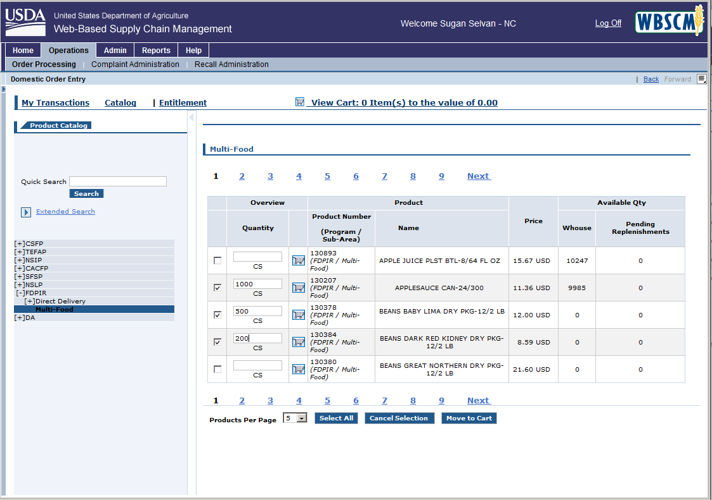

**Screenshot #2:** Multi-Food Order Form (Shopping Cart View)

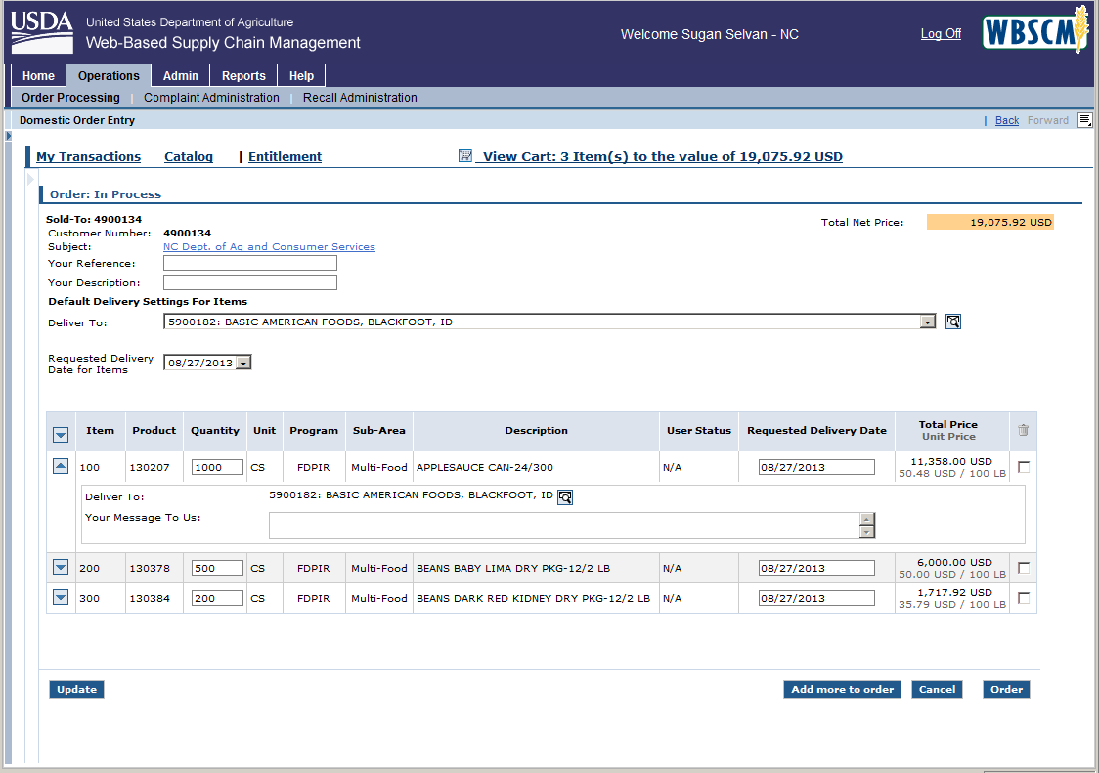

*Click the “Requested Delivery Date for Items” dropdown box to pick a delivery date for all order line items

*Click the “Order” button to submit the order to FNS for fulfillment