Social Sciences Branch
Northeast Fisheries Science Center
Woods Hole, MA

Northeast Fishing Vessel Cost Survey for 2015
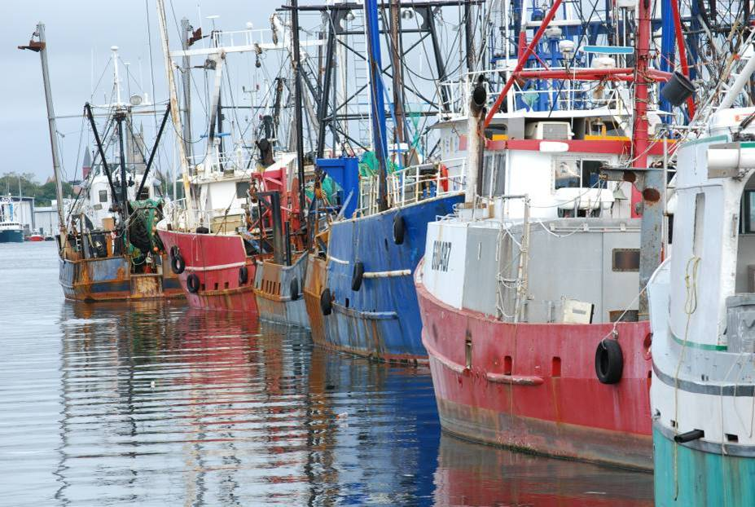
Photo credit: Lisa Colburn, NOAA Fisheries
Thank you very much for participating in this important survey! Your responses and experience will help the Social Sciences Branch as we communicate the economic pressures faced by fishing vessel owners to regulatory agencies.

The questions in this survey relate to the following vessel only:
[Vessel name]
Coast Guard Documentation or State Registration Number: [12345678]

You can take this survey on line at: | www.VesselSurvey.org
Your Username: | [12345678]
Your Password: | [abc123]

Your responses and participation in this survey are CONFIDENTIAL. A private contractor, Eastern Research Group, Inc., will collect the data you provide.

Questions about the survey? Call toll free: 1-800-xxx-xxxx; or email: vesselsurvey@erg.com

Public reporting burden for this collection of information is estimated to average 60 minutes per survey, including the time for reviewing instructions, searching existing data sources, gathering and maintaining the data needed, and completing and reviewing the collection of information. Send comments regarding this burden estimate or any other suggestions for reducing this burden to Tammy Murphy, NOAA Line office, 166 Water Street, Woods Hole, MA, 02543.
Responses to this information request are confidential under section 402(b) of the Magnuson-Stevens Act as amended in 2006. Responses are also confidential under NOAA Administrative Order 216-100, which sets forth procedures to protect confidentiality of fishery statistics. Notwithstanding any other provisions of the law, no person is required to respond to, nor shall any person be subjected to a penalty for failure to comply with, a collection of information subject to the requirements of the Paperwork Reduction Act, unless that collection of information displays a currently valid OMB Control Number.

General Instructions:
- This survey is about your costs in 2015 for the vessel identified in this survey. In your answers, include combined costs for all state and/or federal fisheries for this vessel in 2015, including costs incurred while the vessel was inactive.

Please note that all responses are completely confidential.

Section A: Vessel Information
This section is only about the vessel identified in this survey. All costs requested are for 2015.

1. Ownership type for this vessel (check one):
Sole proprietorship
General partnership
Limited partnership
C Corporation
S Corporation
Limited Liability Company (LLC)
Other ___________________

2. Number of owners, including yourself: ___________

3. Was this vessel acquired from a previous owner or was it bought new?
Acquired from a previous owner
Purchased New

4. In what calendar year did you become the owner of the vessel? ____________________

5. Current estimated market value* of this vessel, including all equipment, fishing gear, permits, and fishing history: $ ______________________________
*Note: By “market value,” we mean your estimate of the best price you could reasonably expect to get if you sold the vessel, equipment, gear, permits, and fishing history right now.

Section B: Repair/Maintenance/Upgrade/Improvements Costs

6a. Was this vessel hauled out in 2015 for any reason? (Possible reasons include regular repair and maintenance, emergency haul-out, long term storage, etc.)
Yes
No [please go to 6c]

6b. What were the haul-out costs in 2015, including taking the vessel out of the water and any transportation? (Do not include any repair/maintenance costs – we’ll ask you for them in question 7.)
Haul out cost in 2015: $ ____________________________

6c. How often do you usually haul out this vessel?
Every year
Every other year
Every ____years
Every ____months
Other (please describe) _________________

7. Please record any repair/maintenance and upgrade/improvement costs for this vessel in year 2015 in the table on the next page.

Instructions:
- For each category in column 1, record your 2015 repair/maintenance costs for this vessel in column 2, and 2015 upgrade/improvement costs in column 3.
- You may find some of these expenses listed on your 2015 tax form, Schedule C.
- Describe the upgrade/improvement in the assigned row for each cost category.
- Include the cost of any tools and equipment you may have purchased.
- If you did not have an expense in 2015, then check $0.

We know that these kinds of costs may vary significantly year to year. However, this survey is about 2015 expenses only.

7. | Please use your best judgment to assign your expenses to either repair/maintenance or upgrade/improvement.  Do not report the same cost under both types of expenses.
Expense Category | Regular Repair/Maintenance, 2015 | Upgrade/Improvements, 2015
Propulsion Engine  (such as engine, drive train, exhaust/cooling systems) | $____________________________  $0 | $ ____________________________  $0
 | Describe Upgrade/Improvement:
Deck Equipment/ Other Machinery  (such as winches, haulers, generators, hydraulics, compressors, reels, pumps) | $____________________________  $0 | $____________________________  $0
 | Describe Upgrade/Improvement:
Hull  (such as frame, deck, wheelhouse, keel, steering, rigging, fish holds, fuel tanks) | $____________________________  $0 | $____________________________  $0
 | Describe Upgrade/Improvement:
Fishing Gear  (such as codends, nets/panels, dredges, buoys, highfliers, doors, pots/traps, cables) | $____________________________  $0 | $____________________________  $0
 | Describe Upgrade/Improvement:
Wheelhouse and Electronics  (such as Radar, GPS, VMS, sounder, radio, depth/temperature/net sensors) | $____________________________  $0 | $____________________________  $0
 | Describe Upgrade/Improvement:
Processing/ Refrigeration  (such as RSW, packaging equipment, icemaker) | $____________________________  $0 | $____________________________  $0
 | Describe Upgrade/Improvement:
Safety Equipment  (such as EPIRB, rafts, fire extinguishers, flares, survival suits) | $____________________________  $0 | $____________________________  $0
 | Describe Upgrade/Improvement:
Other Repair/maintenance or upgrade/improvement: | $____________________________  $0 | $____________________________  $0
 | Describe Upgrade/Improvement:

Section C: Vessel Related Costs

8. For each expense category listed in the table below, please enter the total amount spent in 2015 for this vessel. If you did not have an expense in 2015, then check $0.

Mooring/Dockage Fees for this vessel in 2015 (including upkeep expenses): | Permit and/or License fees for this vessel in 2015:
$____________________________  $0 | $____________________________  $0
Vessel insurance premium in 2015 for this vessel (premium paid for either hull or P & I insurance):  $___________________________ | Quota or DAS lease payments in 2015 for this vessel (if non-monetary payments were used to obtain quota or DAS, please estimate the value of those non-monetary payments):
Number of months insured: _______  $0 | $____________________________  $0
Total payments to crew and hired captain in 2015 for this vessel only:  Crew: $____________________________ | Crew benefits for this vessel in 2015 (the cost to you, as the vessel owner, for providing retirement benefits; health, life, or disability insurance premiums; and unemployment insurance for your crew and hired captain):
Hired Captain: $___________________________  (Do not include what you earn when you are the captain)  $0 | $___ ___ ___, ___ ___ ___  $0
Vessel Activity/Quota Monitoring Cost for this vessel in 2015 (such as observer or dockside monitoring cost): | Other costs for this vessel in 2015:
$____________________________  $0 | $____________________________  $0

Section D: Operating Costs

9. For each expense category listed in the table below, please enter the total amount spent in 2015 for this vessel, including all payments made by you and/or the crew.
- If nothing was spent in a category, please check $0.
- We are aware that these kinds of costs may vary significantly from year to year. Please bear in mind that this survey is about 2015 expenses only.

Fuel/oil/filter for this vessel in 2015: | Food and Drinking Water for this vessel in 2015:
$____________________________  $0 I Don’t Know | $____________________________  $0 I Don’t Know
Ice for this vessel in 2015: | Bait for this vessel in 2015:
$____________________________  $0 I Don’t Know | $____________________________  $0 I Don’t Know
Fresh Water for use in this vessel in 2015: | Communication Costs for this vessel in 2015 (such as cell phones, radio, VMS etc.): Do not include office phone use.
$____________________________  $0 I Don’t Know | $____________________________  $0 I Don’t Know
General Fishing Supplies for this vessel in 2015 (such as knives, picks, hooks, boxes, bags, ties, lobster bands, rags, tape, links/rings, lines/twine, etc.): | General Crew Supplies for this vessel in 2015 (such as gloves, boot liners and foul-weather gear):
$____________________________  $0 I Don’t Know | $____________________________  $0 I Don’t Know
Catch Handling Costs for this vessel in 2015 (such as auction, lumping, grading, shipping and sales rep): | Other Costs for this vessel in 2015:
$____________________________  $0 I Don’t Know | $____________________________  $0 I Don’t Know
Section E: Typical Crew Payment System

10a. Did you hire a captain for the majority of this vessel’s trips in 2015, or were you the captain for most trips?
Mostly Owner-operated
Mostly Hired Captain
Other ___________________

10b. On average, how many crew were on this vessel when it went out in 2015?
DO NOT COUNT YOURSELF OR THE CAPTAIN.

_____________ Average number of crew members, not including you or the captain, in 2015

- If you answered 0 (you had no crew except yourself in 2015), SKIP TO QUESTION 11
- If you DID have a crew in 2015, please CONTINUE WITH QUESTION 10c

10c. Please use the diagram on the next page to list the types of expenses that were normally taken out of gross revenue, crew’s share, and captain’s share in 2015.
You do not need to list the dollar costs. Just list the types of expenses deducted (for example: “fuel” “ice” “food”).

NOTE: If the diagram below is not appropriate for your settlement system, please describe your system on the next page.

If the diagram displayed on the previous page is not appropriate for your crew payment, then please describe your crew payment system in the space below:

10d. Please list the types (not the cost) of items crew members purchase for themselves. Examples include: “food on day boats”, “foul weather gear”, “gloves”, etc.
(These expenses would NOT be included in the diagram above.)

_____________________________ _____________________________

_____________________________ _____________________________

_____________________________ _____________________________

Section F: Overall Business Cost

11a. Including the vessel listed in this survey, how many vessels did your fishing business operate or maintain in 2015?
______vessel(s) operated or maintained in 2015
11b. For each expense category listed below, please enter the amount spent for all your vessels in 2015:
If you did not spend anything on that expense category in 2015, please check $0.
Workshop/Storage Expenses for 2015 (such as gear shed rental and workshop expense): | Office Expenses for 2015 (such as office supplies, office rental, home office, office utilities (such as electric, heat, etc.), postage, photocopying, computer and office phone use, excluding communication costs):
$__________________________  $0 | $____________________________  $0
Business Vehicle Usage Costs for 2015 (for fishing business related purposes only; such as number of miles the vehicle was used for business multiplied by a standard mileage rate): | Business Travel Costs for 2015 (such as cost of lodging, travel, and transportation for business associated travel excluding business vehicle costs):
$____________________________  $0 | $____________________________  $0
Association Fees Paid in 2015 (such as co-operative, fishing organization, sector fees and union dues): | Professional Fees Paid in 2015 (such as settlement, accounting, and legal fees):
$____________________________  $0 | $____________________________  $0
Principal Paid on Business Loans for 2015 (enter only payments made, not amount owed):  $____________________________  $0 | Interest Paid on Business Loans for 2015:  $____________________________  $0
Advertising Costs for 2015:  $____________________________  $0 | Non-Crew Labor Services for 2015 (such as night watchman and office secretary):  $____________________________
Describe: ______________________________

$0
Section G: Other Costs and Earnings

12. Did you have any other costs in 2015 that we have not asked about in this survey? If so, please list them below. (Please do not report your personal costs).

Other costs for the identified vessel only:

Cost | Description of other costs incurred in 2015
$ _______________________ | _______________________________________________
$ _______________________ | _______________________________________________

Other costs for your entire business:

Cost | Description of other costs incurred in 2015
$ _______________________ | _______________________________________________
$ _______________________ | _______________________________________________

13. Personal health insurance can be a significant expense for fishing families. Please check the response that best describes your health insurance situation in 2015:
I (and my family) purchased health insurance during 2015.
The cost was $____________________________ .
I (and my family) did not have health insurance in 2015.
I (and my family) was covered by my spouse/partner’s health insurance.
Other, please explain: ____________________________________________

14. Please record the total gross revenue from all activities generated by this vessel in 2015. (Note: Although we collect revenue information from the dealer reporting system, this question is for cross-checking our record in order to improve our overall data quality.) :
Gross revenue from commercial trips: $____________________________ Gross revenue from non-commercial trips (e.g. charter trips): $____________________________ Gross revenue (vessel was inactive during 2015): $0

Thank you for your response! Please use the space below for comments.

