**APPENDIX**:

This appendix contains supporting details for the burden estimate contained in this Supporting Statement. In particular, flowcharts of the contacts are provided for each state along with estimates of the factors that affect this calculation, such as the percentage of the population in the sample frame that have a valid email address and phone number.

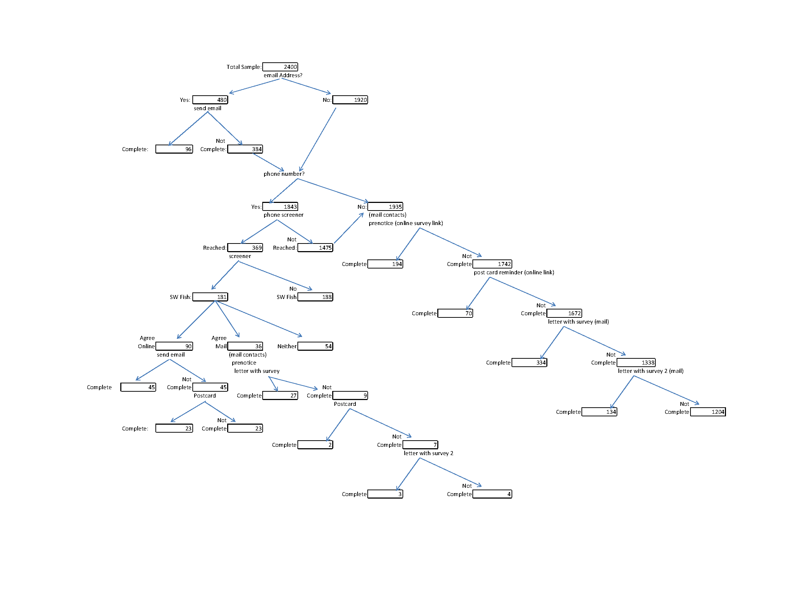

**Figure A1**. Contact Flowchart for Washington State

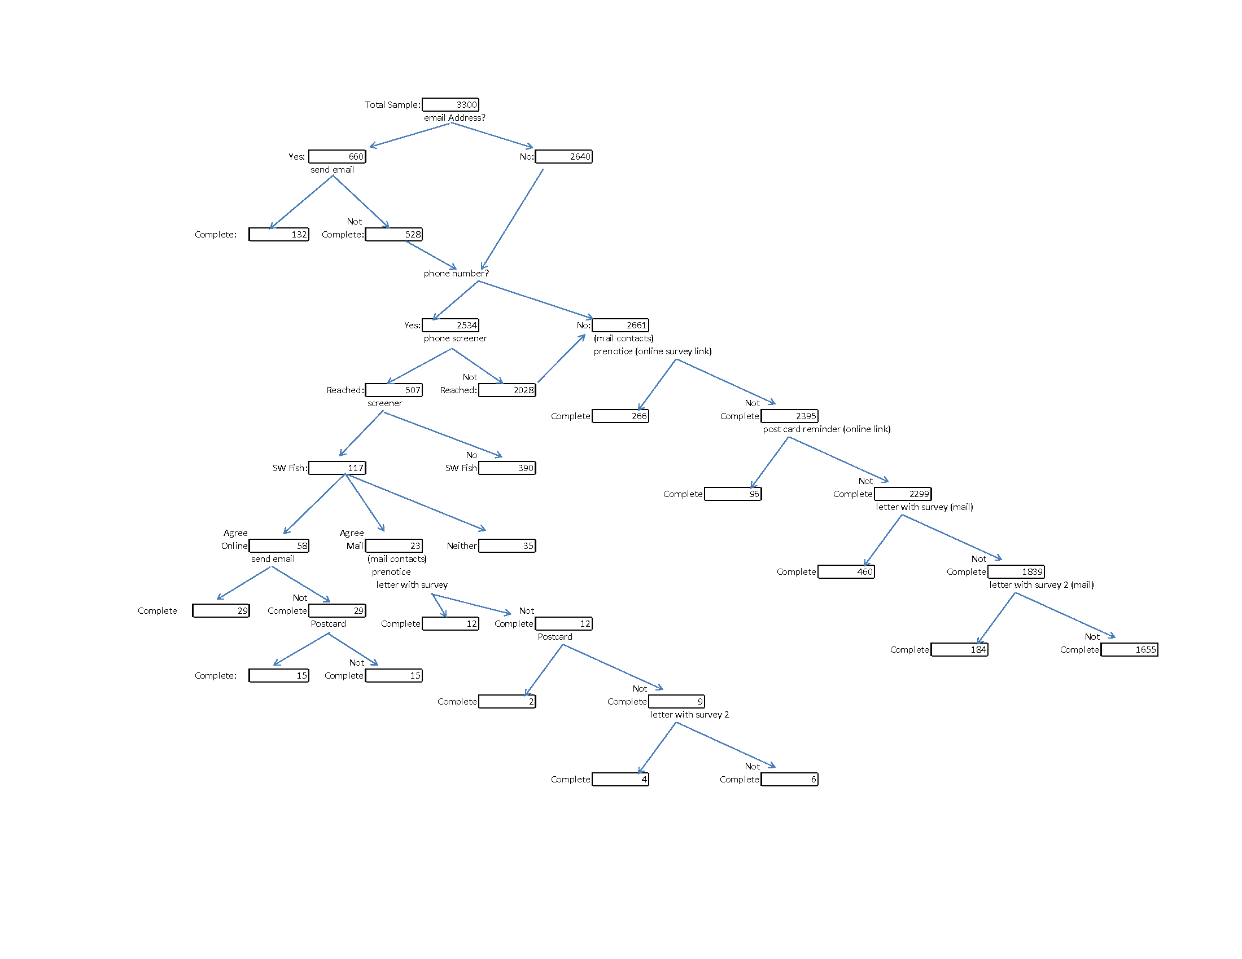

**Figure A2**. Contact Flowchart for Oregon State

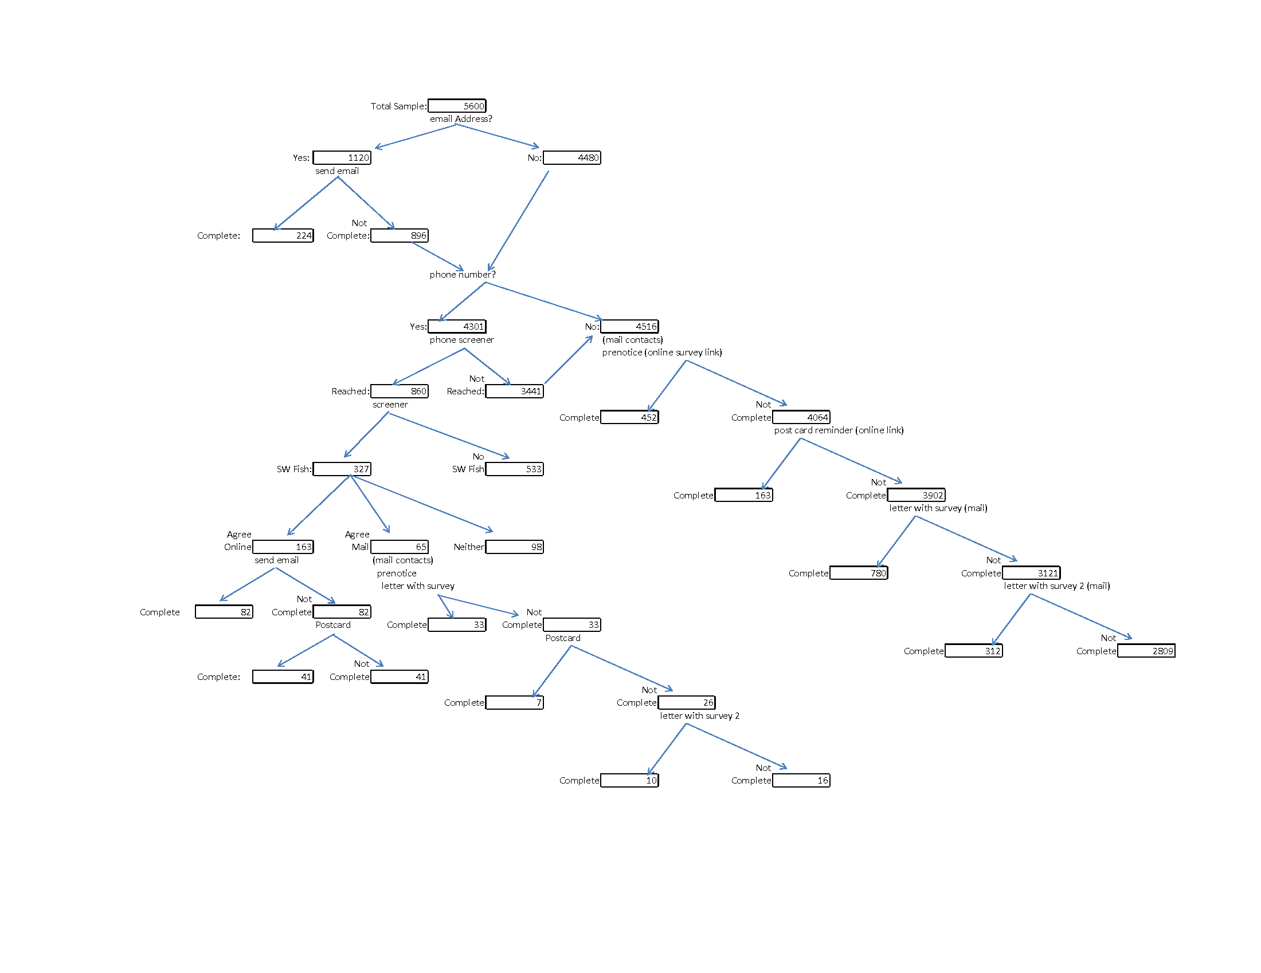

**Figure A3**. Contact Flowchart for California State

**Table A1**. Factors Contributing to Burden Estimate

|  |  |  |
| --- | --- | --- |
| **Factor** | **State** | **Estimate** |
| Email address in licensing database | WA | 20% |
|  | OR | 20% |
|  | CA | 20% |
| Phone number in licensing database | WA | 80% |
|  | OR | 80% |
|  | CA | 80% |
| Reached by phone attempt | WA | 20% |
|  | OR | 20% |
|  | CA | 20% |
| Qualify, saltwater angler | WA | 49% |
|  | OR | 23% |
|  | CA | 38% |
| Complete after email invite only | WA | 20% |
|  | OR | 20% |
|  | CA | 20% |
| Complete after phone invite | WA | 75% |
|  | OR | 75% |
|  | CA | 75% |
| Complete after mail invite | WA | 20% |
|  | OR | 20% |
|  | CA | 10% |
| Prenotice only response rate | WA | 10% |
|  | OR | 10% |
|  | CA | 10% |
| Postcard only response rate | WA | 4% |
|  | OR | 4% |
|  | CA | 4% |
| 1st mailing response rate | WA | 20% |
|  | OR | 20% |
|  | CA | 20% |
| 2nd mailing response rate | WA | 10% |
|  | OR | 10% |
|  | CA | 10% |
| Agree online, phone screener | WA | 50% |
|  | OR | 50% |
|  | CA | 50% |
| Agree mail, phone screener | WA | 20% |
|  | OR | 20% |
|  | CA | 20% |
| Minutes to complete, saltwater angler | All | 25 |
| Minutes to complete, non-saltwater angler | All | 10 |
| Minutes to complete phone survey | All | 3 |