Attachment 2: LGBT YOUNG ADULT Follow-up INSTRUMENT

Research and Evaluation Survey for the Public Education Campaign on Tobacco among Lesbian Gay Bisexual Transgender (LGBT) (RESPECT) – Follow-Up Survey

Programming conventions and specifications notes
Abbreviations used include ‘R’ for ‘respondent’ and ‘PNTA’ for ‘prefer not to answer’
Prefer Not To Answer/Don’t Know/Refused/None of these are not allowed in combination with other responses
Variable names and section headings are not displayed on screen
Response options should not be labeled with numbers.
A back button will not be offered to respondents.
Bolding conveys emphasis while capital letters convey instructions for programmers or interviewers.
Questionnaire will include a progress bar
All items are required
“Next” buttons will be displayed on every survey screen as appropriate.
All images should be arrange in such a way that focus on usability and layout. Images should be aligned and of similar sizes as one another.

Form Approved
OMB No. 0910-0808
Exp. Date 01/31/2019

ZA3. [IF LONGITUDINAL (RFU1=1) OR LONGITUDINAL NR (RNE=1)]
The RESPECT LGBT survey asks LGBT young adults about opinions and behaviors related to tobacco and use of media. If you recall, previously, you were asked to participate in the study. RTI, a non-profit research organization, is working with the FDA to conduct this study. We are contacting you again to determine whether anything has changed, or if it has stayed the same. Before beginning the study, please answer a few questions to determine whether you are eligible. You are one of approximately 6,500 young adults within 24 cities across the United States that is being invited to take part. Your answers to the questions will be kept private to the fullest extent allowable by law, and your participation is voluntary. If we determine you are eligible for the study, you will have the opportunity to complete one or more additional online surveys on your own as part of this study for $20-$25 each.

Do you consent to participate in this survey?
- Yes, I consent to participate in this survey - GO TO Z0
- No, I do not want to participate in this survey

ASK: All longitudinal respondents who were recruited in Cohort 1 or Cohort 2
_________________________________________________________________________
REFSCRN. [IF ZA3 (SCREENER CONSENT) AND LONGITUDINAL (RFU1=1) OR LONGITUDINAL NR (RNE=1)= NO]
Thank you for your time.
ASK: Respondents who refuse to consent to the interview.
_________________________________________________________________________

Z0. [IF LONGITUDINAL (RFU1=1) OR LONGITUDINAL NR (RNE=1)]
Before we begin, we have a couple of general questions about you. You may have seen these questions before, but we appreciate you responding to them again.
NEXT
ASK: All longitudinal respondents who have been recruited in prior waves
_________________________________________________________________________
Z1. [IF LONGITUDINAL (RFU1=1) OR LONGITUDINAL NR (RNE=1)]
What is the 5-digit zip code where you currently live?
__ __ __ __ __ (5-digit, numeric responses only)

ASK: All longitudinal respondents who have been recruited in prior waves _________________________________________________________________________
Z2. [IF LONGITUDINAL (RFU1=1)]
What is your date of birth?
Month Year
PROGRAMMER: DISPLAY A DROP DOWN LIST OF 12 MONTHS AND ANOTHER OF YEARS 1985 – 2005.
ASK: All longitudinal respondents who have been recruited in prior waves
_________________________________________________________________________
Z3. [IF LONGITUDINAL (RFU1=1) OR LONGITUDINAL NR (RNE=1)]
What is your current gender identity?
1 Male
2 Female
3 Trans male/Trans man
4 Trans female/Trans woman
5 Genderqueer/Gender non-conforming
6 Different identity (please state)________________________
9 Prefer not to answer

ASK: All longitudinal respondents who have been recruited in prior waves

_________________________________________________________________________
Z4. [IF LONGITUDINAL (RFU1=1) OR LONGITUDINAL NR (RNE=1)]
What sex were you assigned at birth, on your original birth certificate?
1 Female
2 Male
9 Prefer not to answer

ASK: All longitudinal respondents who have been recruited in prior waves
_________________________________________________________________________
Z5. [IF Z3= 1 or 3 AND LONGITUDINAL (RFU1=1) OR LONGITUDINAL NR (RNE=1)]

Which of the following best represents how you think of yourself?
1 Gay – GO TO Z9
2 Straight, that is, not gay – GO TO Z9
3 Bisexual – GO TO Z9
4 Something else – GO TO Z7
5 I don’t know the answer – GO TO Z8
9 Prefer not to answer – GO TO Z9

ASK: All longitudinal respondents who have been recruited in prior waves and who are male or trans male

_________________________________________________________________________

Z6. [IF Z3= 2 OR 4 AND LONGITUDINAL (RFU1=1) OR LONGITUDINAL NR (RNE=1)] Which of the following best represents how you think of yourself?
1 Lesbian or gay – GO TO Z9
2 Straight, that is, not lesbian or gay – GO TO Z9
3 Bisexual - GO TO Z9
4 Something else – GO TO Z7
5 I don’t know the answer – GO TO Z8
9 Prefer not to answer – GO TO Z9

ASK: All longitudinal respondents who have been recruited in prior waves and who are female or trans female
_________________________________________________________________________
Z7. [IF Z6=4 OR Z5=4 AND LONGITUDINAL (RFU1=1) OR LONGITUDINAL NR (RNE=1)]
What do you mean by something else?
1 You are not straight, but identify with another label such as queer, trisexual, omnisexual, or pansexual – GO TO Z9
2 You are transgender, transsexual, or gender variant - GO TO Z9
3 You have not figured out or are in the process of figuring out your sexuality - GO TO Z9
4 You do not think of yourself as having sexuality - GO TO Z9
5 You do not use labels to identify yourself - GO TO Z9
6 You mean something else (please state) - GO TO Z9 ________________
9 Prefer not to answer - GO TO Z9

ASK: All longitudinal respondents who have been recruited in prior waves and who report ‘something else’ in Z5 or Z6
_________________________________________________________________________
Z8. [IF Z6=5 OR Z5=5 AND LONGITUDINAL (RFU1=1) OR LONGITUDINAL NR (RNE=1)] What do you mean by don’t know?
1 You don’t understand the words
2 You understand the words, but you have not figured out or are in the process of figuring out your sexuality
3 You mean something else
9 Prefer not to answer

ASK: All longitudinal respondents who have been recruited in prior waves and who report ‘don’t know’ in Z6

_________________________________________________________________________
Z9. [IF LONGITUDINAL (RFU1=1) OR LONGITUDINAL NR (RNE=1)]
What is your age? ____________ (Range: 15-80)
ASK: All longitudinal respondents who have been recruited in prior waves
_________________________________________________________________________
PROGRAMMER: IF LONGITUDINAL OR LONGITUDINAL NR (RNE=1) THEN SET ELIGFLAG. IF [Z1 IS THE SAME ZIP OR DMA AS FRAME INFORMATION AND Z2 MATCHES SAMPLE FRAME INFORMATION AND (LONGITUDINAL (RFU1=1) AND Z9= 18 to 26-years-old OR LONGITUDINAL NR (RNE=1) AND Z9= BASELINE AGE OR BASELINE AGE +1) AND [Z3= 3 to 5 OR Z5= 1 or 3 OR Z6= 1 or 3 OR Z7= 1 or 2 or 6] THEN ELIGFLAG=1. ELSE ELIGFLAG=2.
NOTE: This programming directs who is eligible for the study. To be eligible, respondents must be in the same zip code or the same DMA as they were previously. They must have the same date of birth as previously reported. They must be between 18 and 26 years old or be the same age as last wave or one year older than last wave. They must also be LGBT, but their sexual orientation or identity is not compared to that of last survey.
_________________________________________________________________________

INELIG [IF (ELIGFLAG=2 AND LONGITUDINAL (RFU1=1) OR LONGITUDINAL NR (RNE=1))]
Thank you for your responses. Based on your responses, you are not eligible to participate in the study. We have no further questions at this time.
ASK: Respondents who are ineligible due to responses to the screening questions. _________________________________________________________________________

ELIG [IF (ELIGFLAG=1 AND LONGITUDINAL (RFU1=1) OR LONGITUDINAL NR (RNE=1))]
Please click Next to continue.
NEXT
ASK: Respondents who are eligible due to responses to the screening questions.
_________________________________________________________________________

WID [IF INTERCEPT AND NEW COHORT]

Our records indicate that a [PREFILL AGE] year old named [PREFILL NAME] answered some questions for this study. Are you [PREFILL NAME]?
- Yes
- No

ASK: Respondents who were recruited for the first time in this wave through intercept methods

DISPLAY: Prefill Age is the respondent’s age based on the intercept screener. Prefill Name is the respondents name from the contact information survey that the respondent completed during intercept.
_________________________________________________________________________
WINELIG [IF WID=2] Thank you, but you are not eligible to take this survey.

ASK: Respondents who were recruited for the first time in this wave through intercept methods and who answer ‘No’ to WID
_________________________________________________________________________

Section AA: Informed consent
AA1. [IF NEW COHORT]
Research and Evaluation Survey for the Public Education Campaign on Tobacco among LGBT (RESPECT LGBT):
The RESPECT LGBT survey asks young LGBT adults, ages 18-26, about opinions and behaviors related to tobacco, use of media and about their LGBT identity. The survey will take about 30 minutes to complete. About 12,600 people in 24 cities across the United States will take this survey.
Sponsor: This study is sponsored by the U. S. Food and Drug Administration’s Center for Tobacco Products (FDA-CTP). RTI International, a not-for-profit research organization, is conducting the study on the behalf of the FDA-CTP.

Financial Considerations: Within two days of completing the survey you will receive an email offering you the choice of one of over 50 $20 electronic gift cards as a thank you for your participation. [FILL FOR INTERCEPT RESPONDENTS: If you complete this survey within 48 hours of receiving the initial email invitation you will be offered an additional $5, for a total of $25.]
Voluntary Participation: Your participation is completely voluntary. You can refuse to answer any and all questions. You can stop participation at any time.
Confidentiality: The protection of personal information is a primary concern to all institutions involved in this project. All members of the research team receive confidentiality training. Your answers to the survey questions will be kept private to the fullest extent allowable by law. Only we or other researchers involved in this project will have access to the answers you provide. Your name or email address will not be reported with any answers you provide. Your answers will be combined with answers of many others and reported in a summary form. All staff involved in this research are committed to confidentiality and have signed a Confidentiality Pledge. To help us ensure your answers are kept confidential and private, please complete the survey in a place where no one can look over your shoulder and view your answers. In addition, as is the case with all information transmitted online there is a possibility of a breach of confidentiality due to third parties illegally intercepting content. Your answers to questions will not be stored with any personally identifying information and will not be able to be connected with your identity by third parties.
Possible Benefits and Risks: There are no direct benefits to you for participating in this study. It is possible that some questions might make you feel mildly uncomfortable, but you can skip those if you choose.
Future Contacts: To help us understand changes over time, we may contact you in the future to invite you to participate in this study again. Each of these additional surveys will also be completely voluntary and you will be offered $20 for your participation.
Further Questions: If you have any questions about the research now or in the future you can contact the Project toll free number 1-800-848-4072. If you have questions about your rights as a study participant, call RTI’s Office of Research Protection at 1‐866‐214-2043 (a toll‐free number).
CC1. Do you consent to participate in this web survey?
- Yes
- No
ASK: All new cohort respondents
_________________________________________________________________________

Longitudinal Survey Consent
AA1L. [IF LONGITUDINAL (RFU1=1) OR LONGITUDINAL NR (RNE=1)]
Research and Evaluation Survey for the Public Education Campaign on Tobacco among LGBT (RESPECT LGBT):
Thank you for your continued interest in this study. The RESPECT LGBT survey asks young LGBT adults, ages 18-26, about opinions and behaviors related to tobacco, use of media and about their LGBT identity. The survey will take about 30 minutes to complete. We are conducting the study again to see what has changed and what has stayed the same. About 12,600 people in 24 cities across the United States will take this survey.
Sponsor: This study is sponsored by the U. S. Food and Drug Administration’s Center for Tobacco Products (FDA-CTP). RTI International, a not-for-profit research organization, is conducting the study on the behalf of the FDA-CTP.

Financial Considerations: Within two days of completing the survey you will receive an email offering you the choice of one of over 50 $20 electronic gift cards as a thank you for your participation. If you complete this survey within 48 hours of receiving the initial email invitation, you will be offered an additional $5, for a total of $25.
Voluntary Participation: Your participation is completely voluntary. You can refuse to answer any and all questions. You can stop participation at any time.
Confidentiality: The protection of personal information is a primary concern to all institutions involved in this project. All members of the research team receive confidentiality training. Your answers to the survey questions will be kept private to the fullest extent allowable by law. Only we or other researchers involved in this project will have access to the answers you provide. Your name or email address will not be reported with any answers you provide. Your answers will be combined with answers of many others and reported in a summary form. All staff involved in this research are committed to confidentiality and have signed a Confidentiality Pledge. To help us ensure your answers are kept confidential and private, please complete the survey in a place where no one can look over your shoulder and view your answers. In addition, as is the case with all information transmitted online there is a possibility of a breach of confidentiality due to third parties illegally intercepting content. Your answers to questions will not be stored with any personally identifying information and will not be able to be connected with your identity by third parties.
Possible Benefits and Risks: There are no direct benefits to you for participating in this study. It is possible that some questions might make you feel mildly uncomfortable, but you can skip those if you choose.
Future Contacts: To help us understand changes over time, we may contact you in the future to invite you to participate in this study again. Each of these additional surveys will also be completely voluntary and you will be offered $20 for your participation.
Further Questions: If you have any questions about the research now or in the future you can contact the Project toll free number 1-800-848-4072. If you have questions about your rights as a study participant, call RTI’s Office of Research Protection at 1‐866‐214-2043 (a toll‐free number).
CC1. Do you consent to participate in this web survey?
- Yes
- No
ASK: All longitudinal respondents who have been recruited in prior waves
_________________________________________________________________________

Y_video Please try to view this video to make sure you can see it.
PROGRAMMER: DISPLAY OCEAN VIDEO NEXT
ASK: All respondents
_________________________________________________________________________

Y_video1 Are you able to view this video?
- Yes
- No

PROGRAMMER: IF Y_video1=2, display this message: ‘Viewing the videos in this survey is important. Try logging into the survey using a different computer or browser. If that doesn’t work, you will not be able to take the survey online.’ If the respondent answers ‘No’ the instrument should resume at this screen.

ASK: All respondents
_________________________________________________________________________

Section A: Demographic Items
A1. The first part of the survey asks you some general questions about yourself.
What is your date of birth?
Month Year

PROGRAMMER: CALCULATE MINUMUM AGE. FOR EXAMPLE, IF MONTH IS CURRENT MONTH AND R CAN BE EITHER 17 OR 18 BASED ON DATE, CALCULATE 17. INCLUDE DROP DOWN MENUS FOR MONTH AND YEAR. THE RANGE OF YEARS SHOULD INCLUDE 1985 TO 2005.
ASK: All respondents
_________________________________________________________________________

ROUTE [IF MINIMUM AGE <18] Thank you for your responses. Based on your responses, you are not eligible to participate in the study.

NEXT
PROGRAMMER: EXIT INTERVIEW
ASK: Respondents whose month and year of birth could make them 17 years old.
_________________________________________________________________________
A2. [IF LONGITUDINAL (RFU1 NE 1) AND LONGITUDINAL NR (RNE NE 1)]
Are you Hispanic, Latino/a, or of Spanish origin? Check all that apply.
PROGRAMMER: PROGRAM SO THAT RESPONDENTS CAN SELECT MORE THAN ONE RESPONSE ON 2-5

1 No, not of Hispanic, Latino/a, or Spanish origin
2 Yes, Mexican American, Chicano/a
3 Yes, Puerto Rican
4 Yes, Cuban
5 Yes, another Hispanic, Latino/a, or Spanish origin
9 Prefer not to answer

ASK: All new cohort respondents
_________________________________________________________________________
A3. [IF LONGITUDINAL (RFU1 NE 1) AND LONGITUDINAL NR (RNE NE 1)]
What race or races do you consider yourself to be? You can choose one answer or more than one answer or you may skip this question
PROGRAMMER: PREFER NOT TO ANSWER SHOULD NOT BE COMBINABLE WITH OTHER RESPONSE OPTIONS
1 American Indian or Alaska Native
2 Asian
3 Black or African American
4 Native Hawaiian or Other Pacific Islander
5 White
5 Other
9 Prefer not to answer
ASK: All new cohort respondents
_________________________________________________________________________
A4. Which best describes your current job or paid employment status?
1 Work full-time at least 35 hours per week
2 Work part-time 15 to 34 hours per week
3 Work part-time less than 15 hours per week
4 I don't currently work for pay
5 Don’t know
9 Prefer not to answer

ASK: All respondents

_________________________________________________________________________
A5. What is the highest grade or level of school you have completed?
1 Less than high school
2 Some high school, no diploma
3 GED
4 High school graduate—diploma
5 Some college but no degree
6 Associate degree—occupational/vocational
7 Associate degree—academic program
8 Bachelor’s degree (ex: BA, AB, BS)
9 Master’s degree (ex: MA, MS, MEng, Med, MSW)
10 Professional school degree (ex: MD, DDS, DVM, JD)
11 Doctorate degree (ex: PhD, EdD)
12 Don’t know
99 Prefer not to answer

ASK: All respondents
_________________________________________________________________________
A6. Are you currently enrolled in a degree program?
1 Yes
2 No
3 Don’t know
9 Prefer not to answer

ASK: All respondents
_________________________________________________________________________
A7. Which of the following categories best describes your total household income in the past 12 months?
This is the total income before taxes of all persons in your household combined. Please include money from jobs, relatives, pensions, dividends, interest, social security payments or retirement benefits, net income from business, farm or rent, and any other money received by household members.
1 Less than $10,000
2 $10,000 to $14,999
3 $15,000 to $24,999
4 $25,000 to $34,999
5 $35,000 to $49,999
6 $50,000 to $74,999
7 $75,000 to $99,999
8 $100,000 to $149,999
9 $150,000 to $199,999
10 $200,000 or more
11 Don’t know
99 Prefer not to answer

ASK: All respondents
_________________________________________________________________________
Section B: Tobacco Use Behavior

The next section asks about your experiences with tobacco products.

Cigarette Use
B1. Have you ever tried cigarette smoking, even one or two puffs?
1 Yes
2 No – GO TO B9
9 Prefer not to answer

ASK: All respondents
_________________________________________________________________________
B2. [IF B1=1 or 9]
During the past 30 days, on how many days did you smoke cigarettes? Enter 99 if you prefer not to answer.
|_|_| days [RANGE: 0-30, 99]
ASK: Respondents who have ever smoked cigarettes or preferred not to answer whether they smoked cigarettes
_________________________________________________________________________
B3. [IF B2=1 to 30]
During the past 30 days, on the days you smoked, how many cigarettes did you smoke per day?
1 Fewer than 5 cigarettes
2 5-9 cigarettes
3 10 cigarettes (1/2 a pack)
4 11-19 cigarettes (more than 1/2 pack but less than 1 pack)
5 20 cigarettes (1 pack)
6 30 cigarettes (1 ½ packs)
7 40 cigarettes (2 packs)
8 More than 40 cigarettes (more than 2 packs)
9 Prefer not to answer

ASK: Respondents who smoked between 1 and 30 days in the past 30 days
_________________________________________________________________________
B4. [IF B2=1 to 30]
On the days that you smoke, how soon after you wake up do you have your first cigarette? Would you say…
1 Within 5 minutes
2 6-30 minutes
3 31-60 minutes
4 After 60 minutes
9 Prefer not to answer

ASK: Respondents who smoked between 1 and 30 days in the past 30 days
_________________________________________________________________________
B5. [IF B2=1 to 30]
Do you consider yourself a smoker?
1 Yes
2 No
9 Prefer not to answer

ASK: Respondents who smoked between 1 and 30 days in the past 30 days
_________________________________________________________________________
B6. [IF B2=1 to 30]
Do you consider yourself a social smoker?
1 Yes
2 No
9 Prefer not to answer

ASK: Respondents who smoked between 1 and 30 days in the past 30 days
_________________________________________________________________________
B7. [IF B1=1]
About how many cigarettes have you smoked in your entire life? Your best guess is fine.
1 1 or more puffs but never a whole cigarette
2 1 cigarette
3 2 to 5 cigarettes
4 6 to 15 cigarettes (about 1/2 a pack total)
5 16 to 25 cigarettes (about 1 pack total)
6 26 to 99 cigarettes (more than 1 pack, but less than 5 packs)
7 100 or more cigarettes (5 or more packs)
9 Prefer not to answer
ASK: Respondents who have ever smoked a cigarette
_________________________________________________________________________
B8. [IF B1=1 AND B2=0 OR 99]
About how long has it been since you last smoked cigarettes?

1 More than 30 days ago but within the past 3 months
2 More than 3 months ago but within the past 12 months
3 More than 12 months ago but within the past 3 years
4 More than 3 years ago
9 Prefer not to answer

ASK: Respondents who have ever smoked but have not smoked in the past 30 days or refuse to answer whether they have smoked in the past 30 days

_________________________________________________________________________
B9. Have you ever used smokeless tobacco, such as chewing tobacco, snuff, snus (rhymes with goose) or dip, such as Copenhagen, Skoal, Grizzly, Kodiak, and Red Seal even just a small amount?
1 Yes
2 No – GO TO B11
9 Prefer not to answer – GO TO B11

ASK: All respondents
_________________________________________________________________________
B10. [IF B9=1]
During the past 30 days, on how many days did you use chewing tobacco, snuff, snus or dip?
1 0 days
2 1 or 2 days
3 3 to 5 days
4 6 to 9 days
5 10 to 19 days
6 20 to 29 days or
7 All 30 days
9 Prefer not to answer

ASK: Respondents who report ever having used chewing tobacco
_________________________________________________________________________
B11. Have you ever smoked cigars, cigarillos, or little cigars such as Swisher Sweets, White Owl, Cheyenne, Dutch Masters, Garcia Y Vega or Middleton’s, even one or two puffs?
1 Yes
2 No – GO TO B13
9 Prefer not to answer – GO TO B13

ASK: All respondents
_________________________________________________________________________
B12. [IF B11=1]
During the past 30 days, on how many days did you smoke cigars, cigarillos, or little cigars such as Swisher Sweets, White Owl, Cheyenne, Dutch Masters, Garcia Y Vega or Middleton’s?
1 0 days
2 1 or 2 days
3 3 to 5 days
4 6 to 9 days
5 10 to 19 days
6 20 to 29 days or
7 All 30 days
9 Prefer not to answer

ASK: Respondents who report ever smoking cigars

_________________________________________________________________________
B13. Have you ever tried smoking tobacco out of a water pipe (also called “hookah”)?
1 Yes
2 No - GO TO B15
9 Prefer not to answer – GO TO B15
ASK: All respondents

_________________________________________________________________________
B14. [IF B13=1]
During the past 30 days, on how many days did you smoke tobacco out of a water pipe (also called “hookah”)?
1 0 days
2 1 or 2 days
3 3 to 5 days
4 6 to 9 days
5 10 to 19 days
6 20 to 29 days or
7 All 30 days
9 Prefer not to answer

ASK: Respondents who have ever used a hookah
_________________________________________________________________________
B15. These are examples of electronic nicotine products: e-cigarettes, e-cigars, e-hookahs, epipes, vape pens, hookah pens, mods, and personal vaporizers. These products are battery-powered, usually use nicotine fluid, and produce vapor instead of smoke. Some common brands include Fin, NJOY, Blu, e-Go and Vuse. Have you ever tried these products, even once or twice?
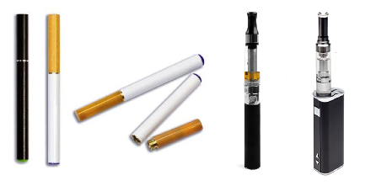

1 Yes
2 No – GO TO B17
9 Prefer not to answer – GO TO B17
ASK: All respondents

_________________________________________________________________________
B16. [IF B15=1]
During the past 30 days, on how many days did you use electronic nicotine products, such as “e-cigarettes”, “e-cigs”, “vapor pens”, or “e-hookahs”?
1 0 days
2 1 or 2 days
3 3 to 5 days
4 6 to 9 days
5 10 to 19 days
6 20 to 29 days or
7 All 30 days
9 Prefer not to answer

ASK: Respondents who report ever using electronic nicotine products
________________________________________________________________________
B17. During the past 30 days, on how many days did you drink one or more drinks of an alcoholic beverage?
1 0 days
2 1 or 2 days
3 3 to 5 days
4 6 to 9 days
5 10 to 19 days
6 20 to 29 days
7 All 30 days
9 Prefer not to answer

ASK: All respondents
_________________________________________________________________________

Section C: Tobacco Use Intentions and Self-Efficacy

C1. [IF B1=2 OR B2= 0]

Thinking about the future…
 |  | Definitely Yes | Probably Yes | Probably Not | Definitely Not | Prefer not to answer
C1_1. | Do you think that you will try a cigarette soon? | 1 | 2 | 3 | 4 | 9
C1_2. | Do you think you will smoke a cigarette at any time in the next year? | 1 | 2 | 3 | 4 | 9
C1_3. | If one of your best friends were to offer you a cigarette, would you smoke it? | 1 | 2 | 3 | 4 | 9
ASK: Respondents who have either not ever smoked or have not smoked in the past 30 days.
________________________________________________________________________

C2. How sure are you that, if you really wanted to, you could avoid smoking cigarettes if…
PROGRAMMER: RANDOMIZE C2_1-C2_5
 |  | Not at all sure | Slightly sure | Somewhat sure | Mostly sure | Completely sure | Prefer not to answer
C2_1 | You are at a party, bar or club? | 1 | 2 | 3 | 4 | 5 | 9
C2_2 | You are in a place where most people are smoking? | 1 | 2 | 3 | 4 | 5 | 9
C2_3 | Someone you know offers it? | 1 | 2 | 3 | 4 | 5 | 9
C2_4 | Someone you want to get to know offers it? | 1 | 2 | 3 | 4 | 5 | 9
C2_5 | Someone offers it to take a break? | 1 | 2 | 3 | 4 | 5 | 9

ASK: All respondents
_________________________________________________________________________

Section D: Cessation (Intention, Behavior, Motivation)
Cigarette Use
D1. [IF B2=1-30]
How much do you want to stop smoking for good? Would you say…?
1 Not at all
2 A little
3 Somewhat
4 A lot
9 Prefer not to answer
ASK: Respondents who have smoked between 1 and 30 days in the past 30 days.
_________________________________________________________________________
D2. [IF B2=1-30]
How much do you think your health would improve if you were to stop smoking for good?
1 Not at all
2 A little
3 Somewhat
4 A lot
9 Prefer not to answer
ASK: Respondents who have smoked between 1 and 30 days in the past 30.
________________________________________________________________________
D3. [IF B2=1-30] How worried are you that smoking will damage your health in the future?
1 Not at all worried
2 A little worried
3 Somewhat worried
4 Very worried
9 Prefer not to answer
ASK: Respondents who have smoked between 1 and 30 days in the past 30.
________________________________________________________________________
D4. [IF B2=1-30] How worried are you that smoking will damage your physical appearance or attractiveness?
1 Not at all worried
2 A little worried
3 Somewhat worried
4 Very worried
9 Prefer not to answer
ASK: Respondents who have smoked between 1 and 30 days in the past 30.
_________________________________________________________________________

Section E: Attitudes, Beliefs & Risk Perceptions, Social Norms

The next set of questions asks for your opinions on cigarette use and other tobacco products.

Attitude
E1. How much do you agree or disagree with the following statements about people who are tobacco-free?

PROGRAMMER: RANDOMIZE ALL ROWS

 |  | Strongly Disagree | Disagree | Neither Agree or Disagree | Agree | Strongly Agree | Prefer not to answer
E1_1. | People who are tobacco-free are confident. | 1 | 2 | 3 | 4 | 5 | 9
E1_2. | People who are tobacco-free are trendsetting. | 1 | 2 | 3 | 4 | 5 | 9
E1_3. | People who are tobacco-free are happy. | 1 | 2 | 3 | 4 | 5 | 9
E1_4. | People who are tobacco-free are judgmental. | 1 | 2 | 3 | 4 | 5 | 9
E1_5. | People who are tobacco-free are attractive. | 1 | 2 | 3 | 4 | 5 | 9
E1_6. | People who are tobacco-free are basic. | 1 | 2 | 3 | 4 | 5 | 9
E1_7. | People who are tobacco-free are boring. | 1 | 2 | 3 | 4 | 5 | 9
E1_8. | People who are tobacco-free are predictable. | 1 | 2 | 3 | 4 | 5 | 9
ASK: All respondents
_________________________________________________________________________
E2. Smoking cigarettes is…
[RANDOMIZE E2_1-E2_2]
E2_1. | Bad |  |  |  |  |  |  |  | Good
E2_2. | Unenjoyable |  |  |  |  |  |  |  | Enjoyable
PROGRAMMER: DETERMINE HOW TO HAVE AN OVERT PREFER NOT TO ANSWER OPTION
ASK: All respondents
_________________________________________________________________________
E3A. [IF B1= 2 OR B2= 0 AND B9=2 OR B10= 1 AND B11= 2 OR B12= 1 AND B13= 2 OR B14= 1 AND B15= 2 OR B16= 1]

How much do you agree or disagree with the following statements?
PROGRAMMER: RANDOMIZE E3A_1- E3A_5
 |  | Strongly Disagree | Disagree | Neither Agree or Disagree | Agree | Strongly Agree | Prefer not to answer
E3A_1. | I am proud to live tobacco-free. | 1 | 2 | 3 | 4 | 5 | 9
E3A_2. | Living tobacco-free is important to me. | 1 | 2 | 3 | 4 | 5 | 9
E3A_3. | Tobacco use is harmful to the LGBT community. | 1 | 2 | 3 | 4 | 5 | 9
E3A_4. | Being tobacco free when I go out makes me feel excluded. | 1 | 2 | 3 | 4 | 5 | 9
E3A_5. | Using tobacco makes life harder. | 1 | 2 | 3 | 4 | 5 | 9

ASK: Any respondents who have either never used any of the tobacco products in Section B or have not used any of them in the past 30 days.
_________________________________________________________________________
E3B. [IF B2 NE 0 OR B10 NE 1 OR B12 NE 1 OR B14 NE 1 OR B16 NE 1]

How much do you agree or disagree with the following statements?
PROGRAMMER: RANDOMIZE E3B_1-E3B_7
 |  | Strongly Disagree | Disagree | Neither Agree or Disagree | Agree | Strongly Agree | Prefer not to answer
E3B_1. | I would be proud to live tobacco-free. | 1 | 2 | 3 | 4 | 5 | 9
E3B_2. | Living tobacco-free is important to me. | 1 | 2 | 3 | 4 | 5 | 9
E3B_3. | If I lived tobacco-free I would be proud to tell other people. | 1 | 2 | 3 | 4 | 5 | 9
E3B_4. | Using tobacco interferes with my life. | 1 | 2 | 3 | 4 | 5 | 9
E3B_5. | Tobacco use is harmful to the LGBT community. | 1 | 2 | 3 | 4 | 5 | 9
E3B_6. | If I was tobacco free I would feel excluded when I go out. | 1 | 2 | 3 | 4 | 5 | 9
E3B_7. | Using tobacco makes life harder. | 1 | 2 | 3 | 4 | 5 | 9
ASK: Respondents who have used any type of tobacco in the past 30 days
_________________________________________________________________________

E4. How much do you agree or disagree with the following statements? If I smoke cigarettes every day, I will…

PROGRAMMER: RANDOMIZE ROWS
 |  | Strongly Disagree | Disagree | Neither Agree or Disagree | Agree | Strongly Agree | Prefer not to answer
E4_1. | Shorten my life | 1 | 2 | 3 | 4 | 5 | 9
E4_2. | Be able to stop smoking when I want to | 1 | 2 | 3 | 4 | 5 | 9
E4_3. | Damage my immune system | 1 | 2 | 3 | 4 | 5 | 9
E4_4. | Turn off potential partners | 1 | 2 | 3 | 4 | 5 | 9
E4_5. | Damage my teeth | 1 | 2 | 3 | 4 | 5 | 9
E4_6. | Damage my skin | 1 | 2 | 3 | 4 | 5 | 9
E4_7. | Develop lung cancer | 1 | 2 | 3 | 4 | 5 | 9

ASK: All respondents
_________________________________________________________________________

Social Norms

E5. How many of your four closest friends…
 |  | None | One | Two | Three | Four | Prefer not to answer
E5_1. | Smoke cigarettes? | 0 | 1 | 2 | 3 | 4 | 9
E5_2. | Use a hookah or water pipe to smoke tobacco? | 0 | 1 | 2 | 3 | 4 | 9
E5_3. | Use electronic nicotine products such as “e-cigarettes”, “e-cigs”, “vapor pens”, or “e-hookahs”?  Common brands are Blu, Njoy, Logic, Fin, Swisher, 21st Century Smoke, Vuse, Markten, V2 Cigs, Nicotek or Vapin Plus. | 0 | 1 | 2 | 3 | 4 | 9

ASK: All respondents
_________________________________________________________________________

E6. How many LGBT people who are your age...
 |  | None | A few | Some | Most | All | Prefer not to answer
E6_1. | Smoke cigarettes? | 0 | 1 | 2 | 3 | 4 | 9
E6_2. | Use a hookah or water pipe to smoke tobacco? | 0 | 1 | 2 | 3 | 4 | 9
E6_3. | Use electronic nicotine products such as “e-cigarettes”, “e-cigs”, “vapor pens”, or “e-hookahs”?  Common brands are Blu, Njoy, Logic, Fin, Swisher, 21st Century Smoke, Vuse, Markten, V2 Cigs, Nicotek or Vapin Plus. | 0 | 1 | 2 | 3 | 4 | 9

ASK: All respondents
_________________________________________________________________________
E7. How do LGBT people your age feel about cigarette smoking? Would you say most LGBT people your age...
1 Strongly disapprove
2 Somewhat disapprove
3 Neither approve nor disapprove
4 Somewhat approve
5 Strongly approve
9 Prefer not to answer

ASK: All respondents
_________________________________________________________________________
E8. Compared to 3 months ago, people your age at LGBT bars, clubs and events are smoking...
1 More often
2 Less often
3 About the same
4 Not sure
9 Prefer not to answer
ASK: All respondents

_________________________________________________________________________

Perceived Approval
E9. How much do you agree or disagree with the following statements?
PROGRAMMER: RANDOMIZE E9_1-E9_3
 |  | Strongly Disagree | Disagree | Neither Agree or Disagree | Agree | Strongly Agree | Prefer not to answer
E9_1. | According to my friends, it is very important for me to not smoke cigarettes. | 1 | 2 | 3 | 4 | 5 | 9
E9_2. | According to most people who hang out where I hang out, it is very important for me to not smoke cigarettes. | 1 | 2 | 3 | 4 | 5 | 9
E9_3. | According to people my age in LGBT communities it is very important for me to not smoke cigarettes. | 1 | 2 | 3 | 4 | 5 | 9

ASK: All respondents

_________________________________________________________________________

E10. How much do you agree or disagree with the following statements? If I only smoke cigarettes on some days (for example, smoking only when I go out), I will…

PROGRAMMER: RANDOMIZE ROWS IN TABLE
 |  | Strongly Disagree | Disagree | Neither Agree or Disagree | Agree | Strongly Agree | Prefer not to answer
E10_1 | Shorten my life | 1 | 2 | 3 | 4 | 5 | 9
E10_2 | Be able to stop smoking when I want to | 1 | 2 | 3 | 4 | 5 | 9
E10_3 | Damage my immune system | 1 | 2 | 3 | 4 | 5 | 9
E10_4 | Turn off potential partners | 1 | 2 | 3 | 4 | 5 | 9
E10_5 | Damage my teeth | 1 | 2 | 3 | 4 | 5 | 9
E10_6 | Damage my skin | 1 | 2 | 3 | 4 | 5 | 9
E10_7 | Develop lung cancer | 1 | 2 | 3 | 4 | 5 | 9

ASK: All respondents
_________________________________________________________________________
Approval of Smoking

E11. This next set of questions asks about how willing or unwilling you are to do things with people who smoke cigarettes. Would you:
 |  | Definitely Yes | Probably Yes | Probably Not | Definitely Not | Prefer not to answer
E11_1. | Go to a bar, club, party, concert or event where people are smoking cigarettes? | 1 | 2 | 3 | 4 | 9
E11_2. | Hang out with someone who smokes cigarettes? | 1 | 2 | 3 | 4 | 9
E11_3. | Dance with someone who smokes cigarettes? | 1 | 2 | 3 | 4 | 9
E11_4. | Kiss someone who smokes cigarettes? | 1 | 2 | 3 | 4 | 9
E11_5. | Date someone who smokes cigarettes? | 1 | 2 | 3 | 4 | 9

ASK: All respondents
_________________________________________________________________________
E12. How much do you agree or disagree with the following statements about smoking cigarettes?
 |  | Strongly Disagree | Disagree | Neither Agree or Disagree | Agree | Strongly Agree | Prefer not to answer
E12_1. | It is safe for me to smoke for only a year or two, as long as I quit after that. | 1 | 2 | 3 | 4 | 5 | 9
E12_2. | If I started to smoke occasionally I would not become addicted. | 1 | 2 | 3 | 4 | 5 | 9
E12_3. | Smoking cigarettes helps people relieve stress. | 1 | 2 | 3 | 4 | 5 | 9
E12_6. | Smoking is a way to show my identity to others. | 1 | 2 | 3 | 4 | 5 | 9
E12_7. | Smoking cigarettes can help keep your weight down. | 1 | 2 | 3 | 4 | 5 | 9
E12_8. | Smoking can cause damage to nearly every part of your body. | 1 | 2 | 3 | 4 | 5 | 9
E12_9. | Smoking weakens your immune system. | 1 | 2 | 3 | 4 | 5 | 9
E12_10. | Please select the option labeled ‘Strongly Disagree’ as your answer. | 1 | 2 | 3 | 4 | 5 | 9

ASK: All respondents
________________________________________________________________________

Section F: Media Use and Awareness

F1. Next, we’d like to ask you about your use of TV and other media.
How often do you…
 | Several times a day | About Once a Day | 3-5 days a week | 1-2 days a week | Every few weeks | Less often | Never | Prefer not to answer
F1_1. Watch TV shows or movies on any platform including a TV set, a computer, laptop or tablet, a smartphone or an iPod or MP3 player? | 1 | 2 | 3 | 4 | 5 | 6 | 7 | 9
F1_2. Watch videos on YouTube? | 1 | 2 | 3 | 4 | 5 | 6 | 7 | 9
F1_3. Listen to streaming radio? | 1 | 2 | 3 | 4 | 5 | 6 | 7 | 9

ASK: All respondents
_________________________________________________________________________

F1_4. How often do you use dating websites or apps?
1 Several times a day
2 About once a day
3 3-5 days a week
4 1-2 days a week
5 Every few weeks
6 Less often
7 Never
9 Prefer not to answer

ASK: All respondents

_________________________________________________________________________
F2. Thinking about the social networking sites you use, about how often do you visit or use …
[RANDOMIZE ALL]
 | Several times a day | About Once a Day | 3-5 days a week | 1-2 days a week | Every few weeks | Less often | Never | Prefer not to answer
F2_1. Facebook | 1 | 2 | 3 | 4 | 5 | 6 | 7 | 9
F2_2. Instagram | 1 | 2 | 3 | 4 | 5 | 6 | 7 | 9
F2_3. Twitter | 1 | 2 | 3 | 4 | 5 | 6 | 7 | 9
F2_4. Tumblr | 1 | 2 | 3 | 4 | 5 | 6 | 7 | 9
F2_5. Snapchat | 1 | 2 | 3 | 4 | 5 | 6 | 7 | 9

ASK: All respondents
_________________________________________________________________________
F2_6. [IF F1_4 NE 7] Thinking about the dating websites and apps you use, about how often do you visit or use OkCupid?
1 Several times a day
2 About once a day
3 3-5 days a week
4 1-2 days a week
5 Every few weeks
6 Less often
7 Never
9 Prefer not to answer
ASK: Respondents who report using dating sites more frequently than ‘Never’
_________________________________________________________________________
F2_7. [IF Z3= 2 OR 4 AND Z6= 1 OR 3; IF A3= 2 OR 4 AND A6= 1 OR 3 AND F1_4 NE 7]
Thinking about the dating websites and apps you use, about how often do you visit or use HER?
1 Several times a day
2 About once a day
3 3-5 days a week
4 1-2 days a week
5 Every few weeks
6 Less often
7 Never
9 Prefer not to answer
ASK: Respondents who identify as female or transfemale and who are lesbian or bisexual and who report using dating sites more frequently than ‘Never’

_________________________________________________________________________
F3. Think about the following websites. About how often do you visit or use…
[RANDOMIZE ALL]
 | Several times a day | About Once a Day | 3-5 days a week | 1-2 days a week | Every few weeks | Less often | Never | Prefer not to answer
F3_1. Queerty http://www.queerty.com/ | 1 | 2 | 3 | 4 | 5 | 6 | 7 | 9
F3_2. Logo TV http://www.logotv.com/ | 1 | 2 | 3 | 4 | 5 | 6 | 7 | 9
F3_3. Out http://www.out.com/ | 1 | 2 | 3 | 4 | 5 | 6 | 7 | 9
F3_4. Autostraddle http://www.autostraddle.com/ | 1 | 2 | 3 | 4 | 5 | 6 | 7 | 9
F3_5. After Ellen http://www.afterellen.com/ | 1 | 2 | 3 | 4 | 5 | 6 | 7 | 9
F3_6. Gay.com http://www.gay.com/ | 1 | 2 | 3 | 4 | 5 | 6 | 7 | 9
F3_7. Towleroad.com http://www.towleroad.com/ | 1 | 2 | 3 | 4 | 5 | 6 | 7 | 9
ASK: All respondents
_________________________________________________________________________
F4. How often do you go to concerts, live shows, or other events at a store, local stage, community center, or music venue?
1 Once a week or more often
2 One or two times a month
3 Once every two or three months
4 One or two times a year
5 I do not attend concerts, live shows, or other events
9 Prefer not to answer

ASK: All respondents
_________________________________________________________________________
F5. In the past 30 days, on how many days did you go to an LGBT party, night, bar, club, or event?
1 0 days
2 1-3 days
3 4-6 days
4 7 or more days
5 Don’t remember how many days
9 Prefer not to answer

ASK: All respondents
_________________________________________________________________________
F6. How many LGBT celebrities, athletes, musicians, or artists do you follow on social media (e.g. Laverne Cox, Tegan & Sara, Ruby Rose, Angel Haze)?
1 0
2 1-2
3 3-4
4 5 or more
9 Prefer not to answer
ASK: All respondents
_________________________________________________________________________
Brand Awareness
F7. We want to ask you about some brands that might or might not have appeared in the media around here, as part of ads or videos about tobacco or at concerts, live shows, or other events.
NEXT
ASK: All respondents
_________________________________________________________________________
F7_1. In the past 3 months, that is since [FILL DATE], have you seen or heard the following brand?
COMMUNE



1 Yes
2 No
3 Not Sure
9 Prefer not to answer

ASK: All respondents
DISPLAY: FILL DATE will calculate the date 3 months prior to the current date.
_________________________________________________________________________
F7_2. In the past 3 months, that is since [FILL DATE], have you seen or heard the following brand?
The Real Cost

1 Yes
2 No
3 Not Sure
9 Prefer not to answer

ASK: All respondents
DISPLAY: FILL DATE will calculate the date 3 months prior to the current date.
_________________________________________________________________________
F7_3. In the past 3 months, that is since [FILL DATE], have you seen or heard the following brand?
This Free Life

1 Yes
2 No
3 Not Sure
9 Prefer not to answer
ASK: All respondents
DISPLAY: FILL DATE will calculate the date 3 months prior to the current date.
_________________________________________________________________________
F7_4. In the past 3 months, that is since [FILL DATE], have you seen or heard the following brand?
Fresh Empire

1 Yes
2 No
3 Not Sure
9 Prefer not to answer

ASK: All respondents
DISPLAY: FILL DATE will calculate the date 3 months prior to the current date.
_________________________________________________________________________
Ad Awareness Other TC Campaigns (To Use As Controls)
F8. The next set of questions asks whether or not you’ve seen any of the following ads.
NEXT
ASK: All respondents
_________________________________________________________________________
PROGRAMMER: RANDOMIZE F8_1-F8_3
_________________________________________________________________________F8_1. In the past 3 months, that is since [FILL DATE], have you seen a Tips from Former Smokers (Tips) ad? Examples of some Tips from Former Smokers ads are shown below.
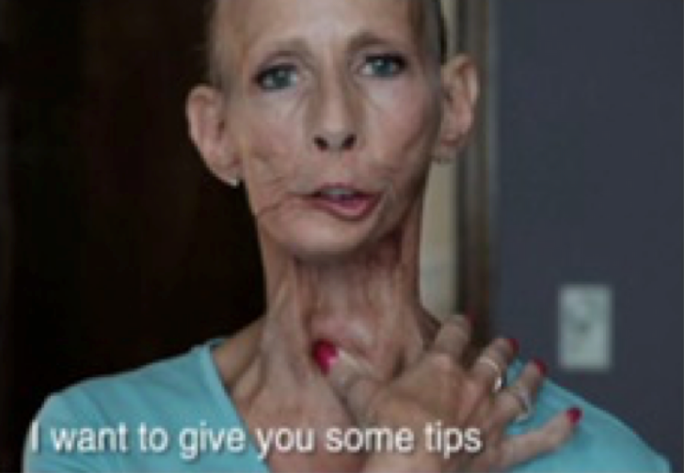
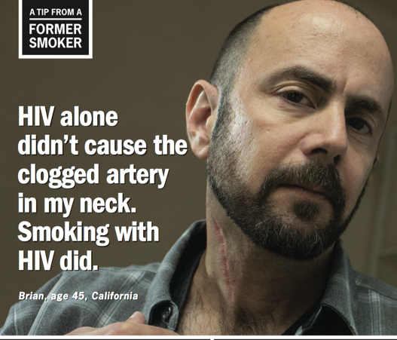

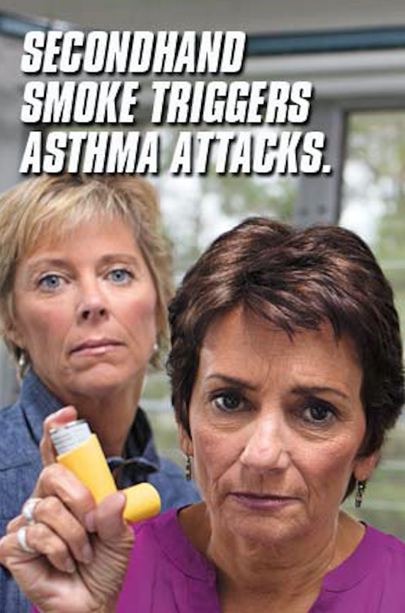
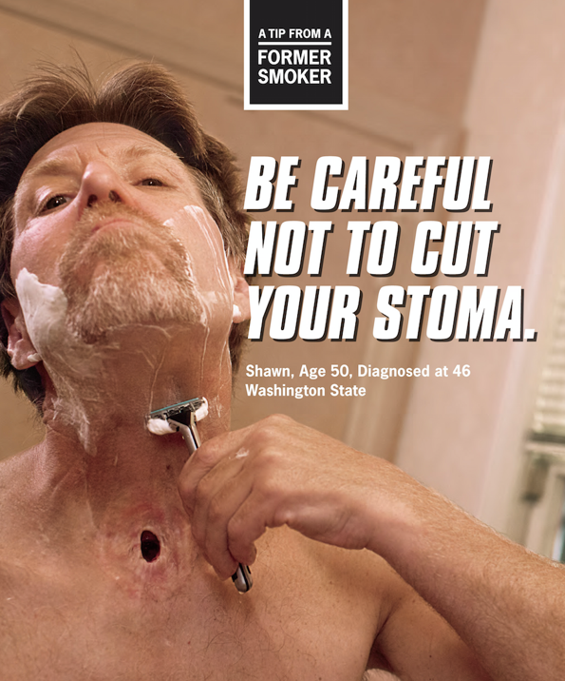

1 Yes
2 No
3 Not Sure
9 Prefer not to answer
ASK: All respondents
DISPLAY: FILL DATE will calculate the date 3 months prior to the current date.
_________________________________________________________________________

F8_2. In the past 3 months, that is since [FILL DATE], have you seen a truth® campaign ad? Examples of some truth® campaign ads are shown below.


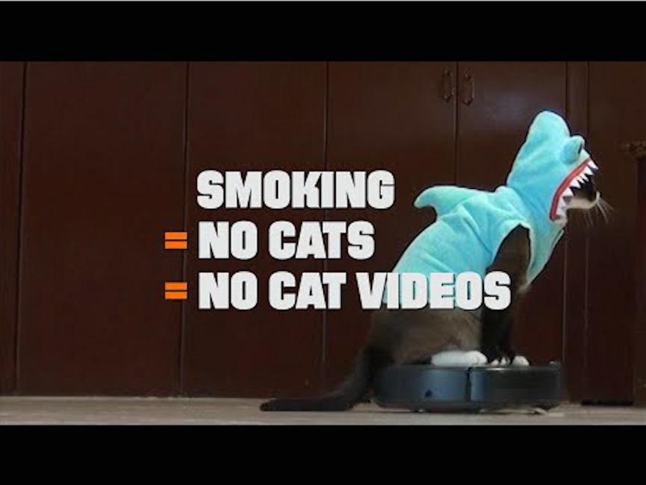
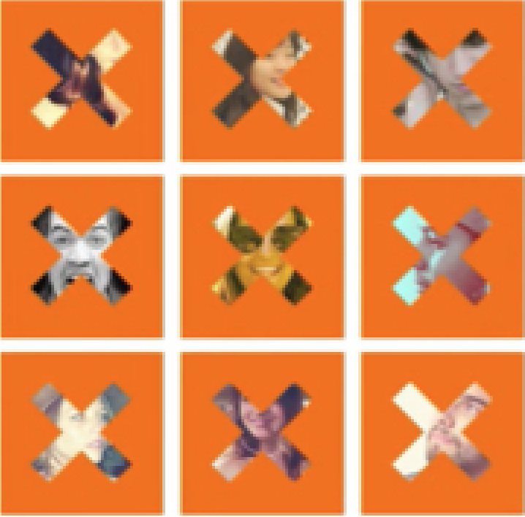

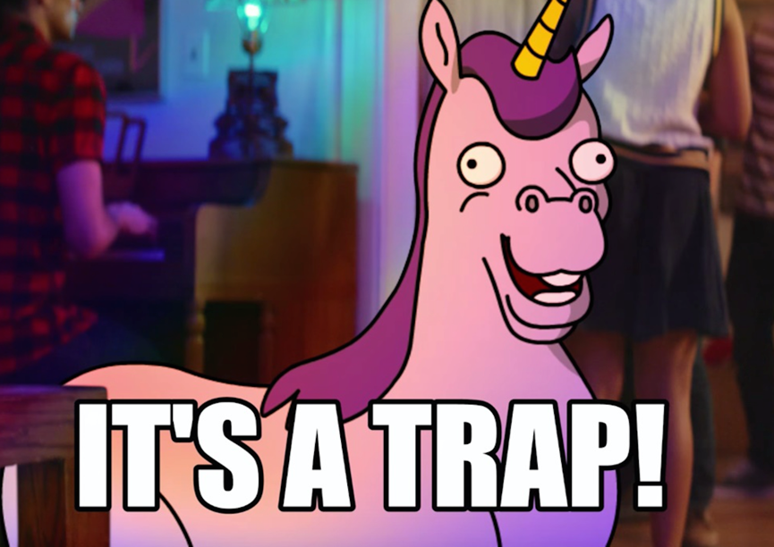
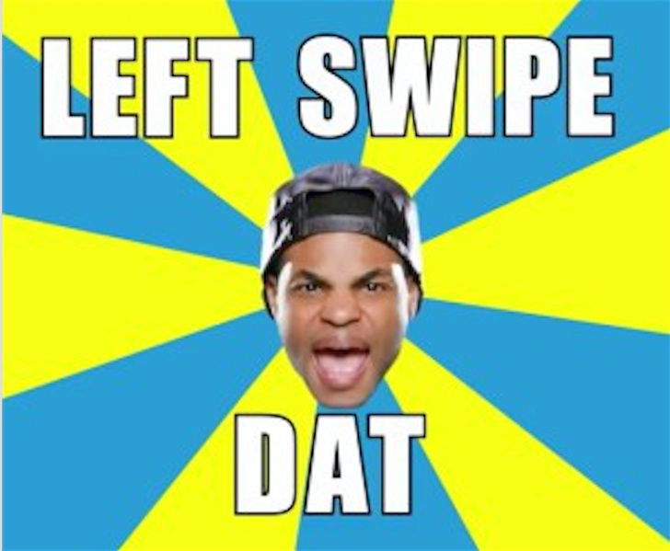

1 Yes
2 No
3 Not Sure
9 Prefer not to answer
ASK: All respondents
DISPLAY: FILL DATE will calculate the date 3 months prior to the current date.
_________________________________________________________________________

F8_3. In the past 3 months, that is since [FILL DATE], have you seen a The Real Cost campaign ad? Examples of some The Real Cost campaign ads are shown below.


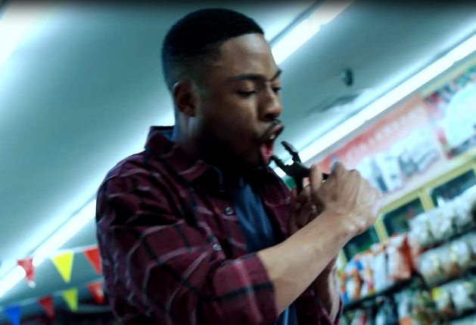
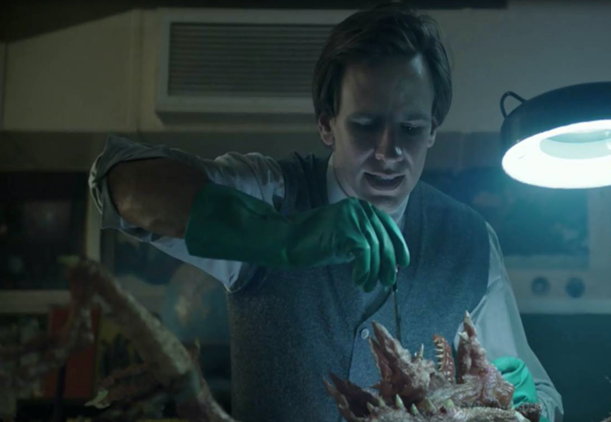

1 Yes
2 No
3 Not Sure
9 Prefer not to answer
ASK: All respondents
DISPLAY: FILL DATE will calculate the date 3 months prior to the current date.
_________________________________________________________________________

F8_4. In the past 3 months, that is since [FILL DATE], have you seen a Fresh Empire campaign ad? Examples of some Fresh Empire campaign ads are shown below.

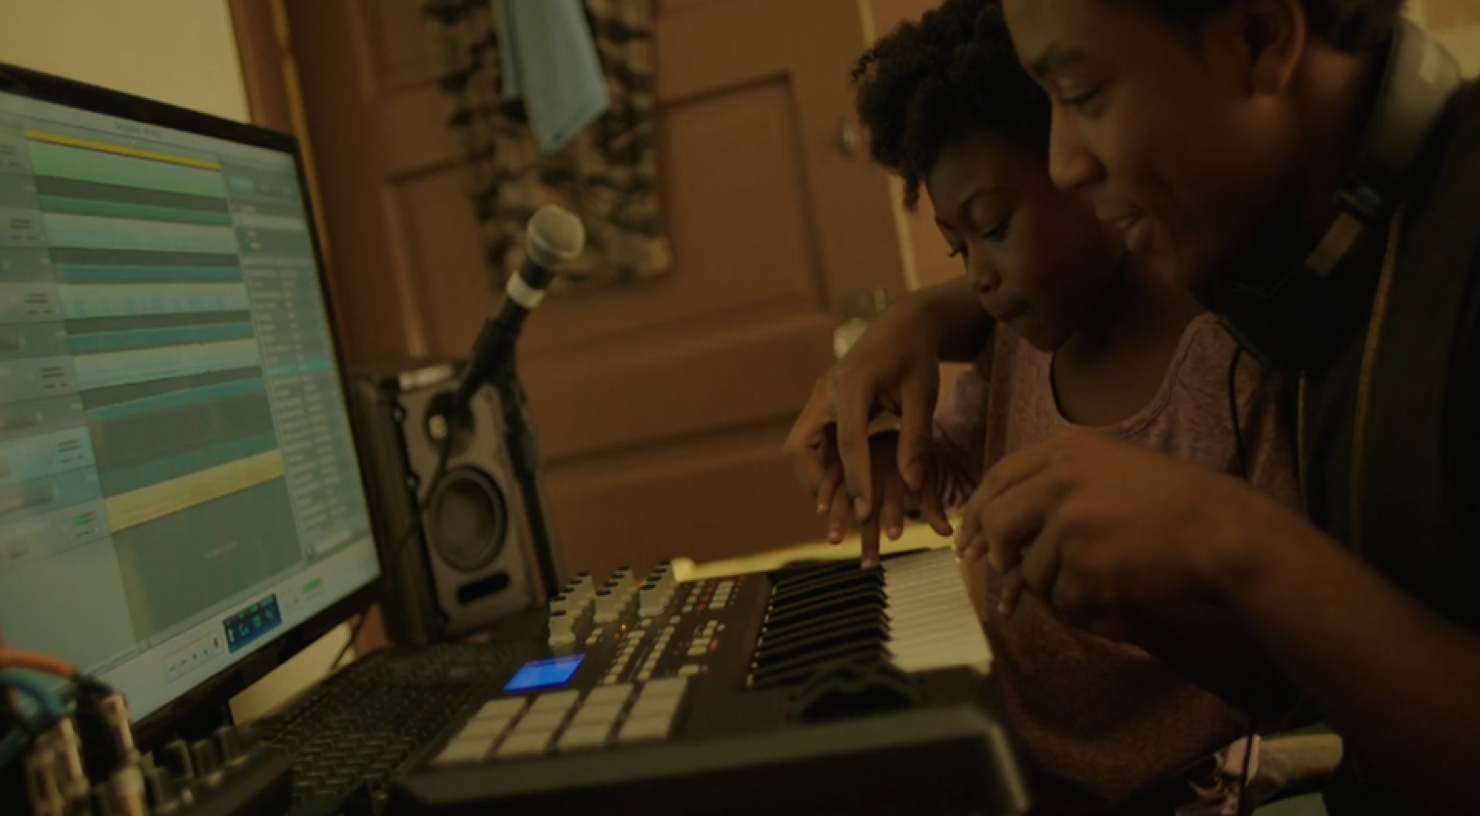

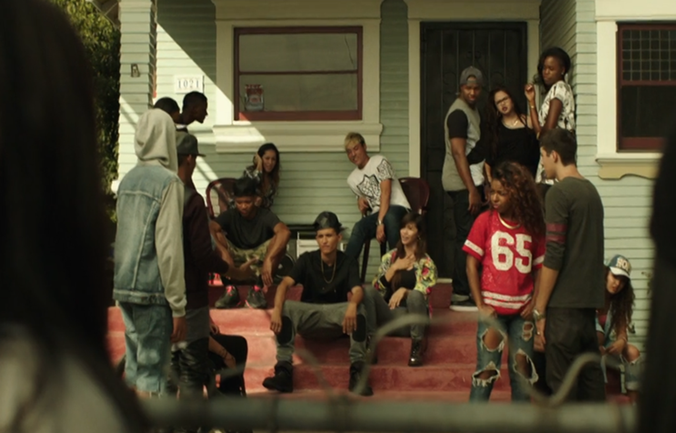
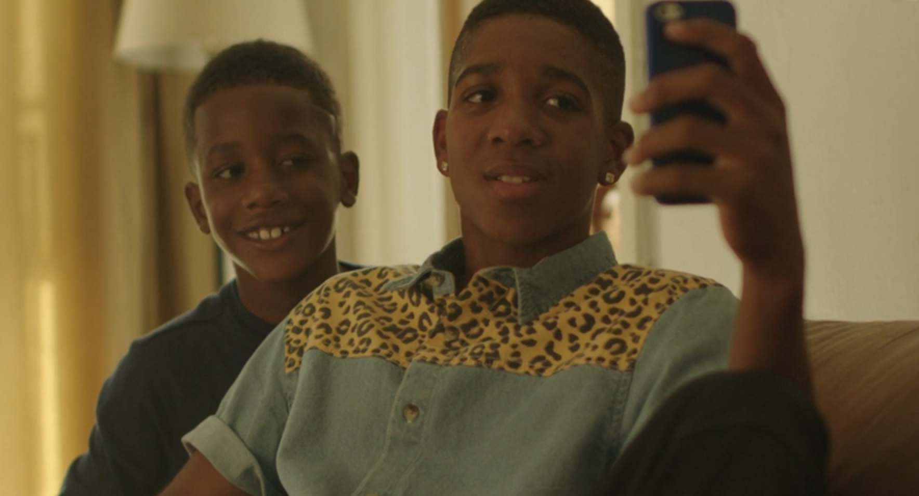

1 Yes
2 No
3 Not Sure
9 Prefer not to answer
ASK: All respondents
DISPLAY: FILL DATE will calculate the date 3 months prior to the current date.
_________________________________________________________________________
Channels of This Free Life Awareness
F9. [IF F7_3= 1 or 3]
Where have you seen or heard about This Free Life? Check all that apply.
PROGRAMMER: RANDOMIZE RESPONSE OPTIONS. KEEP ‘OTHER’ AND ‘PNTA’ AT THE END

- On TV
- On the Internet or anywhere online
- Billboards or other out-of-home ads (e. g., subways, bars, events)
- At an event
- Local LGBT magazines (e.g., NEXT magazine, Frontiers, Metro Weekly)
- National LGBT magazines (e.g., OUT Magazine, Curve, Original Plumbing)
- Some other place (please specify____________)
- Prefer not to answer
ASK: Respondents who have heard of This Free Life or are not sure
_________________________________________________________________________
F10. The This Free Life campaign is online. Have you ever seen This Free Life on… Check all that apply
[RANDOMIZE; ALL APPEAR ON SCREEN AT ONCE]
- Twitter?
- Instagram?
- Facebook?
- YouTube?
- Pandora?
- Tumblr?
- LGBT websites (e.g., Autostraddle, After Ellen, Queerty, Towleroad)?
- Other websites with LGBT content (e.g., Buzzfeed)?
- Dating websites or apps (e.g., OK Cupid, HER)?
- Other (please specify____________)?
- I have not seen the This Free Life campaign online
- Prefer not to answer
ASK: All respondents
_________________________________________________________________________
Events Awareness, Channel of Awareness
F11_1. In the past 3 months, that is since [FILL DATE], have you heard of an event in your area sponsored by, or associated with, This Free Life?

1 Yes
2 No
3 Not Sure
9 Prefer not to answer

ASK: All respondents
DISPLAY: FILL DATE will calculate the date 3 months prior to the current date.

_________________________________________________________________________
F12. [IF F11_1=1 OR 3 OR 9] How did you hear about the This Free Life event? Select all that apply.
1 Poster
2 Flyer or promotional materials
3 Email
4 Text message
5 Friend
6 Social media (Facebook, Instagram)
7 Local LGBT magazine
8 Other (please specify_______________)
9 Not sure
99 Prefer not to answer
ASK: Respondents who have either heard of This Free Life events, weren’t sure, or preferred not to answer

_________________________________________________________________________
Event Attendance and Reactions
F13_1. [IF F11_1=1 OR 3 OR 9] Have you ever attended an event sponsored by, or associated with This Free Life?
1 Yes
2 No
9 Prefer not to answer
ASK: Respondents who have either heard of This Free Life events, weren’t sure, or preferred not to answer

_________________________________________________________________________
F13_2. [IF F13_1=1 OR 9] How many events in your area sponsored by, or associated with, This Free Life have you attended in the past 3 months, that is since [FILL DATE]?
1 None
2 One
3 Two
4 Three
5 Four or more
9 Prefer not to answer
ASK: Respondents who have either attended a This Free Life event or preferred not to answer
DISPLAY: FILL DATE will calculate the date 3 months prior to the current date.

_________________________________________________________________________
_________________________________________________________________________
F15. [IF F13_1=1 OR 9] How much do you agree or disagree with the following statements?
 |  | Strongly Disagree | Disagree | Neither Agree or Disagree | Agree | Strongly Agree | Prefer Not to Answer
F15_1. | The event(s) was worth  remembering | 1 | 2 | 3 | 4 | 5 | 9
F15_2. | The event(s) grabbed my attention | 1 | 2 | 3 | 4 | 5 | 9
F15_3. | The event(s) was powerful | 1 | 2 | 3 | 4 | 5 | 9
F15_4. | The event(s) was informative | 1 | 2 | 3 | 4 | 5 | 9
F15_5. | The event(s) was meaningful to me | 1 | 2 | 3 | 4 | 5 | 9
F15_6. | The event(s) was convincing | 1 | 2 | 3 | 4 | 5 | 9

ASK: Respondents who have either attended a This Free Life event or preferred not to answer
_________________________________________________________________________
_________________________________________________________________________
Video Awareness
F11_2. In the past 3 months, that is since [FILL DATE], have you seen a This Free Life video online?
1 Yes
2 No
3 Not Sure
9 Prefer not to answer

ASK: All respondents
DISPLAY: FILL DATE will calculate the date 3 months prior to the current date.
_________________________________________________________________________
F17. Now we would like to show you some videos that have been shown in the U.S. Once you have viewed the video, please click on the forward arrow below to continue with the survey.
NEXT
ASK: All respondents
____________________________________________________________________________________
PROGRAMMER: RANDOMIZE BLOCKS OF QUESTIONS ABOUT EACH VIDEO (F18_1 – F23_1_h) AND [(F18_2 – F23_2_h) AND (F18_3 – F23_3_h)]. ALL RESPONDENTS RECEIVE ALL QUESTIONS.
_________________________________________________________________________
F18_1. PROGRAMMER: DISPLAY OUR STORY VIDEO
Apart from this survey, how frequently have you seen this video in the past 3 months, that is since [FILL DATE]?
PROGRAMMER: ALLOW ANSWER TO BE MADE ONLY AFTER VIDEO PLAYS FOR 15 SECONDS.
1 Never
2 Rarely
3 Sometimes
4 Often
5 Very Often
9 Prefer not to answer

ASK: All respondents
DISPLAY: FILL DATE will calculate the date 3 months prior to the current date.
_________________________________________________________________________
Reactions to Videos
F19_1. What is the main message of this video?
PROGRAMMER: RANDOMIZE RESPONSE OPTIONS KEEPING NOT SURE AND PNTA LAST
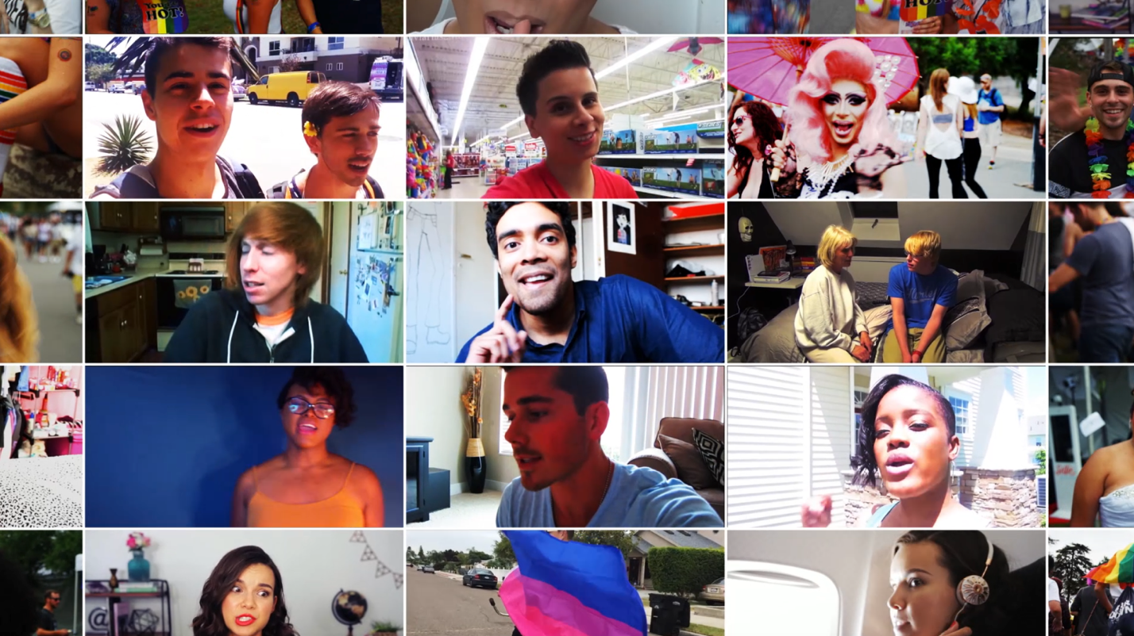

- Many LGBT lives are cut short by tobacco each year
- Tobacco gets in the way of your health and happiness
- Many LGBT people are proud to live tobacco free
- Life is better when you’re tobacco free
- You don’t need tobacco to express who you are
- Smoking tobacco puts poisons into your body
- 3 out of 4 people who start smoking as teens will continue smoking as adults

____________________________________________________________________________________
F18_2. PROGRAMMER: DISPLAY FLAWLESS VIDEO
Apart from this survey, how frequently have you seen this video in the past 3 months, that is since [FILL DATE]?
PROGRAMMER: ALLOW ANSWER TO BE MADE ONLY AFTER VIDEO PLAYS FOR 15 SECONDS.
1 Never
2 Rarely
3 Sometimes
4 Often
5 Very Often
9 Prefer not to answer
ASK: All respondents
DISPLAY: FILL DATE will calculate the date 3 months prior to the current date.
_________________________________________________________________________
F18a_2. To show us that you are paying attention, please select Never as your response to this item.
1 Never
2 Rarely
3 Sometimes
4 Often
5 Very Often
9 Prefer not to answer
ASK: All respondents
_________________________________________________________________________
Reactions to Videos
F19_2. What is the main message of this video?

PROGRAMMER: RANDOMIZE ORDER OF CHECKBOX LIST KEEPING NOT SURE AND PNTA LAST

- Smoking can hurt nearly every part of you
- Smoking tobacco messes with your appearance
- Tobacco gets in the way of your health and happiness
- You don’t need tobacco to express who you are
- Many LGBT lives are cut short by tobacco each year
- Carbon monoxide is a chemical found in both cigarette smoke and car exhaust
98 Not sure
99 Prefer not to answer

ASK: All respondents
_________________________________________________________________________
F21_2. How much do you agree or disagree with the following statements?
 |  | Strongly Disagree | Disagree | Neither Agree or Disagree | Agree | Strongly Agree | Prefer Not to Answer
F21_2_a | This video is worth remembering | 1 | 2 | 3 | 4 | 5 | 9
F21_2_b | This video grabbed my attention | 1 | 2 | 3 | 4 | 5 | 9
F21_2_c | This video is powerful | 1 | 2 | 3 | 4 | 5 | 9
F21_2_d | This video is informative | 1 | 2 | 3 | 4 | 5 | 9
F21_2_e | This video is meaningful to me | 1 | 2 | 3 | 4 | 5 | 9
F21_2_f | This video is convincing | 1 | 2 | 3 | 4 | 5 | 9
F21_2_g | This video is terrible | 1 | 2 | 3 | 4 | 5 | 9
F21_2_h | This video told me things I never knew before about tobacco | 1 | 2 | 3 | 4 | 5 | 9
F21_2_i | This video gave me good reasons not to smoke cigarettes | 1 | 2 | 3 | 4 | 5 | 9
F21_2_j | This video gave me good reasons not to use tobacco | 1 | 2 | 3 | 4 | 5 | 9

ASK: All respondents
_________________________________________________________________________

F22_2_a.
On a scale of 1 to 5, indicate whether the video made using tobacco look like something you would or wouldn’t want to do.
1 The video makes me want to use tobacco
2
3
4
5 The video makes me want to not use tobacco
9 Prefer not to answer

ASK: All respondents
_________________________________________________________________________

_________________________________________________________________________

F23_2. On scale of 1 to 5, where 1 means “not at all” and 5 means “very”, please indicate how much this video made you feel…
 | 1 Not at all | 2 | 3 | 4 | 5 Very | Prefer not to answer
F23_2_a. Afraid | 1 | 2 | 3 | 4 | 5 | 9
F23_2_b. Irritated | 1 | 2 | 3 | 4 | 5 | 9
F23_2_c. Understood | 1 | 2 | 3 | 4 | 5 | 9
F23_2_d. Uneasy | 1 | 2 | 3 | 4 | 5 | 9
F23_2_e. Happy | 1 | 2 | 3 | 4 | 5 | 9
F23_2_f. Accepted | 1 | 2 | 3 | 4 | 5 | 9
F23_2_g. Inspired | 1 | 2 | 3 | 4 | 5 | 9
F23_2_h. Confident | 1 | 2 | 3 | 4 | 5 | 9

ASK: All respondents
_________________________________________________________________________

F18_3. PROGRAMMER: DISPLAY TIP THE SCALE VIDEO
SHOW FEMALE VIDEO IF Z3= 2 OR 4 AND Z6= 1 OR 3; IF A3= 2 OR 4 AND A6= 1 OR 3; ELSE RANDOMLY ASSIGN TO SEE EITHER MALE OR FEMALE VIDEO
SHOW MALE VIDEO IF Z3= 1 OR 3 AND Z5= 1 OR 3; IF A3= 1 OR 3 AND A5= 1 OR 3; ELSE RANDOMLY ASSIGN TO SEE EITHER MALE OR FEMALE VIDEO
Apart from this survey, how frequently have you seen this video in the past 3 months, that is since [FILL DATE]?
PROGRAMMER: ALLOW ANSWER TO BE MADE ONLY AFTER VIDEO PLAY FOR 15 SECONDS.
1 Never
2 Rarely
3 Sometimes
4 Often
5 Very Often
9 Prefer not to answer
ASK: All respondents. Respondents who identify as male will see the video featuring male characters while respondents who identify as female will see the video featuring female characters. Sexual minorities will be randomized to either version of the video.
DISPLAY: FILL DATE will calculate the date 3 months prior to the current date.
________________________________________________________________________
_____________________________________________________________________________________
Reactions to Videos
F19_3. What is the main message of this video?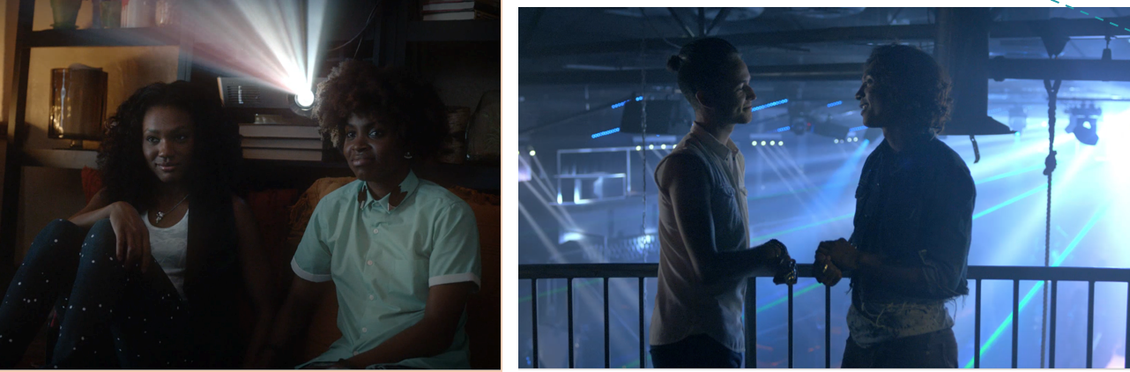
PROGRAMMER: RANDOMIZE ORDER OF CHECKBOX LIST KEEPING NOT SURE AND PNTA LAST

- Tobacco gets in the way of your health and happiness
- Life is better when you’re tobacco free
- Many LGBT people are proud to live tobacco free
- You don’t need tobacco to express who you are
- Even casual smoking can do you damage
- Smoking tobacco puts poisons into your body
98 Not sure
99 Prefer not to answer
ASK: All respondents
_________________________________________________________________________

F21_3. How much do you agree or disagree with the following statements?
 |  | Strongly Disagree | Disagree |  | Neither Agree or Disagree | Agree | Strongly Agree | Prefer Not to Answer
F21_3_a | This video is worth  remembering | 1 |  | 2 | 3 | 4 | 5 | 9
F21_3_b | This video grabbed my attention | 1 |  | 2 | 3 | 4 | 5 | 9
F21_3_c | This video is powerful | 1 |  | 2 | 3 | 4 | 5 | 9
F21_3_d | This video is informative | 1 |  | 2 | 3 | 4 | 5 | 9
F21_3_e | This video is meaningful to me | 1 |  | 2 | 3 | 4 | 5 | 9
F21_3_f | This video is convincing | 1 |  | 2 | 3 | 4 | 5 | 9
F21_3_g | This video is terrible | 1 |  | 2 | 3 | 4 | 5 | 9
F21_3_h | This video told me things I never knew before about tobacco | 1 |  | 2 | 3 | 4 | 5 | 9
F21_3_i | This video gave me good reasons not to smoke cigarettes | 1 |  | 2 | 3 | 4 | 5 | 9
F21_3_j | This video gave me good reasons not to use tobacco | 1 |  | 2 | 3 | 4 | 5 | 9
ASK: All respondents
_________________________________________________________________________

F22_3_a.
On a scale of 1 to 5, indicate whether the video made using tobacco look like something you would or wouldn’t want to do.
1 The video makes me want to use tobacco
2
3
4
5 The video makes me want to not use tobacco
9 Prefer not to answer
ASK: All respondents
_________________________________________________________________________

_________________________________________________________________________

F23_3.
On scale of 1 to 5, where 1 means “not at all” and 5 means “very”, please indicate how much this video made you feel…
 | 1 Not at all | 2 | 3 | 4 | 5 Very | Prefer not to answer
F23_3_a. Afraid | 1 | 2 | 3 | 4 | 5 | 9
F23_3_b. Irritated | 1 | 2 | 3 | 4 | 5 | 9
F23_3_c. Understood | 1 | 2 | 3 | 4 | 5 | 9
F23_3_d. Uneasy | 1 | 2 | 3 | 4 | 5 | 9
F23_3_e. Happy | 1 | 2 | 3 | 4 | 5 | 9
F23_3_f. Accepted | 1 | 2 | 3 | 4 | 5 | 9
F23_3_g. Inspired | 1 | 2 | 3 | 4 | 5 | 9
F23_3_h. Confident | 1 | 2 | 3 | 4 | 5 | 9

ASK: All respondents
_________________________________________________________________________

Streaming Radio Awareness

F24. In the past 3 months, that is since [FILL DATE], have you heard about This Free Life on Pandora, Spotify, or other streaming radio service?
1 Yes
2 No
3 Not Sure
9 Prefer not to answer
ASK: All respondents
DISPLAY: FILL DATE will calculate the date 3 months prior to the current date.
_________________________________________________________________________
F25. Now we would like to play you some radio clips that have aired in the U.S.
NEXT
ASK: All respondents
_________________________________________________________________________
PROGRAMMER: RANDOMIZE PRESENTATION OF CLIPS AND F25_A AND F25_B. ALLOW ANSWER TO BE RECORDED AFTER 10 SECONDS OF PLAY TIME
_____________________________________________________________________________________
F25_a. PLAY FLAWLESS CLIP. Apart from this survey, how frequently have you heard this on the radio in the past 3 months, that is since [FILL DATE]?

1 Never
2 Rarely
3 Sometimes
4 Often
5 Very Often
9 Prefer not to answer
ASK: All respondents
DISPLAY: FILL DATE will calculate the date 3 months prior to the current date.
_________________________________________________________________________
F25_b. [PLAY FLAWLESS NAIL CLIP] Apart from this survey, how frequently have you heard this on the radio in the past 3 months, that is since [FILL DATE]?

1 Never
2 Rarely
3 Sometimes
4 Often
5 Very Often
9 Prefer not to answer
ASK: All respondents
DISPLAY: FILL DATE will calculate the date 3 months prior to the current date.
_________________________________________________________________________
Digital Content Awareness
F26a. Now we would like to show you some digital content that you may have seen online.

Apart from this survey, have you seen this content online in the past 3 months, that is since [FILL DATE]?

1 Yes
2 No
3 Not Sure
9 Prefer not to answer

ASK: All respondents
DISPLAY: FILL DATE will calculate the date 3 months prior to the current date.
_________________________________________________________________________

F27b. [IF F26a=1 OR3 OR 9]

How frequently have you seen this content online in the past 3 months, that is since [FILL DATE]?

1 Never
2 Rarely
3 Sometimes
4 Often
5 Very Often
9 Prefer not to answer

ASK: Respondents who have seen the online content in the past 3 months, or those who are not sure or who preferred not to answer
DISPLAY: FILL DATE will calculate the date 3 months prior to the current date.
_________________________________________________________________________
Promotional Materials Awareness

F28a. Now we would like to show you some materials that have been circulating in some cities in the U.S.
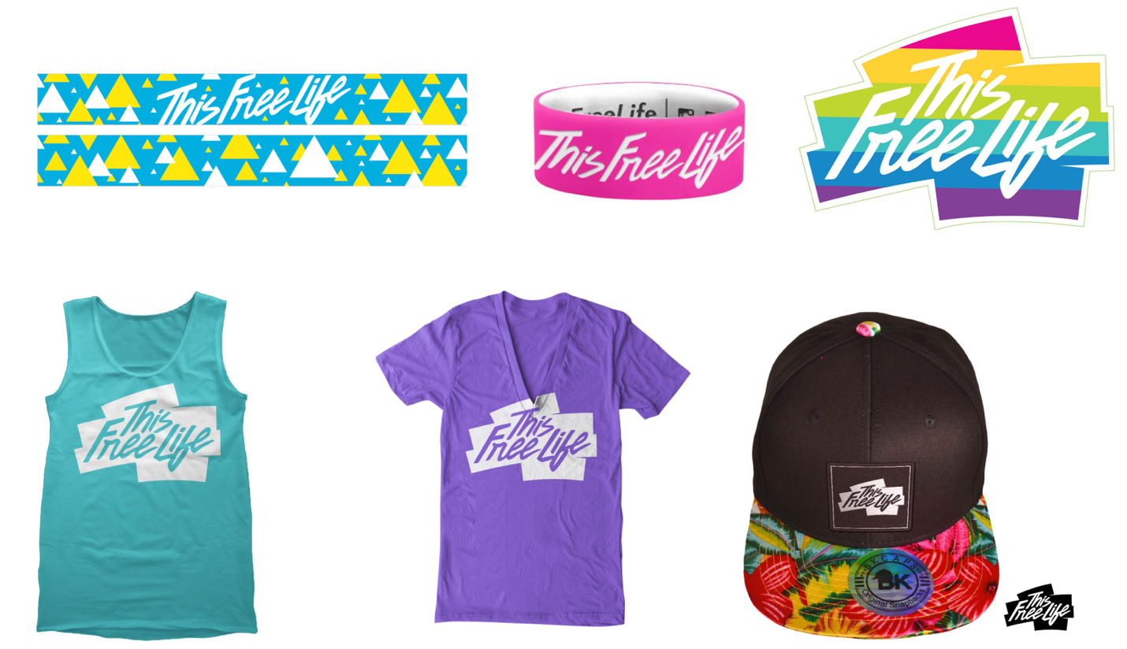
Apart from this survey, have you seen materials like this in the past 3 months, that is since [FILL DATE]?

1 Yes
2 No
3 Not Sure
9 Prefer not to answer
ASK: All respondents
DISPLAY: FILL DATE will calculate the date 3 months prior to the current date.
_________________________________________________________________________
F28b. [IF F28a=1 OR 3 OR 9] How frequently have you seen materials like this in the past 3 months, that is since [FILL DATE]?
1 Never
2 Rarely
3 Sometimes
4 Often
5 Very Often
9 Prefer not to answer

ASK: Respondents who have seen the promotional materials in the past 3 months, or those who are not sure or who preferred not to answer
DISPLAY: FILL DATE will calculate the date 3 months prior to the current date.
_________________________________________________________________________
Brand Equity
F29. [IF F7_3 = 1 OR 3 OR 9]
How much do you agree or disagree with the following statements about This Free Life?
[RANDOMIZE F29_1- F29_3]
 |  | Strongly Disagree | Disagree | Neither Agree or Disagree | Agree | Strongly Agree | Prefer Not to Answer
F29_1 | I want to help promote This Free Life | 1 | 2 | 3 | 4 | 5 | 9
F29_2 | I’d defend This Free Life if someone was making fun of it | 1 | 2 | 3 | 4 | 5 | 9
F29_3 | I’d wear a This Free Life T-shirt | 1 | 2 | 3 | 4 | 5 | 9
ASK: Respondents who have heard of This Free Life, or those who are not sure or who preferred not to answer
_________________________________________________________________________
PROGRAMMER: RANDOMIZE ITEMS BELOW WITH F29_5/ F29_6 ASKED TOGETHER IN THAT ORDER

 |  | Strongly Disagree | Disagree | Neither Agree or Disagree | Agree | Strongly Agree | Prefer Not to Answer
F29_4. | I talk to my friends about This Free Life | 1 | 2 | 3 | 4 | 5 | 9
F29_5. | If I had the chance, I would tell people I know to watch This Free Life videos | 1 | 2 | 3 | 4 | 5 | 9
F29_6. | If I had the chance, I would tell people I know to check out This Free Life at events | 1 | 2 | 3 | 4 | 5 | 9
F29_7. | If I see anything from This Free Life, I check it out | 1 | 2 | 3 | 4 | 5 | 9
ASK: Respondents who have heard of This Free Life, or those who are not sure or who preferred not to answer
_________________________________________________________________________
PROGRAMMER: RANDOMIZE ITEMS BELOW WITH F29_10/ F29_11 AND F29_12/ F29_13 ASKED TOGETHER IN THAT ORDER

 |  | Strongly Disagree | Disagree | Neither Agree or Disagree | Agree | Strongly Agree | Prefer Not to Answer
F29_8. | This Free Life is popular with people like me | 1 | 2 | 3 | 4 | 5 | 9
F29_9. | People are talking about This Free Life | 1 | 2 | 3 | 4 | 5 | 9
F29_10. | This Free Life videos are becoming more popular with the people who hang out where I hang out | 1 | 2 | 3 | 4 | 5 | 9
F29_11. | Checking out This Free Life at events is becoming more popular with the people who hang out where I hang out | 1 | 2 | 3 | 4 | 5 | 9
F29_12. | This Free Life videos are for people like me | 1 | 2 | 3 | 4 | 5 | 9
F29_13. | This Free Life events are for people like me | 1 | 2 | 3 | 4 | 5 | 9
ASK: Respondents who have heard of This Free Life, or those who are not sure or who preferred not to answer
_________________________________________________________________________
F30. [IF F7_3 = 1 OR 3 OR 9]
To what extent do you agree that each of the traits or statements listed below describe This Free Life?
PROGRAMMER: RANDOMIZE RESPONSE OPTIONS
 |  | Strongly Disagree | Disagree | Neither Agree or Disagree | Agree | Strongly Agree | Prefer Not to Answer
F30_1. | Trendsetting | 1 | 2 | 3 | 4 | 5 | 9
F30_2. | Motivating | 1 | 2 | 3 | 4 | 5 | 9
F30_3. | Confident | 1 | 2 | 3 | 4 | 5 | 9
F30_4. | Outgoing | 1 | 2 | 3 | 4 | 5 | 9
F30_5. | Hosts the best parties | 1 | 2 | 3 | 4 | 5 | 9
F30_6. | Always looks good | 1 | 2 | 3 | 4 | 5 | 9
ASK: Respondents who have heard of This Free Life, or those who are not sure or who preferred not to answer
_________________________________________________________________________

F31. [IF F7_3 = 1 OR 3 OR 9]
How much do you agree or disagree with the following statements?
When I think of This Free Life, I think…

 |  | Strongly Disagree | Disagree | Neither Agree or Disagree | Agree | Strongly Agree | Prefer Not to Answer
F31_1 | I have the freedom to be tobacco-free | 1 | 2 | 3 | 4 | 5 | 9
F31_2 | Using tobacco can undo some of the progress I have made | 1 | 2 | 3 | 4 | 5 | 9
F31_3 | Tobacco use is not attractive | 1 | 2 | 3 | 4 | 5 | 9
ASK: Respondents who have heard of This Free Life, or those who are not sure or who preferred not to answer
_________________________________________________________________________

Section G: Environment
G1. The next section asks some questions about your household and peers.
Other than you, has anyone who lives with you used any of the following during the past 30 days? Check all that apply.
1 Cigarettes
2 Cigars, cigarillos, or little cigars such as Swisher Sweets, White Owl, Cheyenne, Dutch Masters, Garcia Y Vega or Middleton’s
3 Tobacco out of a water pipe (also called “hookah”)
4 No, no one who lives with me has used any form of tobacco during the past 30 days
9 Prefer not to answer

PROGRAMMER: DO NOT ALLOW A RESPONSE OF 4 IN COMBINATION WITH OTHER RESPONSES.
ASK: All respondents

_________________________________________________________________________

G2. How often do you attend church or religious services? Would you say…
1 Never
2 Less than once a month
3 About once a month
4 About 2 or 3 times a month
5 Once a week
6 More than once a week
9 Prefer not to answer

ASK: All respondents
_________________________________________________________________________

G3. Please tell us if you strongly disagree, disagree, neither agree nor disagree, agree, or strongly agree with the following statements.
I would like to explore strange places. Would you say you…
1 Strongly Disagree
2 Disagree
3 Neither agree nor disagree
4 Agree
5 Strongly Agree
9 Prefer not to answer
ASK: All respondents
_________________________________________________________________________

G4. I like to do frightening things. Would you say you…
1 Strongly Disagree
2 Disagree
3 Neither agree nor disagree
4 Agree
5 Strongly Agree
9 Prefer not to answer
ASK: All respondents
_________________________________________________________________________
G5. I like new and exciting experiences, even if I have to break the rules. Would you say you…
1 Strongly Disagree
2 Disagree
3 Neither agree nor disagree
4 Agree
5 Strongly Agree
9 Prefer not to answer
ASK: All respondents
_________________________________________________________________________
G6. I prefer friends who are exciting and unpredictable. Would you say you…
1 Strongly Disagree
2 Disagree
3 Neither agree nor disagree
4 Agree
5 Strongly Agree
9 Prefer not to answer
ASK: All respondents
_________________________________________________________________________

G7. Thinking about your mental health, which includes stress, depression, and problems with emotions, for how many days during the past 30 days was your mental health not good?
_____ Number of days (Range: 1-30)

₂ None
₃ Don’t know
₉ Prefer not to answer
ASK: All respondents
_________________________________________________________________________

G8. In the last month, how often have you…
 |  | Never | Almost Never | Sometimes | Fairly often | Very often | Prefer not to answer
G8_1 | Felt that you were unable to control the important things in your life? | 1 | 2 | 3 | 4 | 5 | 9
G8_2 | Felt confident about your ability to handle your personal problems? | 1 | 2 | 3 | 4 | 5 | 9
G8_3 | Felt that things were going your way? | 1 | 2 | 3 | 4 | 5 | 9
G8_4 | Felt difficulties were piling up so high that you could not overcome them? | 1 | 2 | 3 | 4 | 5 | 9

ASK: All respondents
_________________________________________________________________________

Section H: LGBT Identity and Community
Discrimination
H1. Have you ever experienced discrimination, been prevented from doing something, or been hassled or made to feel inferior in any of the following seven situations because of your sexual identity (lesbian, gay, bisexual, transgender)?
 |  | Yes | No | Prefer not to answer
H1_1. | In your family | 1 | 2 | 9
H1_2. | At school | 1 | 2 | 9
H1_3. | Getting a job | 1 | 2 | 9
H1_4. | At work | 1 | 2 | 9
H1_5. | At home | 1 | 2 | 9
H1_6. | Getting medical care | 1 | 2 | 9
H1_7 | On the street or in a public setting | 1 | 2 | 9
ASK: All respondents
_________________________________________________________________________

LGBT Community Involvement
H2_1. Have you ever attended an LGBT pride event?
1 Yes
2 No
9 Prefer not to answer
ASK: All respondents
________________________________________________________________________

H2_2. [IF H2_1= 1]
Have you attended an LGBT pride event in the past 12 months?
1 Yes
2 No
9 Prefer not to answer

ASK: Respondents who have attended an LGBT pride event
_________________________________________________________________________
LGBT Identity Development
H3. For each of the following questions, please mark the response that best indicates your current experience as an LGBT person. Please be as honest as possible. Indicate how you really feel now, not how you think you should feel. There is no need to think too much about any one question. Answer each question according to your initial reaction and then move on to the next.
 |  | Strongly Disagree | Disagree | Neither Agree or Disagree | Agree | Strongly Agree | Prefer Not to Answer
H3_1 | I am glad to be an LGBT person. | 1 | 2 | 3 | 4 | 5 | 9
H3_2 | My sexual identity is an insignificant part of who I am. | 1 | 2 | 3 | 4 | 5 | 9
H3_3 | I’m proud to be part of the LGBT community. | 1 | 2 | 3 | 4 | 5 | 9
H3_4 | My sexual identity is a central part of my identity. | 1 | 2 | 3 | 4 | 5 | 9
H3_5 | To understand who I am as a person, you have to know that I’m LGBT. | 1 | 2 | 3 | 4 | 5 | 9
H3_6 | Being an LGBT person is a very important aspect of my life. | 1 | 2 | 3 | 4 | 5 | 9
H3_7 | I believe being LGBT is an important part of me. | 1 | 2 | 3 | 4 | 5 | 9
H3_8 | I am proud to be LGBT. | 1 | 2 | 3 | 4 | 5 | 9
H3_9 | I feel part of the LGBT community. | 1 | 2 | 3 | 4 | 5 | 9
H3_10 | I feel accepted by the LGBT community. | 1 | 2 | 3 | 4 | 5 | 9
ASK: All respondents

PROGRAMMER: CALCULATE A VARIABLE CALLED COMPELTED THAT EQUALS 1 ONCE A RESPONDENT ANSWERS H3_10. ELSE VARIABLE EQUALS 0.
_________________________________________________________________________
WEBTH Within 2 business days, we will send an email containing information about how to access and redeem your digital gift card. This information must be sent via email to the email address you supplied before starting this survey. Check your spam, junk or clutter folder(s) if you don’t see our email in your email inbox.

NEXT
ASK: All respondents

_________________________________________________________________________

RECON Thank you for your responses! We will be conducting additional rounds of this survey. The next round will take place in about 6 months. At that time, we may contact you to participate. Your participation in these next rounds is really important so that we can measure what has changed over time. Should we contact you, you will be able to decide if you want to take part in the survey at that time, and you can change your mind at any point.

NEXT
ASK: All respondents

_________________________________________________________________________
END Thank you for taking time to complete this survey. You may close this window now.

OMB No: 0910-0808 Expiration Date: 01/31/2019
Paperwork Reduction Act Statement: The public reporting burden for this collection of information has been estimated to average 30 minutes per response. Send comments regarding this burden estimate or any other aspects of this collection of information, including suggestions for reducing burden to PRAStaff@fda.hhs.gov.

