One Health Harmful Algal Bloom System (OHHABS) Case and Event Definitions

Figure 1. Association of the Environmental Form, the Human Form(s), and Animal Form(s) in an OHHABS Report.
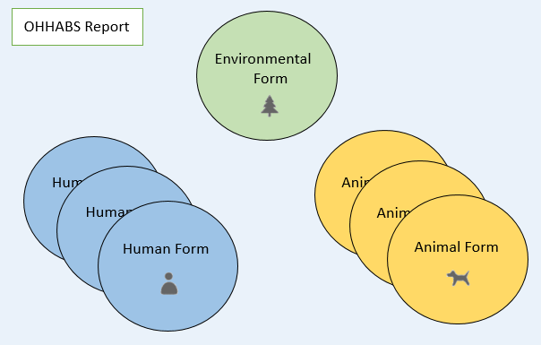

Table 1. Definition of a HAB event
Definition | Criteria
HAB Event | Laboratory-based HAB data¹ | Observational or environmental data² | Associated illness
- Suspect |  | Required to have 1
- Confirmed | Required
- Confirmed |  | Required | Required
¹ Laboratory detection (e.g. microscopic confirmation or DNA analyses) of cyanobacteria, other potentially toxin-producing algae, or algal/cyanobacterial toxins in a water body or finished drinking water supply
² Observational (e.g. scum, algae, water color change, sheen, photographic evidence, satellite data) or environmental (e.g. pH, chlorophyll, nutrient levels) data from a water body to support the presence of an algal bloom

Blue shaded cells: you must have at least one of the criteria described in the shaded cell.
Table 2. Definition of a HAB-related Human Case
Definition | Criteria
HAB-related Human Case | Exposure¹ | Signs/ symptoms² | Public health assessment³ | Professional medical diagnosis⁴ | Other causes of illness ruled out | Observational or environmental data⁵ | Laboratory- based HAB data⁶ | Clinical data⁷
- Suspect | Required | Required | Required
- Probable | Required | Required | Required |  |  | Required to have 1
- Probable | Required | Required | Required | Required | +/- | +/- | +/-
- Confirmed | Required | Required | Required | Required to have 1 |  | +/- | +/- | Required
- Confirmed | Required | Required | Required | Required | Required |  | Required
¹ Exposure (i.e. physical contact, inhalation, ingestion) to water, algae, or seafood, dietary supplements
² Self-reported signs/symptoms after exposure
³ Public health assessment is defined as the action of compiling all data available and deciding that the illness in question is likely HAB-related
⁴ Professional medical diagnosis being provided by a medical practitioner (e.g. doctor, nurse, physician assistant) based on his or her medical assessment of the patient’s symptoms, medical history, exposure, etc.
⁵ Observational (e.g. scum, algae, water color change, sheen, photographic evidence, satellite data) or environmental (e.g. pH, chlorophyll, nutrient levels) data from a water body to supporting the presence of an algal bloom
⁶ Laboratory detection of cyanobacteria or other potentially toxin-producing algae, (e.g. microscopic confirmation or DNA analyses) or algal/cyanobacterial toxins (e.g. bioassay, HPLC) in a water body, finished drinking water supply, seafood or dietary supplements
⁷ Laboratory documentation of cyanobacteria, other potentially toxin-producing algae, or algal/cyanobacterial toxins in a clinical specimen

Blue shaded cells: you must have at least one of the criteria described in the shaded cell.
+/-: indicates that this criteria is optional and while it strengthens the case, but it does not change case classification (e.g. suspect to probable, probable to confirmed).

Table 3. Definition of an HAB-related Animal Case
Definition | Criteria
HAB-related Animal Case | Exposure¹ | Signs² | Public Health Assessment³ | Professional medical diagnosis | Other causes of illness ruled out | Observational or environmental data⁵ | Laboratory- based HAB data⁶ | Clinical data⁷
- Suspect | Required | Required | Required
- Probable | Required | Required | Required |  |  | Required to have 1
- Probable | Required | Required | Required | Required | +/- | +/- | +/-
- Confirmed | Required | Required | Required | Required to have 1 |  | +/- | +/- | Required
- Confirmed | Required | Required | Required | Required | Required |  | Required
¹ Exposure (i.e. physical contact, inhalation, ingestion) to water, algae or other dietary HAB sources. This includes undocumented exposures that are suspected based on temporal or spatial factors (e.g., proximity of carcass to a body of water that is experiencing a bloom) or an animal’s opportunity for exposure due to biological, behavioral, or other relevant factors (e.g. natural habitat of the animal is near or in the body of water, penned livestock’s only source of drinking water, etc.).
² Reported signs after exposure, including the outcome of death prior to discovery.
³ Public health assessment is defined as the action of compiling all data available and deciding that the illness in question is likely HAB-related. Assessments may also be completed by qualified non-public health entities (e.g., fish and wildlife staff, university researchers) that have been identified by State or Federal agency partners.
⁴ Professional medical diagnosis being provided by a medical practitioner (e.g. veterinarian) based on his or her medical assessment of the animal(s)’s signs, medical history, likelihood of exposure, etc.
⁵Observational (e.g. scum, algae, water color change, sheen, photographic evidence, satellite data) or environmental (e.g. pH, chlorophyll, nutrient levels) data from a water body to identify an algal bloom
Laboratory detection of cyanobacteria or other potentially toxin-producing algae, (e.g. microscopic confirmation or DNA analyses) or algal/cyanobacterial toxins (e.g. bioassay, HPLC) in a water body, finished drinking water supply, or animal dietary sources
⁷Laboratory documentation of cyanobacteria, other potentially toxin-producing algae, or algal/cyanobacterial toxins in a clinical specimen

Blue shaded cells: you must have at least one of the criteria described in the shaded cell.
+/-: indicates that this criteria is optional and while it strengthens the case, but it does not change case classification (e.g. suspect to probable, probable to confirmed).

