## 5.8 PHS 398 Inclusion Enrollment Report

**NOTE: These report formats should NOT be used for collecting data from study participants. To ensure proper performance, please save frequently.**

See below for the form description and please refer to Part II (Supplemental Instructions for Preparing the Protection of Human Subjects Section of the Research Plan) for additional guidance on how and when to use the PHS 398 Inclusion Enrollment report form.

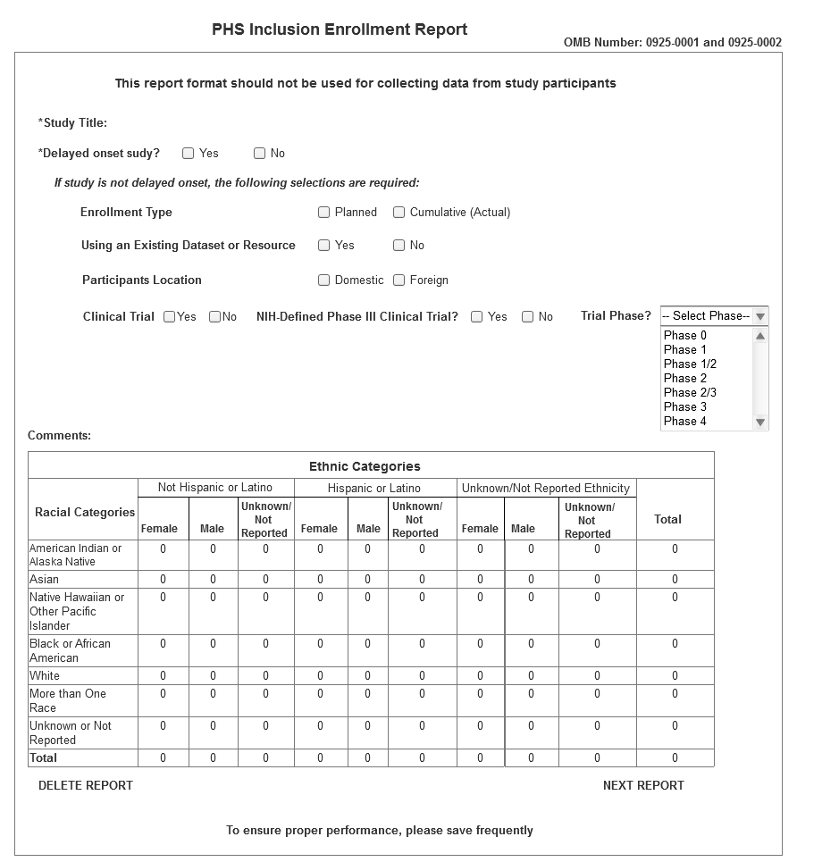

| Field Name | Instructions |
| --- | --- |
| Study Title | Enter a unique title that describes the study that the participants will be involved in. The title should be the same as submitted on the original Planned Enrollment form for this study. Follow the instructions provided in the Application Guide and the FOA regarding the Inclusion of Women and Minorities. Maximum 250 characters. This is a required field. |
| Delayed onset study? | Select whether the study is considered delayed onset. This generally means that a study has not been developed and cannot be described in terms of human subjects’ protections and inclusion. This does NOT apply to a study that can be described but will not start immediately. Additional guidance on whether a study meets the criteria to be considered delayed onset can be found in Section 2, Scenario D of the [Part II (Supplemental Instructions for Preparing the Protection of Human Subjects Section of the Research Plan)](http://grants.nih.gov/grants/funding/424/SupplementalInstructions.pdf#part_ii_supplemental_instruct). If the study is delayed onset, select YES. If the study is not delayed onset, select NO. This is a required field. |
| Enrollment Type | Select whether the table reflects Planned Enrollment of individuals to be recruited into the study or Cumulative (e.g., actual) Enrollment for 1) participants already recruited into the study or 2) studies using an existing dataset or resource. This is a required field. |
| Using an existing dataset or resource? | Select whether this study involves use of an existing dataset or resource. This generally means that investigators are utilizing data from a previous study or data bank. Do NOT answer Yes for individuals previously recruited specifically for this study. For additional guidance on what is considered an existing dataset refer to [Part II, Section 4.2 (Supplemental Instructions for Preparing the Protection of Human Subjects Section of the Research Plan)](http://grants.nih.gov/grants/funding/424/SupplementalInstructions.pdf#part_ii_supplemental_instruct) and this [FAQ](http://grants.nih.gov/grants/funding/women_min/datasets_faq.htm). This is a required field. |
| Domestic/Foreign | Select whether the participants described in the inclusion enrollment report are based at a US or non-US site. At a minimum, participants at US and non-US sites must be reported separately even if for the same study. For additional guidance on what is considered an existing dataset refer to [Part II (Supplemental Instructions for Preparing the Protection of Human Subjects Section of the Research Plan)](http://grants.nih.gov/grants/funding/424/SupplementalInstructions.pdf#part_ii_supplemental_instruct) and this [FAQ](http://grants.nih.gov/grants/funding/women_min/nonus.htm). This is a required field. |
| Clinical Trial | Select whether the study these participants are involved in is considered a clinical trial. This is a required field. |
| Agency-Defined Phase III Clinical Trial | Select whether the study is an agency-defined Phase III clinical trial. This is a required field. |
| Clinical Trial Phase | If this study is considered a [clinical trial](http://grants.nih.gov/grants/funding/424/SupplementalInstructions.pdf#3_definitions), select what Phase is most appropriate. The choices are the same as those available in <Clinicaltrials.gov>. This is a required field. |
| Comments | Enter information you wish to provide about this Cumulative Inclusion Enrollment Report. This includes but is not limited to information if distinctive subpopulations are relevant to the scientific hypotheses being studied. Maximum 500 characters. |
| American Indian/Alaska Native | Enter the number of females, males, and individuals of unknown/not reported sex/gender (in the respective fields) who are American Indian/Alaska Native and Not Hispanic or Latino, and; enter the number of females, males, and individuals of unknown/not reported sex/gender (in the respective fields) who are American Indian/Alaska Native and Hispanic or Latino; and enter the number of females, males, and individuals of unknown/not reported sex/gender (in the respective fields) who are American Indian/Alaska Native and of unknown/not reported ethnicity. Unknown/not reported fields will only be used when reporting actual enrollment on “Enrollment Type” Cumulative. These are required fields. |
| Asian | Enter the number of females, males, and individuals of unknown/not reported sex/gender (in the respective fields) who are Asian and Not Hispanic or Latino, and; enter the number of females, males, and individuals of unknown/not reported sex/gender (in the respective fields) who are Asian and Hispanic or Latino; and enter the number of females, males, and individuals of unknown/not reported sex/gender (in the respective fields) who are Asian and of unknown/not reported ethnicity. Unknown/not reported fields will only be used when reporting actual enrollment on “Enrollment Type” Cumulative. These are required fields. |
| Native Hawaiian or Other Pacific Islander | Enter the number of females, males, and individuals of unknown/not reported sex/gender (in the respective fields) who are Native Hawaiian or Other Pacific Islander and Not Hispanic or Latino, and; enter the number of females, males, and individuals of unknown/not reported sex/gender (in the respective fields) who are Native Hawaiian or Other Pacific Islander and Hispanic or Latino; and enter the number of females, males, and individuals of unknown/not reported sex/gender (in the respective fields) who are Native Hawaiian or Other Pacific Islander and of unknown/not reported ethnicity. Unknown/not reported fields will only be used when reporting actual enrollment on “Enrollment Type” Cumulative. These are required fields. |
| Black or African American | Enter the number of females, males, and individuals of unknown/not reported sex/gender (in the respective fields) who are Black or African American and Not Hispanic or Latino, and; enter the number of females, males, and individuals of unknown/not reported sex/gender (in the respective fields) who are Black or African American and Hispanic or Latino; and enter the number of females, males, and individuals of unknown/not reported sex/gender (in the respective fields) who are Black or African American and of unknown/not reported ethnicity. Unknown/not reported fields will only be used when reporting actual enrollment on “Enrollment Type” Cumulative. These are required fields. |
| White | Enter the number of females, males, and individuals of unknown/not reported sex/gender (in the respective fields) who are White and Not Hispanic or Latino, and; enter the number of females, males, and individuals of unknown/not reported sex/gender (in the respective fields) who are White and Hispanic or Latino; and enter the number of females, males, and individuals of unknown/not reported sex/gender (in the respective fields) who are White and of unknown/not reported ethnicity. Unknown/not reported fields will only be used when reporting actual enrollment on “Enrollment Type” Cumulative. These are required fields. |
| More than One Race | Enter the number of females, males, and individuals of unknown/not reported sex/gender (in the respective fields) who identify with more than one racial category and are Not Hispanic or Latino, and; enter the number of females, males, and individuals of unknown/not reported sex/gender (in the respective fields) who identify with more than one racial category and are Hispanic or Latino; and enter the number of females, males, and individuals of unknown/not reported sex/gender (in the respective fields) who identify with more than one racial category and of unknown/not reported ethnicity. Unknown/not reported fields will only be used when reporting actual enrollment on “Enrollment Type” Cumulative. These are required fields. |
| Unknown or Not Reported | Enter the number of females, males, and individuals of unknown/not reported sex/gender (in the respective fields) whose race is unknown/not reported and who are Not Hispanic or Latino, and; enter the number of females, males, and individuals of unknown/not reported sex/gender (in the respective fields) whose race is unknown/not reported and who are Hispanic or Latino; and enter the number of females, males, and individuals of unknown/not reported sex/gender (in the respective fields) who are of unknown/not reported race and of unknown/not reported ethnicity. Unknown/not reported fields will only be used when reporting actual enrollment on “Enrollment Type” Cumulative. These are required fields. |
| Total | The total fields at the bottom are auto-calculated to total all racial categories for females, males, and individuals of unknown/not reported sex/gender who are Not Hispanic or Latino; all racial categories for females, males, and individuals of unknown/not reported sex/gender who are Hispanic or Latino, and all racial categories for females, males, and individuals of unknown/not reported sex/gender who are of unknown/not reported ethnicity. The total fields at the right are auto-calculated to total all individuals in a given racial category. |