Screen Shots Document
Grouped By Scenario
Electronic Access Multi-Factor Authentication
Registration And Customer Support (RCS)

3/2/2016



Table of Contents
Document Version Information 4
Scenario 1: Update (Reset) Cell Phone Number (BPD Section 2.3.2.2) 5
1.1 LOA2 in Person 5
User Search 5
Account Summary (LOA2) _InPerson 6
Account Summary (LOA2) _InPerson (Change Pending) 7
Account Summary (LOA2) _InPerson (Not Registered) 8
Account Summary (LOA2)_OnPhone (Change Pending) 9
Account Summary (LOA2)_OnPhone (Not Registered) 10
S1-P1 Verify Address Verification (LOA2) 11
S1-P2 Update Code Print Confirmation (LOA2) 12
S1-P6 Customer-Provided Address Does Not Match ID 13
1.2 LOA3 in Person 14
Account Summary (LOA3)_InPerson 14
S1-P3 Verify Address Verification (LOA3) 15
S1-P4 Verify Address Verification Confirm YY NY 16
S1-P5 Cannot Verify Address Internal (LOA3) YN NN 17
S1-P7 Decline or Fail External Verification (LOA3) 18
1.3 LOA2 or LOA3 on Phone 19
Account Summary (LOA2)_OnPhone 19
Account Summary (LOA3 on Phone) Before Send Text Message Selected 20
Account Summary (LOA3 on Phone) After Send Text Message Selected 21
Account Summary (LOA3 on Phone) After Text Code Verification 22
S1-P10 Verify Address Verification (LOA2 & LOA3) 23
S1-P11 Verify Address Verification Confirm (LOA2 & LOA3) YY NY 24
S1-P12 Cannot Verify Address Internal (LOA2 & LOA3) YN NN 25
S1-P14 Fail External Verification (LOA2 & LOA3) 26
S1-P15 No to External Verification (LOA2 & LOA3) 27
2. De-Elevate Account (BPD Section 2.5.2) 28
2.1 LOA3 in Person 28
Account Summary (LOA3)_InPerson 28
S5-P1 - Remove Extra Security: Confirmation (LOA3) 29
S5-P9 - (Remove Extra Security Confirmation) Account Summary (LOA3) 29
2.2 LOA3 on Phone – Before Send Text Message Selected 31
Account Summary (LOA3)_OnPhone 31
Account Summary (LOA3 on Phone) After Send Text Message Selected 32
Account Summary (LOA3 on Phone) After Text Code Verification 33
S5-P2 - Verify Address Verification (LOA3) 34
S5-P4 - Cannot Verify Address Internal (LOA3) 35
S5-P6 - Fail External Verification (LOA3) 36
S5-P5 - No to External Verification (LOA3) 37
S5-P7 - (Remove Extra Security Confirmation) Account Summary (LOA3) 38
3.0 Miscellaneous Screen Changes 39
3.1 Screen YWES – Add Extra Security Immediately After Creating Account 39
3.2 Screen AXSEAC – Add Extra Security to Existing Account 40
3.3 Screen AXSNEV – Cannot Verify Address Internally 41
3.4 Screen EXTOS – Cannot Verify Address Internally 42

Document Version Information
Version  Number | Date | Content Revisions | Revised by
- (Draft) | 11/04/2015 | Initial Version | Kirk Crawford and Lester Jones
- (Draft) | 12/03/2015 | - Globally changed “reset” to “update” cell phone number.  - Returned OTP verification container to Account Summary screen.  - Removed buttons from Account Summary screen, prior to OTP verification, for LOA3 phone scenarios.  - Changed “Verify Address” button labels to “Next”.  - Removed unnecessary screens.  - Changed wording to de-couple phone verification from extra security.  - Added pages for unhappy paths of address verification (i.e,. verification failed, user declines ISP verification).  - Changed button text change from “Done” to “Yes, Remove Extra Security” (Remove Extra Security)  - Added new confirmation message (LOA2 Account Summary Page – Post LOA3 Degrade) | Kirk Crawford, Lester Jones, Lauren Agro
- (Draft) | 12/04/2015 | - Removed notices  - Added screen shots of Account Summary for LOA3 on Phone after text code verification. | Beth Hanst
- (Draft) | 12/07/2015 | - Removed Done buttons from S1-P5 and S1-P12.  - Added “clean” screen shots of Account Summary for LOA3 on Phone after text code verification. | Beth Hanst
- (Draft) | 12/17/2015 | - Added screenshots of new Account Summary pages for an LOA2 account with a phone number change pending and/or not cell phone not enabled  - Global text change for “update” to “reset”  - Global removal of fraud prevention wording  - Removed screens S1-P6, S1-P8, and S5-P3.  - Modified address verification pathing to reflect RCS Val.  - Mofified verbiage spoken to customer to reflect RCS Val. | Kirk Crawford
- (Draft) | 12/23/2015 | - Removed old annotation for S1-P3 pg. 13 | Kirk Crawford
- (Draft) | 01/12/2016 | - Added “Change Cell Phone Number” button to the Account Summary page for LOA2, Change Pending (In-person and phone).  - Added screens S1-P1 and S1-P6, to support LOA2 In-Person scenario as documented in the BPD. | Kirk Crawford
- (Draft) | 01/19/2016 | - Changed text on S1-P12 and S5-P4 from “verified” to “verifies” | Kirk Crawford
1.0 (Final) | 03/02/2016 | - Changed language on screens YWES, AXSEAC, AXSNEV, and EXTOS (pages 39-42), per the sponsor’s request. Please note these screens were not included in the previous versions of the screen package. | Beth Hanst

Scenario 1: Update (Reset) Cell Phone Number (BPD Section 2.3.2.2)

1.1 LOA2 in Person

User Search

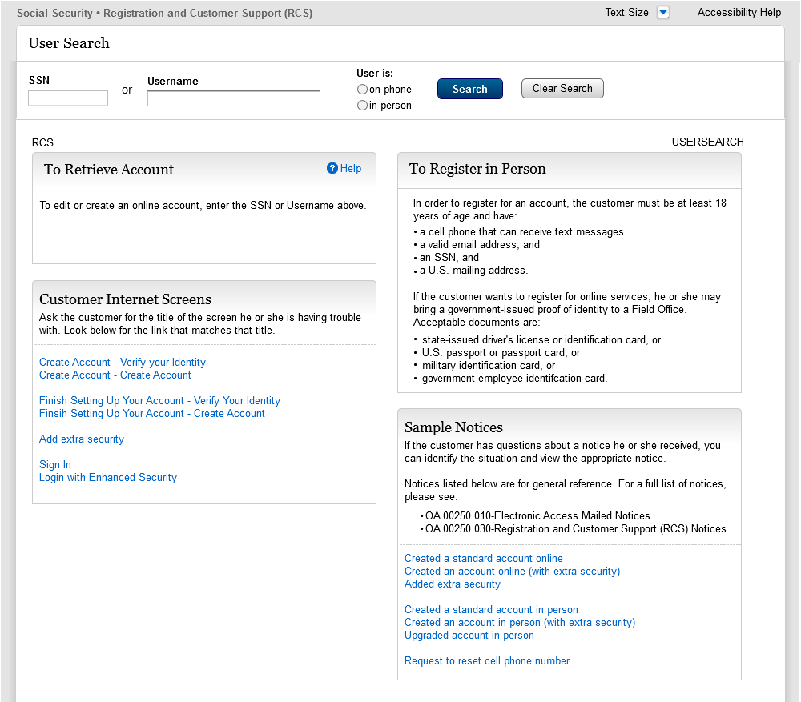
Added new descriptive text: “a cell phone that can receive text messages”

Account Summary (LOA2) _InPerson

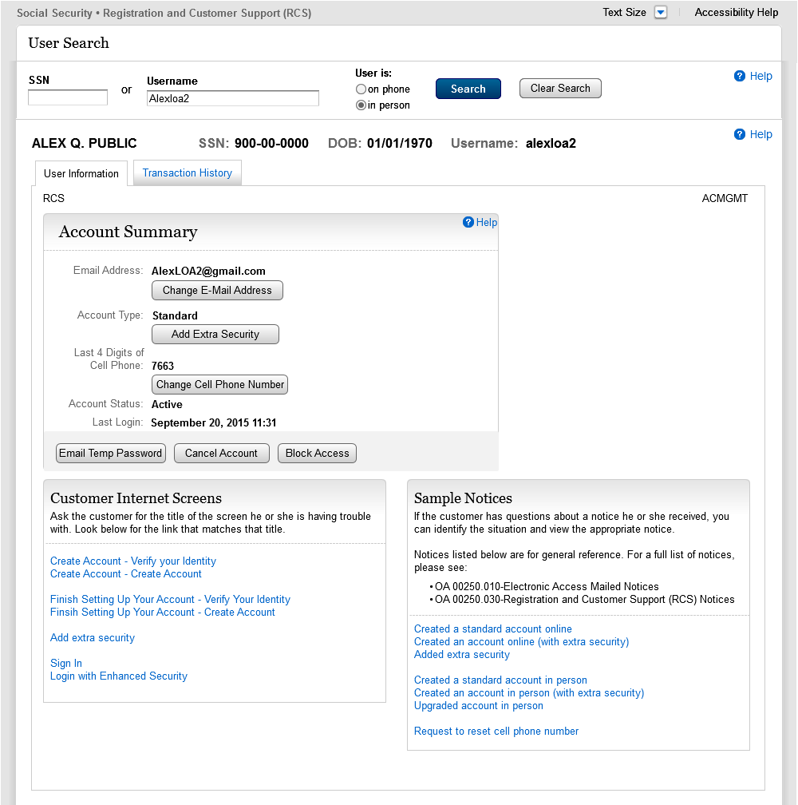

Account Summary (LOA2) _InPerson (Change Pending)

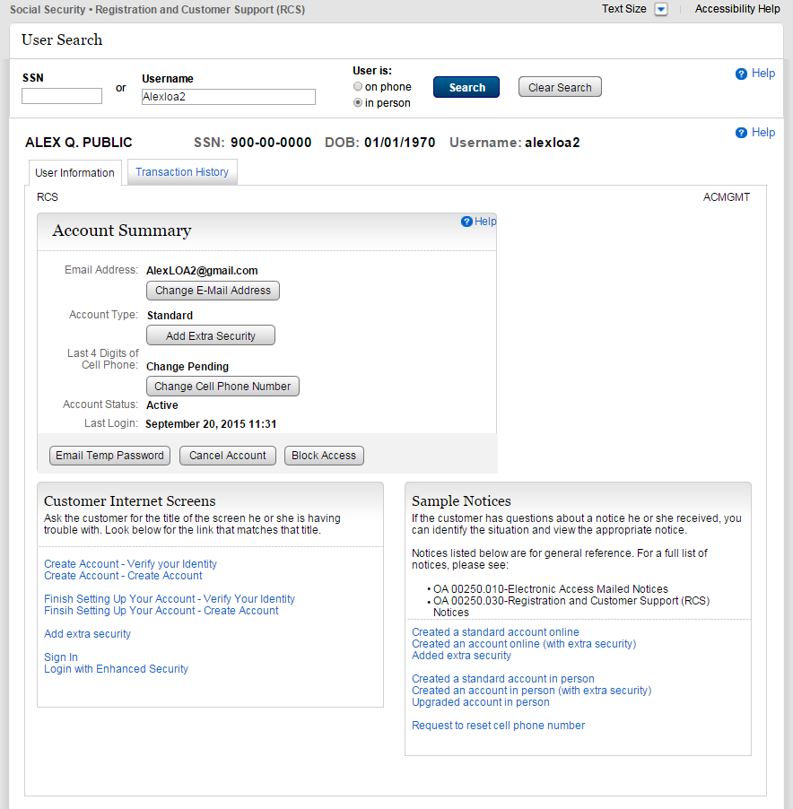
Added “Change Cell Phone Number” button. (1/12/2016)
Added “Change Pending” for LOA2 in person account with a pending cell phone number change.

Account Summary (LOA2) _InPerson (Not Registered)

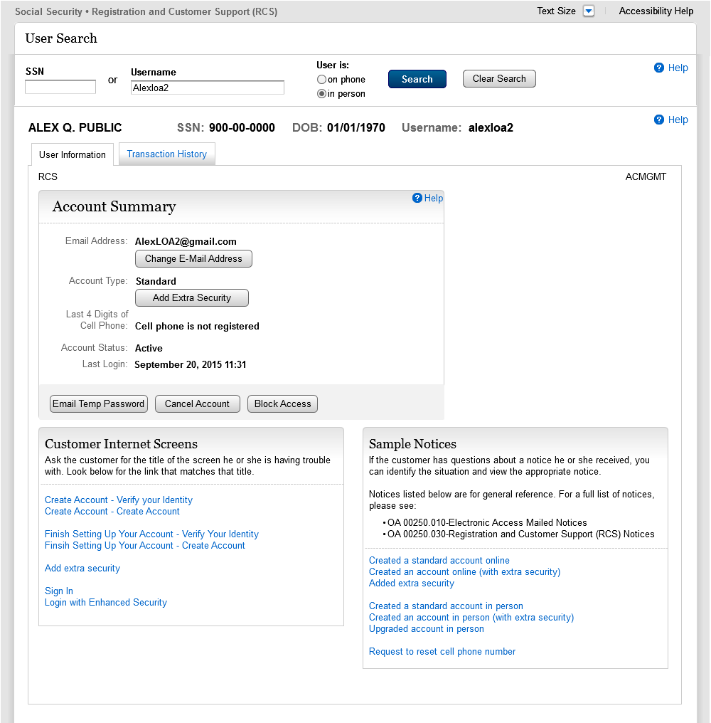
Added “Cell Phone is not registered” for LOA2 in person account with no cell phone registered.

Account Summary (LOA2)_OnPhone (Change Pending)

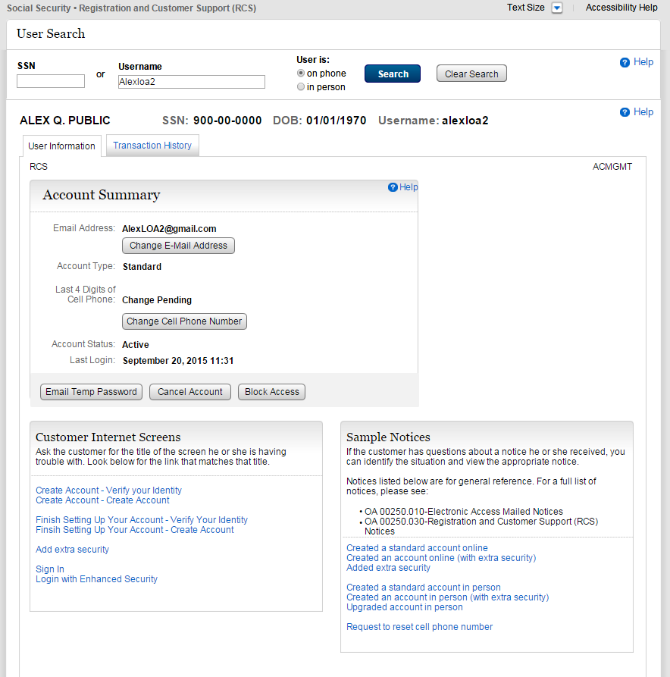
Added “Change Cell Phone Number” button. (1/12/2016)

Added “Change Pending” for LOA2 on phone account with no cell phone registered.

Account Summary (LOA2)_OnPhone (Not Registered)

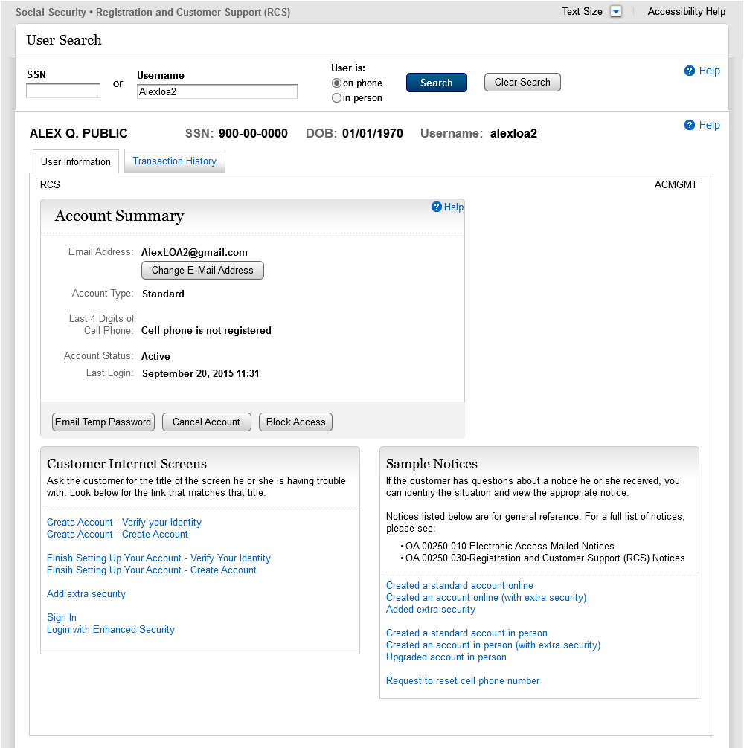
Added “Cell Phone is not registered” for LOA2 on phone account with no cell phone registered.

S1-P1 Verify Address Verification (LOA2)
Screen added on 1/12/2016.
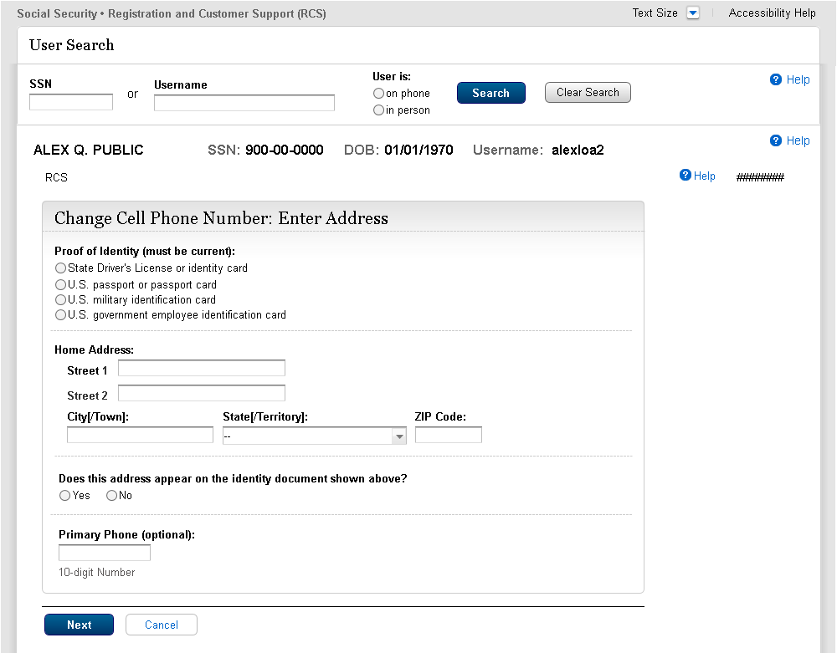

S1-P2 Update Code Print Confirmation (LOA2)
Displayed if customer-provided address matches customer’s ID.

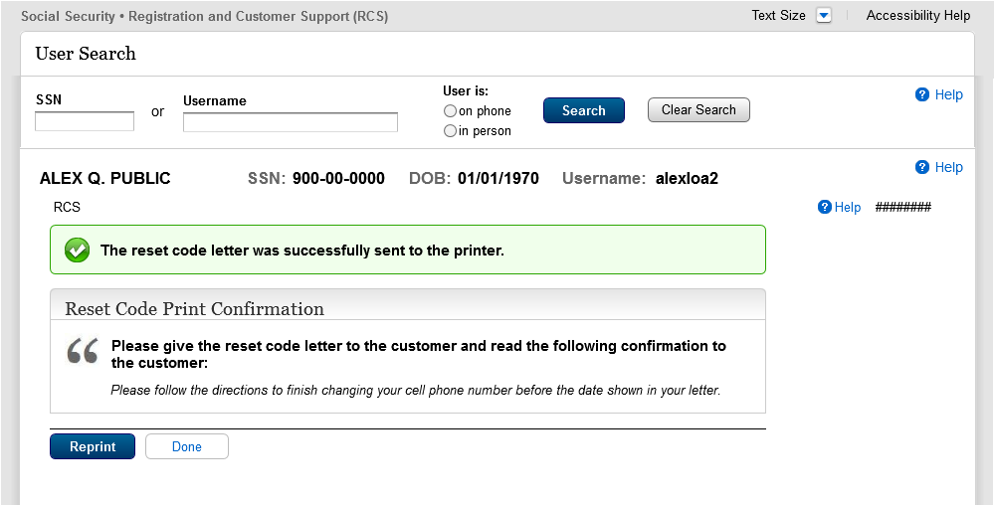
Changed from “Update” to “Change” [GLOBAL]
Changed “Update Code Letter” to “Reset Code Letter” [GLOBAL]
New text: Reset Code [GLOBAL]
Change of text from “The letter…” to “The reset code letter” [GLOBAL]

Reprint button is now primary…with done button being secondary

S1-P6 Customer-Provided Address Does Not Match ID
Displayed if customer-provided address does not match address on customer’s ID.
Screen added on 1/12/2016.
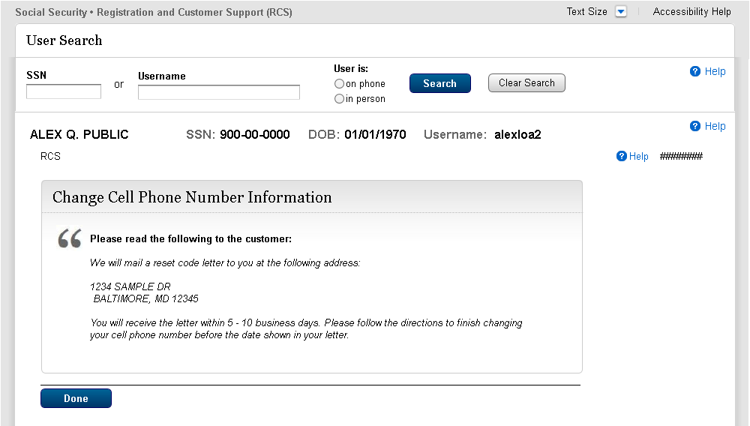

1.2 LOA3 in Person

Account Summary (LOA3)_InPerson

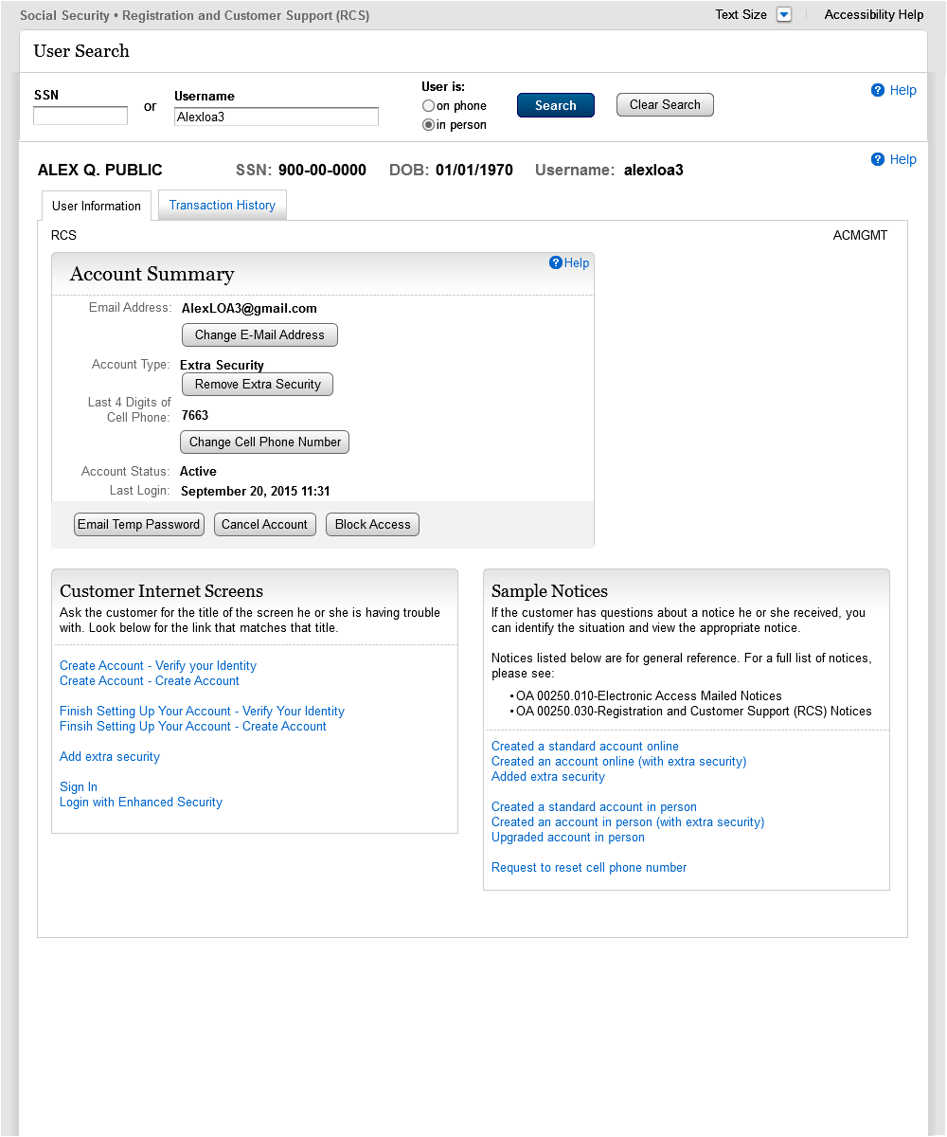

S1-P3 Verify Address Verification (LOA3)

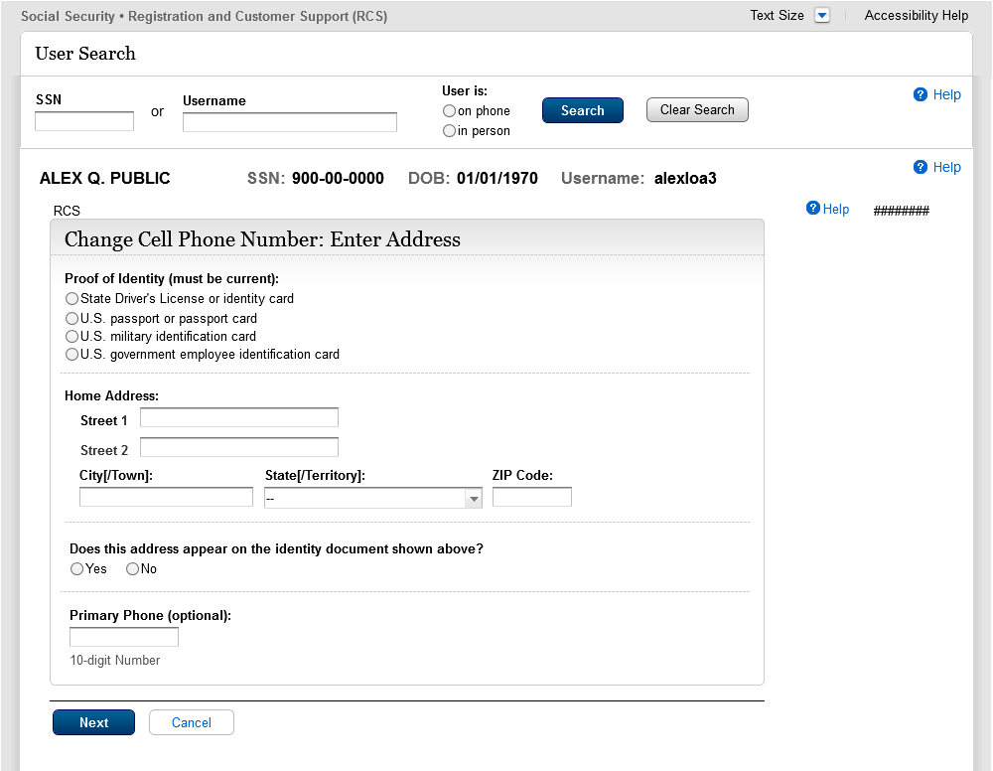
Spacing reduced

S1-P4 Verify Address Verification Confirm YY NY

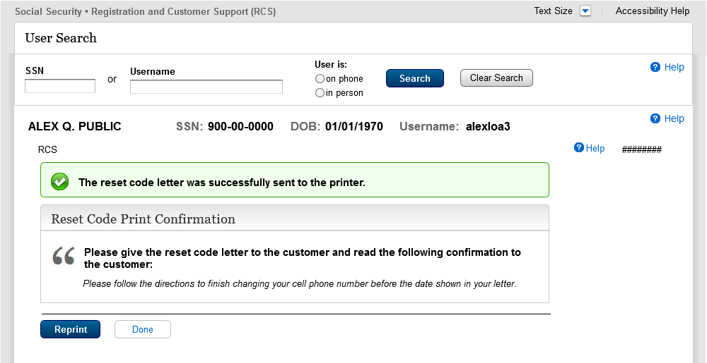
New text: “Reset code” to be consistent with other screens [GLOBAL]
Reprint button is primary, and done is secondary
Text change from “Update” to “Change”

S1-P5 Cannot Verify Address Internal (LOA3) YN NN

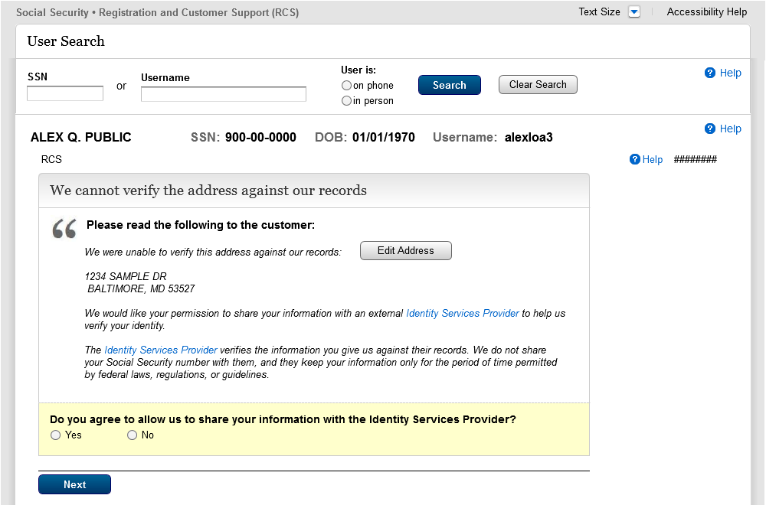
Fraud text removed [GLOBAL]

S1-P7 Decline or Fail External Verification (LOA3)

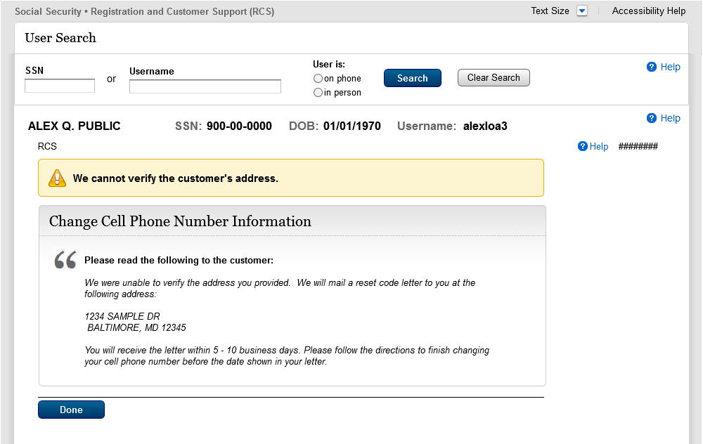
Text change: From “update” to “change”

1.3 LOA2 or LOA3 on Phone

Account Summary (LOA2)_OnPhone

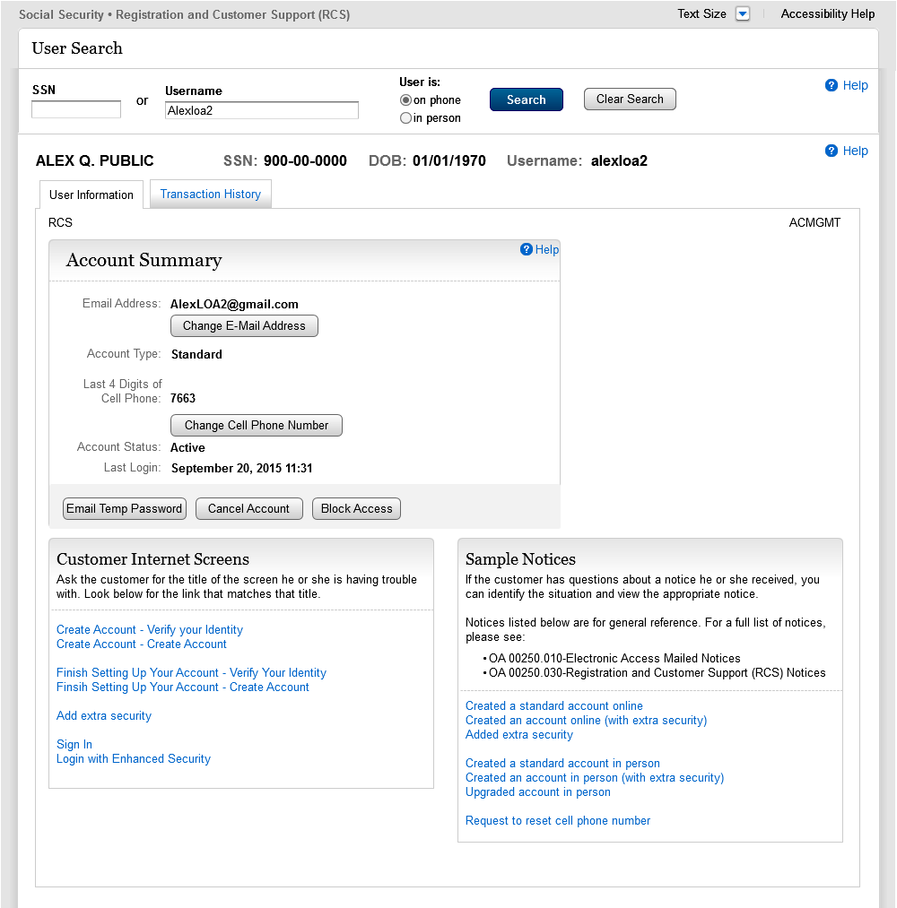

Account Summary (LOA3 on Phone) Before Send Text Message Selected
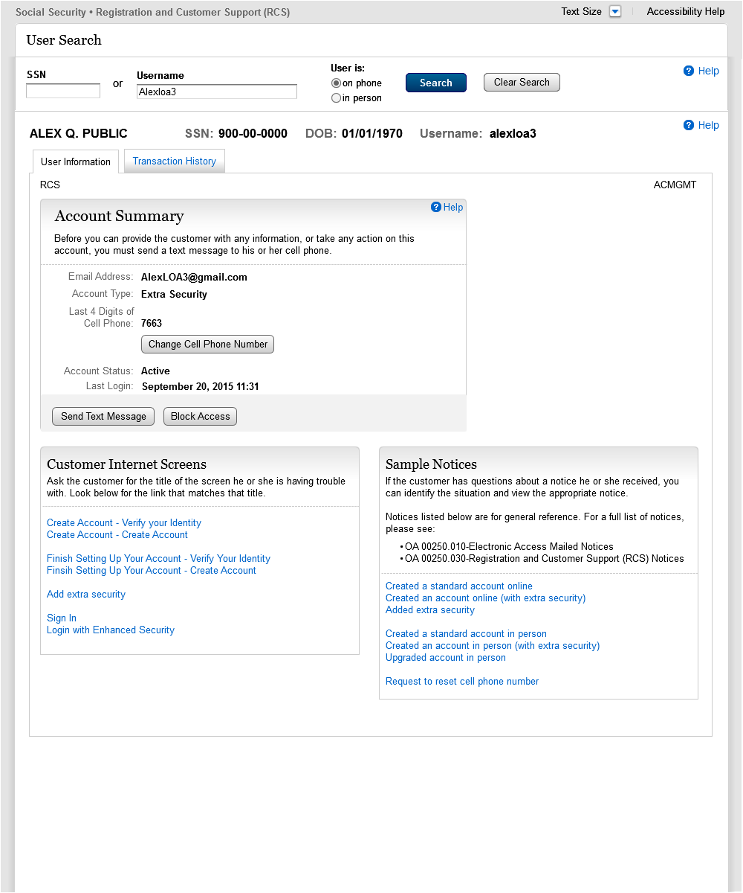

Account Summary (LOA3 on Phone) After Send Text Message Selected
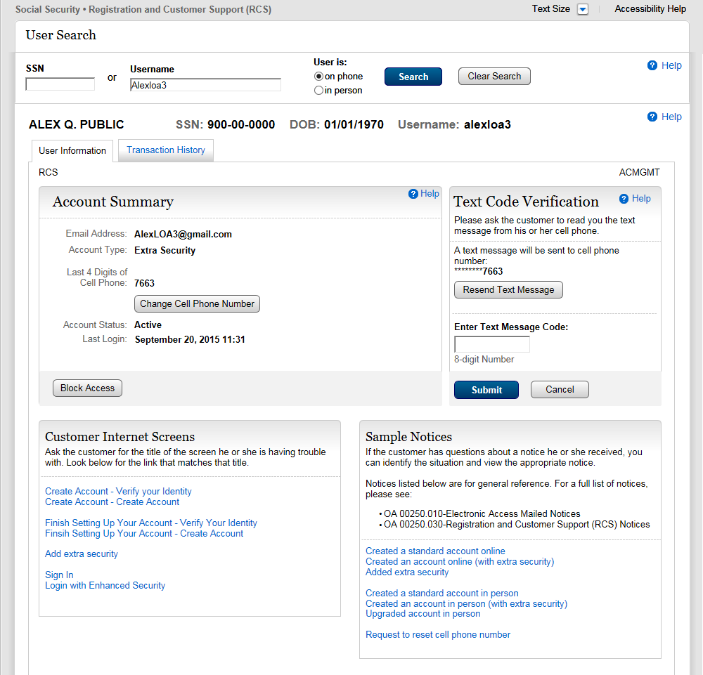

Account Summary (LOA3 on Phone) After Text Code Verification
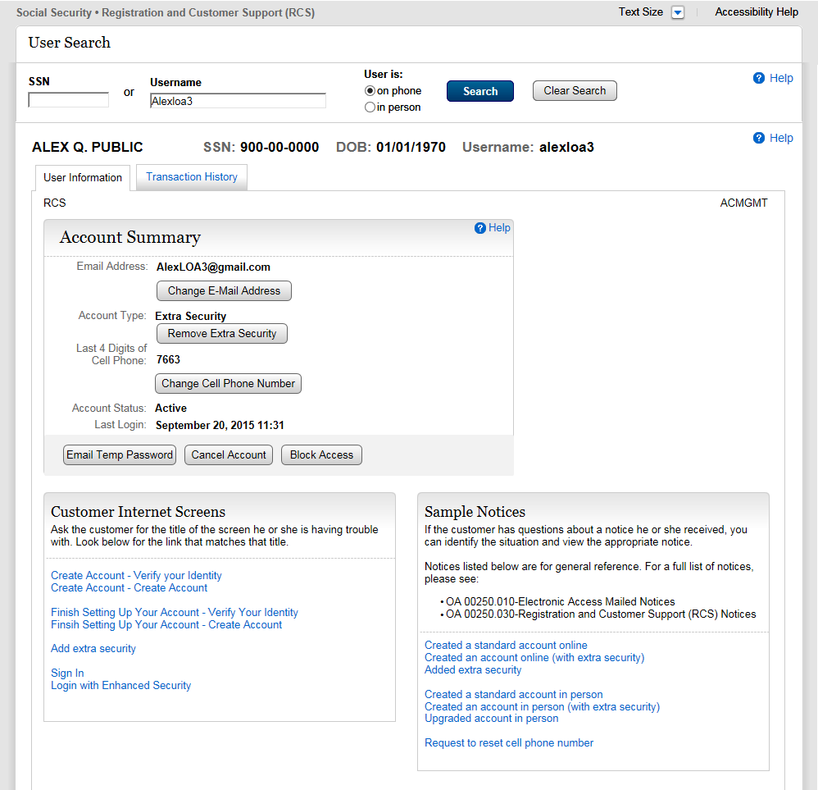
Text Code Verification container is hidden again. Account Summary container now contains buttons for available functionality.

S1-P10 Verify Address Verification (LOA2 & LOA3)

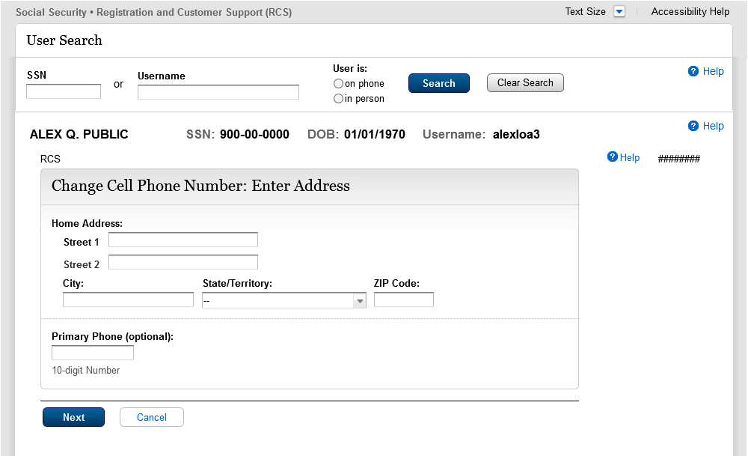
Text change: from “update” to “change”

S1-P11 Verify Address Verification Confirm (LOA2 & LOA3) YY NY

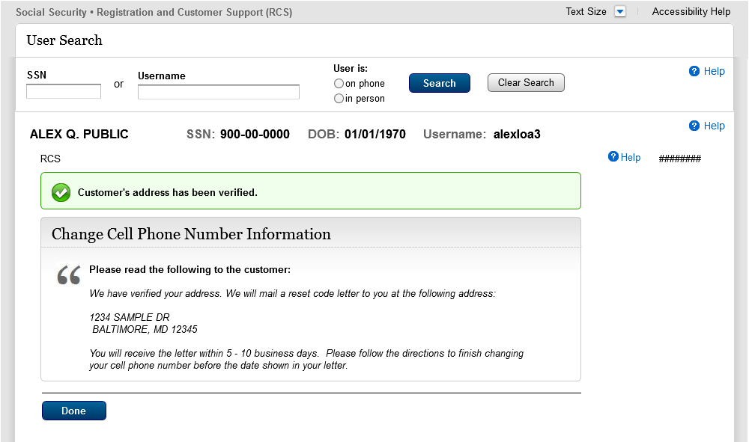
“Mail” text inserted

S1-P12 Cannot Verify Address Internal (LOA2 & LOA3) YN NN

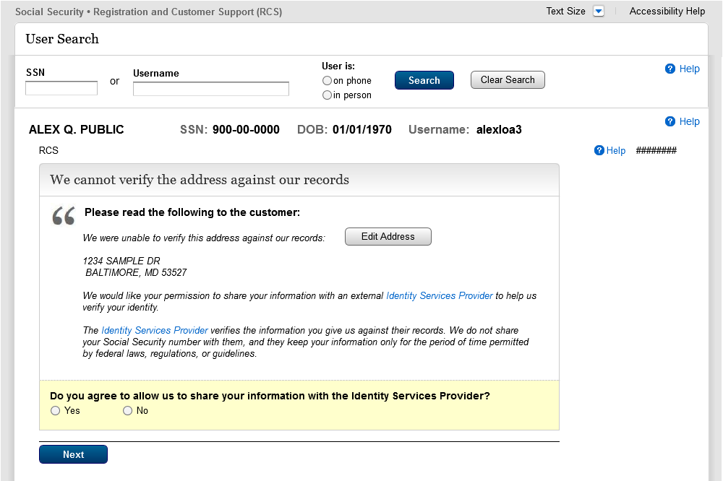
Change from “verified” to “verifies” 1/19/16
Fraud text removed

S1-P14 Fail External Verification (LOA2 & LOA3)

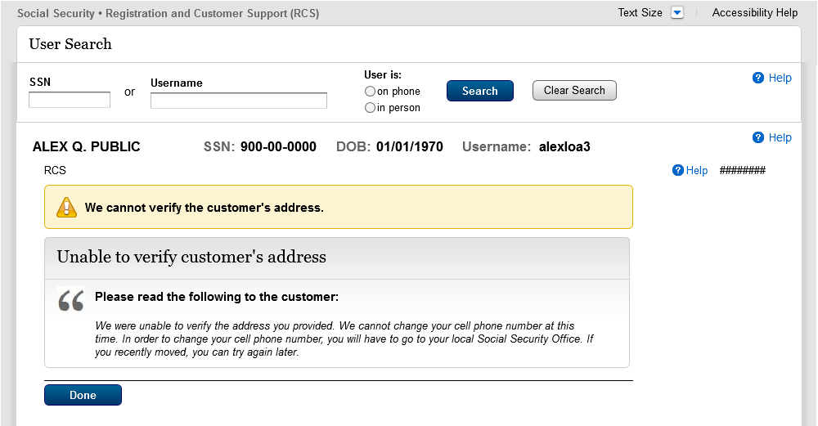
“Update” changed to “Change”
Text added for going to the local SSA office

S1-P15 No to External Verification (LOA2 & LOA3)

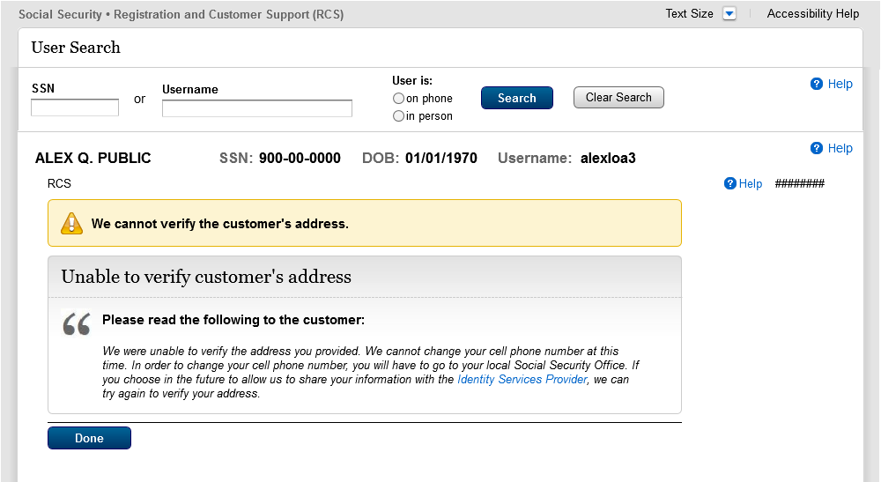
From “update” to “change”. Added 2nd sentence. Removed “If you recently moved…later.”

2. De-Elevate Account (BPD Section 2.5.2)

2.1 LOA3 in Person

Account Summary (LOA3)_InPerson

S5-P1 - Remove Extra Security: Confirmation (LOA3)

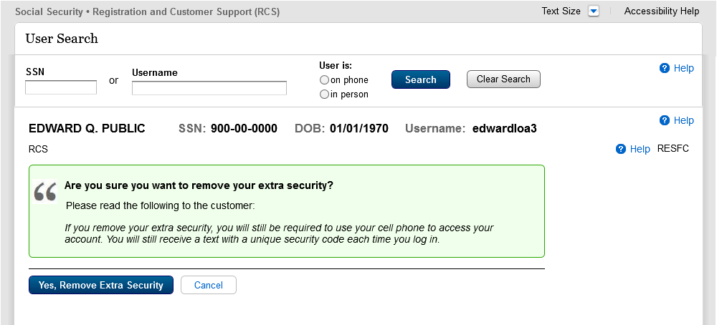
Wording updated to reflect MFA changes

S5-P9 - (Remove Extra Security Confirmation) Account Summary (LOA3)
Button updated to reflect RCS Val

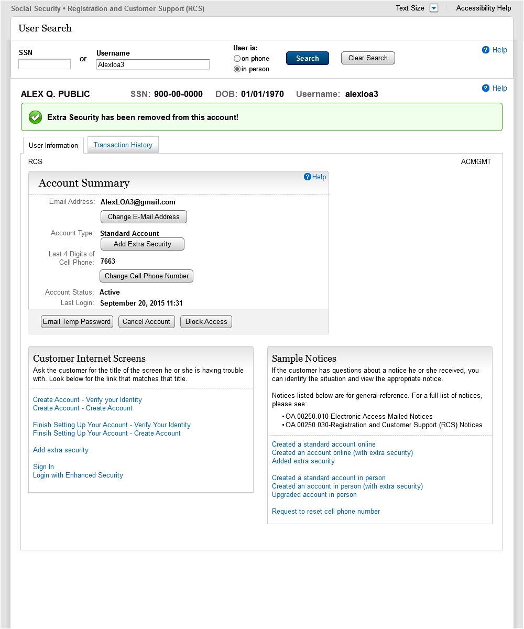

2.2 LOA3 on Phone – Before Send Text Message Selected

Account Summary (LOA3)_OnPhone

Account Summary (LOA3 on Phone) After Send Text Message Selected
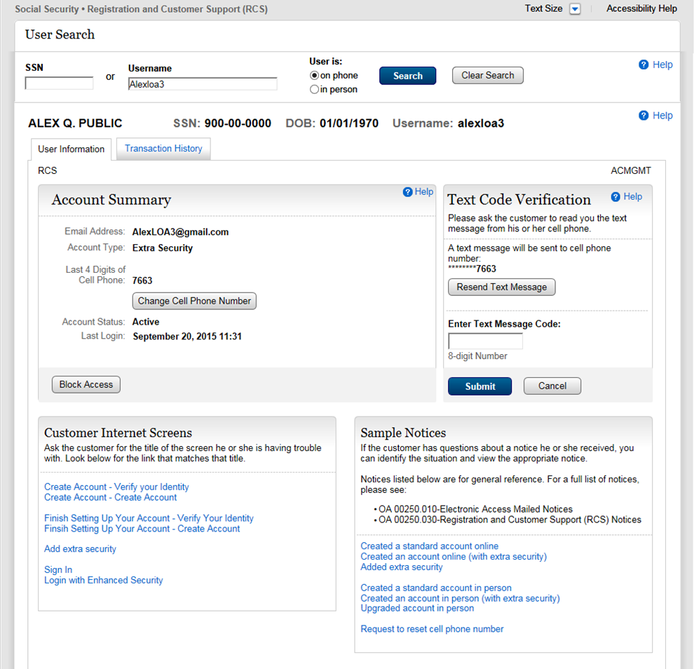

Account Summary (LOA3 on Phone) After Text Code Verification

S5-P2 - Verify Address Verification (LOA3)

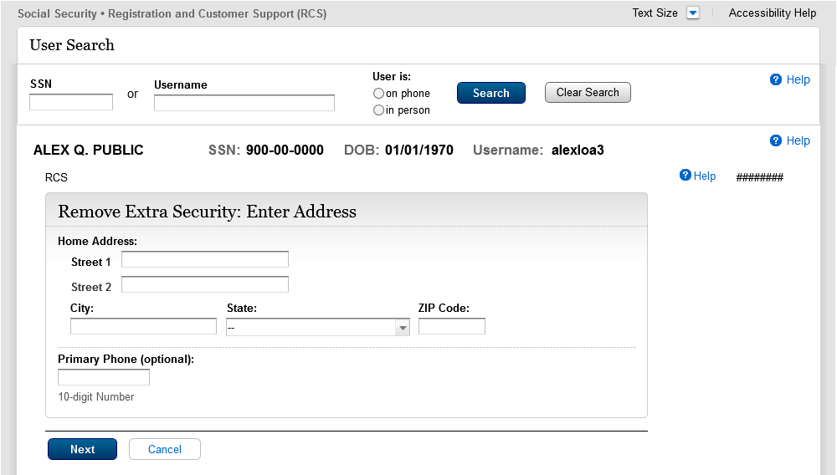
Container heading updated to reflect RCS Val

S5-P4 - Cannot Verify Address Internal (LOA3)

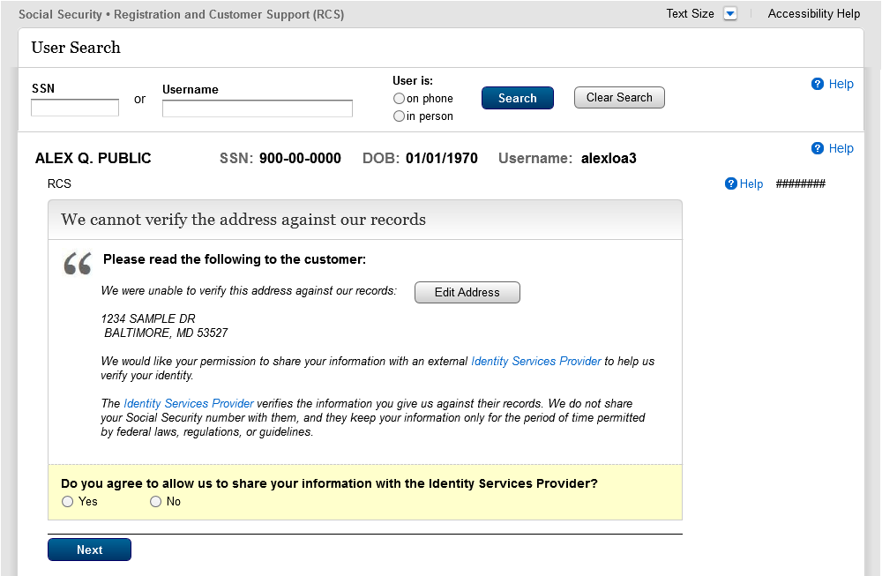
Change text from “verified” to “verifies”
Yellow container removed.
Fraud message removed.

S5-P6 - Fail External Verification (LOA3)

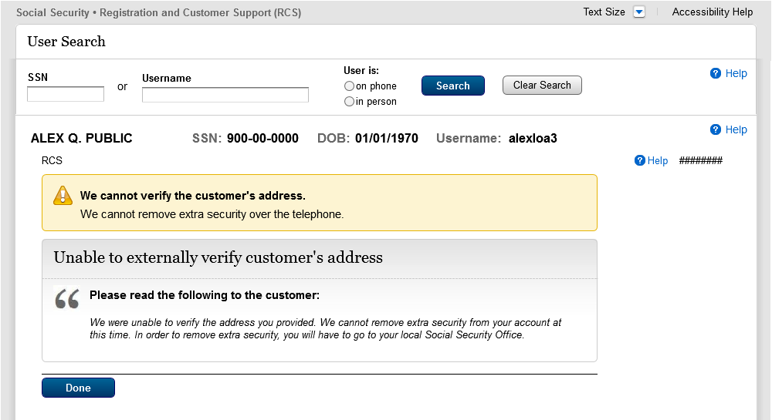
Added 2nd and 3rd sentences to reflect RCS Val. Removed “If you recently moved…later.”
Added sentence to reflect RCS Val.

S5-P5 - No to External Verification (LOA3)

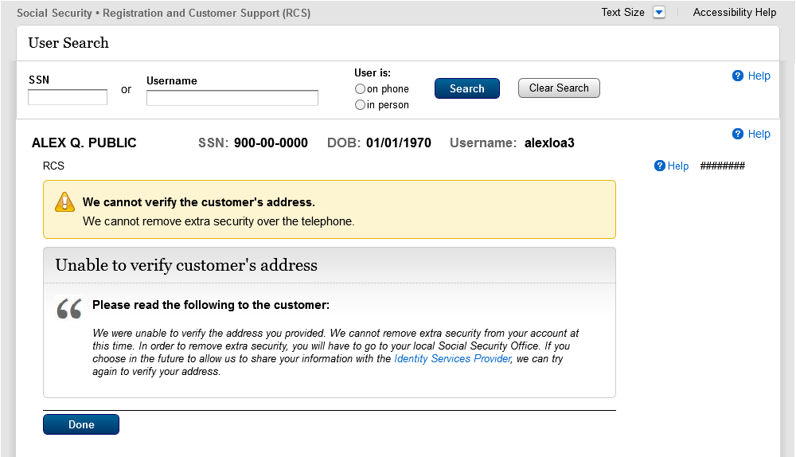
Added sentence to reflect RCS Val.
Added 2nd and 3rd sentences to reflect RCS Val. Removed “If you recently moved…later.”

S5-P7 - (Remove Extra Security Confirmation) Account Summary (LOA3)

3.0 Miscellaneous Screen Changes

3.1 Screen YWES – Add Extra Security Immediately After Creating Account
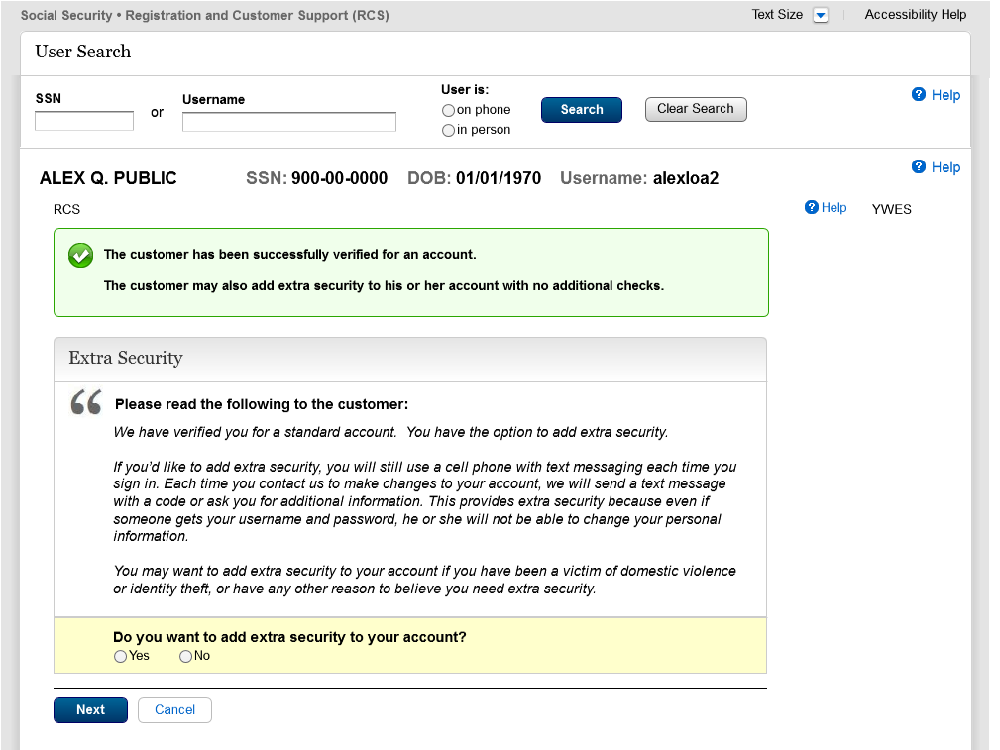
Changed language on 3/2/2016.

3.2 Screen AXSEAC – Add Extra Security to Existing Account

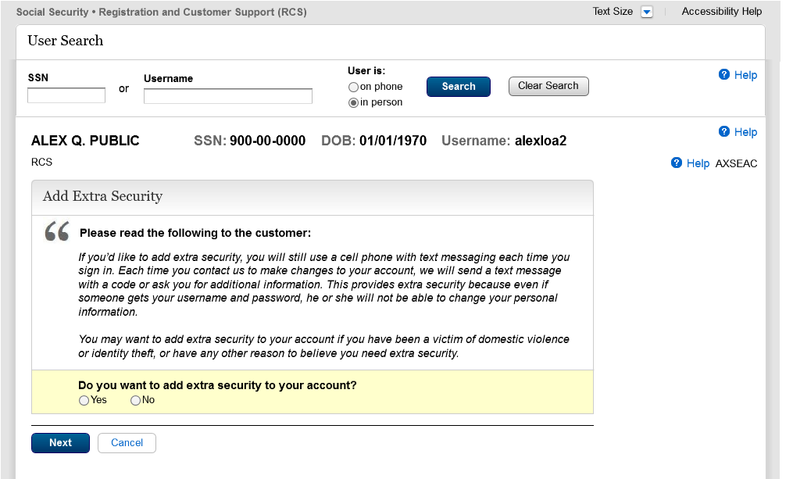
Changed language on 3/2/2016.

3.3 Screen AXSNEV – Cannot Verify Address Internally

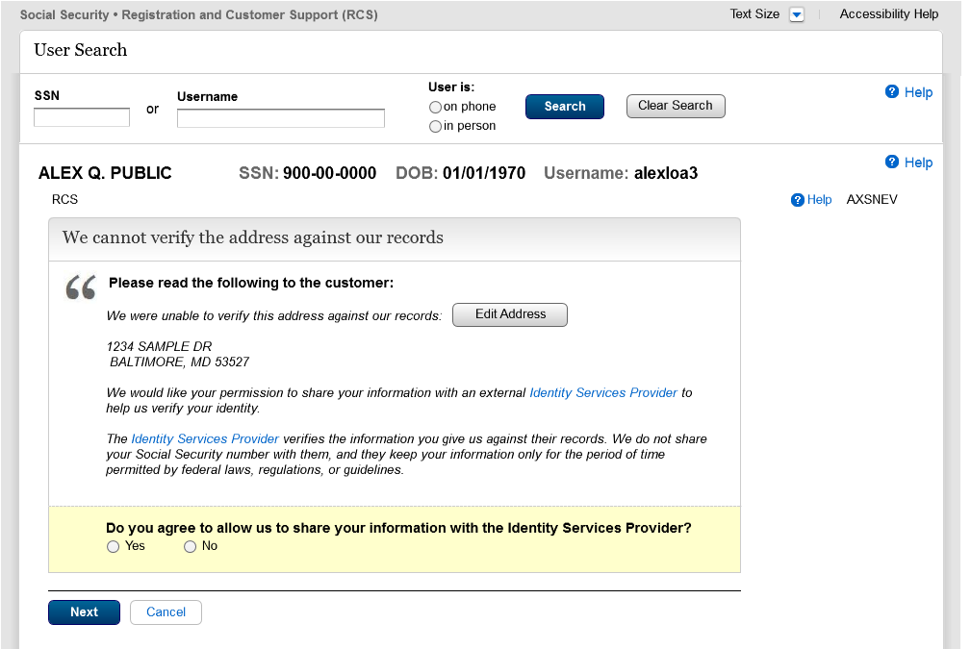
Removed wording about fraud prevention services on 3/2/2016.

3.4 Screen EXTOS – Cannot Verify Address Internally
Removed wording about fraud prevention services on 3/2/2016.

