Collection and Use of Personal Information

Sections 205(a), 223(d), and 1631(e)(1) of the Social Security Act, as amended, allow us to collect the requested information. We will use the information you provide to make a determination of eligibility for Social Security benefits. Providing us this information is voluntary. However, not providing this information may prevent us from making an accurate and timely decision on any claim filed. Additional information about this and other Social Security programs is available on our Internet website, www.socialsecurity.gov, or at your local Social Security office.

EDCS Screenshots of the 3369 Form
September 20, 2013

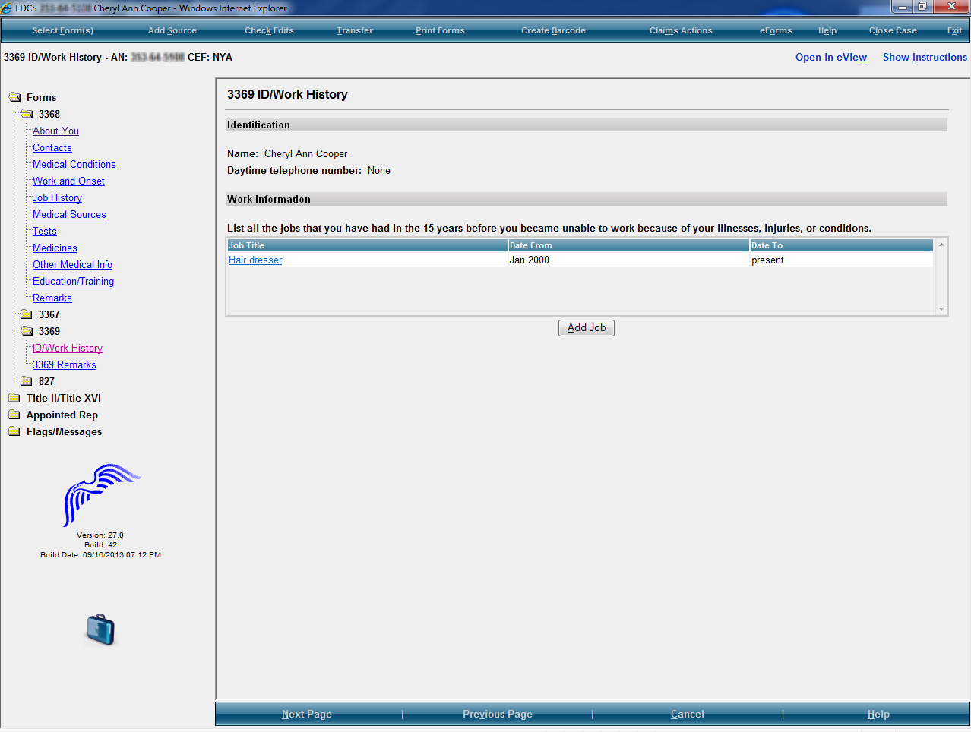

3369 ID/Work History Page
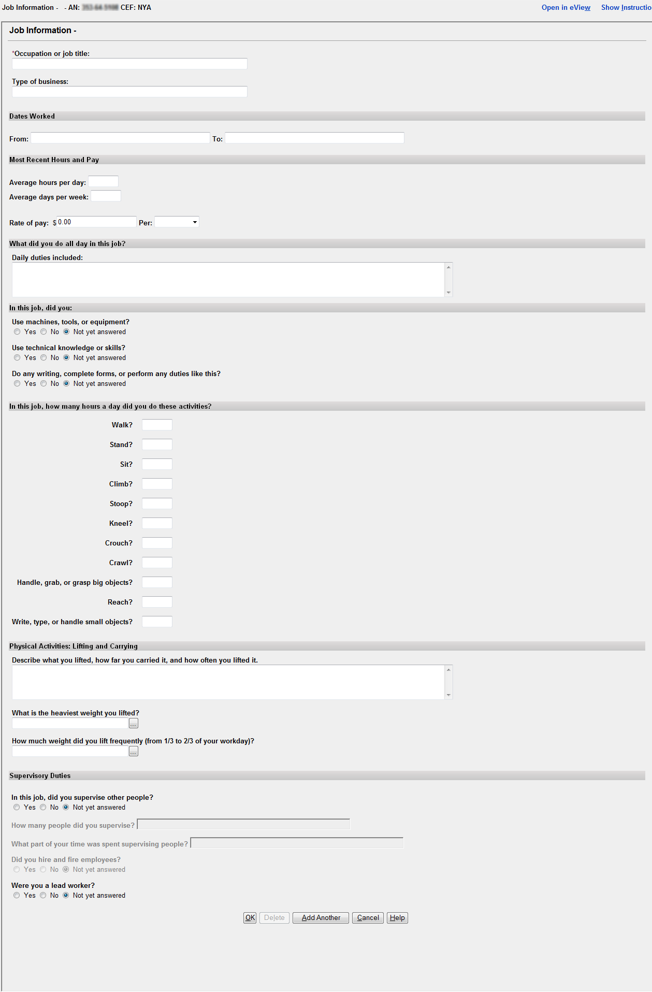
3369 Job Information Page
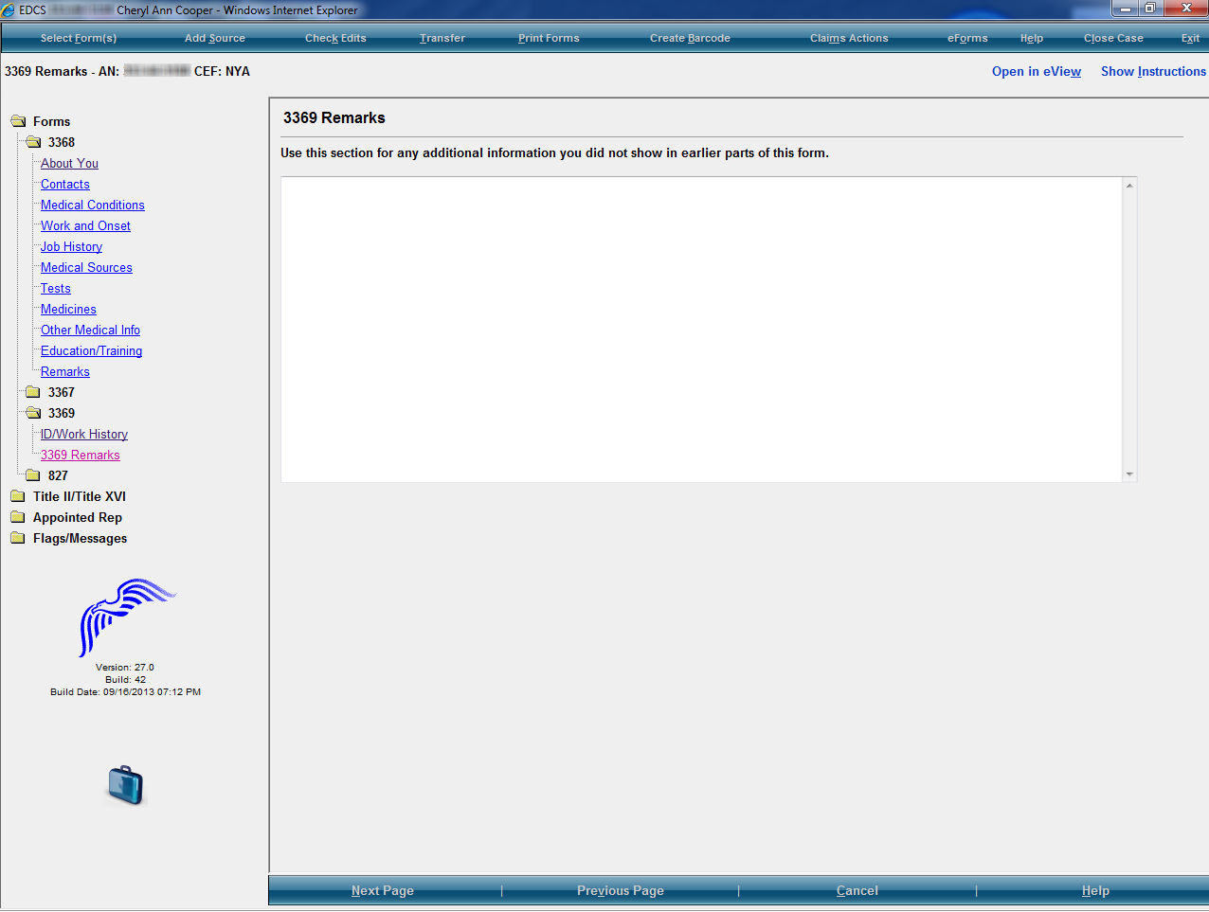

3369 Remarks Page

