In accordance with the provision of the Construction Contract dated ```````````````` and Contractor's and/or Mortgagor's Cost Breakdown (Schedule of Values) attached thereto, this requisition is submitted for the amount of $ `````````````````` due for work performed up to the ```````````` day of `````````````` and as itemized below by the trades listed in the Schedule of Values.

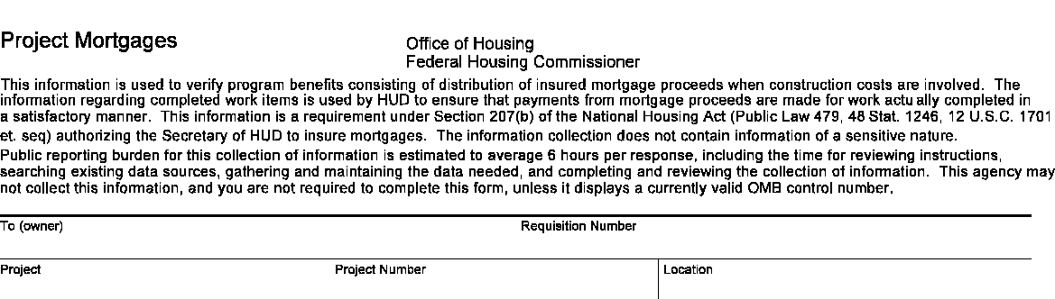
U.S. Department of Housing
and Urban Development
Contractor's Requisition
OMB Approval No. 2502-0028 (Exp. 06/31/2017)
To be submitted to mortgagee in quadruplicate
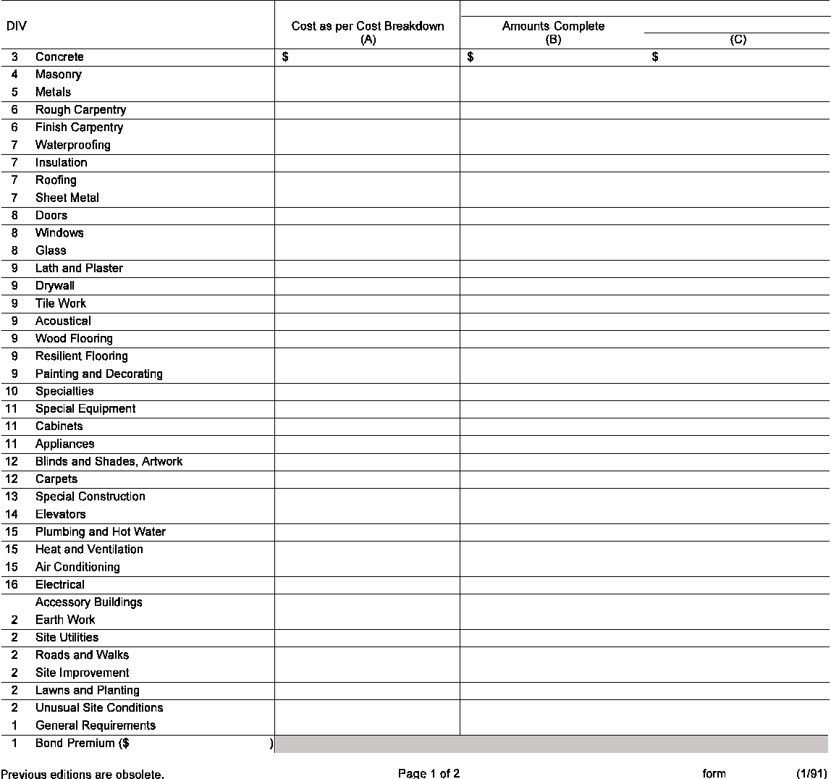
Enter Amounts to Nearest Even Dollar
For HUD-FHA Use
Trade Item
HUD-92448

I certify that the Work covered by this requisition has been completed in accordance with the Contract Documents, and that I have actually received

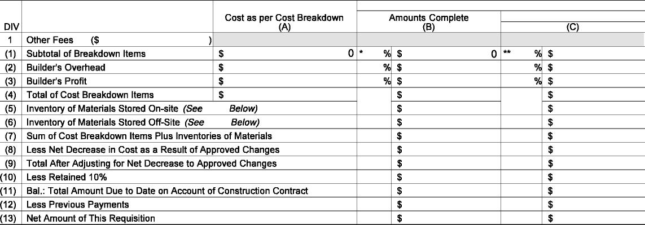
Note
Trade Item
Enter Amounts to Nearest Even Dollar
For HUD-FHA Use
Note
HUD-92448
$ for Work performed and materials purchased up to the `````````````` day of ```````````` (date of previous requisition).
For Use of HUD-Federal Housing Commissioner
Architect's Certificate I certify, based on my on-site observations (or those of my authorized representative) and the data comprising this requisition, that the Work has progressed to the point indicated; that to the best of my knowledge, information and belief the Work is in accordance with the Contract Documents; and that the Contractor is entitled to payment of the amount certified.
Inspector's Certificate Amount Modified No Modification
I certify that I have visited the site on this date ``````````````````````````````, observed the Work, and monitored the log and reports of the Architect (if an architect is administering the Construction Contract); that to the best of my knowledge, information and belief the amount certified represents acceptable Work; and that I have no personal interest, present or prospective, in the property, applicant or proceeds of the mortgage.
Contractor's Prevailing Wage Certificate (For use under all sections of the National Housing Act requiring certification as to payment of prevailing wages. To be completed with each request for insurance of advance of mortgage proceeds which includes a payment on account of construction cost, or at the time the mortgage is presented for insurance pursuant to a commitment to insure upon completion.)
The undersigned, as principal contractor in connection with the construction of the above project, states that he/she is fully familiar with applicable wage determination decision of the Secretary of Labor and certifies that:
- A copy of the applicable wage determination decision is posted in a conspicuous place at the site of the work and he/she has required each subcontractor as a part of his/her contract, to agree to pay wages at rates not less than those contained in the decision.
- All laborers and mechanics employed in the construction of the project have been, to the date hereof, paid for such employment at wage rates not less than those contained in the applicable wage determination decision of the Secretary of Labor and no deductions or rebates have been made, either directly or indirectly, from the full weekly wages earned by any person, other than permissible deductions as defined in Regulations of the Secretary of Labor, Part 3 (29 CFR Part 3).
- He/She has fulfilled his/her obligations, to the date hereof, under The Labor Standards Provisions of the Supplementary Conditions of the Contract for Construction and has included said conditions in all subcontracts.
This certificate is executed by the undersigned for the purpose of inducing the Commissioner to approve for insurance that certain mortgage loan, or an advance thereof, made or to be made by the mortgagee in connection with the construction of the project, and with the intent that the Commissioner rely upon this certification to establish compliance with the provisions of Section 212 of the National Housing Act, which provides in part: The Commissioner shall not insure ... unless the principal contractor files a certificate ... certifying that the laborers and mechanics ... have not been paid not less than the wages prevailing ... as determined by the Secretary of Labor..."
I hereby certify that all the information stated herein, as well as any information provided in the accompaniment herewith, is true and accurate. Warning: HUD will prosecute

