Figure 1: Signing up for a USA.gov and All Related Subdomains account

Using an External Identity Provider (EIP):
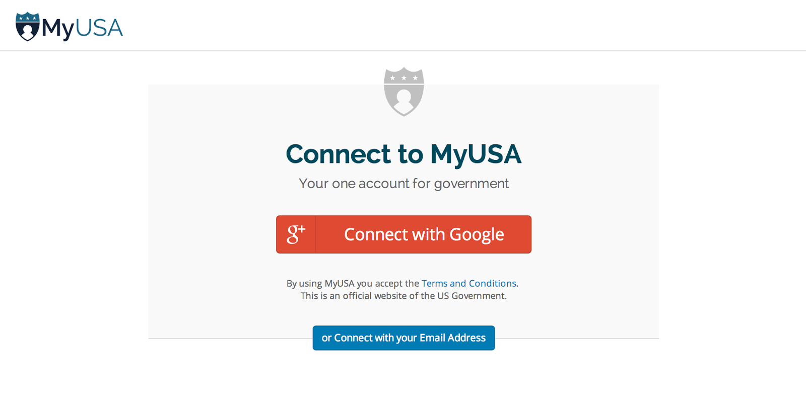
Using your email address:
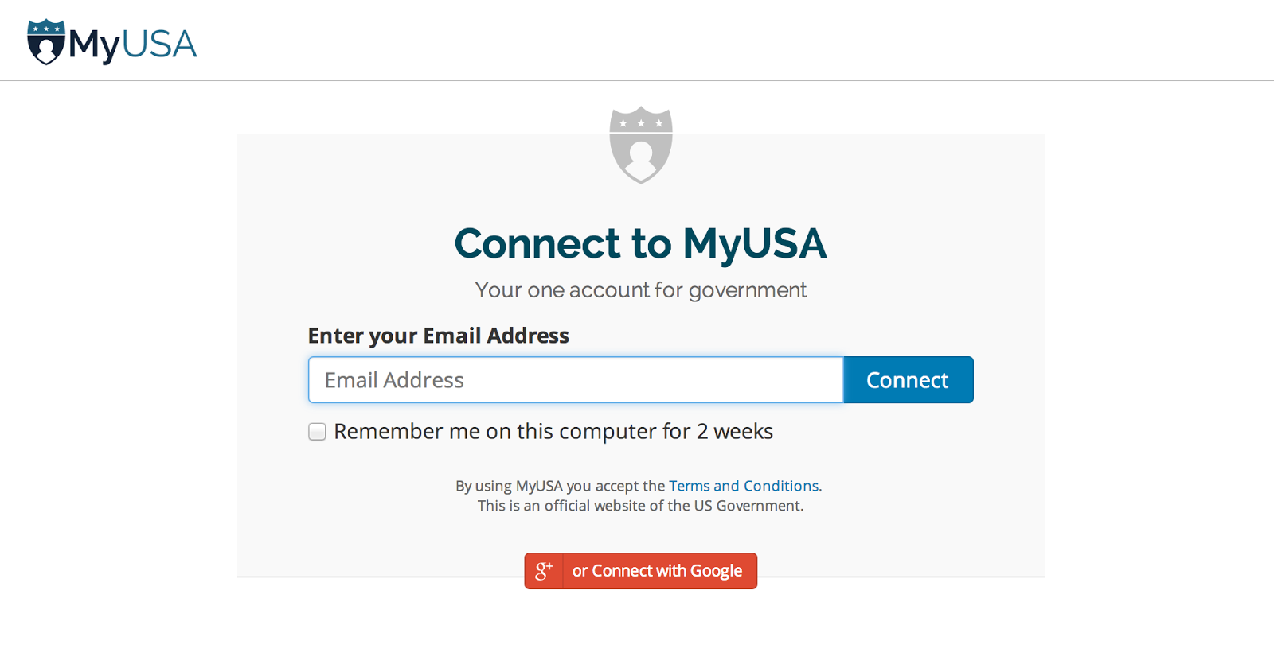

Figure 2a: Editing your USA.gov profile: providing personal information

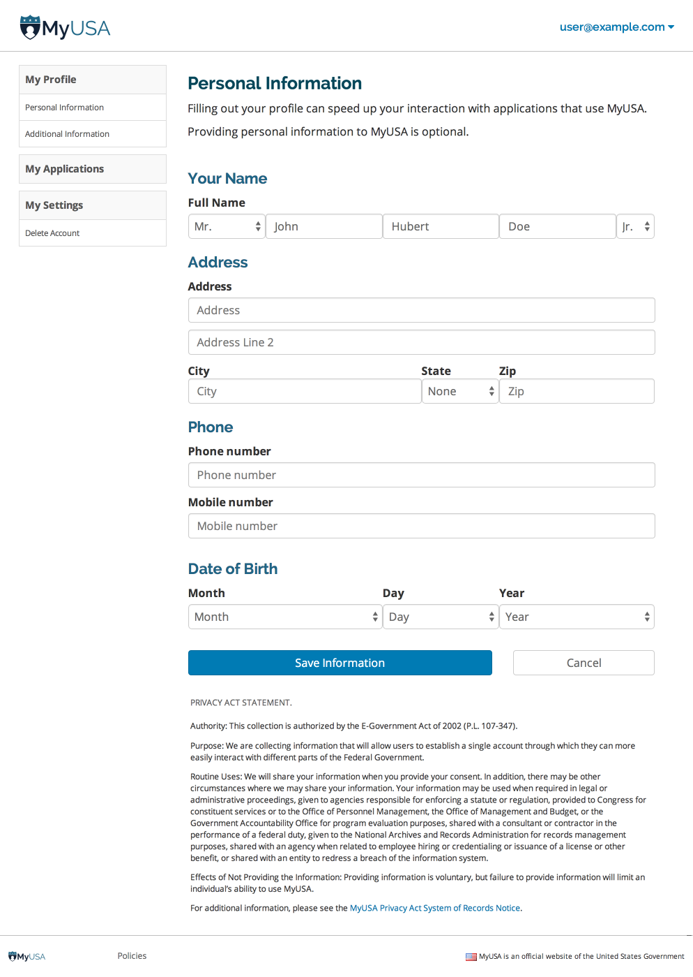

Figure 2b: Editing your USA.gov profile: providing additional information

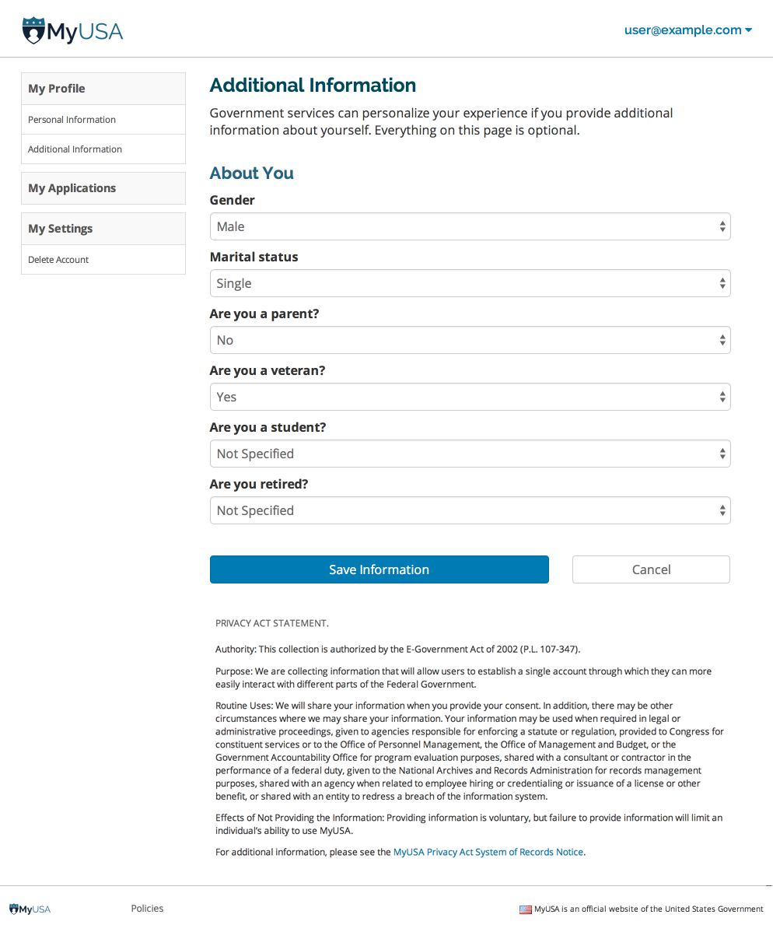

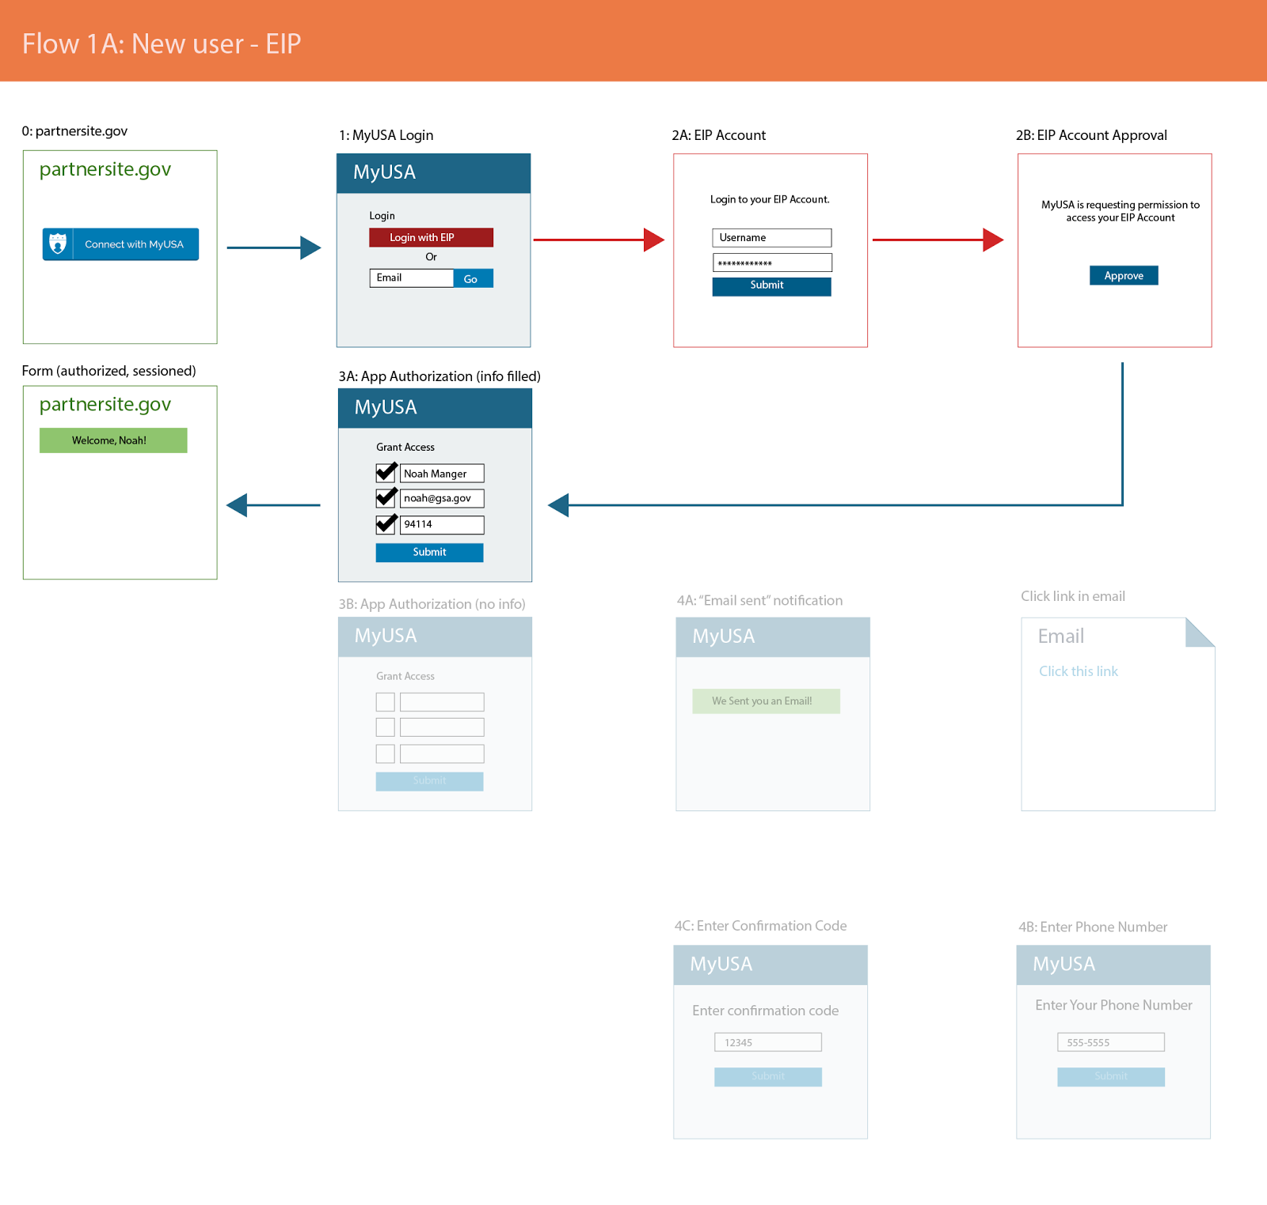

Figure 4: This user flow shows how someone logs in with USA.gov on a government partner site.

The user chooses to sign up for USA.gov with their email address (1). They receive a verification email (4A), and then proceed with registration (4B & 4C).

After signing up, the user approves the app and the information that it is requesting (3A & 3B)

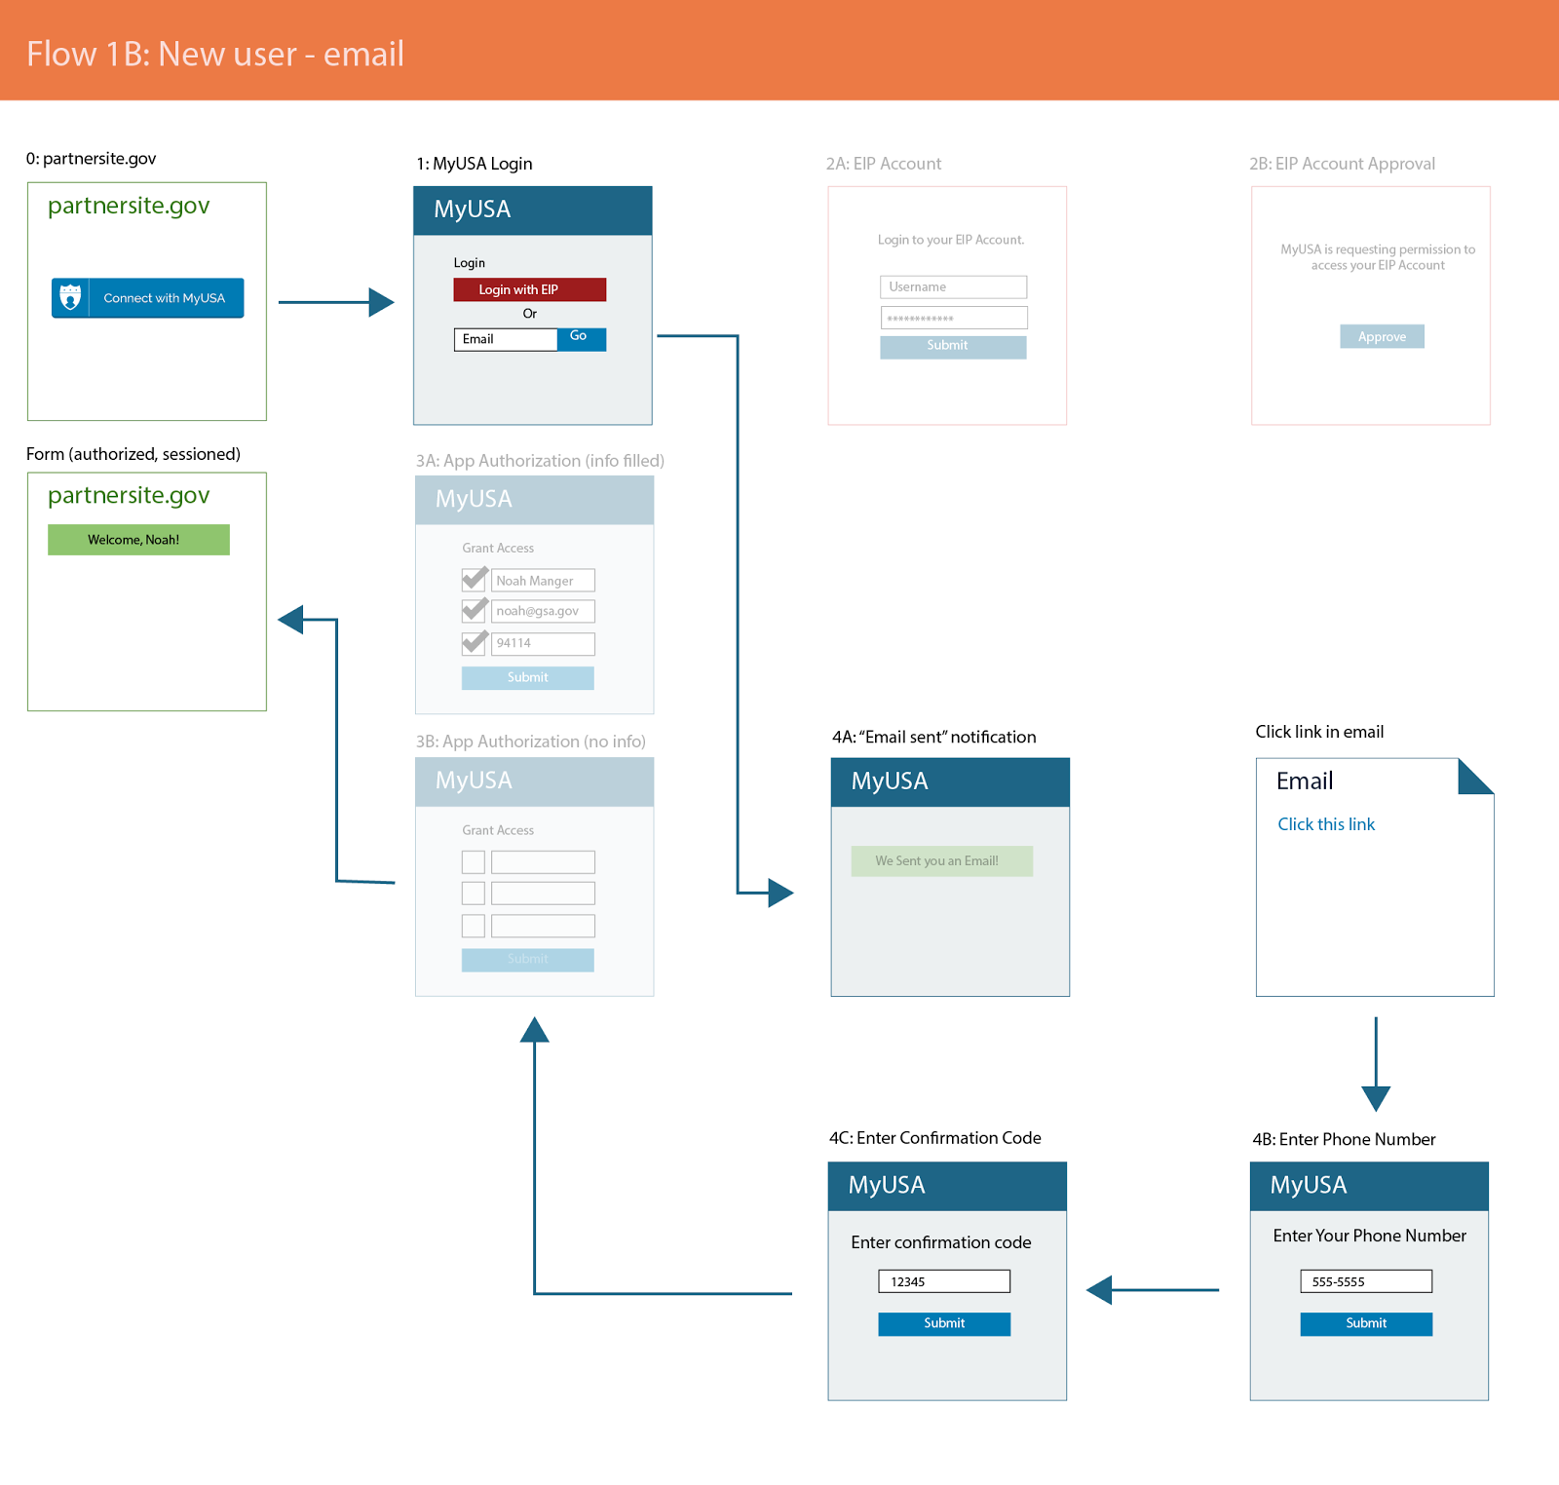

Figure 5: An originating application provides an option for individuals to log in with USA.gov

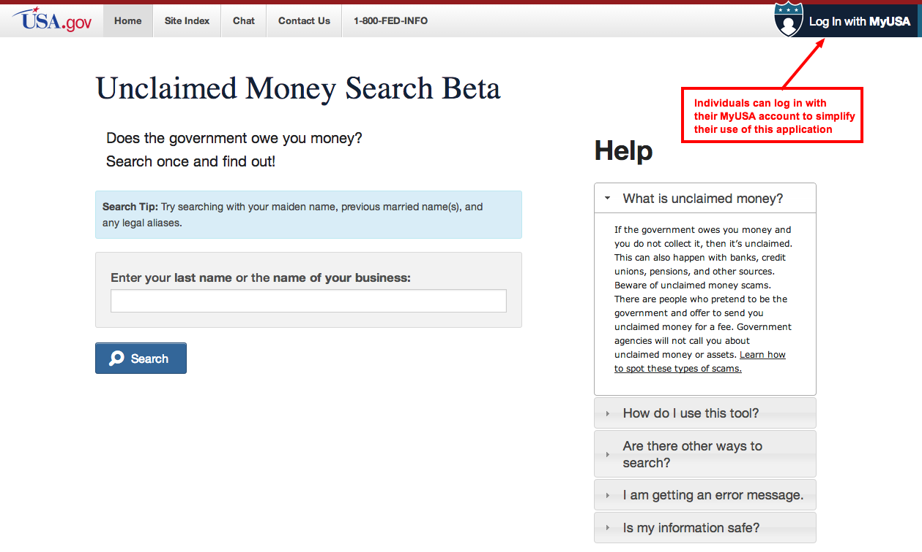

Figure 6: USA.gov asks for explicit approval from the individual to share their profile information with the originating application.
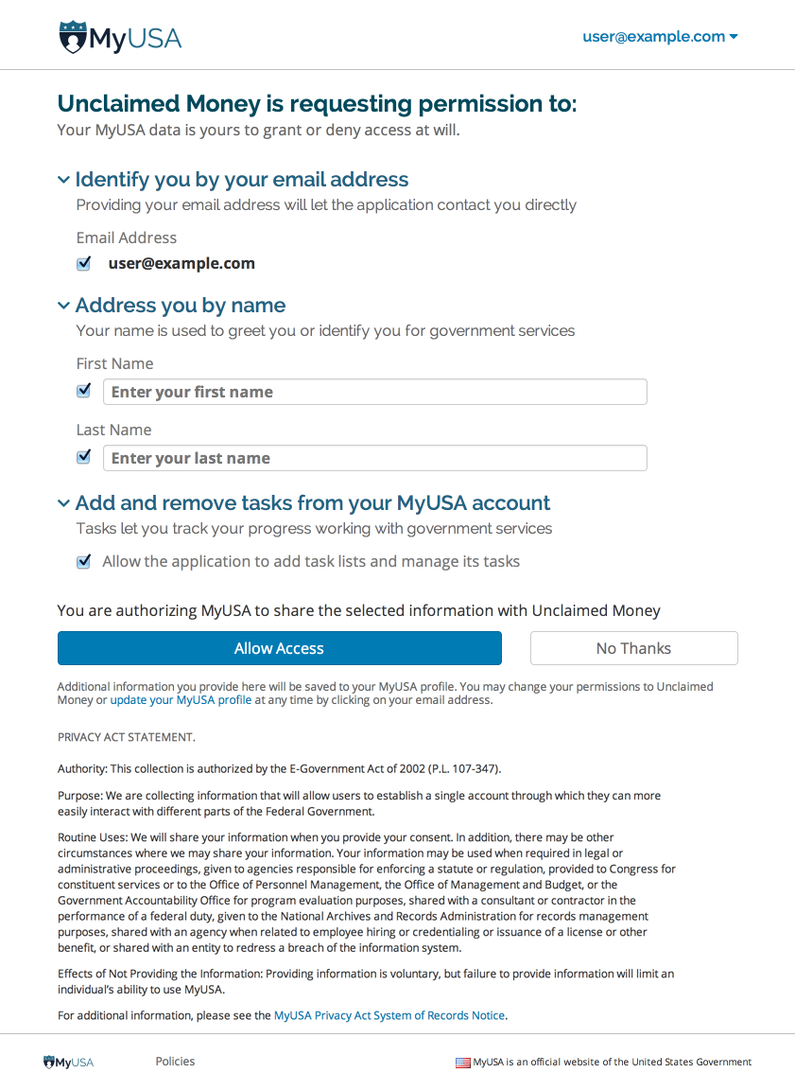

Figure 7: List of authorized applications, their permission, and ability to revoke access to your USA.gov account

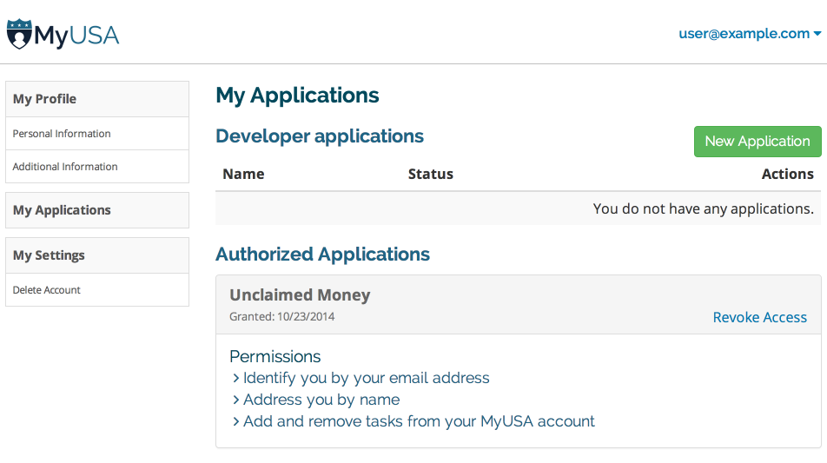

Figure 8: An originating application (Unclaimed Money) offers individuals the opportunity to save a task to their USA.gov account.
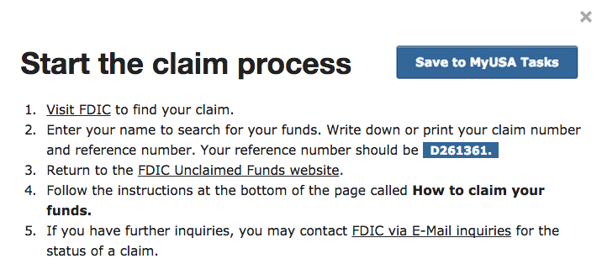

Figure 9: Viewing your stored information (in this case, tasks) at USA.gov
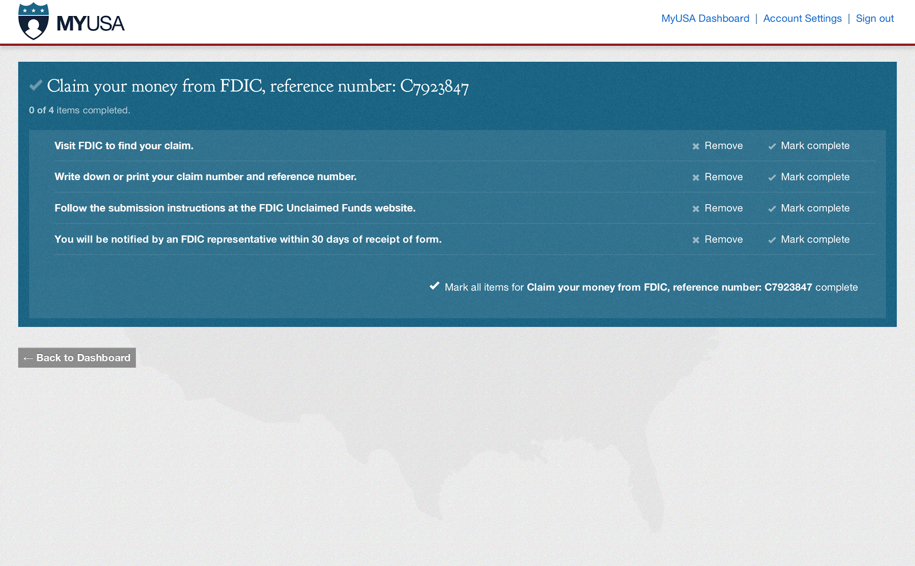

Figure 10: Managing your tasks at USA.gov
