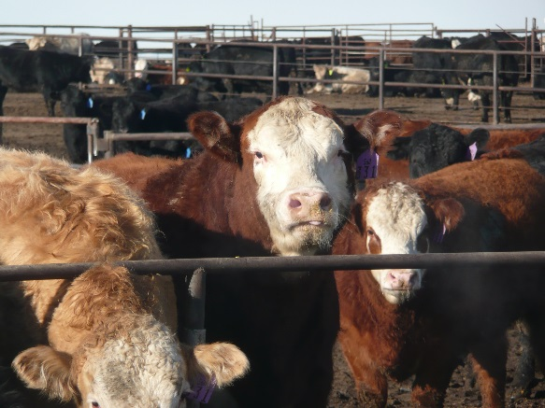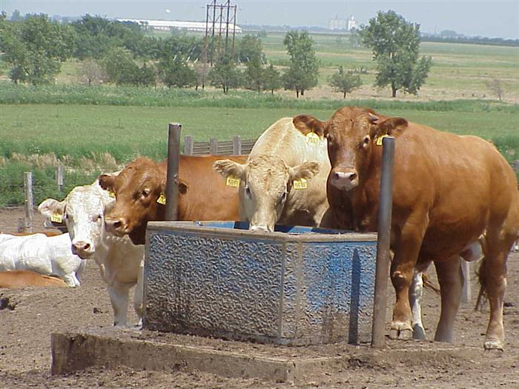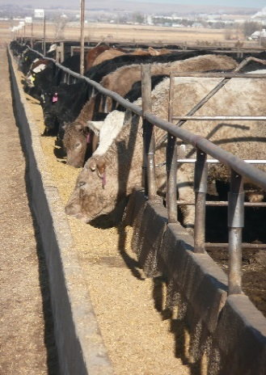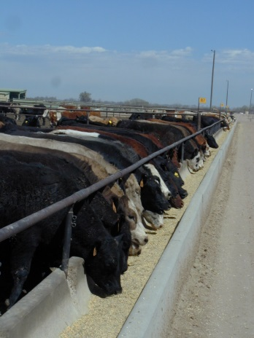

April 2017

**February 2017**

**NAHMS Antimicrobial Use on U.S. Feedlots, 2017 Study**

From May through August 2017, the USDA’s National Animal Health Monitoring System (NAHMS), in collaboration with the National Agricultural Statistics Service (NASS), will conduct a national study focusing on how antimicrobials are used on feedlots in the United States. The NAHMS Antimicrobial Use on   
U.S. Feedlots, 2017 study represents a new data collection and reporting effort for NAHMS, intended to   
be repeated biennially. In particular, this national study will examine antimicrobial use and stewardship practices on feedlots with a capacity of at least 50 head.

**Background**

The USDA Antimicrobial Resistance Action Plan, released in 2015, recommended that USDA agencies perform enhanced monitoring of antimicrobial use in food-producing animals. In addition, beginning on January 1, 2017, the Food and Drug Administration (FDA) initiated policy changes regarding the use of antimicrobials in food-producing animals. These changes include

1. Eliminating the use of medically important antimicrobials for growth promotion purposes in food-producing animals, and
2. Requiring veterinary oversight for use of medically important antimicrobials in animal feed or water.

**Study objectives**

The NAHMS Antimicrobial Use on U.S. Feedlots, 2017 study will gather information on antimicrobial-use practices in 2016, before implementation of FDA policy changes. Specific objectives of the study follow:

* Describe antimicrobial-use practices in feed and water on feedlots with a capacity of at least 50 head.
* Estimate the percentage of feedlots administering and the percentage of cattle receiving specific antimicrobials in feed and water by reasons for use.
* Provide baseline data on antimicrobial-use practices in place prior to implementation of FDA policy changes. This baseline can be used for evaluating trends over time.
* Describe antimicrobial stewardship practices on   
  U.S. feedlots.



**Study activities**

Participants with a feedlot capacity of at least 50 head (see map above) will be asked to provide information on antimicrobial use and stewardship practices. No biologic testing will be performed. The timeline for the study is follows:

* In May 2017, representatives from NASS will contact producers to inquire about their interest in participating in the study. NASS’ role will be to obtain producers’ consent for study participation.
* Beginning July 2017, feedlot operators who agreed to participate in the study will be contacted by APHIS personnel to schedule an in-person interview, which will be conducted by an APHIS veterinarian.
* Data collection will end in August 2017.

**How the U.S. beef industry and feedlot operators will benefit from participating in the study**

* Information on antimicrobial-use practices will provide transparency to consumers and others regarding why antimicrobials are used in cattle feed and/or water.
* Information will also be provided on the percentage of operations using specific antimicrobials in cattle feed and/or water.
* Information from this study will provide a national snapshot of antimicrobial stewardship practices, such as recordkeeping related to antimicrobial use and whether a veterinarian was consulted in the decision to use antimicrobials.

**A scientific approach**

NAHMS collects and reports accurate and useful information on animal health and management in the United States. Since 1990, NAHMS has developed national estimates on disease prevalence and other factors related to the health of U.S. beef cattle, sheep, goat, dairy cattle, swine, equine, poultry, and catfish populations. The science-based results produced by NAHMS have proven to be of considerable value to the U.S. livestock, poultry, and aquaculture industries as well as to other animal health stakeholders. NAHMS studies are

* National in scope,
* Science based,
* Statistically valid,
* Collaborative,
* Voluntary, and
* Confidential.

**Confidentiality**

NAHMS is a statistical unit under the Confidential Information Protection and Statistical Efficiency Act (CIPSEA). All information acquired for the Antimicrobial Use on U.S. Feedlots, 2017 study will be used for statistical purposes only and will be treated as confidential in accordance with CIPSEA guidelines. Only summary estimates based on the inference population will be reported. Data collected under CIPSEA are protected from Freedom of Information (FOIA) Requests.

**For more information, contact:**

USDA–APHIS–VS–CEAH

NRRC Building B, M.S. 2E7

2150 Centre Avenue

Fort Collins, CO 80526-8117

970.494.7000

Email: NAHMS@aphis.usda.gov

Or visit NAHMS at: http://nahms.aphis.usda.gov

#634.0417

**____________________________________**

The U.S. Department of Agriculture (USDA) prohibits discrimination in all its programs and activities on the basis of race, color, national origin, age, disability, and where applicable, sex, marital status, familial status, parental status, religion, sexual orientation, genetic information, political beliefs, reprisal, or because all or part of an individual’s income is derived from any public assistance program. (Not all prohibited bases apply to all programs.) Persons with disabilities who require alternative means for communication of program information (Braille, large print, audiotape, etc.) should contact USDA’s TARGET Center at (202) 720–2600 (voice and TDD). To file a complaint of discrimination, write to USDA, Director, Office of Civil Rights, 1400 Independence Avenue, S.W., Washington, D.C. 20250–9410, or call (800) 795–3272 (voice) or (202) 720–6382 (TDD). USDA is an equal opportunity provider and employer.

Photographs courtesy of Judy Rodriguez