U.S. Department of Agriculture, Food and Nutrition Service (FNS),

OMB Control Number: 0584-0591 Expiration date: xx/xx/xxxx

Special Supplemental Nutrition Program for Women, Infants and Children (WIC)

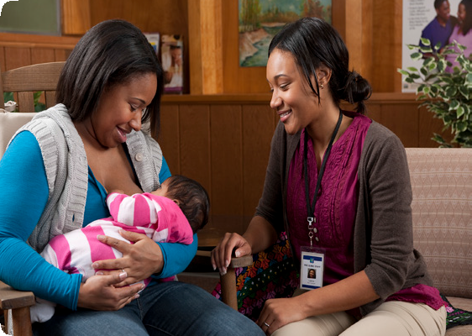

Loving Support Award of Excellence
Gold Premiere and Gold Elite Award Application

Local Agency Name Street Address

Cover Sheet
City, State, Zip code Applicant’s Name and Title Telephone Number

Email address Date

Public reporting burden for this collection of information is estimated to average 2 hours per response, including the time for reviewing instructions, searching existing data sources, gathering and maintaining the data needed, and completing and reviewing the collection of information. An agency may not conduct or sponsor, and a person is not required to respond to, a collection of information unless it displays a currently valid OMB control number. Send comments regarding this burden estimate or any other aspect of this collection of information, including suggestions for reducing this burden, to:
U.S. Department of Agriculture, Food and Nutrition Services, Office of Research and Analysis, Room 1014, Alexandria, VA 22302 ATTN: PRA (0584- 0591). Do not return the completed form to this address.

Loving Support Award of Excellence

DOWNLOAD AND SAVE INSTRUCTIONS FROM FNS PUBLIC WEBSITE BEFORE
BEGINNING APPLICATION. In order to be eligible to apply for an award, your local agency must first be able to verify the following question.

1. Have you completed the Gold Award application for this application? Yes ☐
Application

PEER COUNSELING
1. Do you have established guidelines for how many hours of observation/ shadowing is required as part of peer counseling training/continuing education? | Yes ☐ | No ☐
2. Do you have an IBCLC on staff or do you contract with an IBCLC to serve as a referral source for peer counselors? | Yes ☐ | No ☐
3. Do you have a referral process in place between hospitals and the WIC Program to facilitate peer counselor follow-up care for newly-delivered WIC mothers after discharge? | Yes ☐ | No ☐
4. Do you have a system that electronically documents and tracks peer counseling referrals and contacts? | Yes ☐ | No ☐
5. Do you have policies and procedures for home visits as part of your peer counseling program?  Attach supportive documentation.  Fill in the document title and indicate the page number(s) where the information that answers the question can be found. | Yes ☐Document Title  Page Number(s) | No ☐
6. Do you have policies and procedures for hospital visits as part of your peer counseling program?  Attach supportive documentation. Fill in the document title and indicate the page number(s) where the information that answers this question can be found. | Yes ☐Document Title  Page Number(s) | No ☐

7. Do you have a recognition program in place to acknowledge peer counselor accomplishments? | Yes ☐ | No ☐
8. Do you include career path structures for upward mobility of peer counselors? | Yes ☐ | No ☐
9. Do you have policies and procedures for peer counselors to communicate via social media technologies, e.g., Facebook, text messaging, Twitter, Skype or PalTalk?  Attach narrative and supportive documentation that indicate existing policies and procedures for peer counselors to communicate via social media technologies.  Fill in both document titles and indicate the page numbers(s) that corresponds to each document. | Yes ☐Narrative Title  Document Title Page Number(s) | No ☐
10. Do you ensure that peer counselors are solely dedicated to peer counselor support for breastfeeding, or, if you allow peer counselors to work in dual-role positions, do you ensure that those positions do not compromise the intent and purpose of the BFPC program? | Yes ☐ | No ☐
PARTNERSHIP
A partnership is defined as a sustainable ongoing voluntary collaborative agreement between two or more parties based on mutually agreed objectives and a shared vision, generally within a formal structure.
The partners agree to work together to achieve a common goal, undertake specific tasks, and share risks, responsibilities, resources, competencies and benefits in order to provide breastfeeding support throughout the continuum of care.
11. Does the partnership have a written agreement or a Memorandum of Understanding?  Attach supportive documentation. Fill in the document title and indicate the page number(s) where the information that answers this question can be found. | Yes ☐  Document Title  Page Number(s) | No ☐
12. Have new policies or procedures been developed because of the partnership? Please describe the new procedures in a narrative, or attach supportive documentation, that indicates policies or procedures have been developed as a result of the partnership.  Attach supportive documentation. Fill in the document title and indicate the page number(s) where the information that answers this question can be found. | Yes ☐  Document Title Page Number(s) | No ☐
13. Does the partnership have a plan for sustainability? | Yes ☐ | No ☐
14. Do you partner with stakeholders such as the American Hospital Association to support the Baby-Friendly Hospital Initiative in your community? | Yes ☐ | No ☐
OTHER CRITERIA
15. Do you have a supportive clinic environment that implements breastfeeding-friendly workplace polices for WIC staff?  Attach supportive documentation. Fill in the document title and indicate the page number(s) where the information that answers this question can be found | Yes ☐Document Title Page Number(s) | No ☐
16. Do you provide funding or work hours for education and training for staff to pursue certifications and advanced credentials in breastfeeding? (e.g. CLC, CLE, IBCLC)  Attach supportive documentation. Fill in the document title and indicate the page number(s) where the information that answers this question can be found | Yes ☐Document Title  Page Number(s) | No ☐
17. Do you provide around the clock assistance to assist mothers working through their breastfeeding problems?  Attach narrative. Fill in narrative title. | Yes ☐Narrative Title | No ☐

Loving Support Award of Excellence Gold Premiere/Gold Elite Application 4

Loving Support of Excellence Gold Award Application Checklist

Please review the checklist prior to submitting application and supportive documentation.

You must be eligible for the Gold Award (30 points) to apply for the Gold Premiere and Gold Elite Award. | Yes ☐ | No ☐
Verify that you have met the performance data criteria. | Yes ☐ | No ☐
Narratives and/or supportive documentation must be attached to the application to be eligible for an Award. | Yes ☐ | No ☐
If attaching supportive documents make sure you indicate the page number(s) where the information that answers the question can be found. | Yes ☐ | No☐
Please enter the full name of your Local Agency without abbreviations or acronyms and complete the Application Verification Form on page 6 of the Application. | Yes ☐ | No ☐

Loving Support Award of Excellence Gold Premiere/Gold Elite Application 5

The State agency and FNS reserve the right to verify all information on the application and reject applications that are incomplete or otherwise fail to provide accurate information.

Loving Support Award of Excellence Applicant Verification Form

Please read the following statement and sign below if you agree:

I have reviewed this application, and I attest to the accuracy of the information provided. I agree to maintain the standards and procedures indicated in this application for the duration of our award period. Furthermore, I agree to cooperate with USDA and other organizations, upon request, to publicize our efforts.

Local Agency Applicant’s Name Date

Please upload your completed application and supporting documentation to

Thank you for applying for the Loving Support Award of Excellence.
For more information, visit the FNS/WIC Website: http://www.fns.usda.gov/wic/breastfeeding-promotion-and-support-wic.

Loving Support Award of Excellence Gold Premiere/Gold Elite Application 6

