U.S. Department of Agriculture, Food and Nutrition Service (FNS),
Special Supplemental Nutrition Program for Women, Infants and Children (WIC)

Loving Support Award of Excellence Gold Premiere and Gold Elite Award Evaluation Worksheet

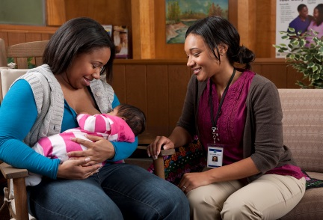

Public reporting burden for this collection of information is estimated to average 1.2 hours per response, including the time for reviewing instructions, searching existing data sources, gathering and maintaining the data needed, and completing and reviewing the collection of information. An agency may not conduct or sponsor, and a person is not required to respond to, a collection of information unless it displays a currently valid OMB control number. Send comments regarding this burden estimate or any other aspect of this collection of information, including suggestions for reducing this burden, to: U.S. Department of Agriculture, Food and Nutrition Services, Office of Research and Analysis, Room 1014, Alexandria, VA 22302 ATTN: PRA (0584-0591). Do not return the completed form to this address.

