**APPENDIX A.1: PARTICIPANT SURVEY INTRODUCTORY LETTER – ENGLISH**

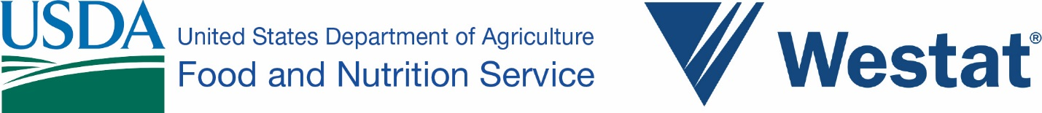

OMB Number: XXXX-XXXX

Expiration Date: XX/XX/20XX

{FIRST NAME} {LAST NAME}

{STREET ADDRESS}

{CITY}, {STATE} {ZIP CODE}

Dear {FIRST NAME} {LAST NAME}:

The Food and Nutrition Service (FNS) of the U.S Department of Agriculture (USDA) needs your help in an important survey. FNS is the federal agency that offers {NAME OF STATE SNAP PROGRAM} (also known as SNAP or the Food Stamp program), which is run by your state. We are trying to understand where people shop for groceries, why they buy certain foods, and what effect this has on their diet and health. As someone who participates in {NAME OF STATE SNAP PROGRAM}, you have been selected at random to participate in this study.

Participation is easy. We are asking you to complete the survey in this package and mail it back in the enclosed envelope. The survey asks questions about where you shop, the foods you buy and eat, how you prepare meals, and information about your household. After we receive your completed survey, we will send you $20 as a token of our thanks for your participation.

We hope you decide to join the study. Participation in this study is strictly voluntary. If you decide not to participate, there will be no penalty or loss of benefits. You can skip any questions you do not want to answer.

Westat, a research organization working for FNS, is conducting the survey. Your answers will be kept private. They won’t be seen by anyone other than the research team. Your answers will be put together with answers from others taking the survey. The results will be reported as totals so that no one person can be identified. Your name will not be recorded on your completed survey.

The enclosed $2 is our gift to you, to thank you for your consideration for doing the survey. You are free to keep the money, even if you do not complete the survey. [FOR VA ONLY] Acceptance of the $2 or $20 for completing the survey will not impact your eligibility for social service benefits currently being received. Thank you in advance for your help. If you have any questions, please call Westat toll-free at 1-800-xxx-xxxx.

Sincerely,

Rosemarie Downer, Ph.D. Maeve Gearing, Ph.D.

Project Officer Project Director

Food and Nutrition Service, USDA Westat

According to the Paperwork Reduction Act of 1995, an agency may not conduct or sponsor, and a person is not required to respond to, a collection of information unless it displays a valid OMB control number. The valid OMB control number for this information collection is XXXX-XXXX. The time required to complete this information collection is estimated to average 2 minutes per response, including the time for reviewing instructions, searching existing data resources, gathering and maintaining the data needed, and completing and reviewing the collection of information.