Attachment F-1. Screener form and registration for focus groups with women enrolled and not enrolled in Z-CAN
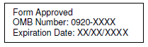

Focus Group Registration
The University of Puerto Rico, along with collaborating partners, Total Solutions, Inc., PROGyn, and the Centers for Disease Control and Prevention (CDC), is conducting focus groups to learn more about the experiences women in Puerto Rico have accessing birth control. Focus groups are guided discussions that allow individuals the opportunity to express their views in a group environment.

To see if you qualify to participate in these focus groups, we will need to ask you some personal questions. Your answers will be kept private. You can choose not to answer any question or stop at any time.

May we ask you the questions to see if you are a good match for these focus groups?
₁ Yes [CONTINUE]
₂ No [IMMEDIATELY TERMINATE]

  - What is your sex?
₁ Female
₂ Male [INELIGIBLE – IMMEDIATELY TERMINATE]
₉ Prefer not to answer [INELIGIBLE]

  - How old are you?
Age__________ [INELIGIBLE IF UNDER 18]

  - Which of the following best describes you?
₁ I am currently pregnant [INELIGIBLE]
₂ I am trying to become pregnant within the next 12 months. [INELIGIBLE]
₃ I cannot become pregnant. [INELIGIBLE]
₄ I have no plans to become pregnant within the next 12 months.
₉ Prefer not to answer [INELIGIBLE]

  - Have you had sex in the past 3 months?
₁ Yes
₂ No [INELIGIBLE]
₉ Prefer not to answer [INELIGIBLE]

  - Do you currently reside in Puerto Rico?
₁ Yes
₂ No [INELIGIBLE]
₉ Prefer not to answer [INELIGIBLE]

  - Are you able to participate in a group discussion in Spanish?
₁ Yes
₂ No [INELIGIBLE]
₉ Prefer not to answer [INELIGIBLE]

  - Have you received contraceptive services through the Z-CAN program?
₁ Yes
₂ No
₉ Prefer not to answer [INELIGIBLE]

  - In what region do you live in Puerto Rico? (refer to below map)
₁ West
₂ North
₃ Southwest
₄ Metro-North
₅ Southeast
₆ Northeast
₇ East
₈ San Juan
₉ Prefer not to answer

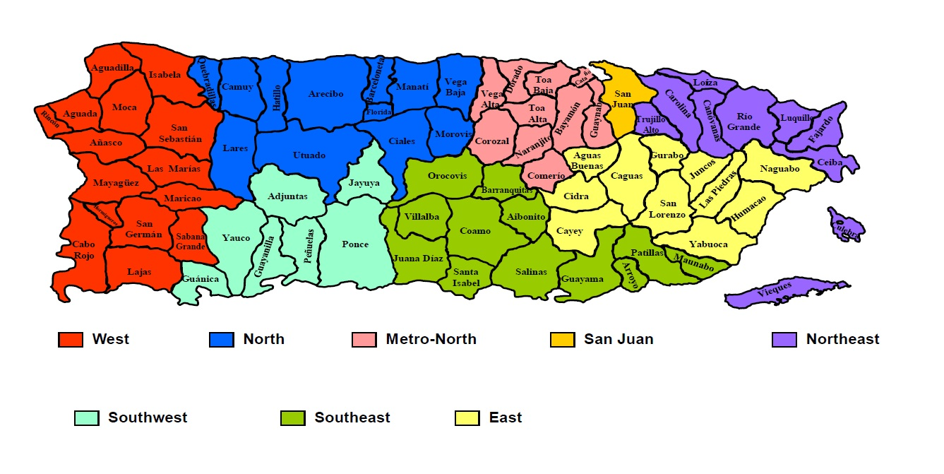

If eligible – Invitation:
Thank you for answering all of the questions. You are eligible to take part in the focus group. Can we contact you to participate in the focus group?
₁ Yes [CONTINUE]
₂ No [INELIGIBLE]

What is your first name? _________________________
What is your personal email address? _________________________
What is your phone number? _________________________

If ineligible – Closing:
Thank you for answering all of the questions. You are not eligible to be in the focus group because you did not meet our eligibility criteria. These reasons were decided on earlier by the collaborators. We value your time and interest. Thank you for being willing to help us.

