Appendix E-1. Recruitment flyer for focus groups with women enrolled and not enrolled in Z-CAN
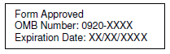
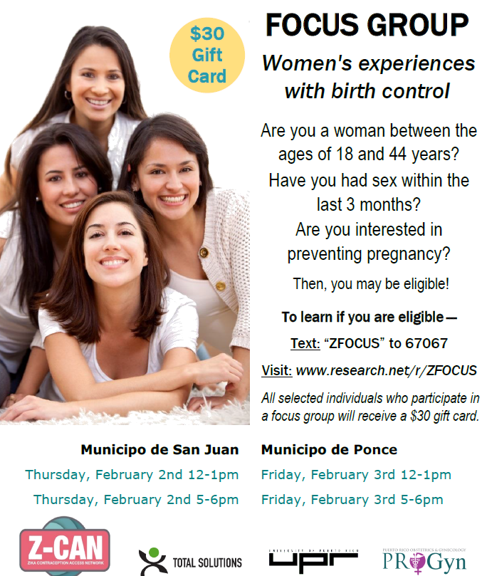
$50 Gift Card
Are you a woman age 18 or older?

