Attachment 2b

60-Day Federal Register Notice Comments and Response

Attachment 2b. 60-Day Federal Register Notice Comments and Response
Public comment:
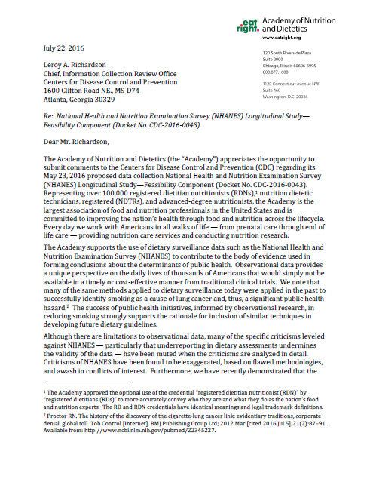
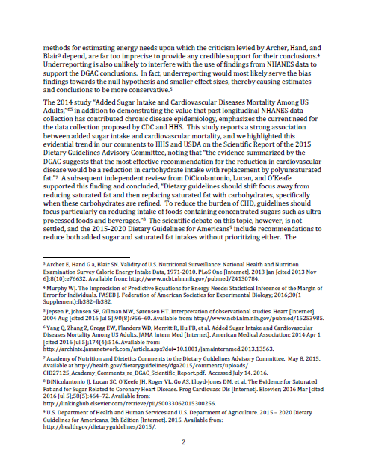

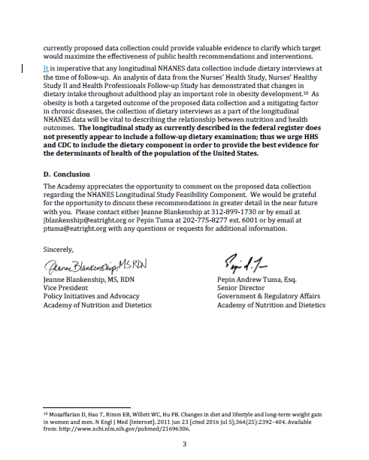
Agency response:
August 15, 2016

Jeanne Blankenship, MS, RDN
Vice President
Policy Initiatives and Advocacy
Academy of Nutrition and Dietetics

Pepin Andrew Tuma, Esq.
Senior Director
Government & Regulatory Affairs
Academy of Nutrition and Dietetics

120 South Riverside Plaza
Suite 2000
Chicago, Illinois 60606-6995

1120 Connecticut Avenue NW
Suite 460
Washington, DC 20036

Subject: Re: Re: National Health and Nutrition Examination Survey (NHANES) Longitudinal Study - Feasibility Component (Docket No. CDC-2016-0043)

Dear Ms. Blankenship and Mr. Tuma,

Thank you for your letter on behalf of the Academy of Nutrition and Dietetics (the “Academy”) regarding the National Health and Nutrition Examination Survey (NHANES) Longitudinal Study. NHANES appreciates both your expression of how our past survey data has been of use to your organization and your comments regarding this current project. We are pleased to be among the data sources the Academy finds useful.
We have noted your request to include a dietary interview component in the NHANES Longitudinal Study. In response we would like to clarify that the project described in the current Notice is only for the feasibility portion of the NHANES Longitudinal Study and is a logistical test to see whether and how a follow-up survey can be practically carried out with reasonable response rates. As such, we only included a very limited scope of components in this initial testing. If the response rate for the longitudinal study’s feasibility component reaches 70% or higher, then planning would be proceeded for the full longitudinal project. At that time, we would have an open proposal process to solicit additional content for components to include in the full study. We would welcome your organization as well as others in the research community to participate in the proposal process and help our planning for the full NHANES longitudinal study. We hope you understand the iterative nature of this investigative project. Thank you again for your interest in NHANES studies.
Sincerely,

The NHANES Longitudinal Investigative Team

