Attachment 4a

Advance Materials for Contacting Presumed Living Participants

Appendix 4a-1. The “Welcome back to the NHANES” Letter – Word Document
Appendix 4a-2. Example of the “Welcome back to the NHANES” Letter with Letterhead
Appendix 4a-3. The Reminder Letter
Appendix 4a-4. The Reminder Card
Appendix 4a-5. Example Letter with Assistance Note in Traditional Chinese

Attachment 4a. Advance Materials for Contacting Presumed Living Participants
The advance materials are designed to encourage participation and to establish rapport with the participants by providing options for them to contact us via internet or telephone prior to the home visit. There are three advance mailings prepared for participants with no vital records indicating death prior to the follow-up:
- The “Welcome back to the NHANES” package
- Send to the participant’s last known address 28 days prior to the start of home visits to make the initial contact
- Use Priority Mail with the “Address Service Requested” option
- Content:
- A letter to invite participation (Appendices 4a-1 and 4a-2)
An infographic will be embedded in the letter to highlight race-ethnicity specific diabetes data from NHANES for participants with different race and Hispanic origin. For example, non-Hispanic Asian participants will be given a letter with an infographic highlighting results for Asian Americans. This design is to help connect participants with different race and Hispanic origin to the survey. Please see examples in Appendices 4a-2 and 4a-5.
- The NHANES magnet - same magnet they received at the baseline to jog their memory of previous participation.
- $2 cash as a token of appreciation to encourage continued participation. According to a meta-analysis published in 2015, which quantified the dose-response relationship between monetary incentives and response rates among 40 household surveys across the past 21 years, the expected increase in response rate for a $2 incentive in a mailed solicitation to participate was 10 percentage points.
- The reminder letter
- Send to the participant 14 days later, if the welcome-back letter was delivered successfully, but no response was received from the participant
- Use First Class Mail
- Content:
- A reminder letter (Appendix 4a-3), and
- A blank debit card: at the end of the home visit, the Health Representative will verify and activate the card and have remuneration added electronically
- A replacement card will be provided as needed
- For participants who have responded to the first welcome-back letter, the debit card will be delivered by the Health Representative at the end of the home visit
- The reminder card (Appendix 4a-4)
- Send to the participant 7 days after the reminder letter, if no response was received from the participant
- Use First Class Mail

All letters/cards will be available in English and Spanish. Asian language assistance will be available via telephone. During the original NHANES interview, several participants requested that material be mailed to them in specific Asian languages. For these participants, a note in the specified language will be included in the letters to provide a toll-free number for them to call and receive assistance. Please see Appendix 4a-5 for an example in traditional Chinese.

Appendix 4a-1. The “Welcome back to the NHANES” Letter – Word Document

Reading Level: 9.1

--------------------------------------------------------------------------------------------------------------------------------

Dear {SP’S PREFIX} {SP’s Name}:

Thank you for participating in the 20XX National Health and Nutrition Examination Survey (NHANES). Your participation has helped us understand some of the most important health issues of our time. The National Center for Health Statistics, part of the Centers for Disease Control and Prevention, is conducting a follow-up study focusing on certain health conditions like diabetes and heart disease. We would like to invite you to take part in this study. This time, we will conduct the study at your home, and it should take about an hour. Your information will be linked to your prior NHANES data to help us understand how health changes over time.

Participants like you have provided important health information. For example, combining your health information with others, we have learned more about diabetes (see box on the right). Collecting this health information may help treat and prevent these health conditions in the future. That’s why your participation is important!

A NHANES Health Representative will come to your home to tell you more about the study. Your participation is voluntary. You may choose not to answer any question and you can stop participation at any time. The information that you give will be kept private.

To make it easier for you to participate, you can arrange an appointment for the study either online at www.cdc.gov/nchs/nhanes-ls or use the QR code on the back of this letter, or by phone at 1-XXX-XXX-XXXX. Your user ID is XXXXXX, and your password is XXXXXX.

We have enclosed a $2 bill as a token of appreciation for your continued support. We hope you will agree to be part of this important health study. If you have any questions about this study please call us, toll-free, at 1-800-452-6115, Monday-Friday, 7:30 AM-4:30 PM EST. Thank you in advance for your help.

Sincerely,

Kathryn S. Porter, MD, MS, FACPM
Captain, U.S. Public Health Service
Director, Division of Health and Nutrition Examination Surveys
National Center for Health Statistics, Centers for Disease Control and Prevention

Appendix 4a-2. Example of the “Welcome back to the NHANES” Letter with Letterhead
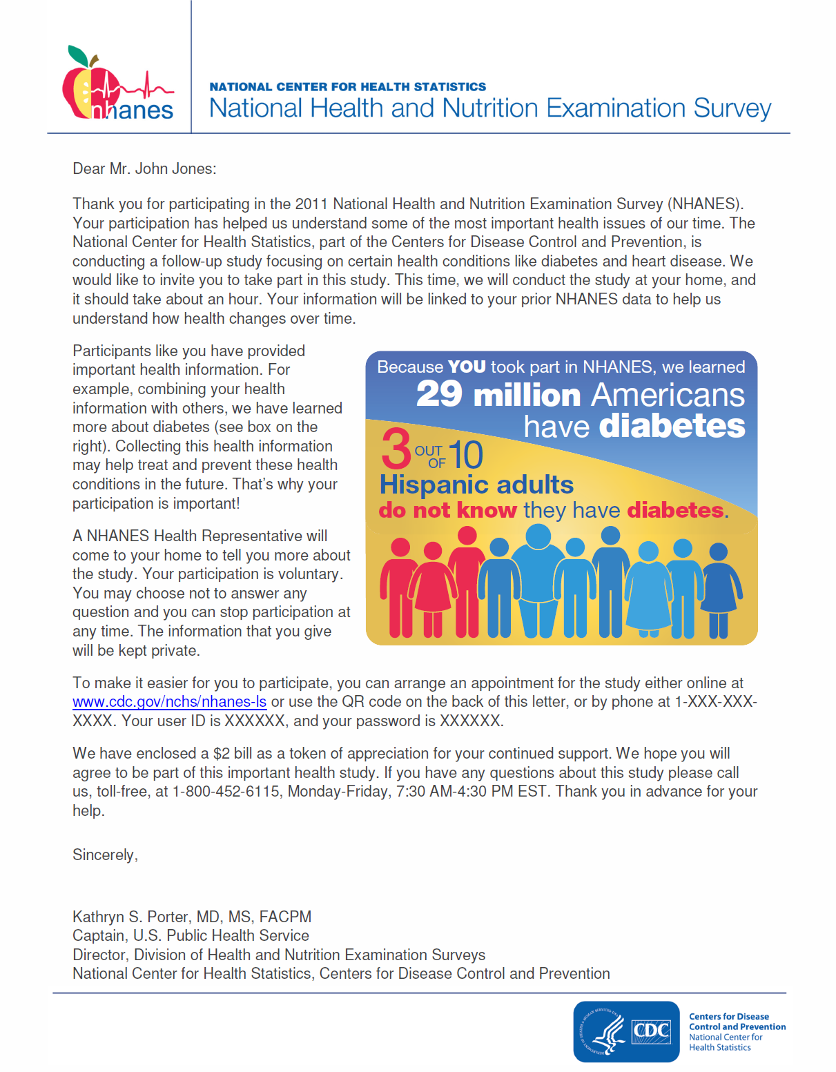

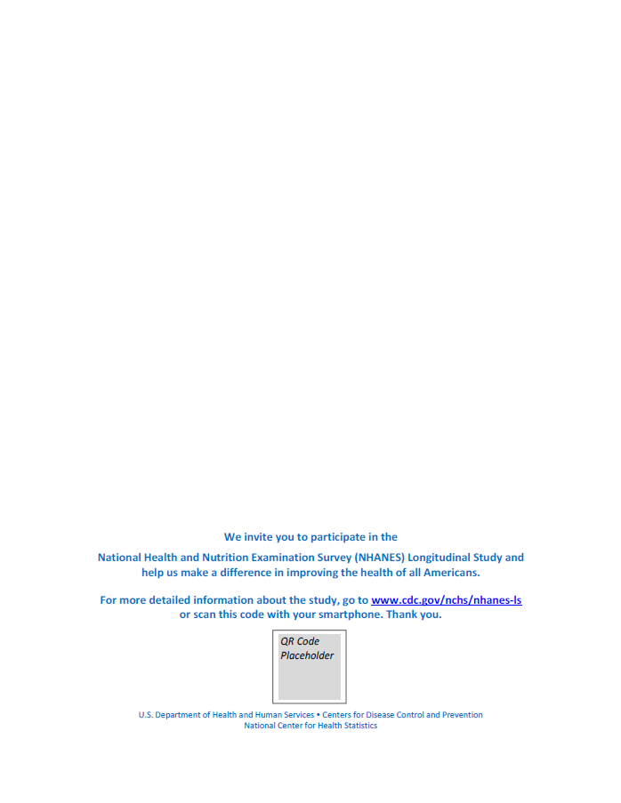

Appendix 4a-3. The Reminder Letter
Reading Level: 9.7

--------------------------------------------------------------------------------------------------------------------------------

Dear {SP’S PREFIX} {SP’s Name}:
Recently, we sent you a letter inviting you to participate in a health study which is an extension of the National Health and Nutrition Examination Survey (NHANES). The study, conducted by the National Center for Health Statistics, which is part of the Centers for Disease Control and Prevention, will focus on health conditions like diabetes and heart disease. If you decide to participate, the one hour interview and exam will take place at your home.

Enclosed is a debit card. When you participate, we will add $80 to the debit card after the home visit as a thank you for your continued support.

For your convenience, you can arrange an appointment for the study either online at www.cdc.gov/nchs/nhanes-ls or use the QR code on the back of this letter, or by phone at 1-XXX-XXX-XXXX.

Your user ID is XXXXXX, and your password is XXXXXX.

Please remember to keep your debit card in a safe place.

If you have any questions please call us, toll-free, at 1-800-452-6115, Monday-Friday, 7:30 AM-4:30 PM EST. We hope you will agree to continue to be part of this important health study. Thank you in advance for your help.

Sincerely,

Kathryn S. Porter, MD, MS, FACPM
Captain, U.S. Public Health Service
Director, Division of Health and Nutrition Examination Surveys
National Center for Health Statistics, Centers for Disease Control and Prevention
Appendix 4a-4. The Reminder Card
Reading Level: 7.4

--------------------------------------------------------------------------------------------------------------------------------

Welcome, NHANES Participant!

Thank you again for participating in the 2007 - 2014 National Health and Nutrition Examination Survey (NHANES). Your participation has helped us understand some of the most important health issues of our time!
Recently, we sent you letter inviting you to participate in a health study which is an extension of the NHANES with a focus on certain health conditions such as heart disease and diabetes. This time, we will conduct the interview and exam at your home. This will take about an hour. To thank you for continuing to take part in NHANES, we will give you a debit card for $80.
Please schedule your appointment at www.cdc.gov/nchs/nhanes-ls or use the QR code on the back of this card, or at 1-XXX-XXX-XXXX.
Your user ID is XXXXXX, and your password is XXXXXX.
We hope you will agree to continue to be part of this important health study. Thank you in advance for your help.

Appendix 4a-5. Example Letter with Assistance Note in Traditional Chinese
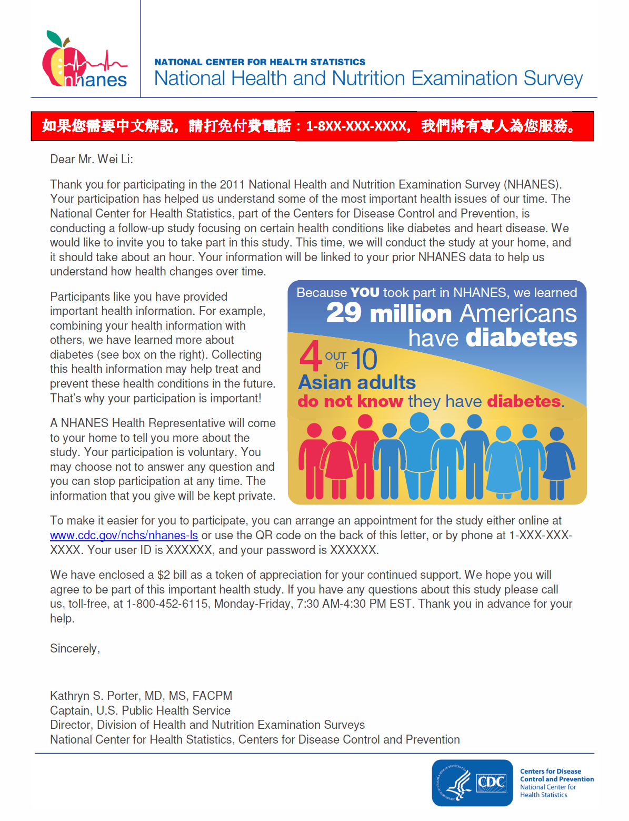

Mercer A, et al. How much gets you how much? Monetary incentives and response rates in household surveys. Public Opinion Quarterly, Vol. 79, No. 1, spring 2015, pp. 105–129.
The reminder card will be sent in an envelope via first-class mail.

