Mobile Messaging Intervention to Present New HIV Prevention Options for Men who have Sex with Men: Randomized Controlled Trial

OMB #0920-New

Section B: Supporting Statement

April 7, 2017

CONTACT
Gordon Mansergh, PhD
Project Officer
Centers for Disease Control and Prevention
Division of HIV/AIDS Prevention
1600 Clifton Road, NE, Mailstop E-37
Atlanta, GA 30333
Phone: 404-639-6135
Fax: 404-639-1950
E-mail: gcm2@cdc.gov

TABLE OF CONTENTS

- Respondent Universe and Sampling Methods
- Procedures for the Collection of Information
- Methods to Maximize Response Rates and Deal with No Response
- Tests of Procedures or Methods to be Undertaken
- Individuals Consulted on Statistical Aspects and Individuals Collecting and/or Analyzing Data

EXHIBITS

Exhibit 1.1: Summary of Recruitment Targets
Exhibit 2.1: Recruitment and Screening Procedures
Exhibit 5.1: Statistical Consultants

LIST OF ATTACHMENTS

Attachment 1 Authorizing Legislation

Attachment 2 60-day Federal Register Notice

Attachment 3 Recruitment Materials

Attachment 4 Data Collection Instruments
4a. Participant Screening Form
4b. Contact Information Form
4c. Assessment
4d. Online Screening Form
4e. Online Contact Information Form
4f. Online Assessment

Attachment 5 Consent Form

Attachment 6 Human Subjects Approvals
6a. Emory IRB Letter of Approval
6b. Public Health Solutions IAA
6c. University of Michigan IAA
6d. University of Pennsylvania IAA

Attachment 7 Intervention Messages

Respondent Universe and Sampling Methods

City Selection

This study will be carried out in three metropolitan areas in the United States: Atlanta, GA, Detroit, MI and New York City, NY. These cities were selected not only because they have high rates of HIV, but also because significant disparities in HIV among men who have sex with men (MSM) have been observed by race/ethnicity and age.

Atlanta is the southern study site. The South accounts for about half of all new HIV diagnoses in the United States; Georgia, as a state, ranks second in the rate of HIV diagnoses among US states, and as a city, Atlanta ranks second in the number of new HIV diagnoses among black/African American MSM. Marked racial disparities in HIV prevalence have been observed in the Atlanta metro, and HIV incidence among young black MSM has been estimated at nearly 11% per year.

The Detroit Metro Area (DMA) is one of the most racially segregated areas in the United States, and it is the state of Michigan’s HIV epicenter, accounting for 67% of all HIV/AIDS cases in the state. MSM account for 60% of HIV cases and more than two thirds of HIV-positive MSM statewide reside in Southeast Michigan.⁶ In 2010, black MSM accounted for 59% of all MSM cases, while White and Latino MSM account for 34% and 3%, respectively. Further, while the rate of new HIV infections in the DMA remained stable for most age groups from 2006 to 2010, incidence among youth (13-29) doubled.

New York City (NYC) was selected as a study site because it remains an area of high transmission in the HIV epidemic in the United States, with MSM accounting for the majority of infections. NYC surveillance data from the Department of Health and Mental Hygiene (DOHMH) show that approximately 58% of all new HIV diagnoses in 2013 were among MSM, with 46,562 residents living with diagnosed HIV. The HIV diagnosis rate among black males was 1.5 times higher than the rate among Hispanic males and >2 times higher than white males, and men aged 20-29 accounted for more than 40% of new HIV diagnoses.

Target population:
This study plans to sample 1,206 MSM living in the Atlanta, GA, Detroit, MI, or New York City, NY metropolitan statistical areas. Men recruited to the study will be at least 18 years in age, who have had anal sex with at least one man in the past 12 months. Across the three sites, we will ensure that at least 40% of participants are people of color (non-white or Hispanic) by quota sampling.

Inclusion criteria:
* Assigned male at birth
* Current, self-reported gender identity as “Male”
* Aged 18 or over
* Self-reported ability to read and understand English-language
* Resides or works in the Atlanta, GA, New York, NY, or Detroit, MI MSA.
* Self-reported anal sex with a male partner in the past 12 months
* Owns and uses an Android or iOS smartphone
* Is included in one of the following risk groups, by self-report:
- HIV seropositive
- HIV seronegative at “higher risk” (HIV-negative enrollees who report anal sex without using a condom and without taking PrEP in the past 3 months)
- HIV seronegative at “lower risk” (HIV-negative enrollees who report: 1) no anal sex or 2) no anal sex in which a condom or PrEP was not used in the past 3 months)

Exclusion criterion:
* Currently participating in another HIV prevention research study or program
* Participant’s phone or device does not support HealthMindr application
* Self-reported HIV status is indeterminate or does not know HIV status
* Tested positive for HIV for the first time in the past 6 months
* Has a plan to move out of the Atlanta, GA, New York, NY or Detroit, MI, MSA within in the next 9 months

As shown in Exhibit 1.1, men will be enrolled to achieve a balance of men by site and in the three risk groups: 1) MSM living with HIV, defined as eligible MSM who self-report their HIV status as HIV-positive; 2) HIV-negative MSM at higher-risk, defined as eligible MSM who self-report HIV status as “HIV negative” while also indicating incomplete or inconsistent use of condoms and/or PrEP; 3) HIV-negative MSM at lower-risk, defined as eligible MSM who self-report HIV status as “HIV negative” while also indicating complete and consistent use of condoms and/or PrEP.

Participants in the study will be randomly assigned to either the intervention arm or the waitlist control arm of the study. Participants assigned to the intervention arm will receive the intervention materials upon enrollment, and participants assigned to the waitlist control arm will receive the intervention materials after the study is complete.

Exhibit 1.1: Summary of Recruitment Targets
 | HIV-Positive |  | HIV-Negative
 |  |  | Lower Risk |  | Higher Risk
 | Intervention | Waitlist Control | Intervention | Waitlist Control | Intervention | Waitlist Control | Total MSM
Atlanta | 67 | 67 | 67 | 67 | 67 | 67 | 402
Detroit | 67 | 67 | 67 | 67 | 67 | 67 | 402
New York City | 67 | 67 | 67 | 67 | 67 | 67 | 402
Total | 201 | 201 | 201 | 201 | 201 | 201 | 1,206

Our recruitment goal will be to recruit a study-wide sample with at least 40% MSM of color (participants indicating American Indian or Alaska Native, Asian, black or African American, Hispanic or Latino, or Native Hawaiian or Pacific Islander), or a maximum of 60% white participants in the study-wide sample. Given the possibility that racial and ethnic compositions vary from site to site, we will not set fixed, within-site proportions for race or ethnicity, but on a study-wide basis. We expect that our participants of color will be present in roughly similar racial proportions as found nationally among people of color.

We will recruit men into the study through a combination of approaches, including online advertisement, traditional print advertisement, referral, in-person outreach, and through word of mouth (Attachment 3). If we notice that our recruitment is falling short of these goals, we will direct the recruitment contractor to change the mix of selected venues and recruitment strategies to increase recruitment where there are shortfalls and to discontinue recruitment in groups where group maxima have been reached. This will involve weekly review of recruitment data and weekly meetings with recruitment staff to assess efforts.

This is a randomized controlled trial which is primarily designed to make comparisons between the two study groups, not to make generalizations to the larger population. Given the focus on internal, as opposed to external, validity, we intend to use a convenience sampling methodology. Rather than using probabilistic methods (i.e., random selection with known, non-zero chances of selection for each unit in the population) to generate a sample, non-probability sampling requires researchers to use their subjective judgments, drawing on theory (i.e., the academic literature) and practice (i.e., the experience of the researcher and the evolutionary nature of the research process). Unlike probability sampling, the goal is not to achieve objectivity in the selection of the sample, or necessarily attempt to make statistical inferences from the sample being studied to the wider population of interest.

Rationale for proposed number of subjects
1,206 participants are required to determine the prevalence of testing behaviors among men in the intervention arm compared with men in the waitlist-control arm. The sample size of 1,206 is based on the minimum detectable effect size for the outcomes of the primary analyses, assuming 80% power, α=0.05, under the full sample size of 1,206 (100% retention), and of 964 (80% retention). For continuous partner numbers for CAI, we assumed a Poisson distribution with mean =2^{3,205}. Using the Wilcoxon test, we expect power to detect a mean decline of 0.26 in partner number (Poisson rate-ratio = 0.87) or more extreme. In analogous Poisson regression ANOVA-like models, we expect power for rate-ratio ≤ 0.83. For proportion outcomes, we assumed a waitlist-control arm (e.g., delayed onset) value of 50% for maximum variation. Using χ2 tests, we expect power to detect risk-ratios of 1.18 (OR = 1.44) or more extreme. Accounting for the study’s stratified design using logistic regression, we expect power to detect OR ≥ 1.68. Our sample size allows for a maximum 20% attrition rate over the project period, or approximately 7% attrition between assessment time-points (baseline, 3-month, 6-month, 9-month)

We will be consenting participants before the eligibility screener. Therefore, we will need to consent more than 1,206 persons in order to reach 1,206 participants who are eligible, and enroll in the study. We expect to consent 1693 persons, in order to reach 1,206 participants who are eligible and complete the baseline survey.

Procedures for the Collection of Information

To collect information for this study, we will use a quantitative assessment, approximately 1.5 hours in length and administered at baseline, 3-month, 6-month and 9-month follow-ups (Attachment 4c). All potential participants will complete a brief, two-phase screening process for eligibility (Attachment 4a-b), which includes initial screening and reverification of eligibility prior to consent and data collection, as outlined in Exhibit 2.1 below. In the first phase of screening, men will consent to screen and complete a brief screening online screening questionnaire (Attachment 4a). Eligible men will be asked to provide contact information (name, phone number and email address) through a separate online questionnaire (Attachment 4b). In the second phase of screening, men will be asked to verify their eligibility before enrolling in the study. Those who remain eligible will complete the corresponding informed consent (Attachment 5) and prior to completing the baseline assessment and being randomized to one of the two study arms.

Exhibit 2.2: Recruitment and Screening Procedures
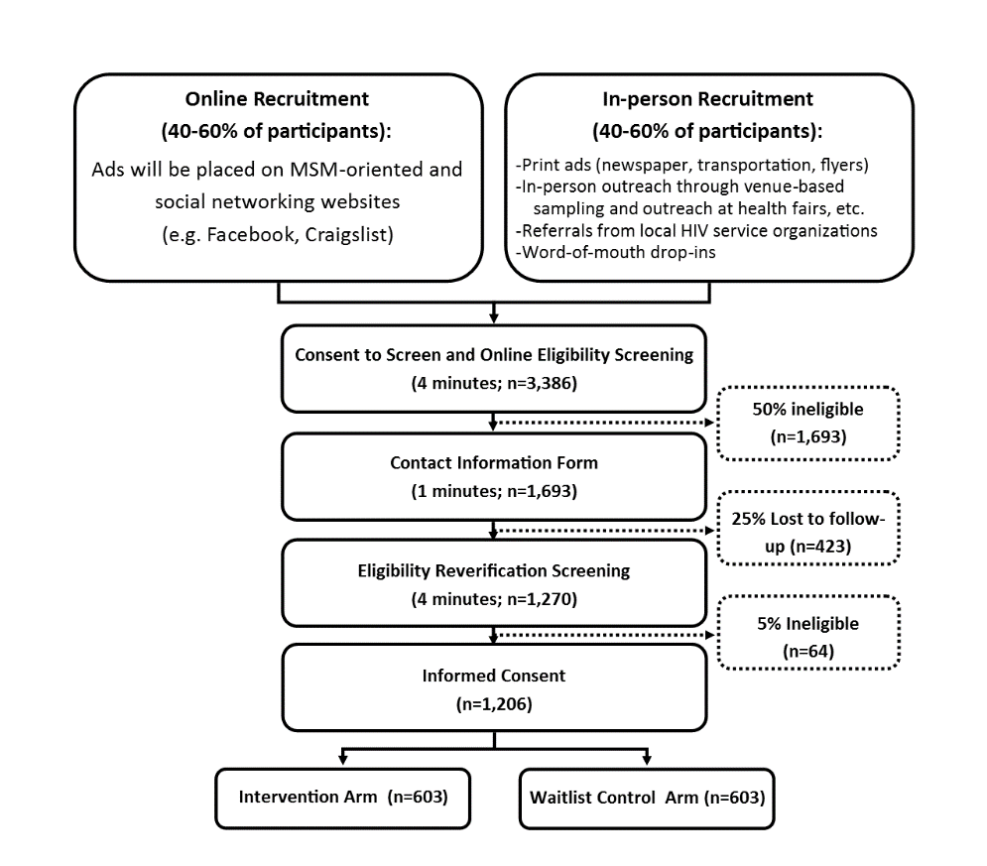
At enrollment, participants will be provided access to a computer with internet access at each study site. They will be directed to register an account which they will use to access the survey website, SurveyGizmo.com, with whom Emory has established secure and compliant business practices. Participants will self-administer the assessment survey (Attachment 4c) on four occasions: at baseline, 3-month, 6-month and 9-month follow-ups. Any participants who require assistance operating the computer, or those who require assistance due to literacy issues, will be provided assistance in a private room at the study site. Participants will be asked to present at their local study site to take the baseline assessment and the final, 9-month assessment, and will be instructed how and when to self-administer the 3-month and 6-month assessments online.

Participants are required to present in-person for study activities at baseline and at 9-month follow up. Participants presenting in-person at baseline will likely require some assistance from M-CUBED staff in setting up the M-CUBED intervention app and registering for access to the assessment survey. Providing access to M-CUBED staff at this stage is important for the retention of eligible participants. Set-up and installation of the M-CUBED intervention application, and sign-up for access to the assessment surveys, are both multi-step processes. If participants were asked to complete these steps remotely, without the on-site assistance of an M-CUBED staff member, there is a higher likelihood of user error, misunderstood directions, and potential for drop-outs. By requesting that participants present in-person for their baseline assessment, M-CUBED staff are given the opportunity to resolve any technical difficulties, or to provide clarification directly to participants when requested.

Participants presenting in-person for 9-month follow up assessment will also likely require direct assistance from M-CUBED staff. For participants in the intervention arm, M-CUBED staff will assist participants with the removal of the M-CUBED intervention application from their personal device, if such assistance is requested. For participants in the waitlist control arm, M-CUBED staff will provide access to the M-CUBED intervention app at the 9-month follow up, and assist participants in installing the app, if such assistance is requested. For both study arms, the in-person visit at 9-month follow up will also provide an opportunity to debrief participants on the study, and answer any participant questions that remain at the conclusion of study activities. While post-activity questions will also be answered remotely, the need to assist participants with installation or deletion of M-CUBED intervention app at 9-month follow up provides an opportunity to further personalize each participants’ experience through direct, interpersonal interaction with study staff.

The assessment survey will be used to establish baseline levels of HIV and sexual health behaviors, and to measures changes in these behaviors, by study arm, after participants have completed the mobile messaging intervention. The assessment will be used to collect outcomes information on men’s condom use behavior, number and type of sex partners, HIV and STI testing behaviors, health care engagement, and uptake and adherence to pre-exposure prophylaxis (PrEP) or antiretroviral therapy (ART), depending on HIV status. We will additionally collect participant socio-demographic information, information about participant technology use, and several other key covariates (e.g., substance use, intimate partner violence) that have been associated with HIV and sexual health behaviors in this population, as demonstrated by previous research.

Methods to Maximize Response Rates and Deal with No Response

We will use the following procedures to maximize cooperation and to achieve the desired high response rate:

- Participant accrual rates will be monitored by the recruitment contractor to maintain consistent and accurate procedures. Race/ethnicity will be tracked across all study sites to ensure that approximately 30% of participants are MSM of color. Within each study location, we will monitor MSM recruitment by targeted risk group to ensure that 134 HIV-positive MSM, 134 high-risk HIV negative, and 134 low-risk HIV negative MSM are recruited within each location. We anticipate a sample size of 1,206 for analysis with targets.
- If recruitment falls short we will work with the recruitment contractor and study staff to determine the best course of action, including recruiting additional participants at alternative MSM venues or changing the mix of recruitment strategies in the city or cities where additional participants are needed.
- Participants will receive a $50 token of appreciation at each in-person assessment (baseline and 9-months) and an online $10 pharmacy gift card (e.g. CVS Pharmacy, Walgreens, Rite-Aid) for each assessment that is completed remotely (immediate intervention post-test and 3-month post-intervention follow up at 3 and 6 month study time points). Participants who complete all study activities will receive a combined total of $120 (two $50 tokens, and two $10 pharmacy gift cards) in appreciation of their time and efforts across the various study activities.
- Online screening of interested individuals will be used to determine initial participant eligibility.
- All recruitment materials indicate the voluntary nature of the study and high participation is due in part to interest in the study and participation from individual respondents.

Tests of Procedures or Methods to be Undertaken

Our team includes experts with the HIV population and quantitative research, including screening and survey development and testing. We will conduct pretesting of the screening tool and assessment surveys on three to five qualified respondents to assess question wording, skip patterns, question sensitivity, and overall flow of the screener and assessment.

Individuals Consulted on Statistical Aspects and Individuals Collecting and/or Analyzing Data

Exhibit 5.1 below lists the project team members who were consulted on the aspects of research design and those who will be collecting and analyzing the data. Please note: The CDC staff are primarily responsible for providing technical assistance in the design and implementation of the research; assisting in the development of the research protocol and data collection instruments for CDC Project Determination and local IRB reviews; working with investigators to facilitate appropriate research activities; and analyzing data and presenting findings at meetings and in publications. The staff will neither collect data from nor interact with research participants. Data will be collected by members of contractor project staff listed. No individual identifiers will be linkable to collected data, and no individually identifiable private information will be shared with or accessible by CDC staff.

Exhibit 5.1: Statistical Consultants
Team Member | Organization | Phone | Email | Point of Contact
Gordon Mansergh | CDC | 404-639-6135 | gcm2@cdc.gov | Study Design POC / Data Analysis POC
Deborah Gelaude | CDC | 404-639-1905 | zoi1@cdc.gov
Evelyn Olansky | CDC Contractor | 404-639-6438 | ism9@cdc.gov
Patrick Sullivan | Emory University | 404-727-2038 | pssulli@emory.edu
Aaron Siegler | Emory University | 404-712-9733 | asiegle@emory.edu
Eli Rosenberg | Emory University | 404-712-8897 | esrose2@emory.edu | Data Analysis POC
Jennie McKenney | Emory University | 404-712-1269 | jennie.l.mckenney@emory.edu
Ryan Zahn | Emory University | 404-712-0123 | Ryan.j.zahn@emory.edu | Data Collection POC
Jose Bauermeister | University of Pennsylvania | 215-898-9993 | bjose@upenn.edu
Rob Stephenson | University of Michigan | 734-615-0149 | rbsteph@med.umich.edu
Daniela Lopez Vives | University of Michigan | 734-647-7260 | chilena@umich.edu
Sabina Hirshfield | Public Health Solutions | 646-619-6676 | shirshfield@healthsolutions.org
Martin Downing | Public Health Solutions | 646-619-6528 | mdowning@healthsolutions.org
Mary Ann Chiasson | Public Health Solutions | 646-619-6411 | machiasson@healthsolutions.org
Steven Houang | Public Health Solutions | 646-619-6443 | shouang@healthsolutions.org

References

Centers for Disease Control and Prevention. HIV Surveillance Report, 2013; vol. 25. http://www.cdc.gov/hiv/pdf/library/reports/surveillance/cdc-hiv-surveillance-report-vol-25.pdf
Centers for Disease Control and Prevention. Diagnosed HIV infection among adults and adolescents in metropolitan statistical areas—United States and Puerto Rico, 2013. HIV Surveillance Supplemental Report 2015; 20(4). http://www.cdc.gov/hiv/pdf/library/reports/surveillance/cdc-hiv-surveillancereport-vol20-no4.pdf
Sullivan PS, Peterson J, Rosenberg ES, et al. Understanding Racial HIV/STI Disparities in Black and White Men Who Have Sex with Men: A Multilevel Approach. PloS One. 2014;9(3):e90514.
Sullivan PS, Rosenberg ES, Sanchez TH, et al. Explaining racial disparities in HIV incidence in black and white men who have sex with men in Atlanta, GA: A prospective observational cohort study. Ann Epidemiology. 2015 Jun; 25(6): 445-54.
Farley R, Danzinger S, Holzer ZJ. Detroit Divided. New York: Russell Sage Foundation; 2000.
Michigan Department of Community Health. Annual HIV Surveillance Report, Michigan, July 2014. http://www.michigan.gov/documents/mdch/July_2014_full_report_465192_7.pdf
New York City Department of Health and Mental Hygiene. HIV Surveillance Annual Report, 2013. 2014 Dec. http://www.nyc.gov/html/doh/downloads/pdf/dires/2013-hiv-surveillance-annual-report.pdf

