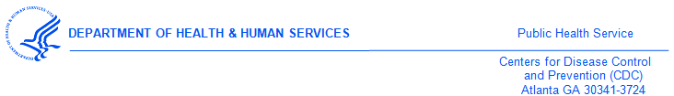

February 14, 2017

<<Medical Provider>>

<<Street1>>

<<Street2>>

<<city>><<state>><<zip>>

Dear <<Medical Provider>>,

I am writing to invite you to participate in the 2017 National Survey of Medical Providers on policies and practices for preventing or treating Sexually Transmitted Diseases (STDs). STDs, including congenital syphilis, are on the rise in the US and this survey will help CDC prioritize over $10 million dollars’ worth of clinical training, tools and guidelines, and investments. Your practice has been randomly selected from 814,000 medical providers across the United States. The survey seeks to understand your guidelines and practices regarding STD diagnosis, treatment, partner notification and treatment, reporting and disease control practices. This survey is sponsored by the Division of STD Prevention, an office of the U.S. Centers for Disease Control and Prevention (CDC).

This study is also supported by the American College of Physicians (ACP), the American Academy of Family Physicians (AAFP), the American Congress of Obstetricians and Gynecologists (ACOG), and the American College of Emergency Physicians (ACEP).

This survey should take about 20 minutes to complete. Once we receive your completed survey, we will send $40 as a token of appreciation for your participation in this important research.

Please complete the enclosed questionnaire and return it in the envelope provided. If you have any questions, please contact ICF, the independent health research firm hired to conduct this study. They can be reached toll-free at 1-###-###-#### or via email at [survey name]@icfsurveysupport.com.

Participation in the survey is voluntary. Survey responses will be kept private and only aggregate data will be analyzed or reported. Thank you in advance for your help as we recognize your time is valuable and your resources are limited with many competing priorities.

Sincerely,

Gail Bolan, MD

Director of Division of STD Prevention,

Centers for Disease Control & Prevention

1600 Clifton Road NE, Mailstop E-02

Atlanta, GA 30329-4027