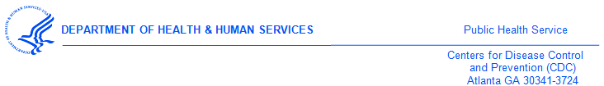DATE

<<Medical Provider>>
<<Street1>>
<<Street2>>
<<city>><<state>><<zip>>

Dear Dr. <<Medical Provider>>,

The Division of STD Prevention, an office of the U.S. Centers for Disease Control and Prevention (CDC) is conducting a study to understand medical providers’ policies and practices for preventing or treating Sexually Transmitted Diseases (STD). ICF, an independent health research firm, is conducting this survey for the CDC.
QR Code
Please access the survey online by going to:
www.URL.com
You will need to enter the following PIN to complete the survey: <<pin>>

If you have completed the survey we previously mailed to your practice, thank you!

If you have not yet completed the survey, please do so now by using the website and password provided below. The survey should take about 32 minutes. Once we receive your completed survey, we will send $40 as a token of appreciation for your participation in this important research

Please take a few minutes to complete the survey. Your practice has been randomly selected to help represent almost 814,000 physicians, and we cannot replace you with anyone else.

Participation in the survey is voluntary. Survey responses will be kept private and only aggregate data will be analyzed or reported. If you have any questions, please contact ICF. They can be reached via email at [survey name]@icfsurveysupport.com or toll-free at 1-###-###-####.

Thank you for your time and consideration. It’s only with the generous assistance from people like you that our research can be successful.

Sincerely,

Gail Bolan, MD
Director of Division of STD Prevention,
Centers for Disease Control & Prevention
1600 Clifton Road NE, Mailstop E-02
Atlanta, GA 30329-4027

