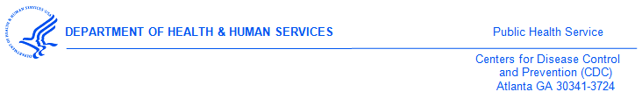

<<Medical Provider>>
<<Street1>>
<<Street2>>
<<city>><<state>><<zip>>

Dear Dr. <<Medical Provider>>,

Thank you for participating in the 2017 National Survey of Medical Providers on policies and practices for preventing or treating sexually transmitted diseases (STDs) for the Division of STD Prevention at the U.S. Centers for Disease Control and Prevention.

As a token of our appreciation for completing the survey, we have enclosed $40.
If you have any questions, please contact ICF at 1-###-###-#### or via email at [survey name]@icfsurveysupport.com.

Thank you again for assisting us in this very important research study.

Sincerely,

Gail Bolan, MD
Director of Division of STD Prevention,
Centers for Disease Control & Prevention
1600 Clifton Road NE, Mailstop E-02
Atlanta, GA 30329-4027

