**Attachment A: Pharmacy Eligibility and Registration Form**

A secure data submission Web site allows interested parties such as pharmacies and health systems to register and submit data. Registration takes about 5 minutes to complete and asks for contact information and other basic information. The following screen shots demonstrate the registration process.

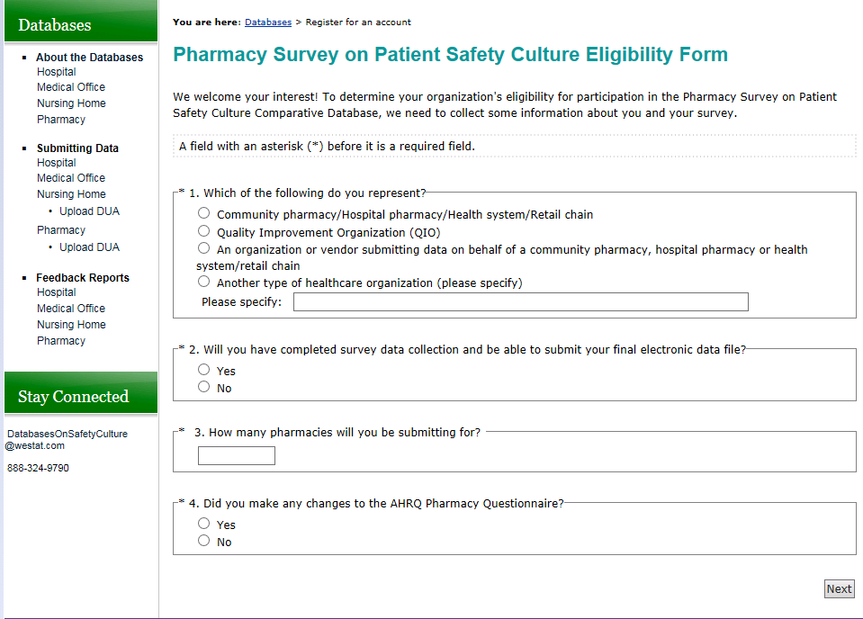

Public reporting burden for this collection of information is estimated to average 3 minutes per response, the estimated time required to complete the survey. An agency may not conduct or sponsor, and person is not required to respond to, a collection of information unless it displays a currently valid OMB control number.  Send comments regarding this burden estimate or any other aspect of this collection of information, including suggestions for reducing this burden, to: AHRQ Reports Clearance Officer Attention: PRA, Paperwork Reduction Project (0935-XXXX) AHRQ, 5600 Fishers Lane, Rockville, MD 20857.

