**Attachment G: Example Screen Shots of Pharmacy Survey on Patient Safety Culture Data Submission Web Site Information Collection**

Users upload the survey questionnaire they administered to enable us to determine whether any changes were made to the survey. They then link the survey to their pharmacies and upload individual-level survey data for each pharmacy. The screen shots below demonstrate the survey and data submission process.

Figure 1: Submit Questionnaire and Link Questionnaire to Pharmacies

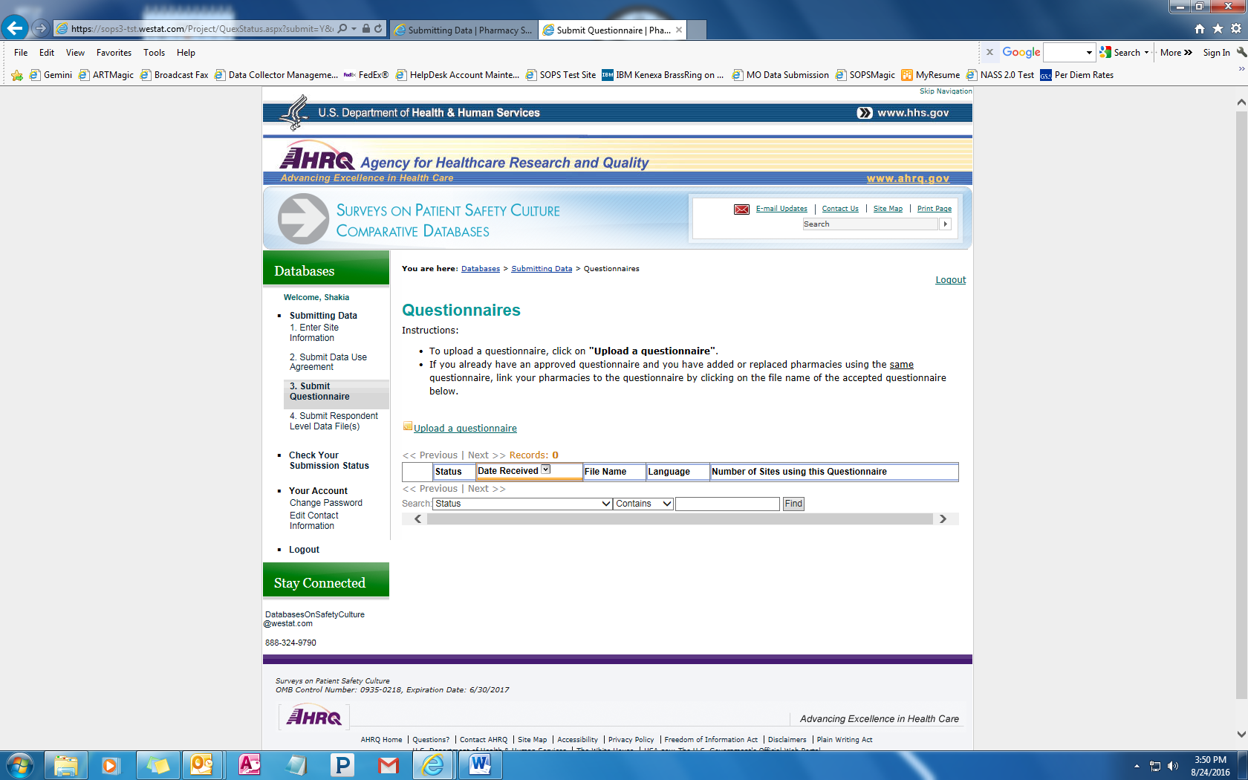

Figure 2: Submit Questionnaire and Link Questionnaire to Pharmacies

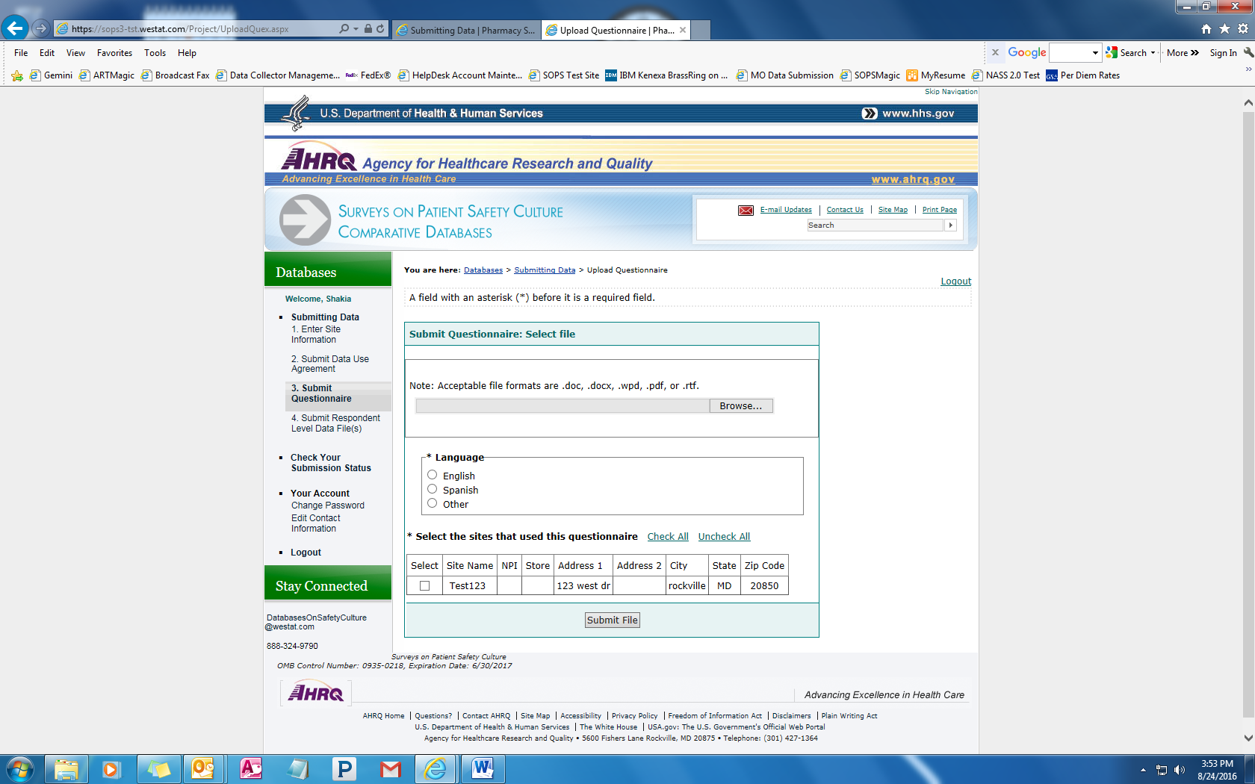

Figure 3: Upload Data for Each Participating Pharmacy

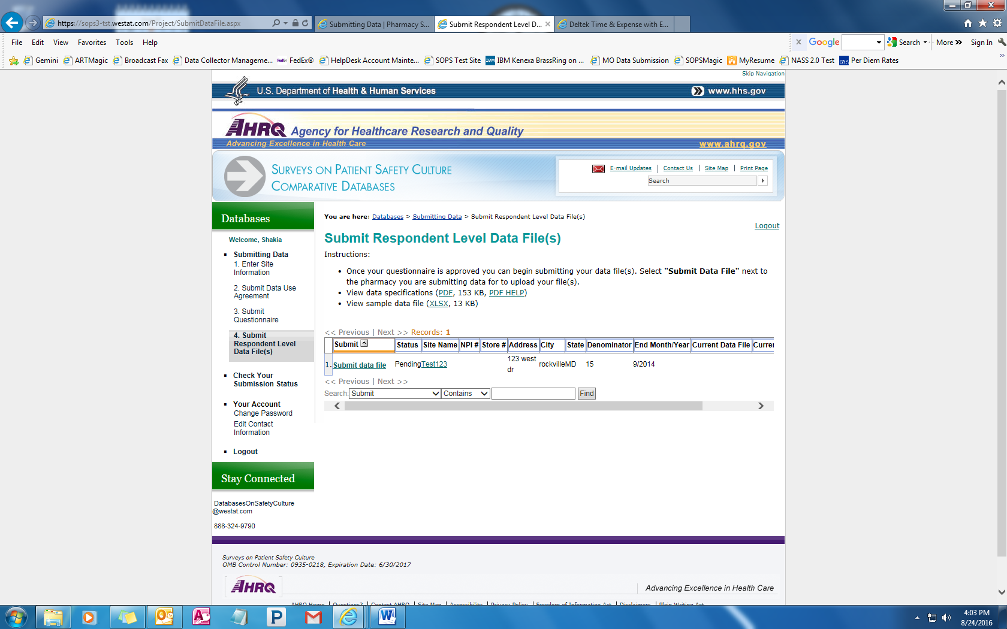

Figure 4: Upload Data for Each Participating Pharmacy

