**Attachment H: Example Screen Shots of Pharmacy Survey on Patient Safety Culture Data Submission Web Site Information Collection**

Users upload the survey questionnaire they administered to enable us to determine whether any changes were made to the survey. They then link the survey to their pharmacies and upload individual-level survey data for each pharmacy. In uploading their files, users select Community Pharmacy or Hospital Pharmacy. The screen shots below demonstrate the survey and data submission process.

Figure 1: Submit Questionnaire and Link Questionnaire to Pharmacies

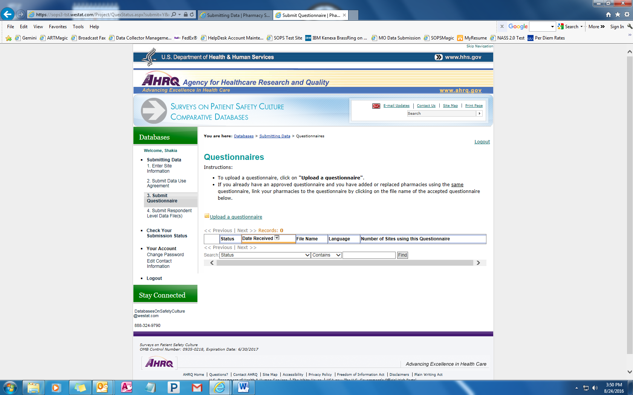

Figure 2a: Submit Questionnaire and Link Questionnaire to Pharmacies, continued

**--Select-- Community Pharmacy**

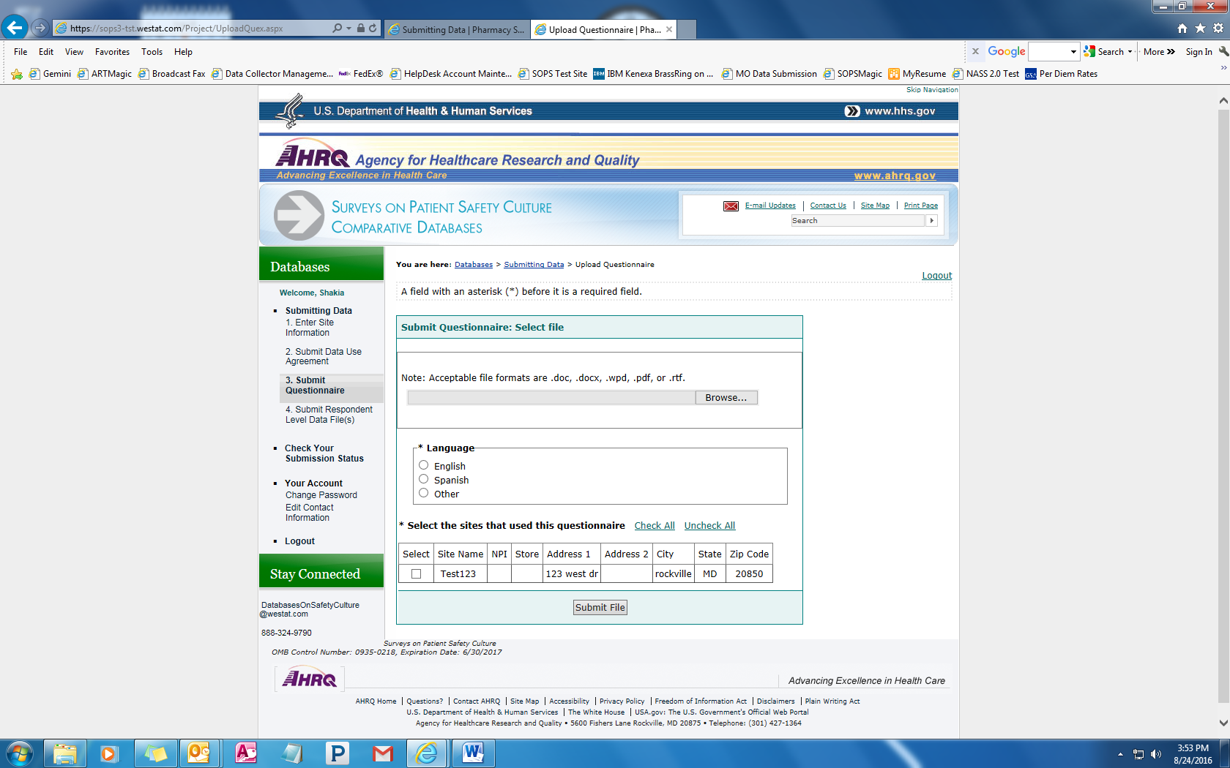

Figure 2b: Submit Questionnaire and Link Questionnaire to Pharmacies, continued

**--Select—Hospital Pharmacy**

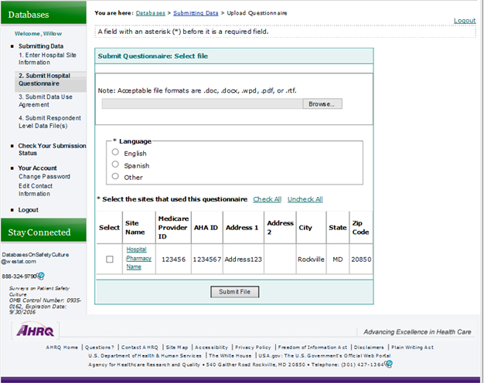

Figure 3a: Upload Data for Each Participating Pharmacy

**--Select—Community Pharmacy**

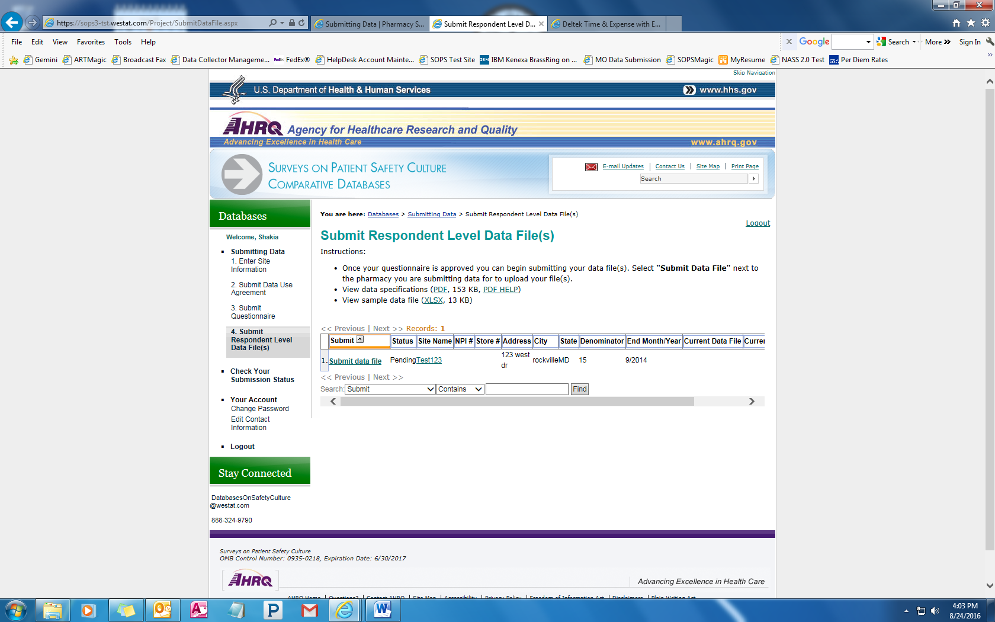

Figure 3b: Upload Data for Each Participating Pharmacy

**-- Select-- Hospital Pharmacy**

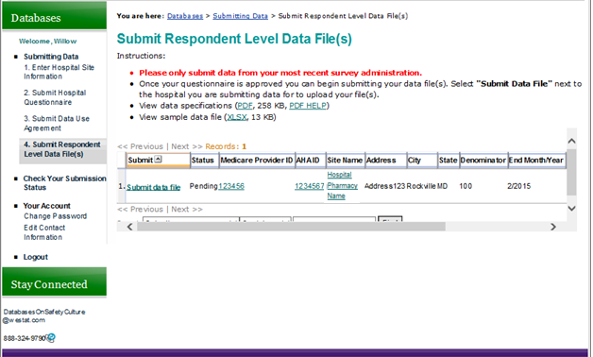

Figure 4: Upload Data for Each Participating Pharmacy, continued

