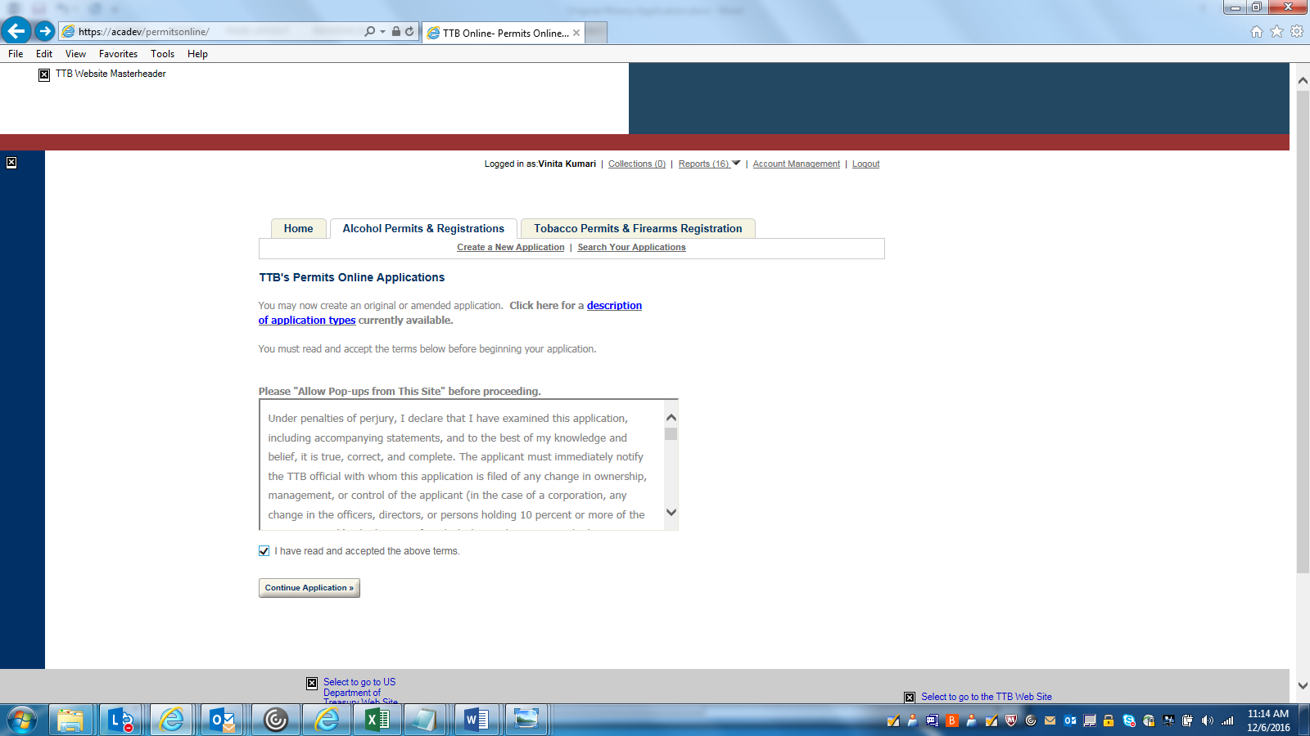

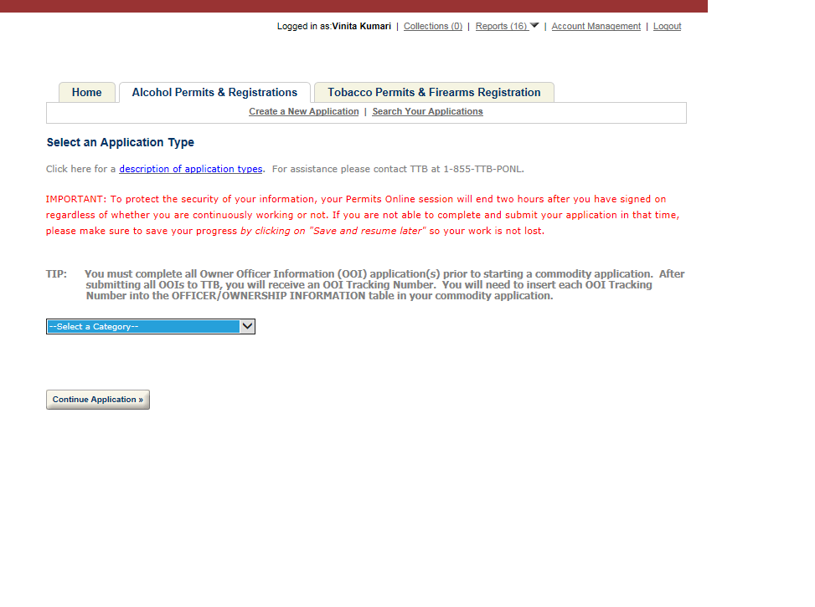

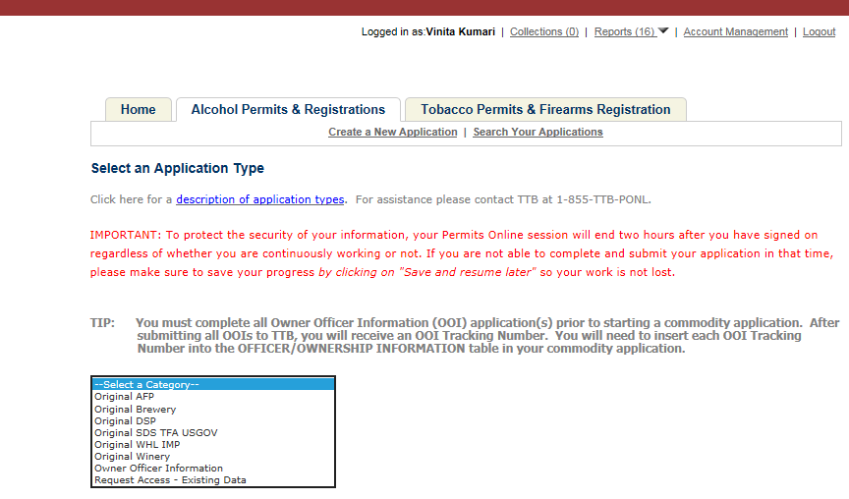
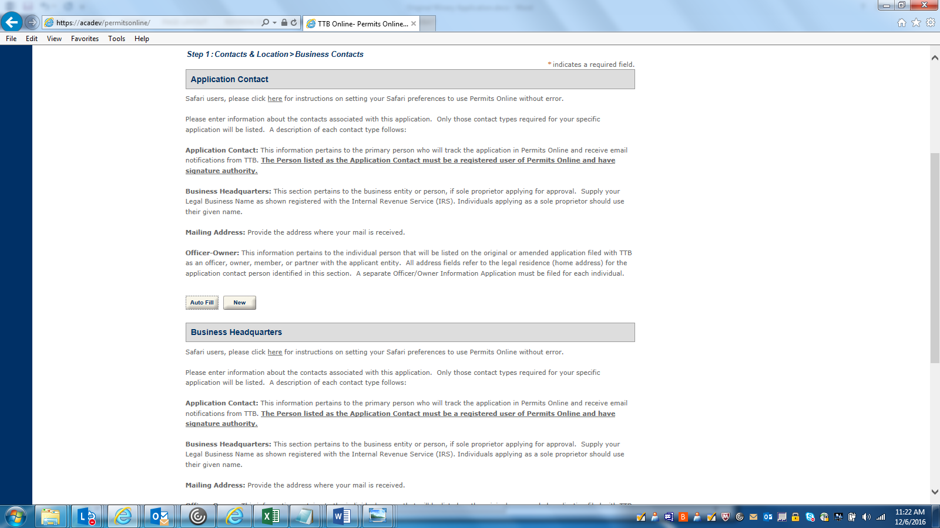
APPLICATION CONTACT DETAILS: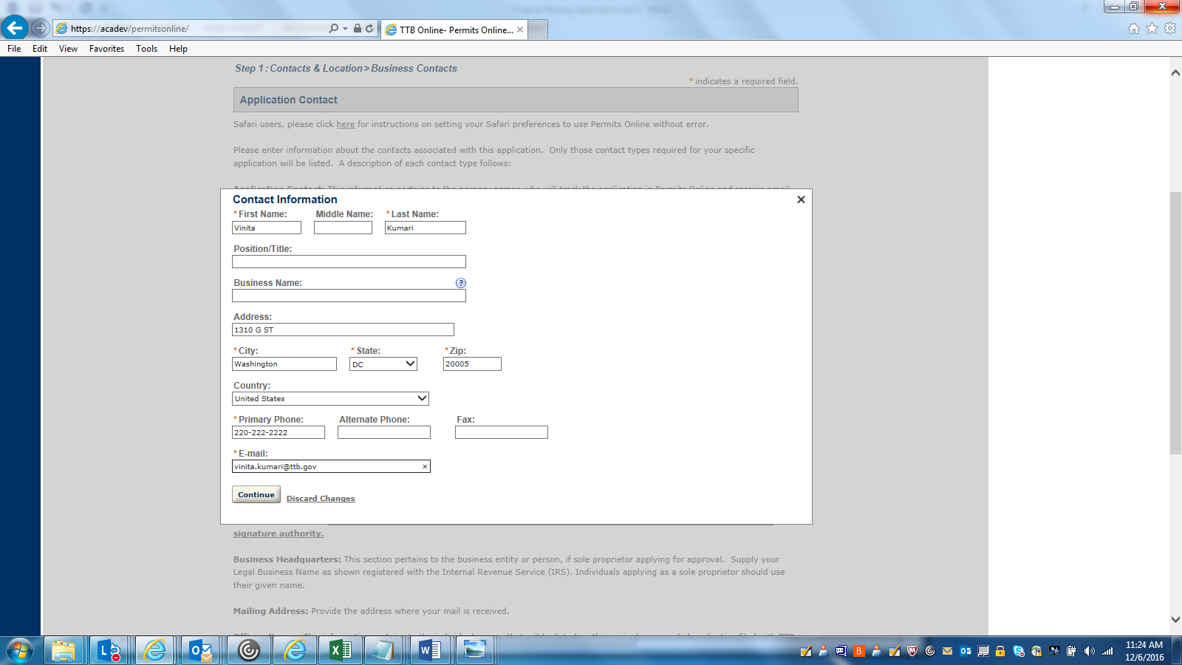

BUSINESS HEADQUARTER DETATILS: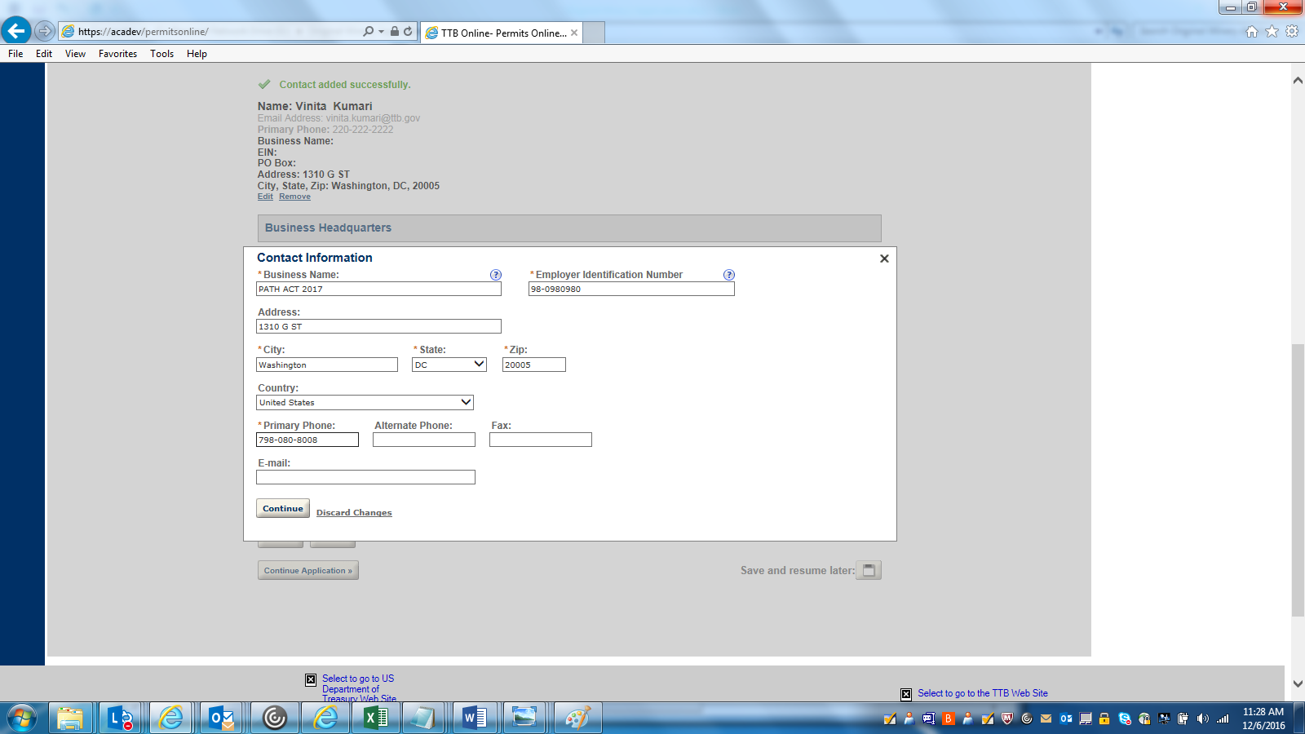

PREMISE ADDRESS DETAILS: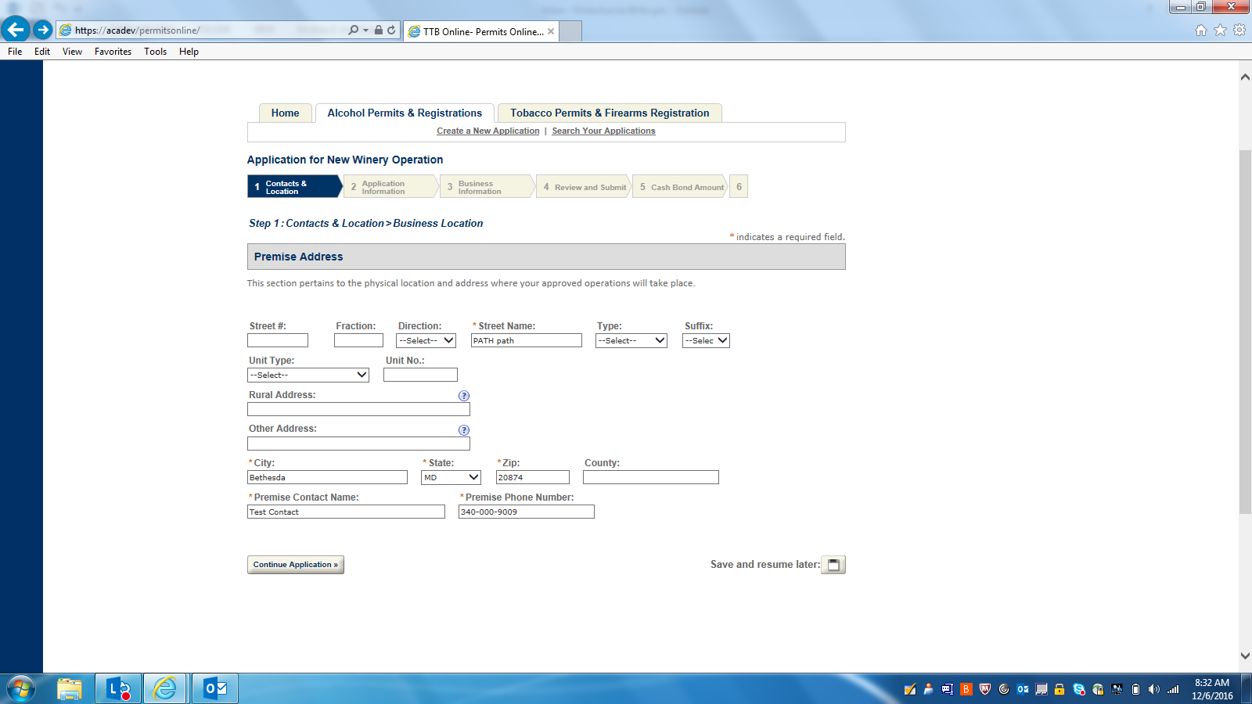

MAILING ADDRSS DETAILS: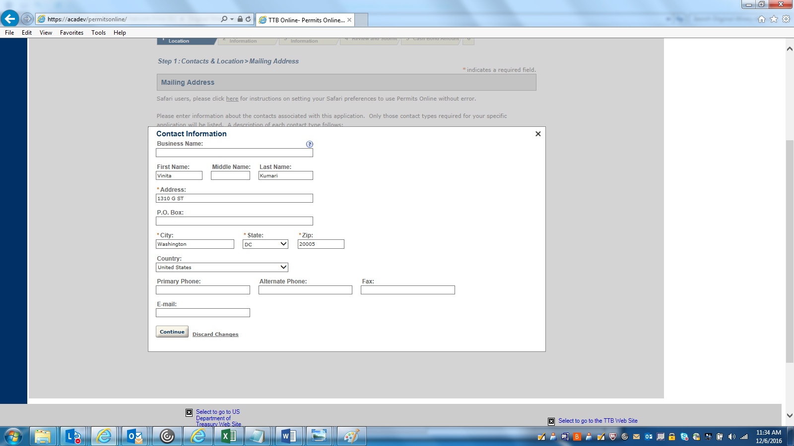

APPLICATION INFORMATION-1: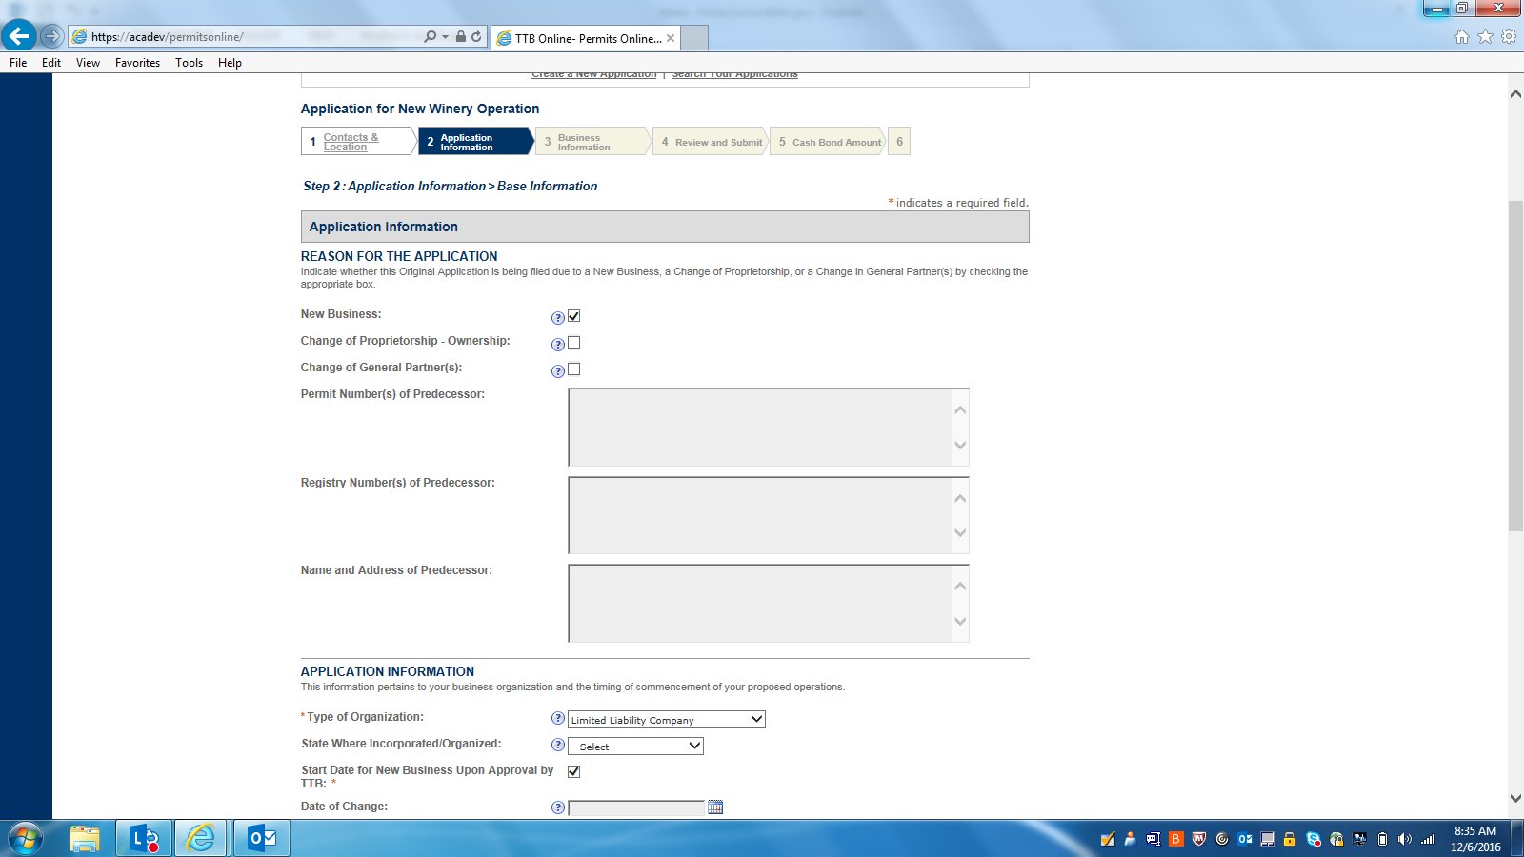

APPLICATION INFORMATION-2: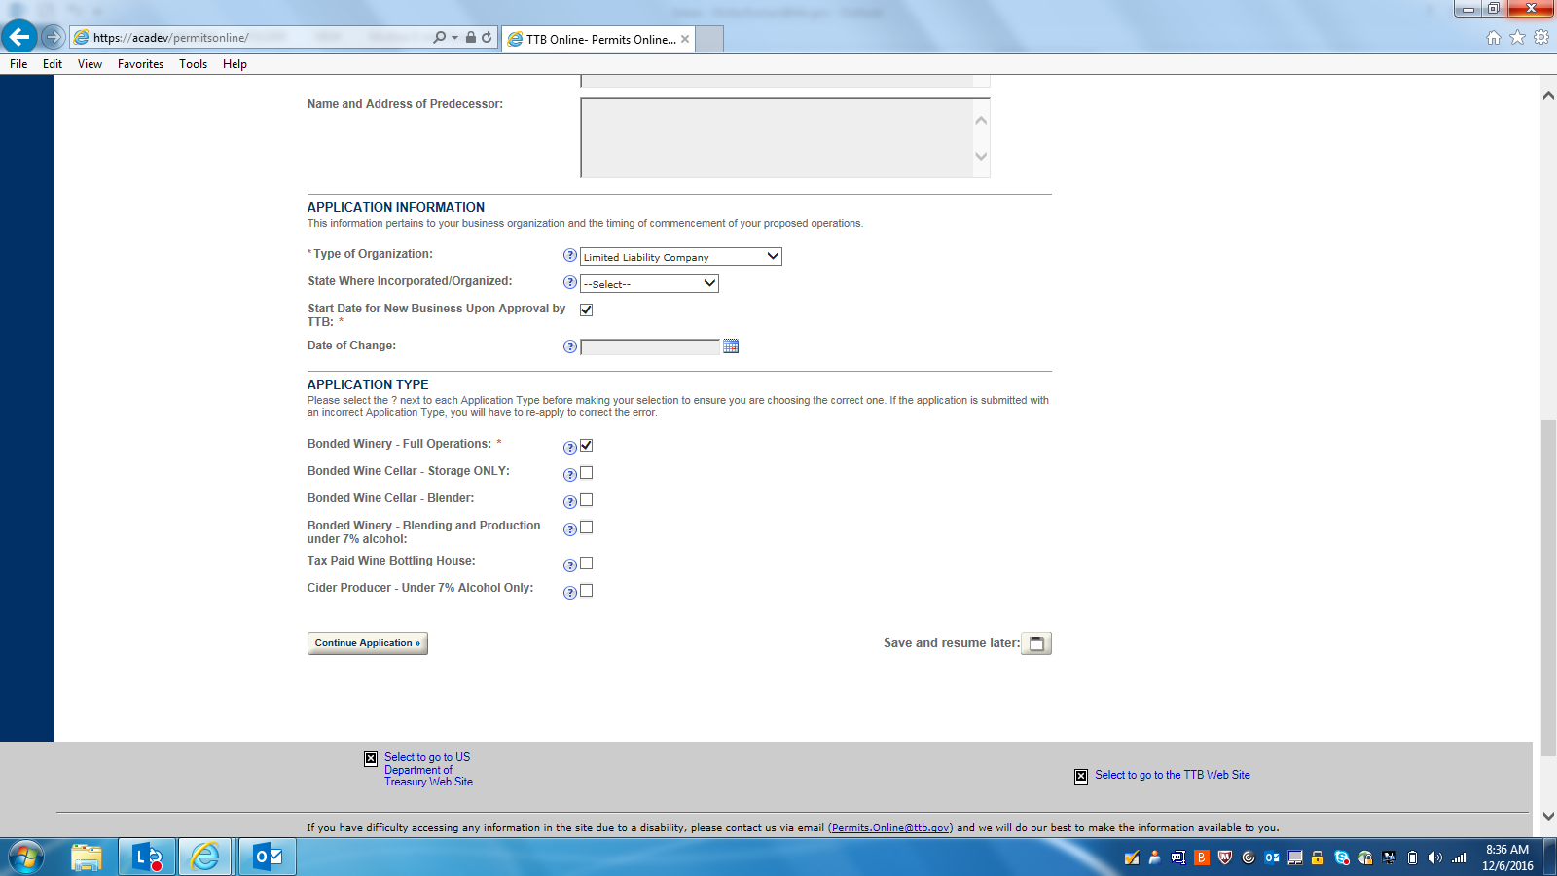

OWNER BACKGROUND INFORMATION: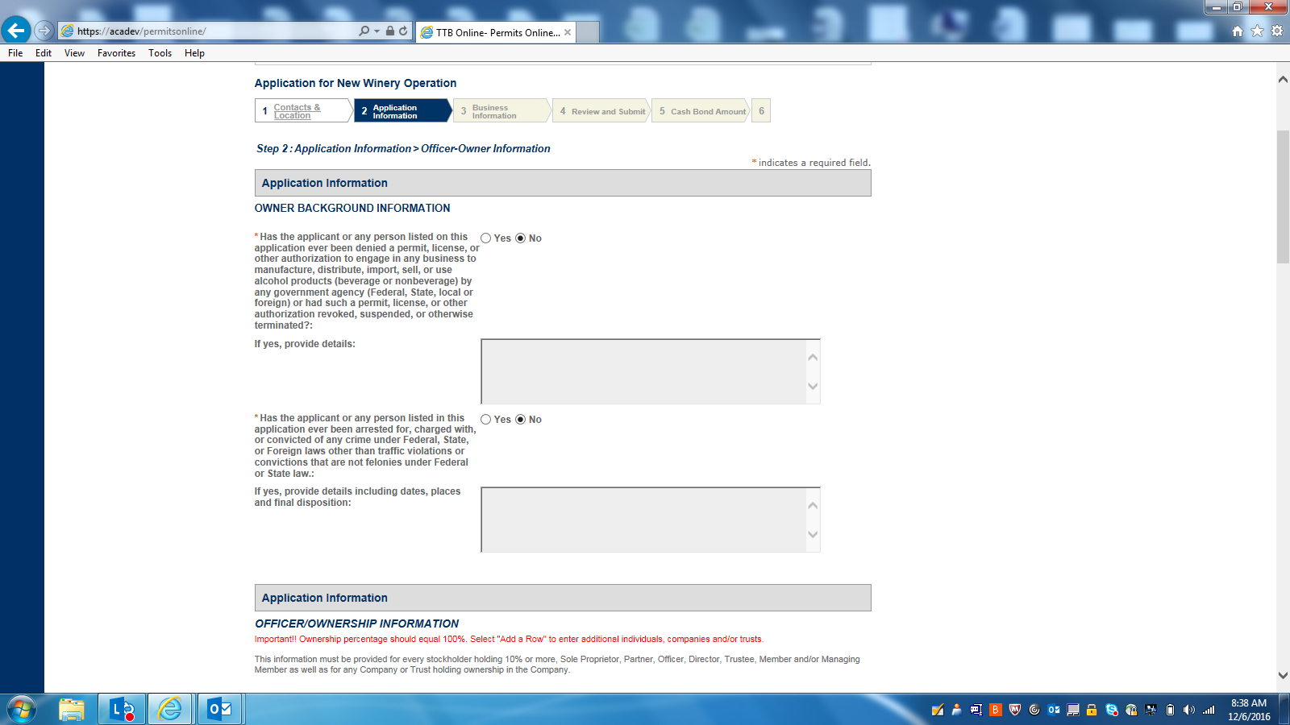

OFFICER-OWNER INFORMATION-1: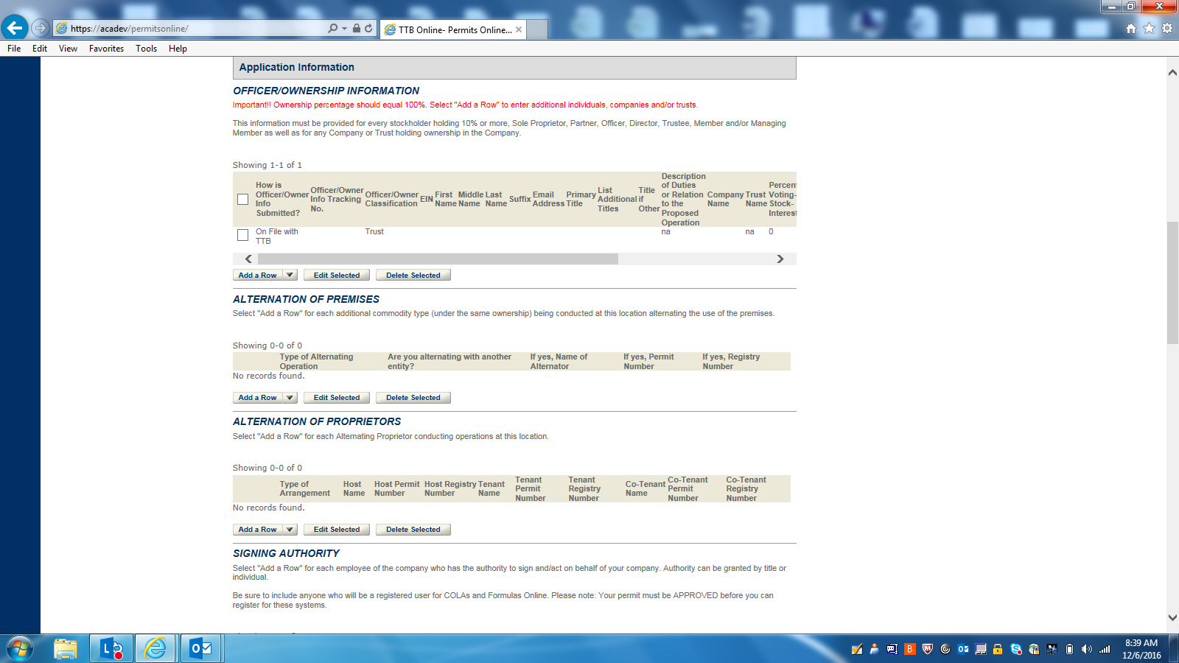OFFICER-OWNER INFORMATION (DETAIL):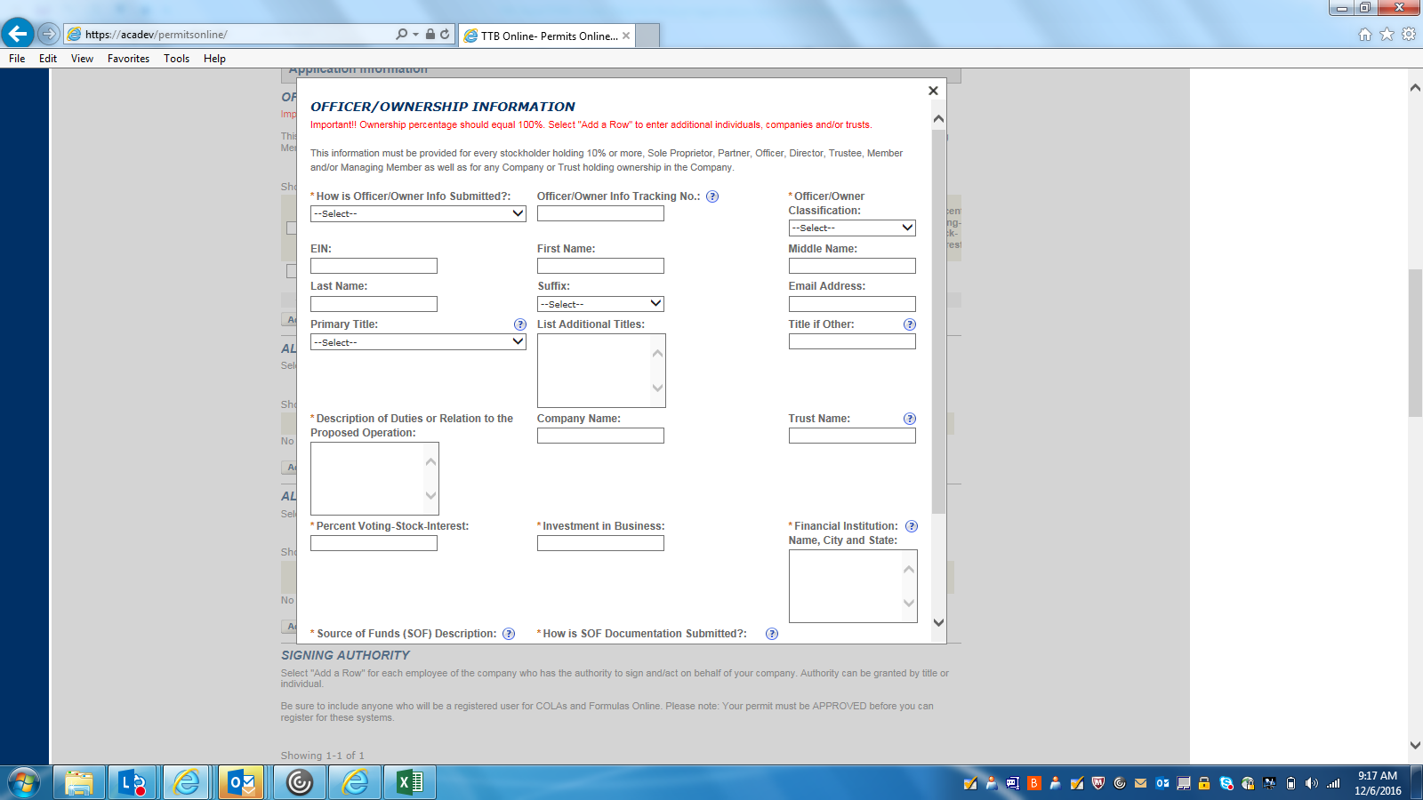

ALTERNATION OF PREMISES(DETAILS):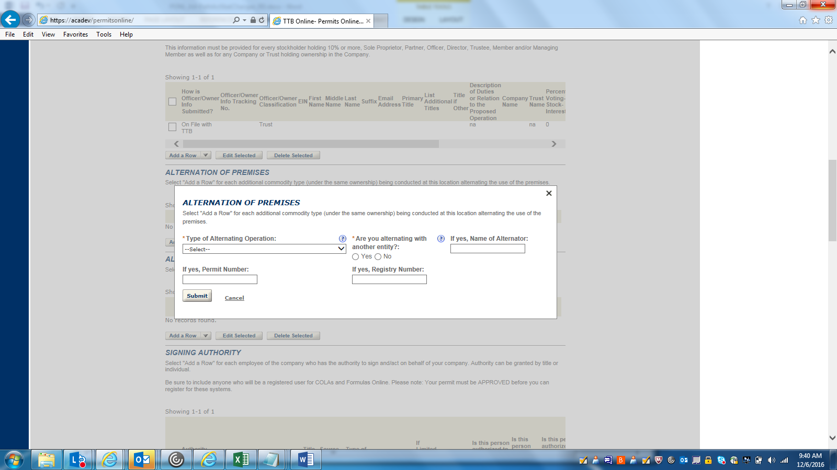

ALTERNATION OF PROPRIETORS (DETAILS):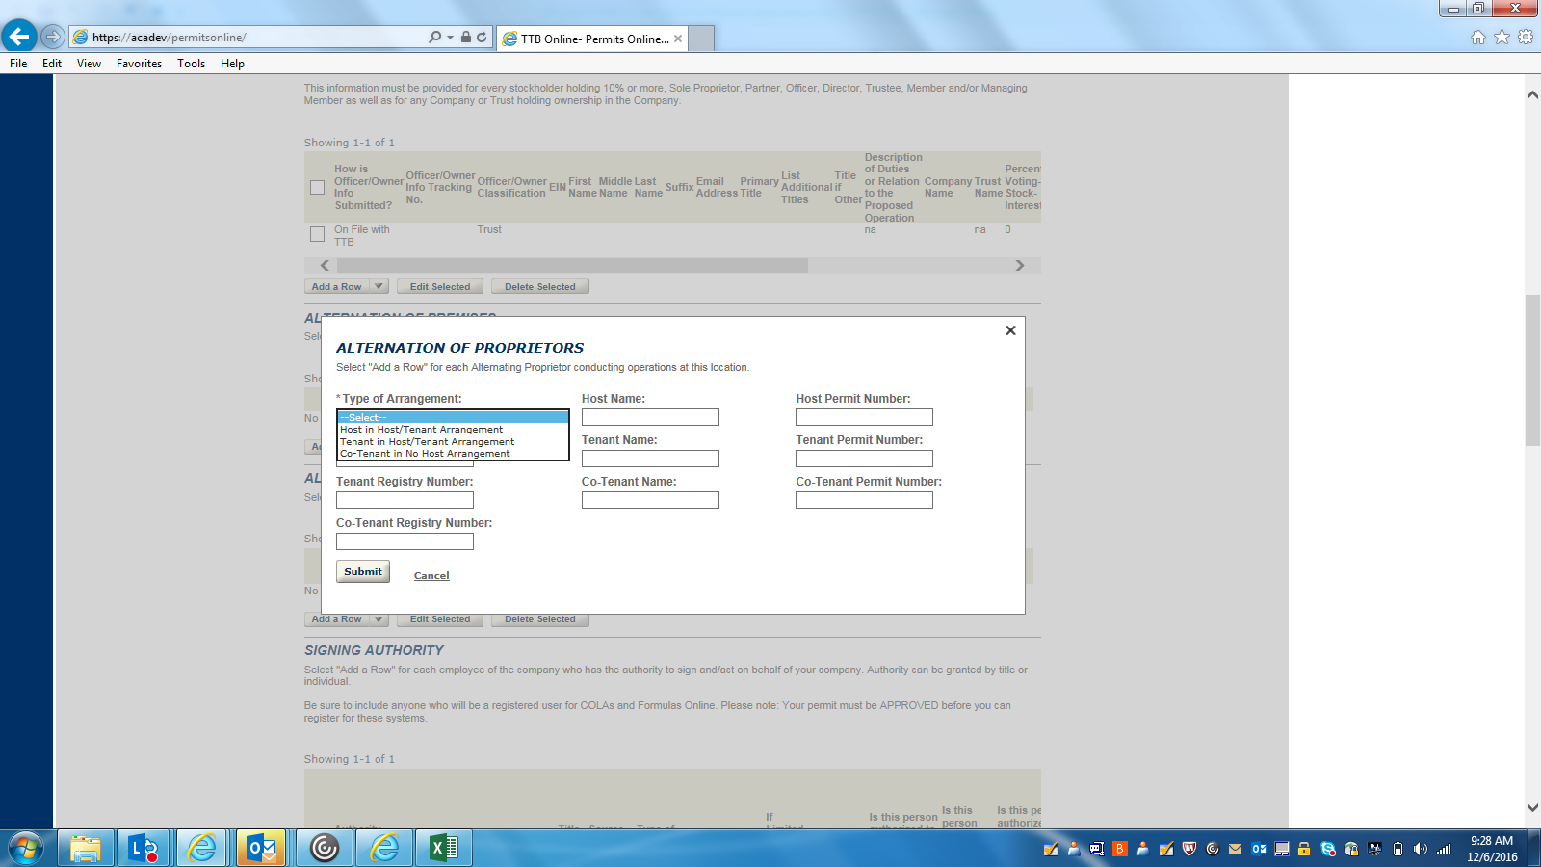

SIGNING AUTHORITY(DETAILS):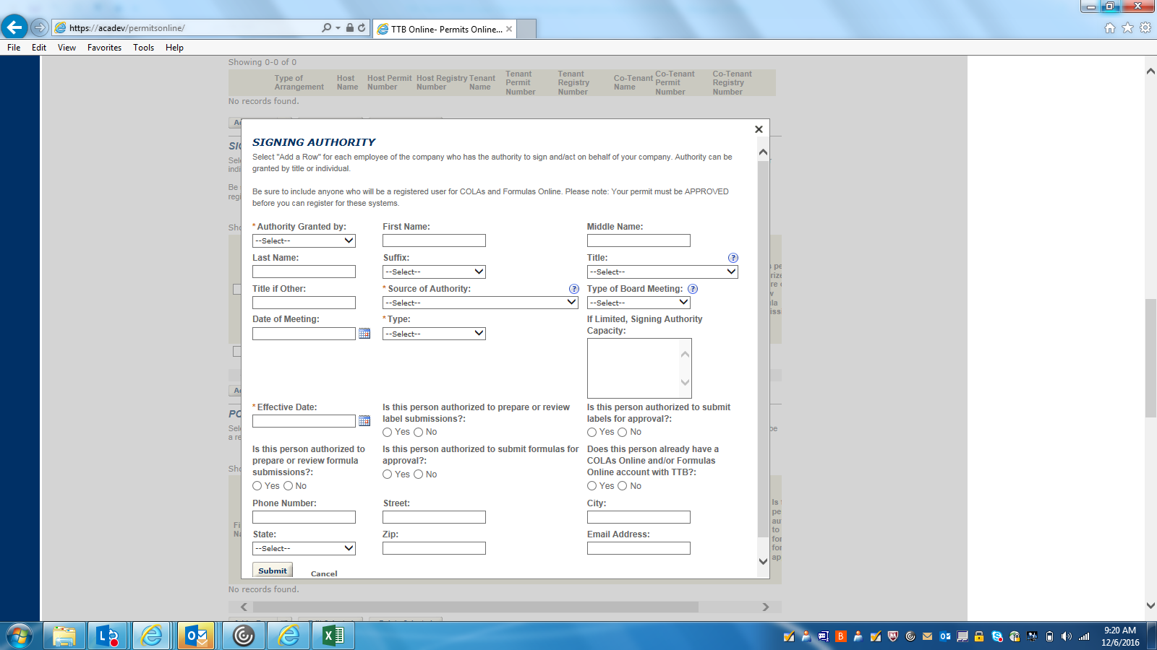

OFFICER-OWNER INFORMATION-2: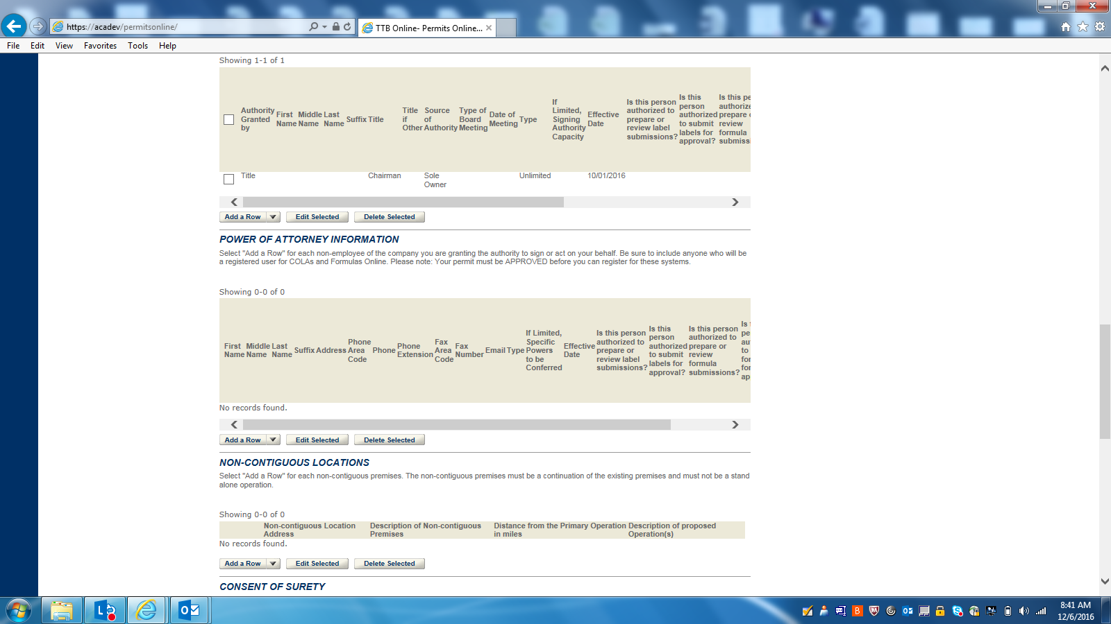

POWER OF ATTORNEY (DETAILS):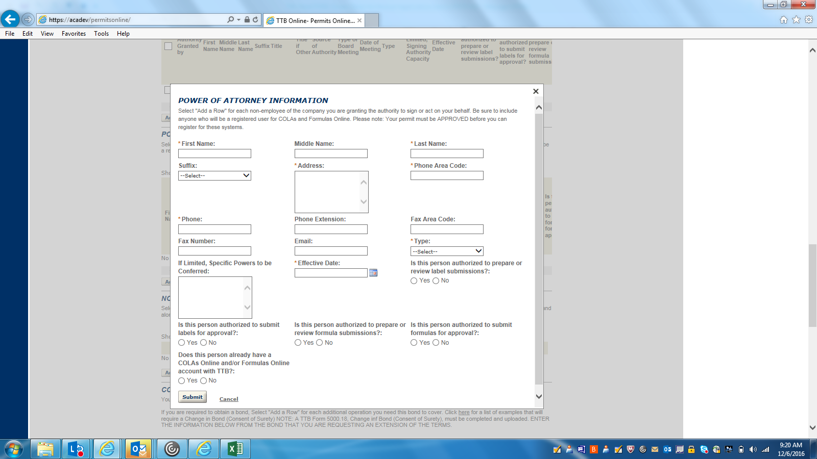

NON-CONTIGUOUS LOCATION (DETAILS):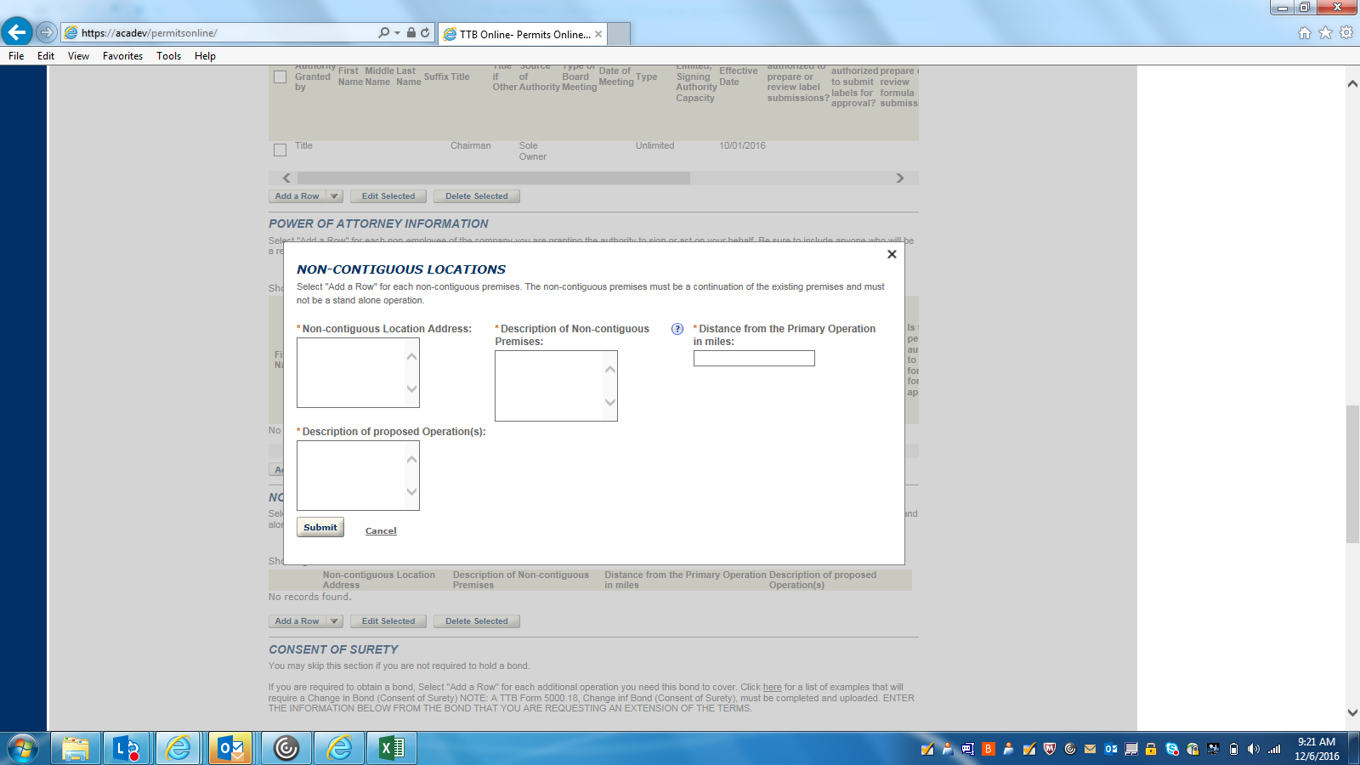

OFFICER-OWNER INFORMATION-3: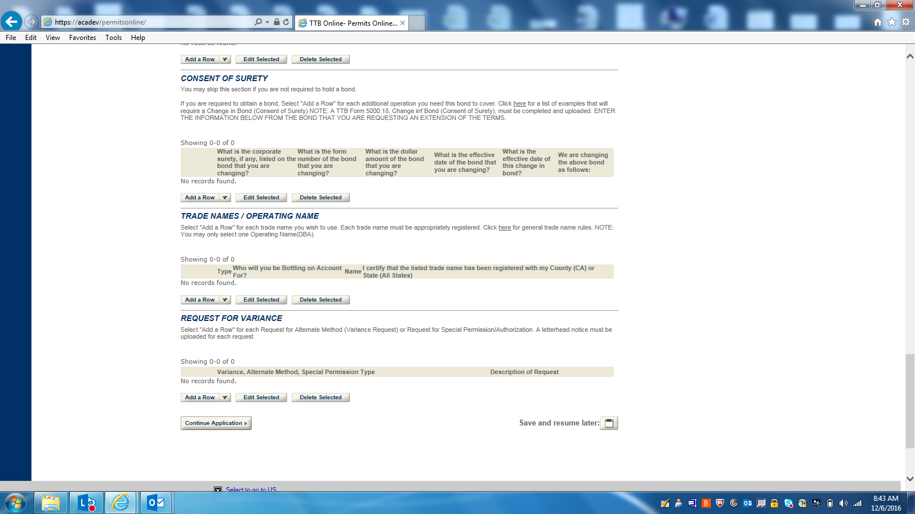

CONSENT OF SURETY(DETAILS):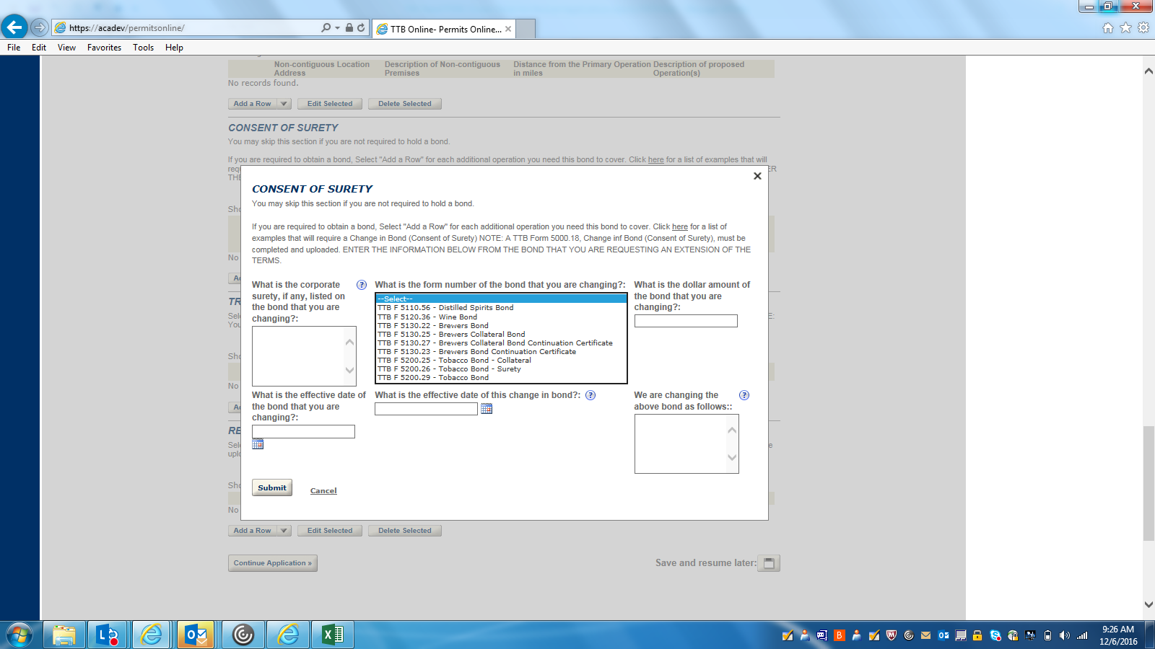

TRADE NAMES/ OPERATING NAME (DETAILS):
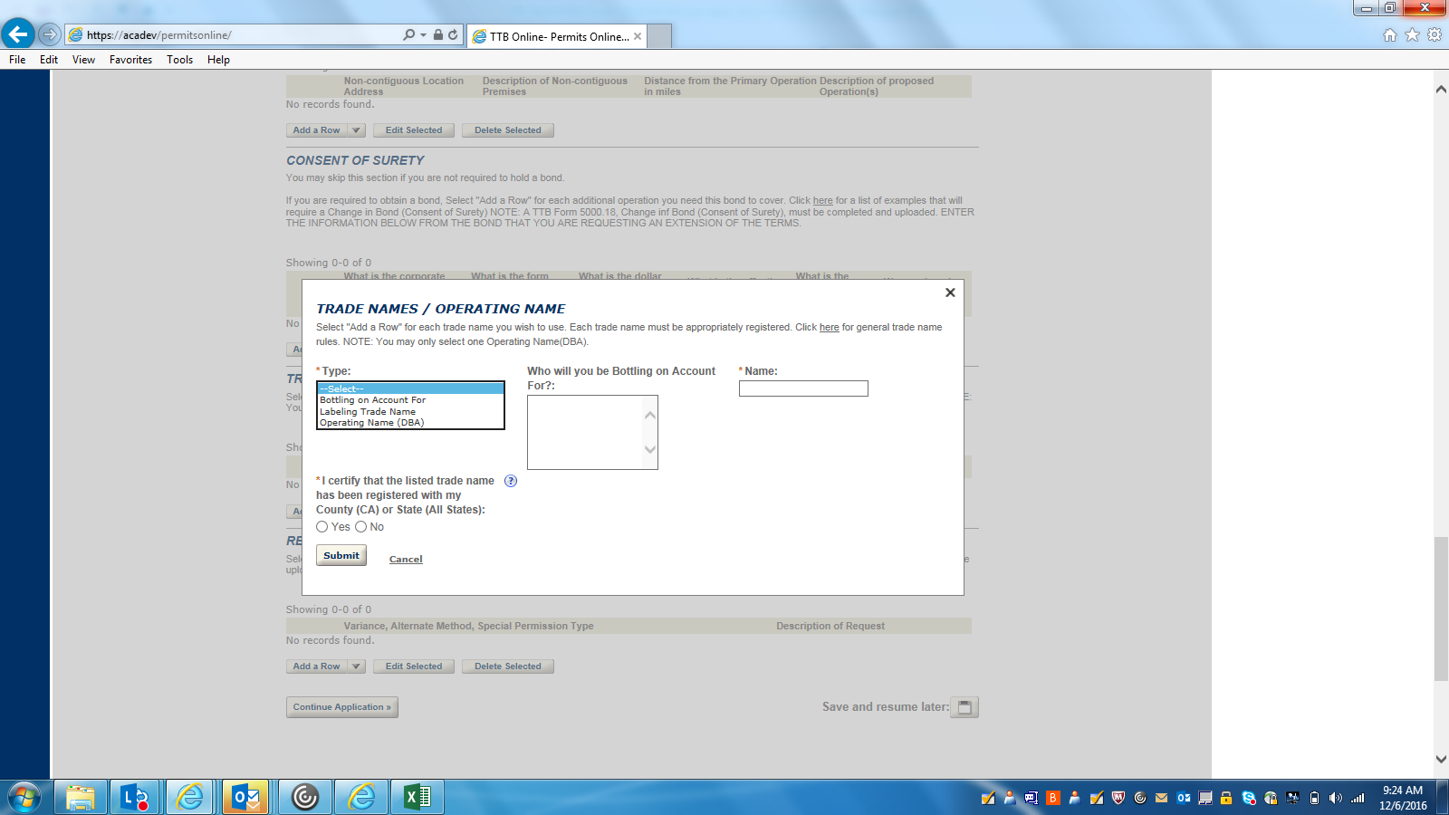

REQUEST FOR VARIANCE (DETAILS):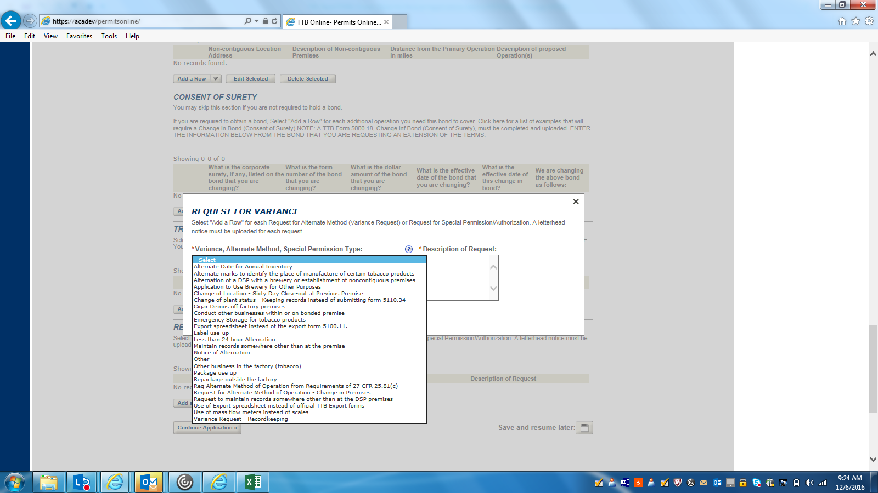

WINERY BUSINESS INFORMATION-1: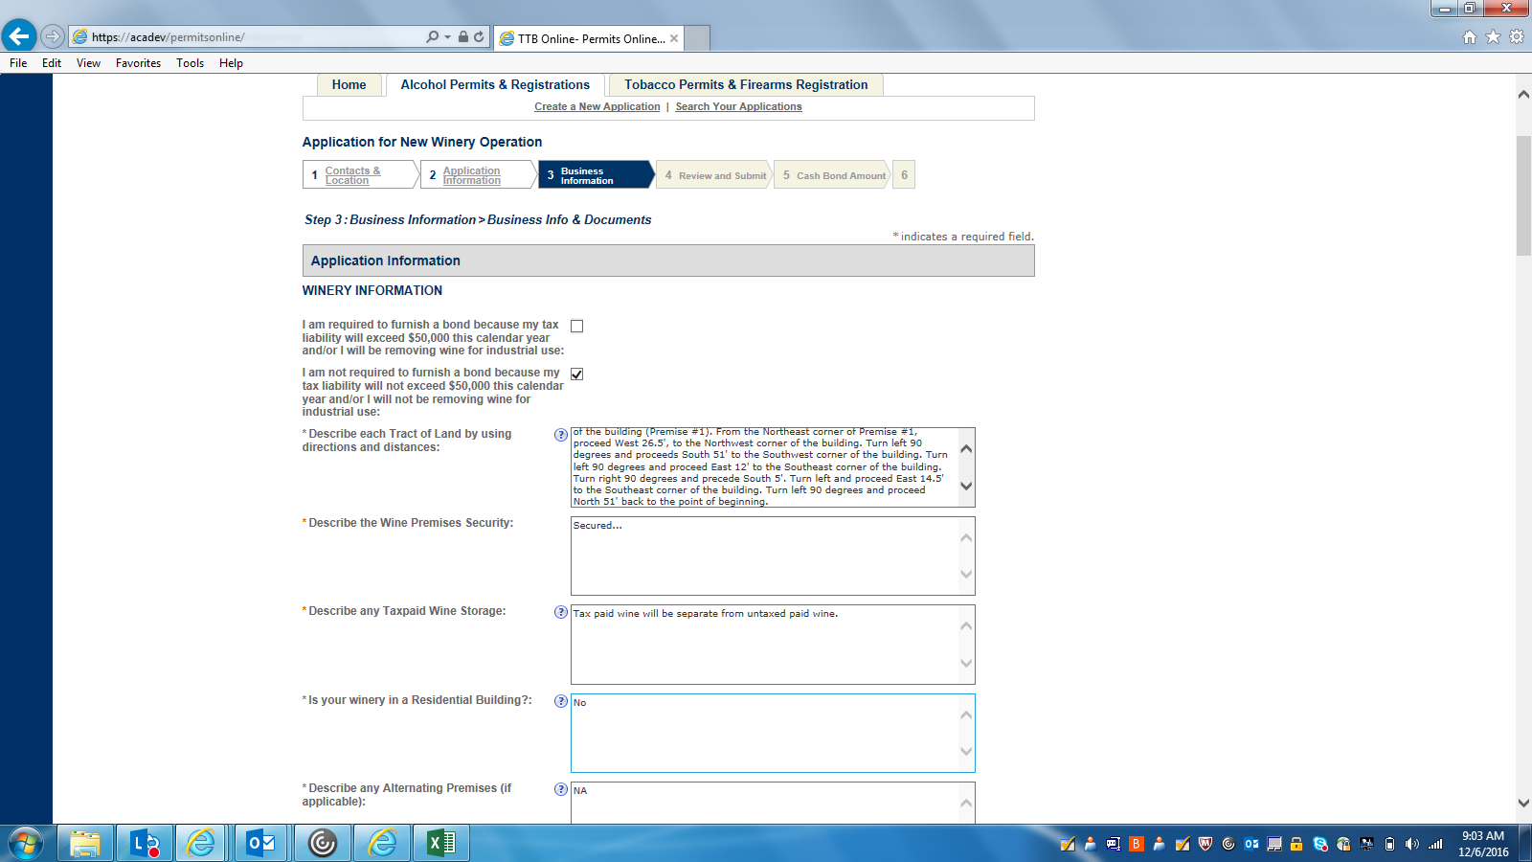

WINERY BUSINESS INFORMATION-2: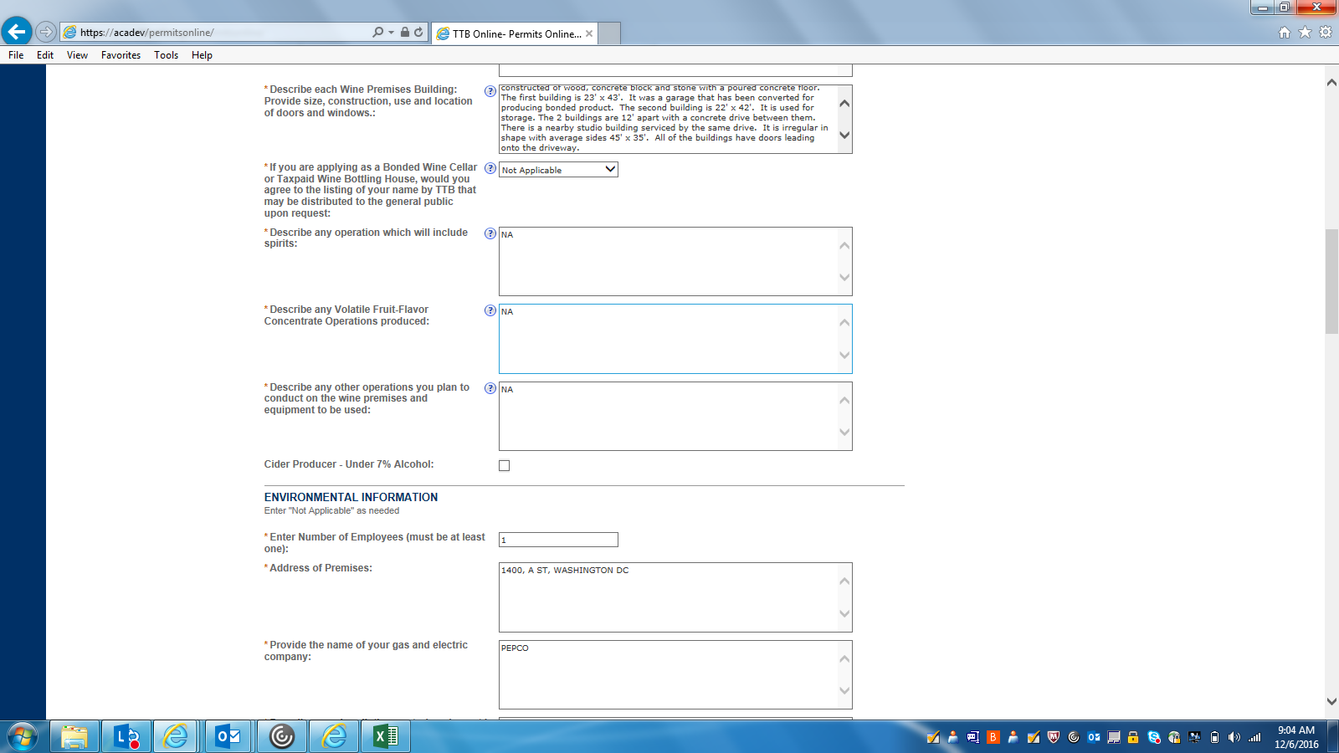

WINERY BUSINESS INFORMATION 3: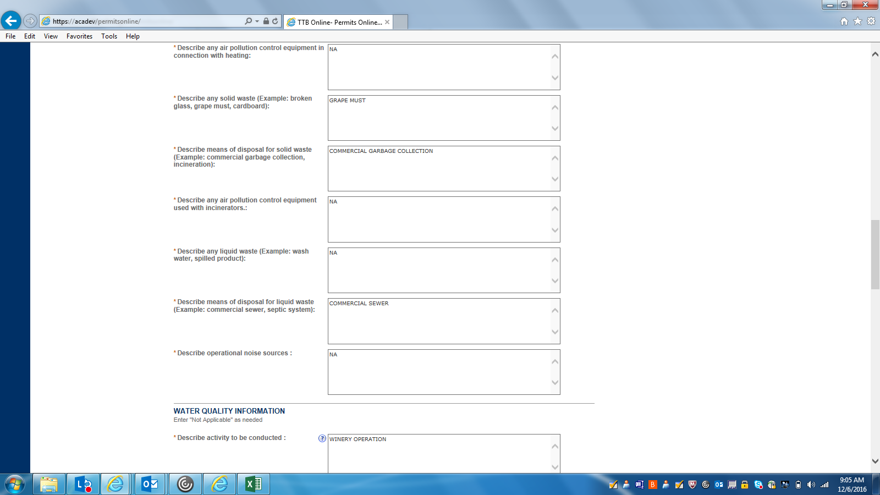

WINERY BUSINESS INFORMATION 4: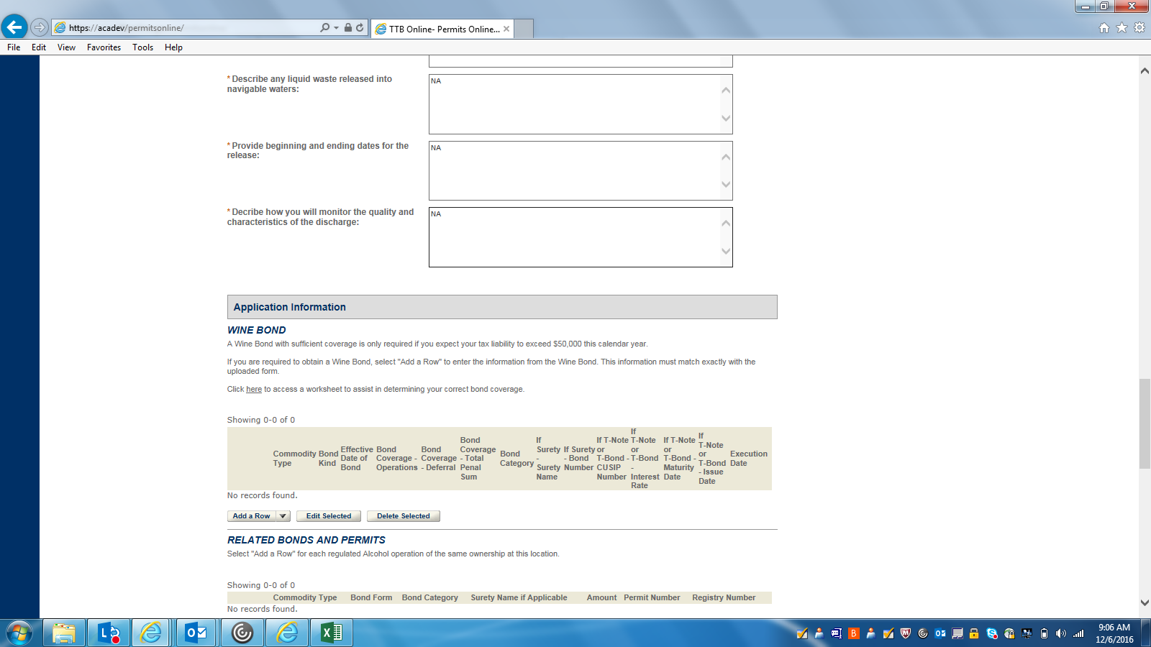

WINE BOND (DETAIL):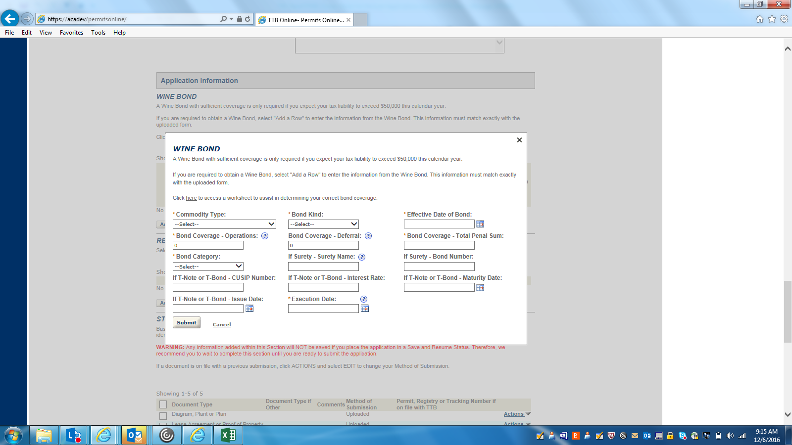

RELATED BOND AND PERMITS (DETAIL):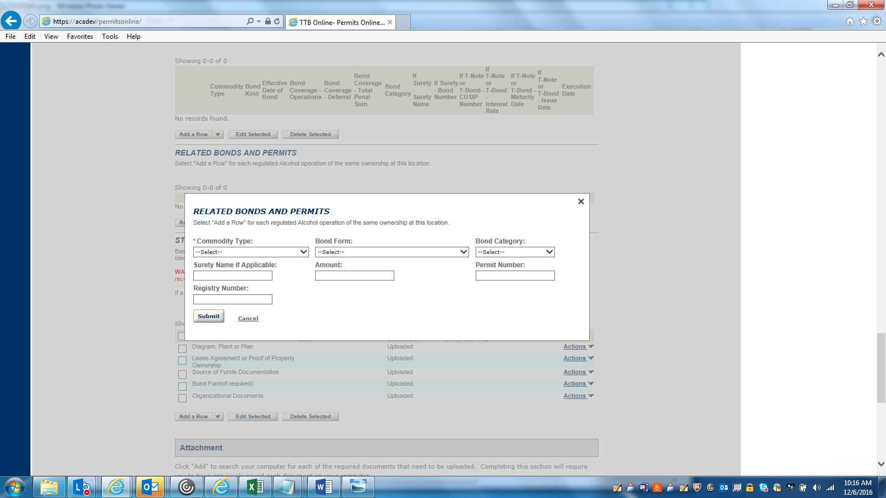

WINERY BUSINESS INFORMATION-5: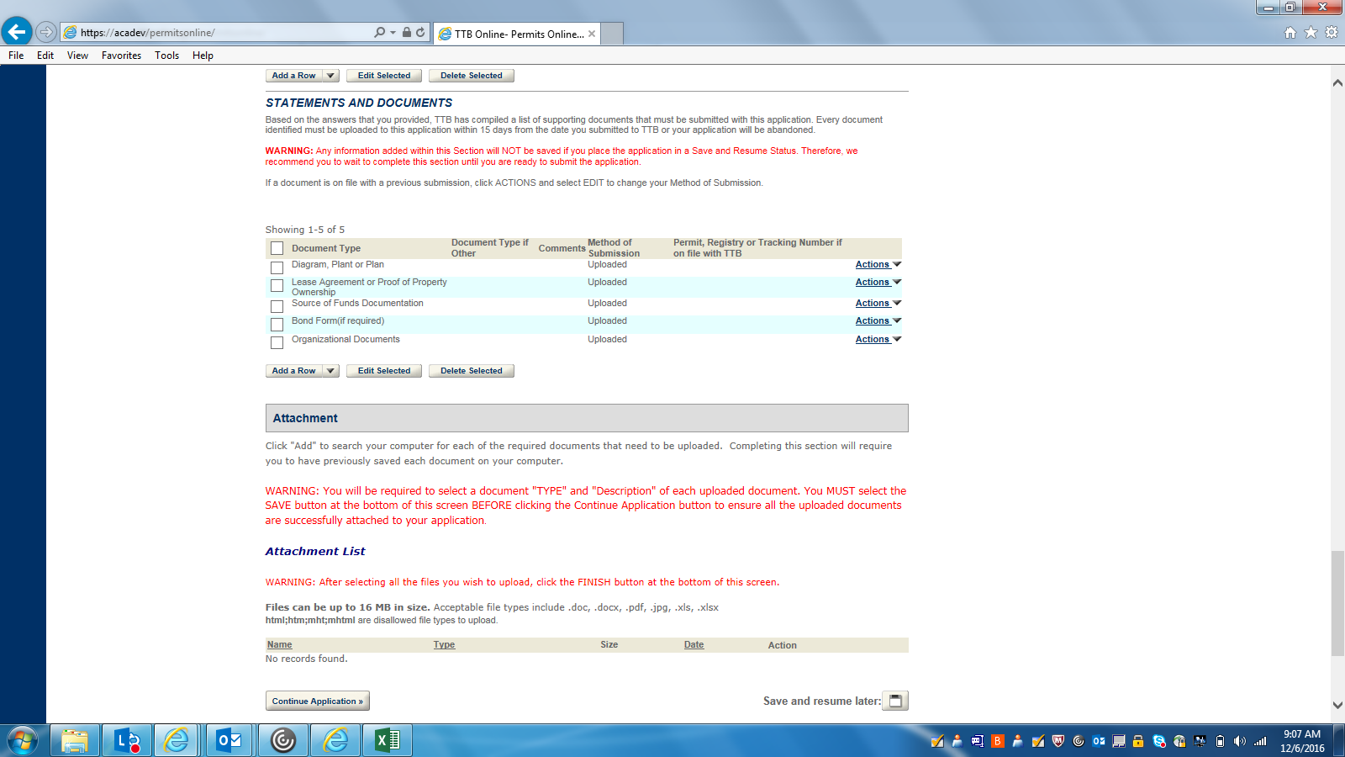

DECLARATION: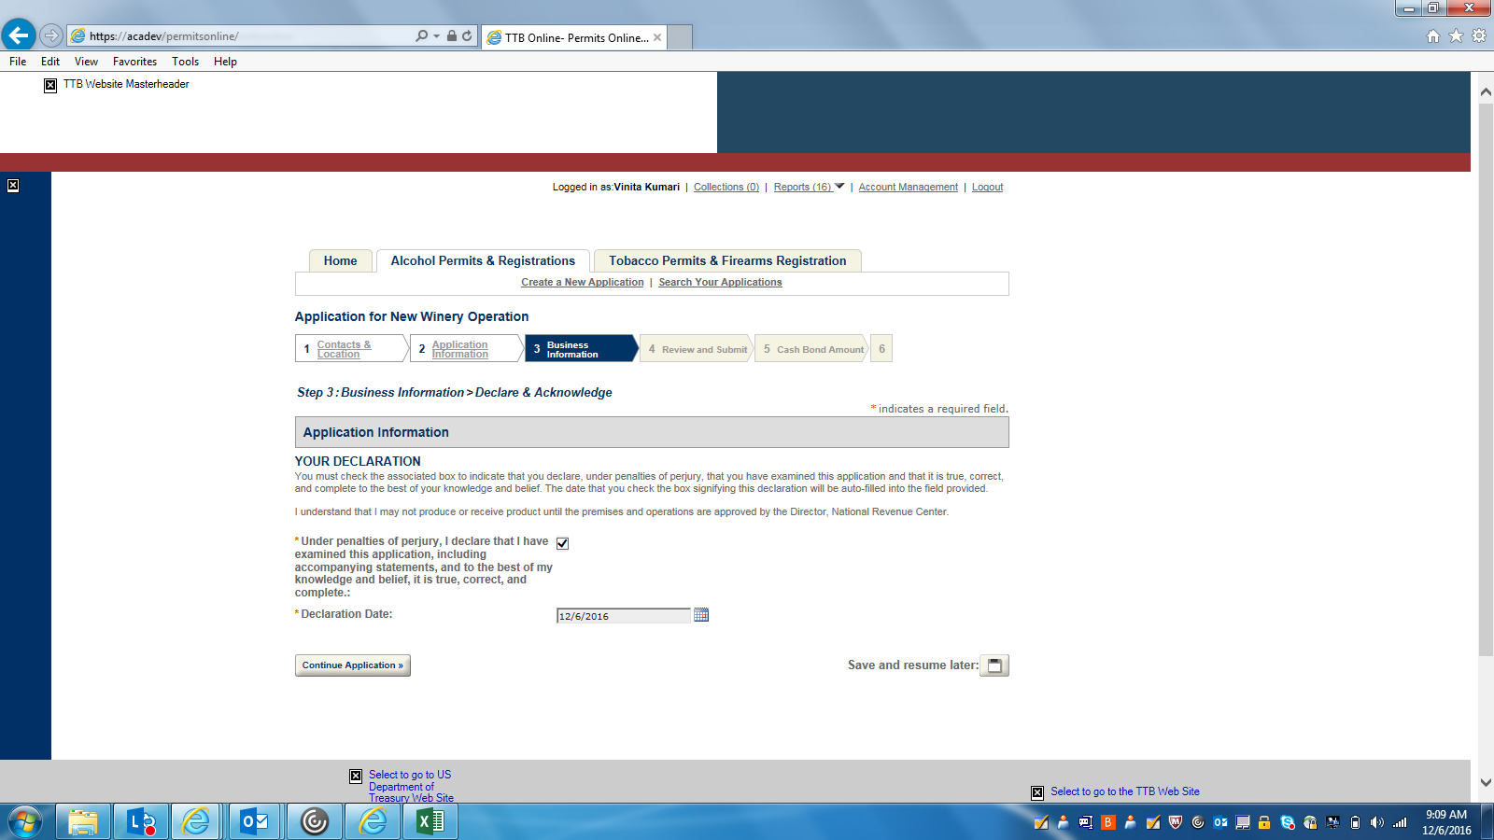

REVIEW AND SUBMIT 1: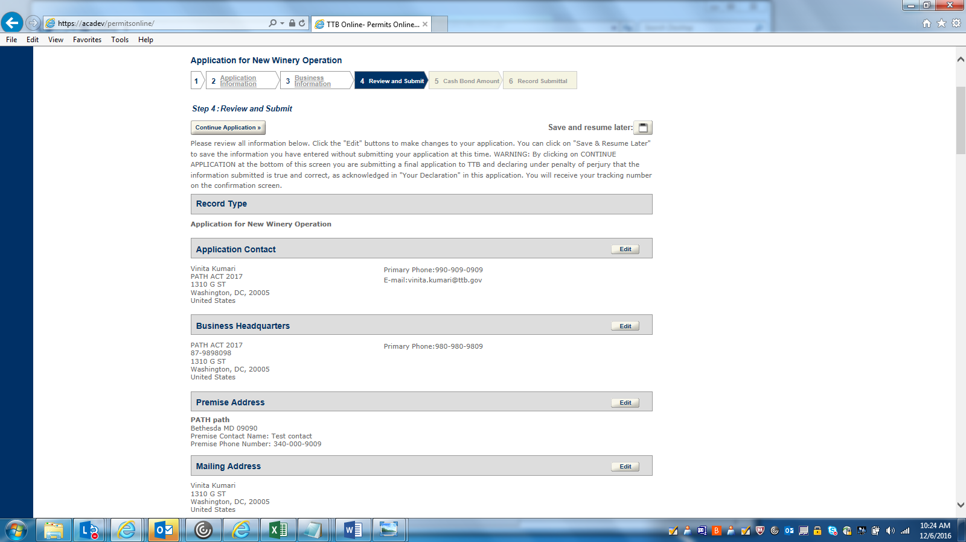
REVIEW AND SUBMIT 2: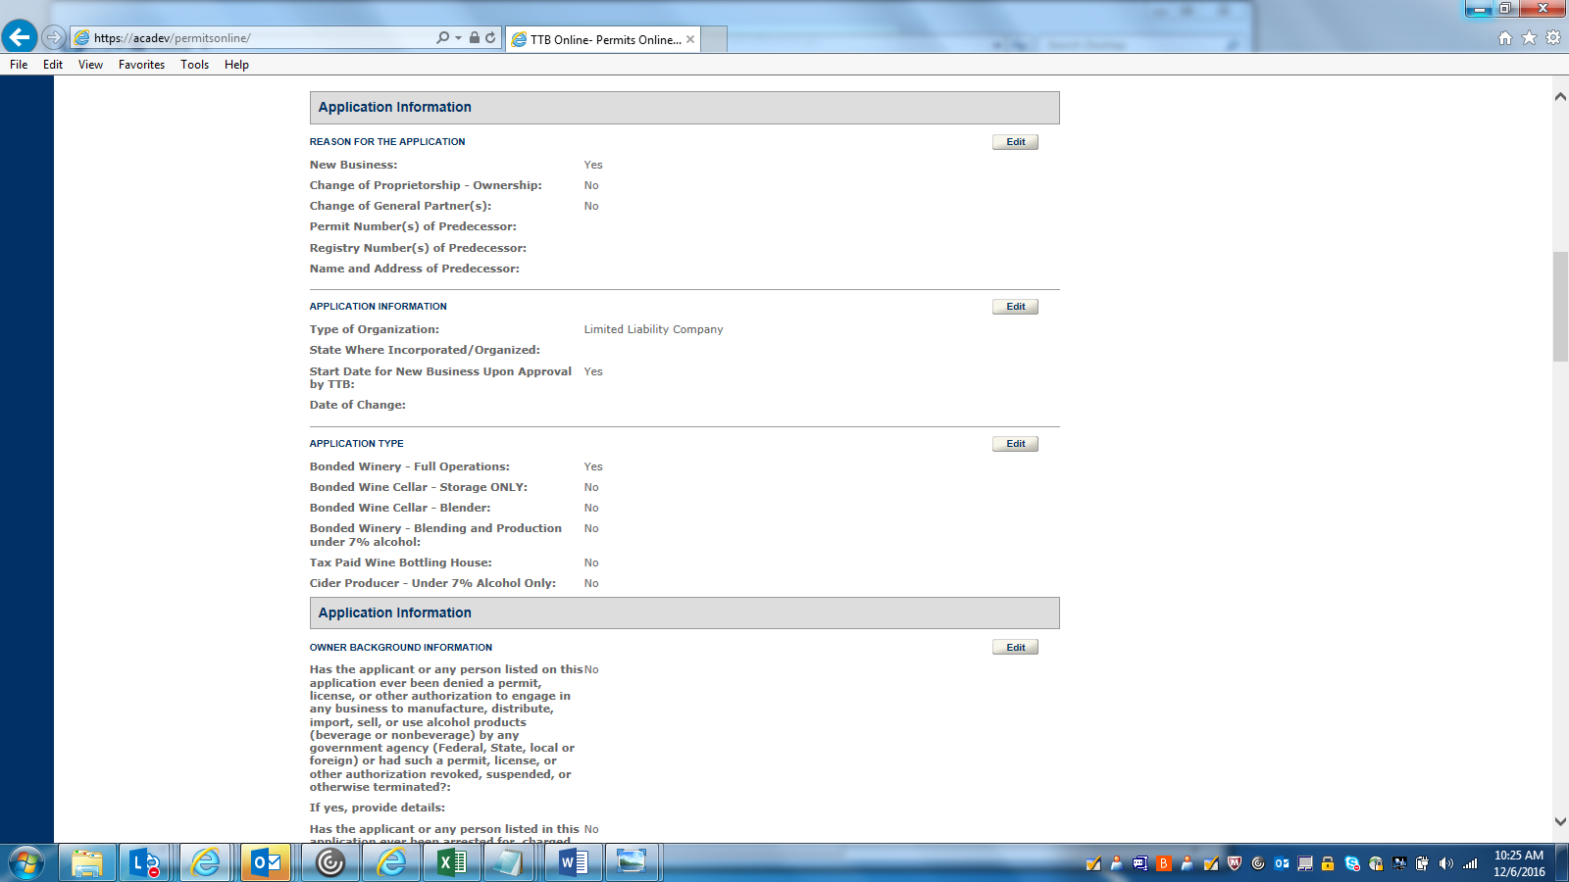

REVIEW AND SUBMIT 3: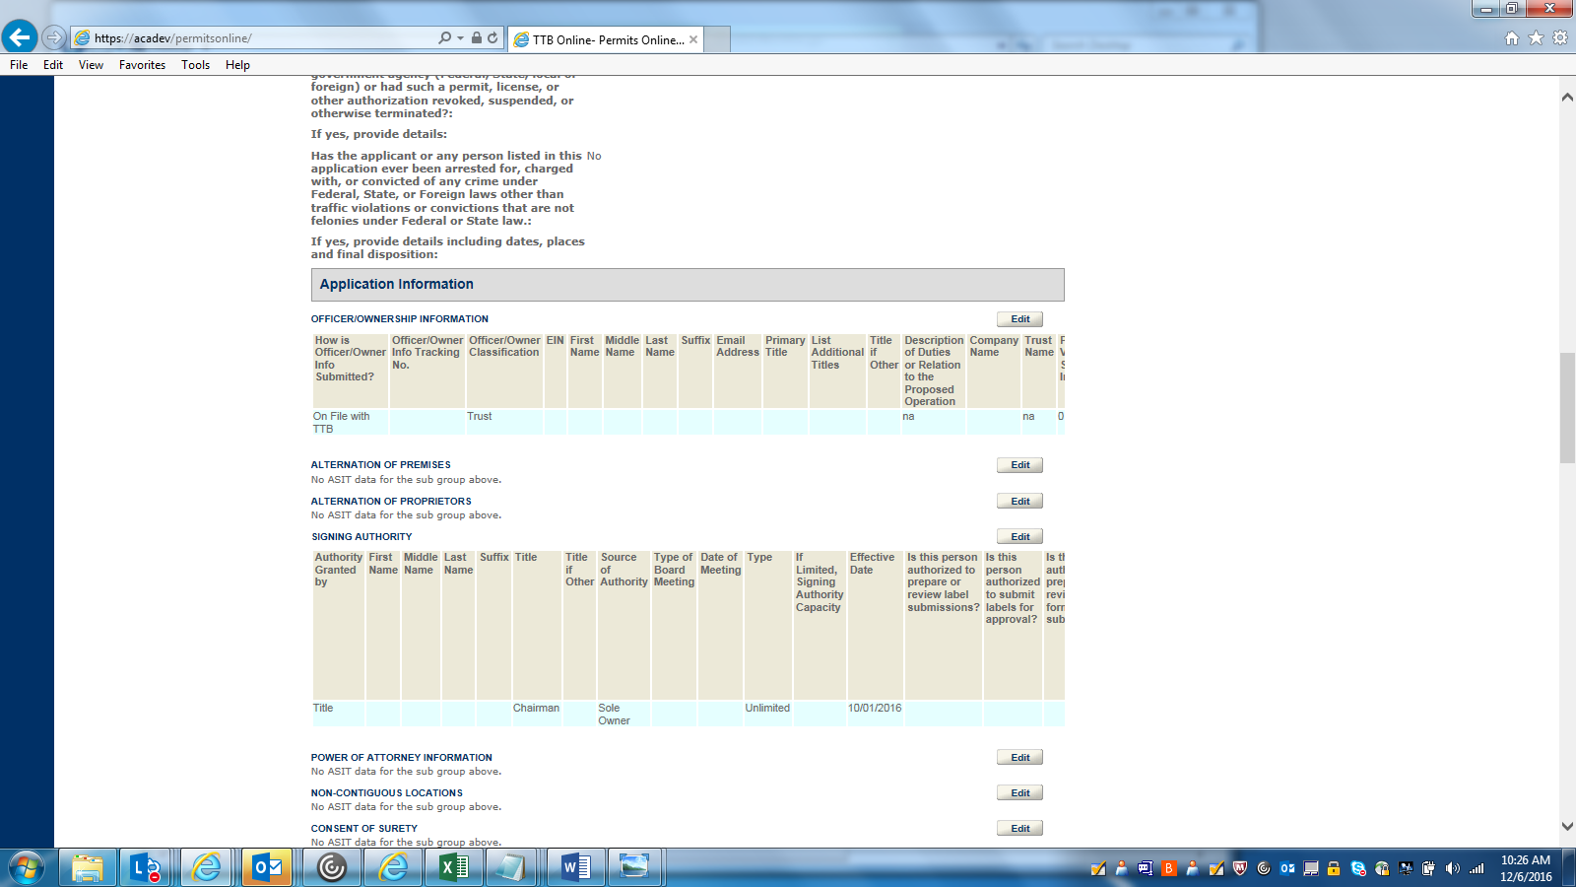

REVIEW AND SUBMIT 4: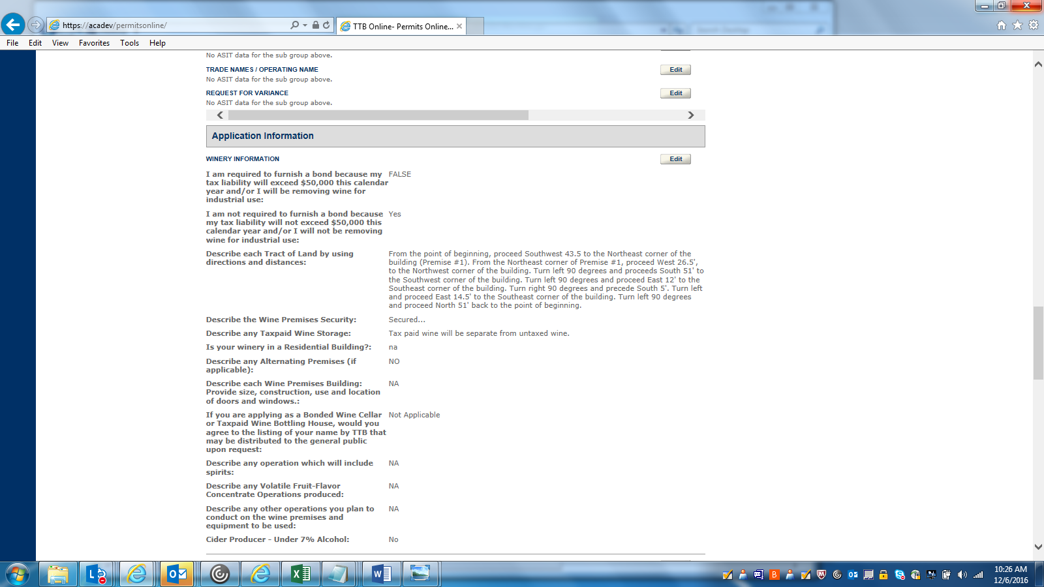

REVIEW AND SUBMIT 5: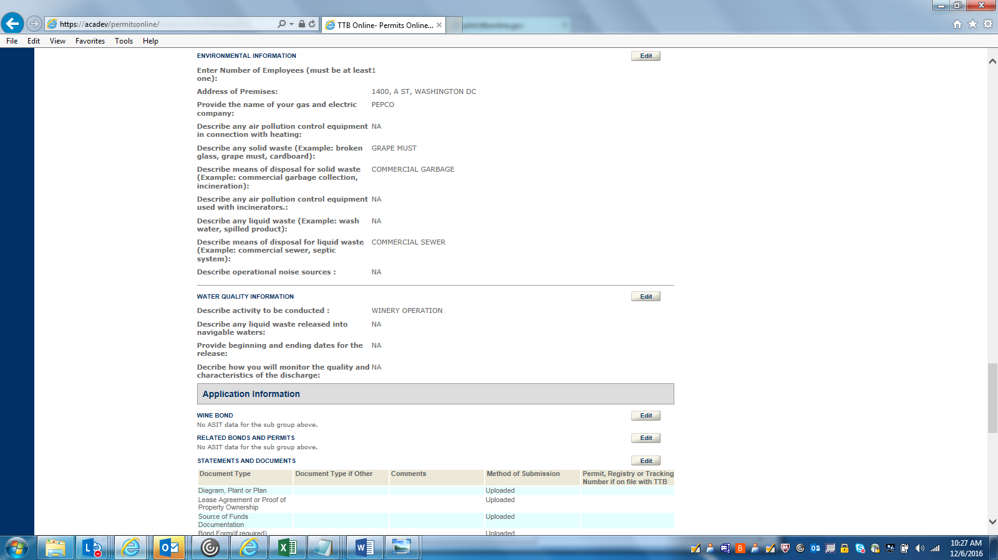

REVIEW AND SUBMIT 6: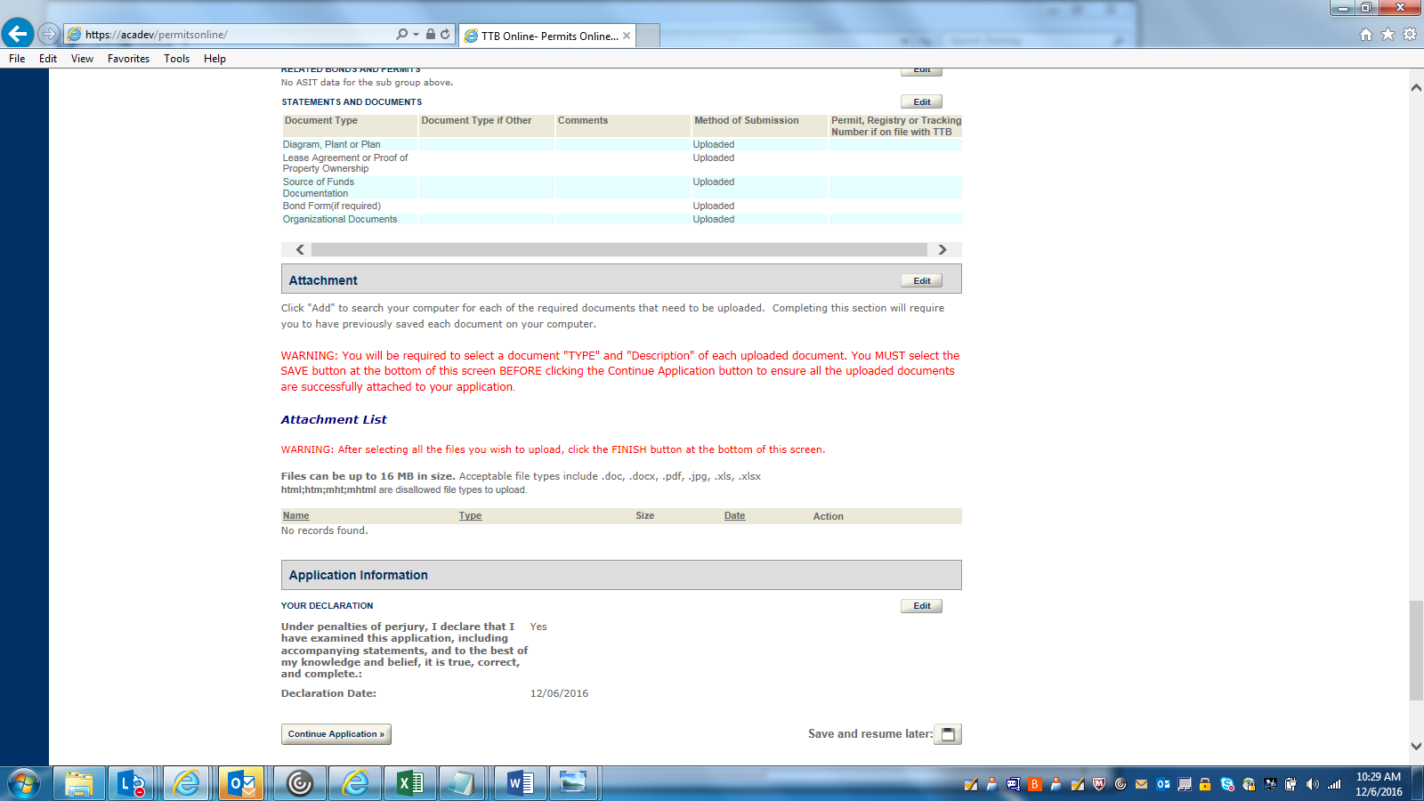

RECORD SUBMITTAL 1: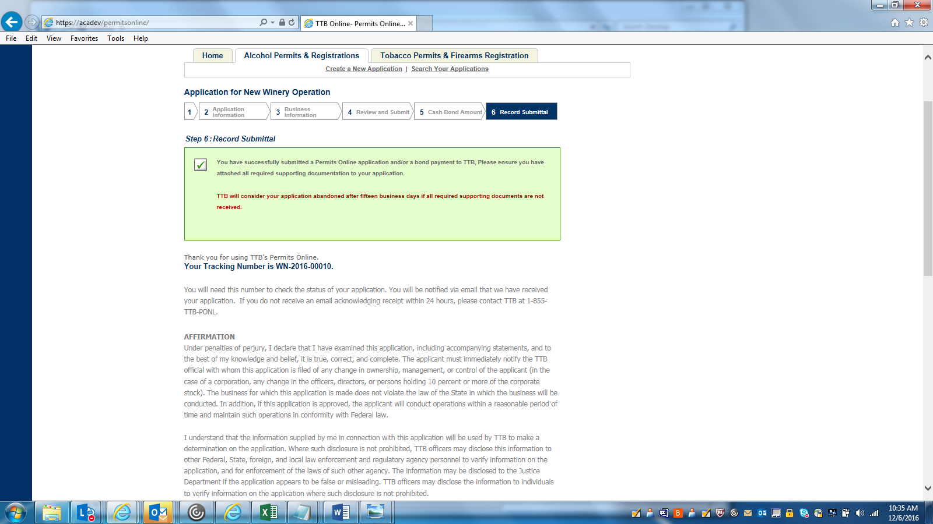

RECORD SUBMITTAL 2: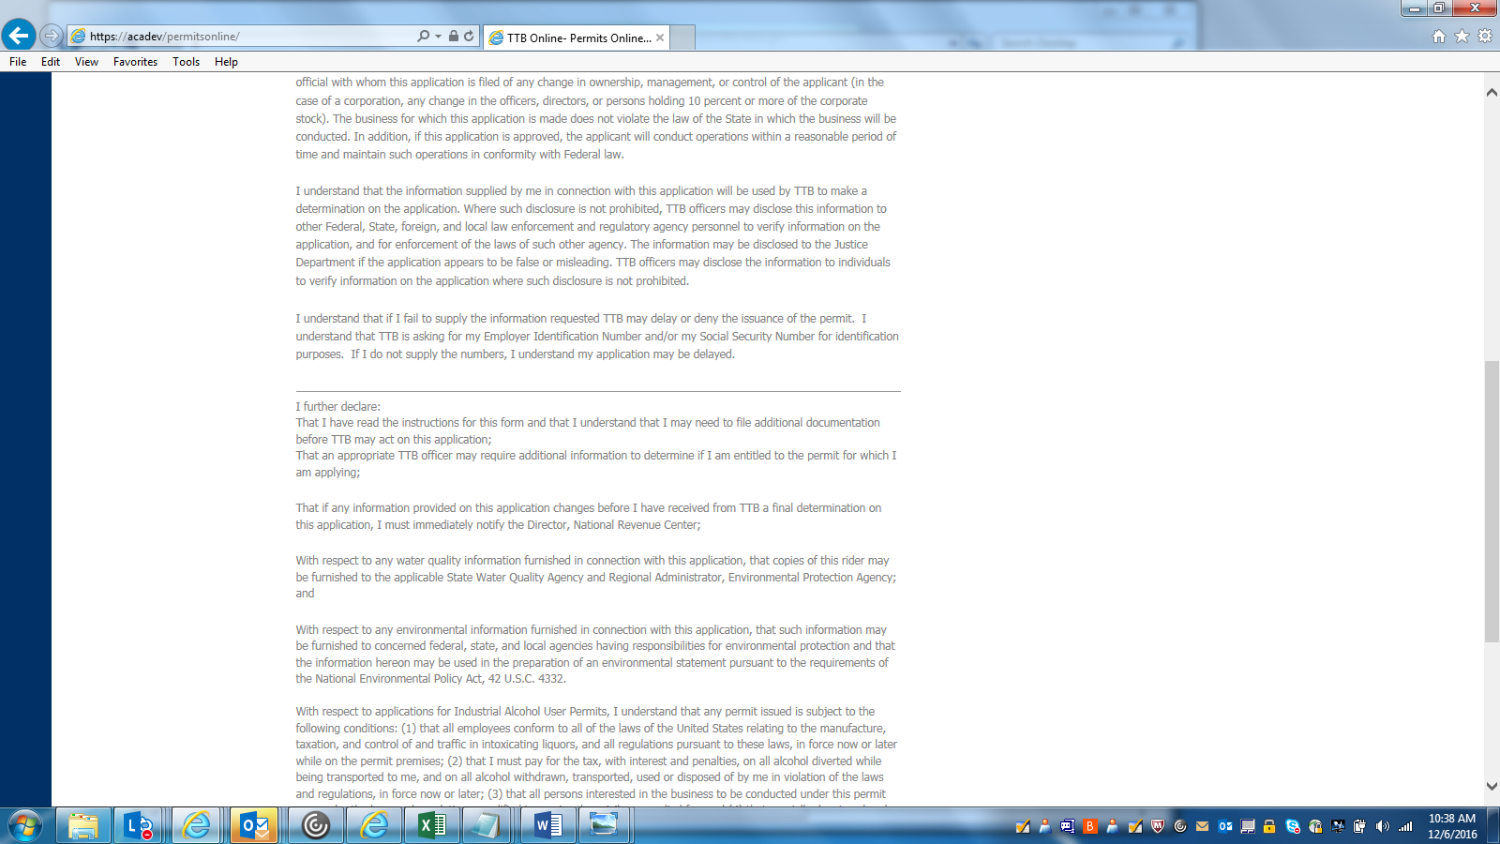

RECORD SUBMITTAL 3: