Attachment E: Thank You Letter

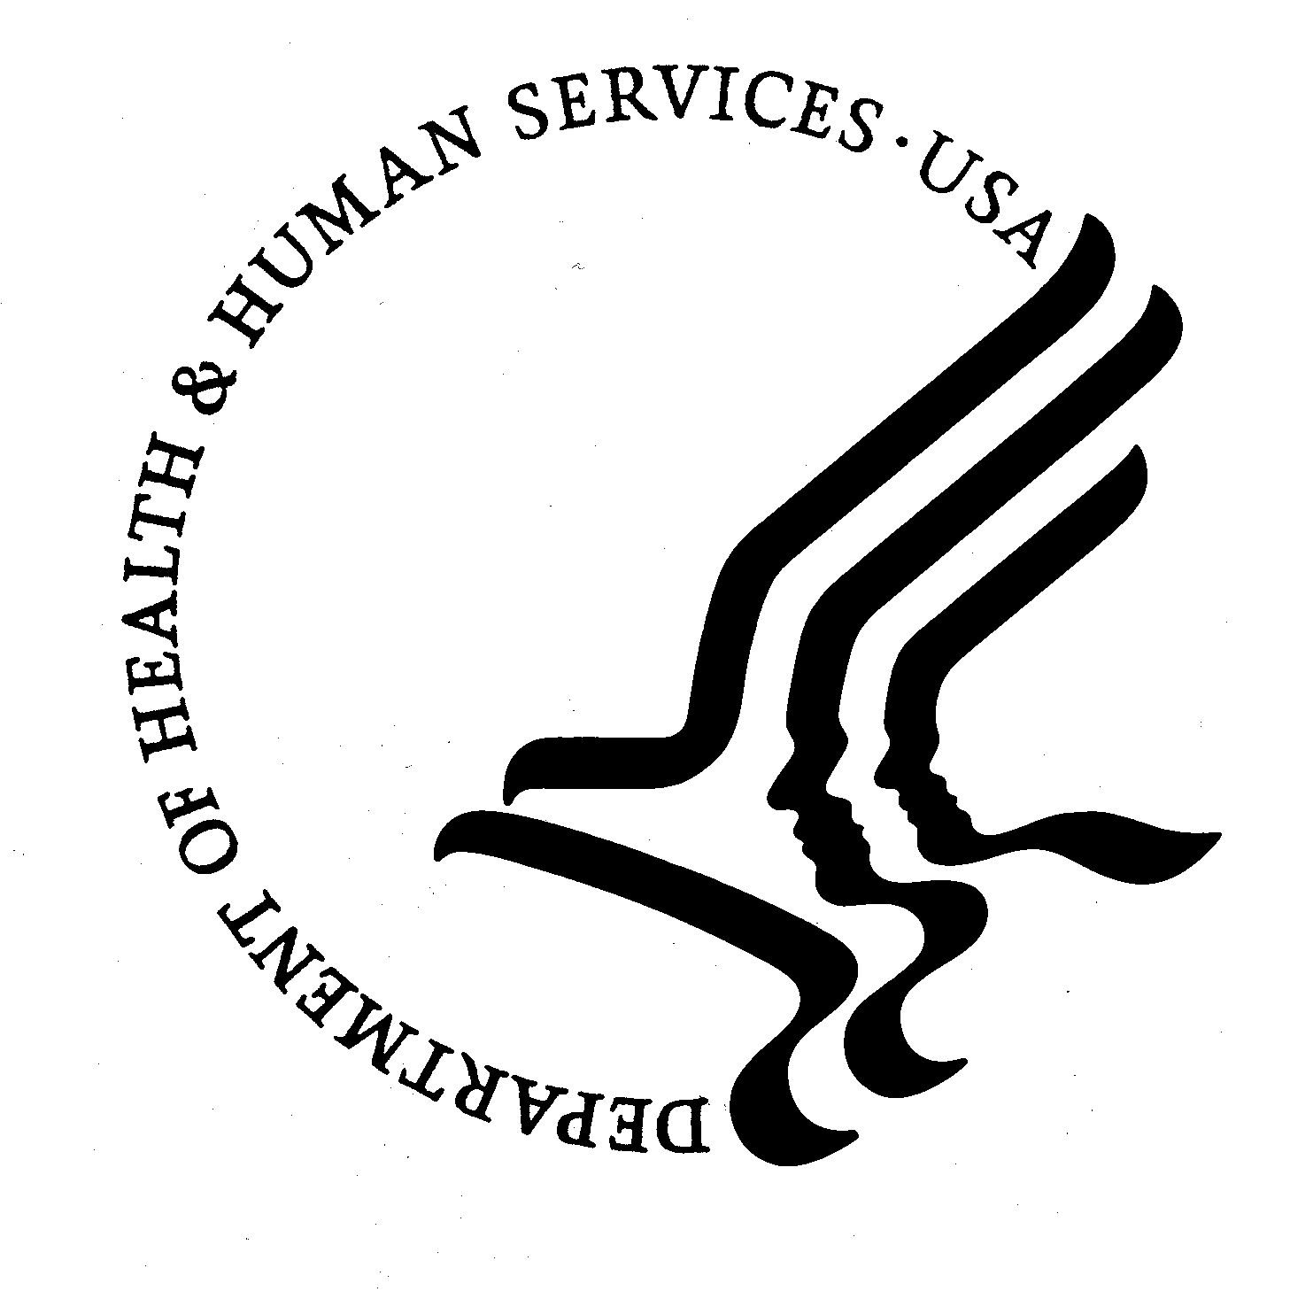
DEPARTMENT OF HEALTH & HUMAN SERVICES
Centers for Disease Control and Prevention
National Center for Health Statistics
3311 Toledo Road
Hyattsville, Maryland 20782

Thank You

I want to personally thank you for helping us to construct a listing of licensed assisted living and similar residential care communities in your state. It is only through the cooperation of state officials like you that we are able to create a national list to be used in an important national survey across long-term care settings, the National Study of Long Term Care Providers (NSLTCP). NSLTCP’s findings will be an invaluable source of information for health care professionals, long-term care providers, policymakers, researchers, and the general public.

Again, I appreciate the time and effort you have given in support of this study.

Sincerely,

Charles J. Rothwell
Director, National Center for Health Statistics

