Attachment B.3 Letter of Support

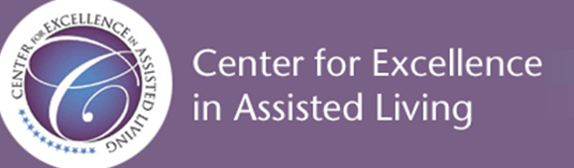

CDC’s National Center for Health Statistics (NCHS) is in the process of building a national list of all state-licensed residential care communities in the United States. This listing will be used in the National Post-Acute and Long-Term Care Study (NPALS) (formerly known as the National Study of Long-Term Care Providers or NSLTCP), a biennial national study of the major sectors of paid, regulated post-acute and long-term care services. This data collection effort will include a representative sample of assisted living and similar residential care communities across the country.

The information will be collected from state government representatives in 50 states and the District of Columbia. Information to be collected includes the name, address, phone number, and website (if available) of the residential care community, name, phone number, and email address (if available) of community director, licensure category, chain affiliation, ownership type, and bed size.

The Center for Excellence in Assisted Living (CEAL), an organization representing providers, advocates, and other stakeholders in assisted living (see theceal.org) strongly encourages your participation as do the following organizations:
- American Seniors Housing Association (ASHA)
- Argentum
- LeadingAge
  - National Center for Assisted Living/American Health Care Association (NCAL/AHCA)
The collected data will enable NCHS to 1) determine which providers should be in the sampling frame of the residential care community component for the next wave of NPALS, 2) select a nationally representative sample of residential care communities for that component of the NPALS, and 3) produce and release summary residential care community estimates (i.e., number of residential care communities, number of residential care beds). All estimates will be confidential and aggregated, so that the names of the communities, staff, residents, and respondents will not be identifiable.

