|  |
| --- |
| Attachment 1  **OMB Control Number 0920-0765 Fellowship Management System**  **Non-substantive Change Request  Proposed changes to the CDC Public Health Associate program (PHAP)  FMS Applicaton Module  Date Submitted: September 4, 2015** |
| PHAP Application Module |
|  |
| **Screen shots of modified questions** |
|  |
|  |

Table of Contents

Table of Contents

1 Application Status Page 3

2 Education Page 4

2.1 Add College Education 4

3 Language Skills Section 5

4 Special Requirements 5

5 Personal Statement 6

7 Program Awareness Survey 7

# Application Status Page

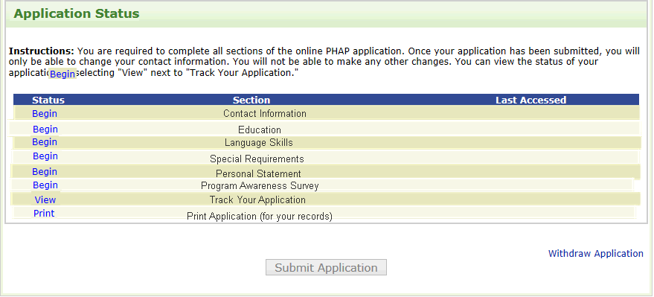

# Education Page

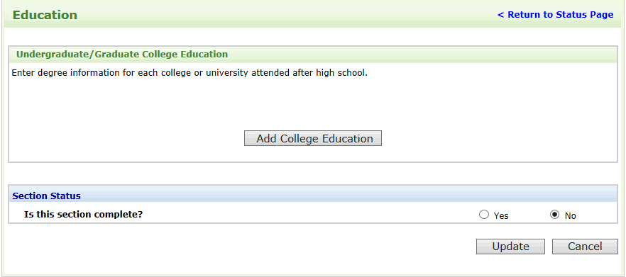

## Add College Education

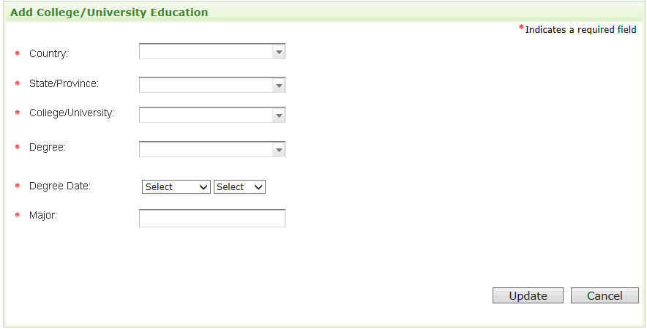

# Language Skills Section

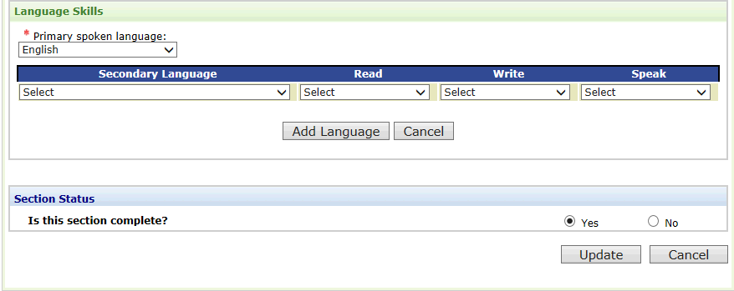

# Special Requirements

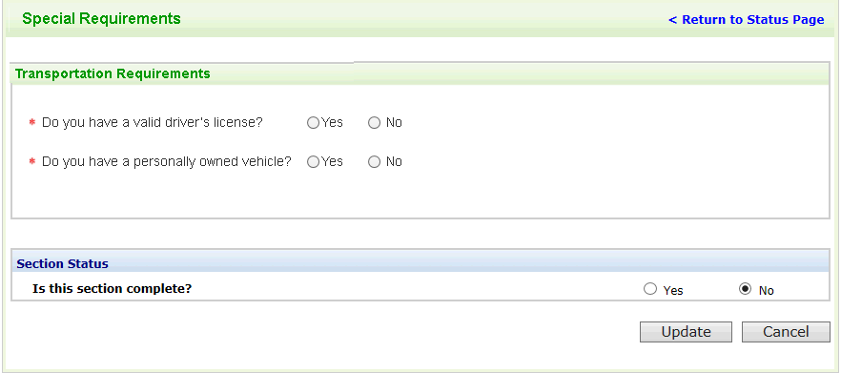

# Personal Statement

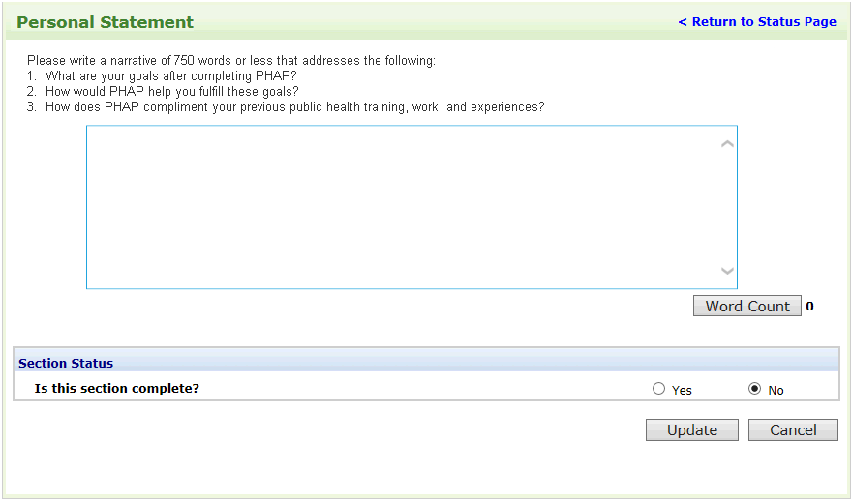

# 

# Program Awareness Survey

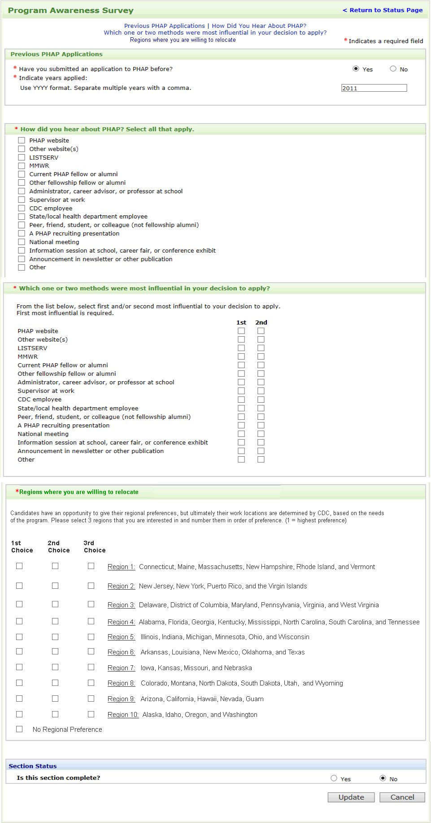

1. **12.4-c Add functionality so the candidates can select 1st, 2nd, and 3rd regional preferences. Also include an option for no regional preference (however the candidate must still select 1-3 preferences)**

