OMB No. 0930-0329
Expiration Date: 09/30/19

Public Burden Statement: An agency may not conduct or sponsor, and a person is not required to respond to, a collection of information unless it displays a currently valid OMB control number. The OMB control number for this project is 0930-0329. Public reporting burden for this collection of information is estimated to average 15 minutes per respondent, per year, including the time for reviewing instructions, searching existing data sources, gathering and maintaining the data needed, and completing and reviewing the collection of information. Send comments regarding this burden estimate or any other aspect of this collection of information, including suggestions for reducing this burden, to SAMHSA Reports Clearance Officer, 5600 Fishers Lane, Room 15E57-B, Rockville, Maryland, 20857.

Attachment A

Screen Shots of Part I of the

SAMHSA SOAR Web-Based Data Form (No Revisions)

Registration Page for New Users to the System
New users, who are caseworkers, agency directors, local or state leads need to complete and submit this registration form. Users create a username and password, select their role, location, funding source and SOAR training completed.
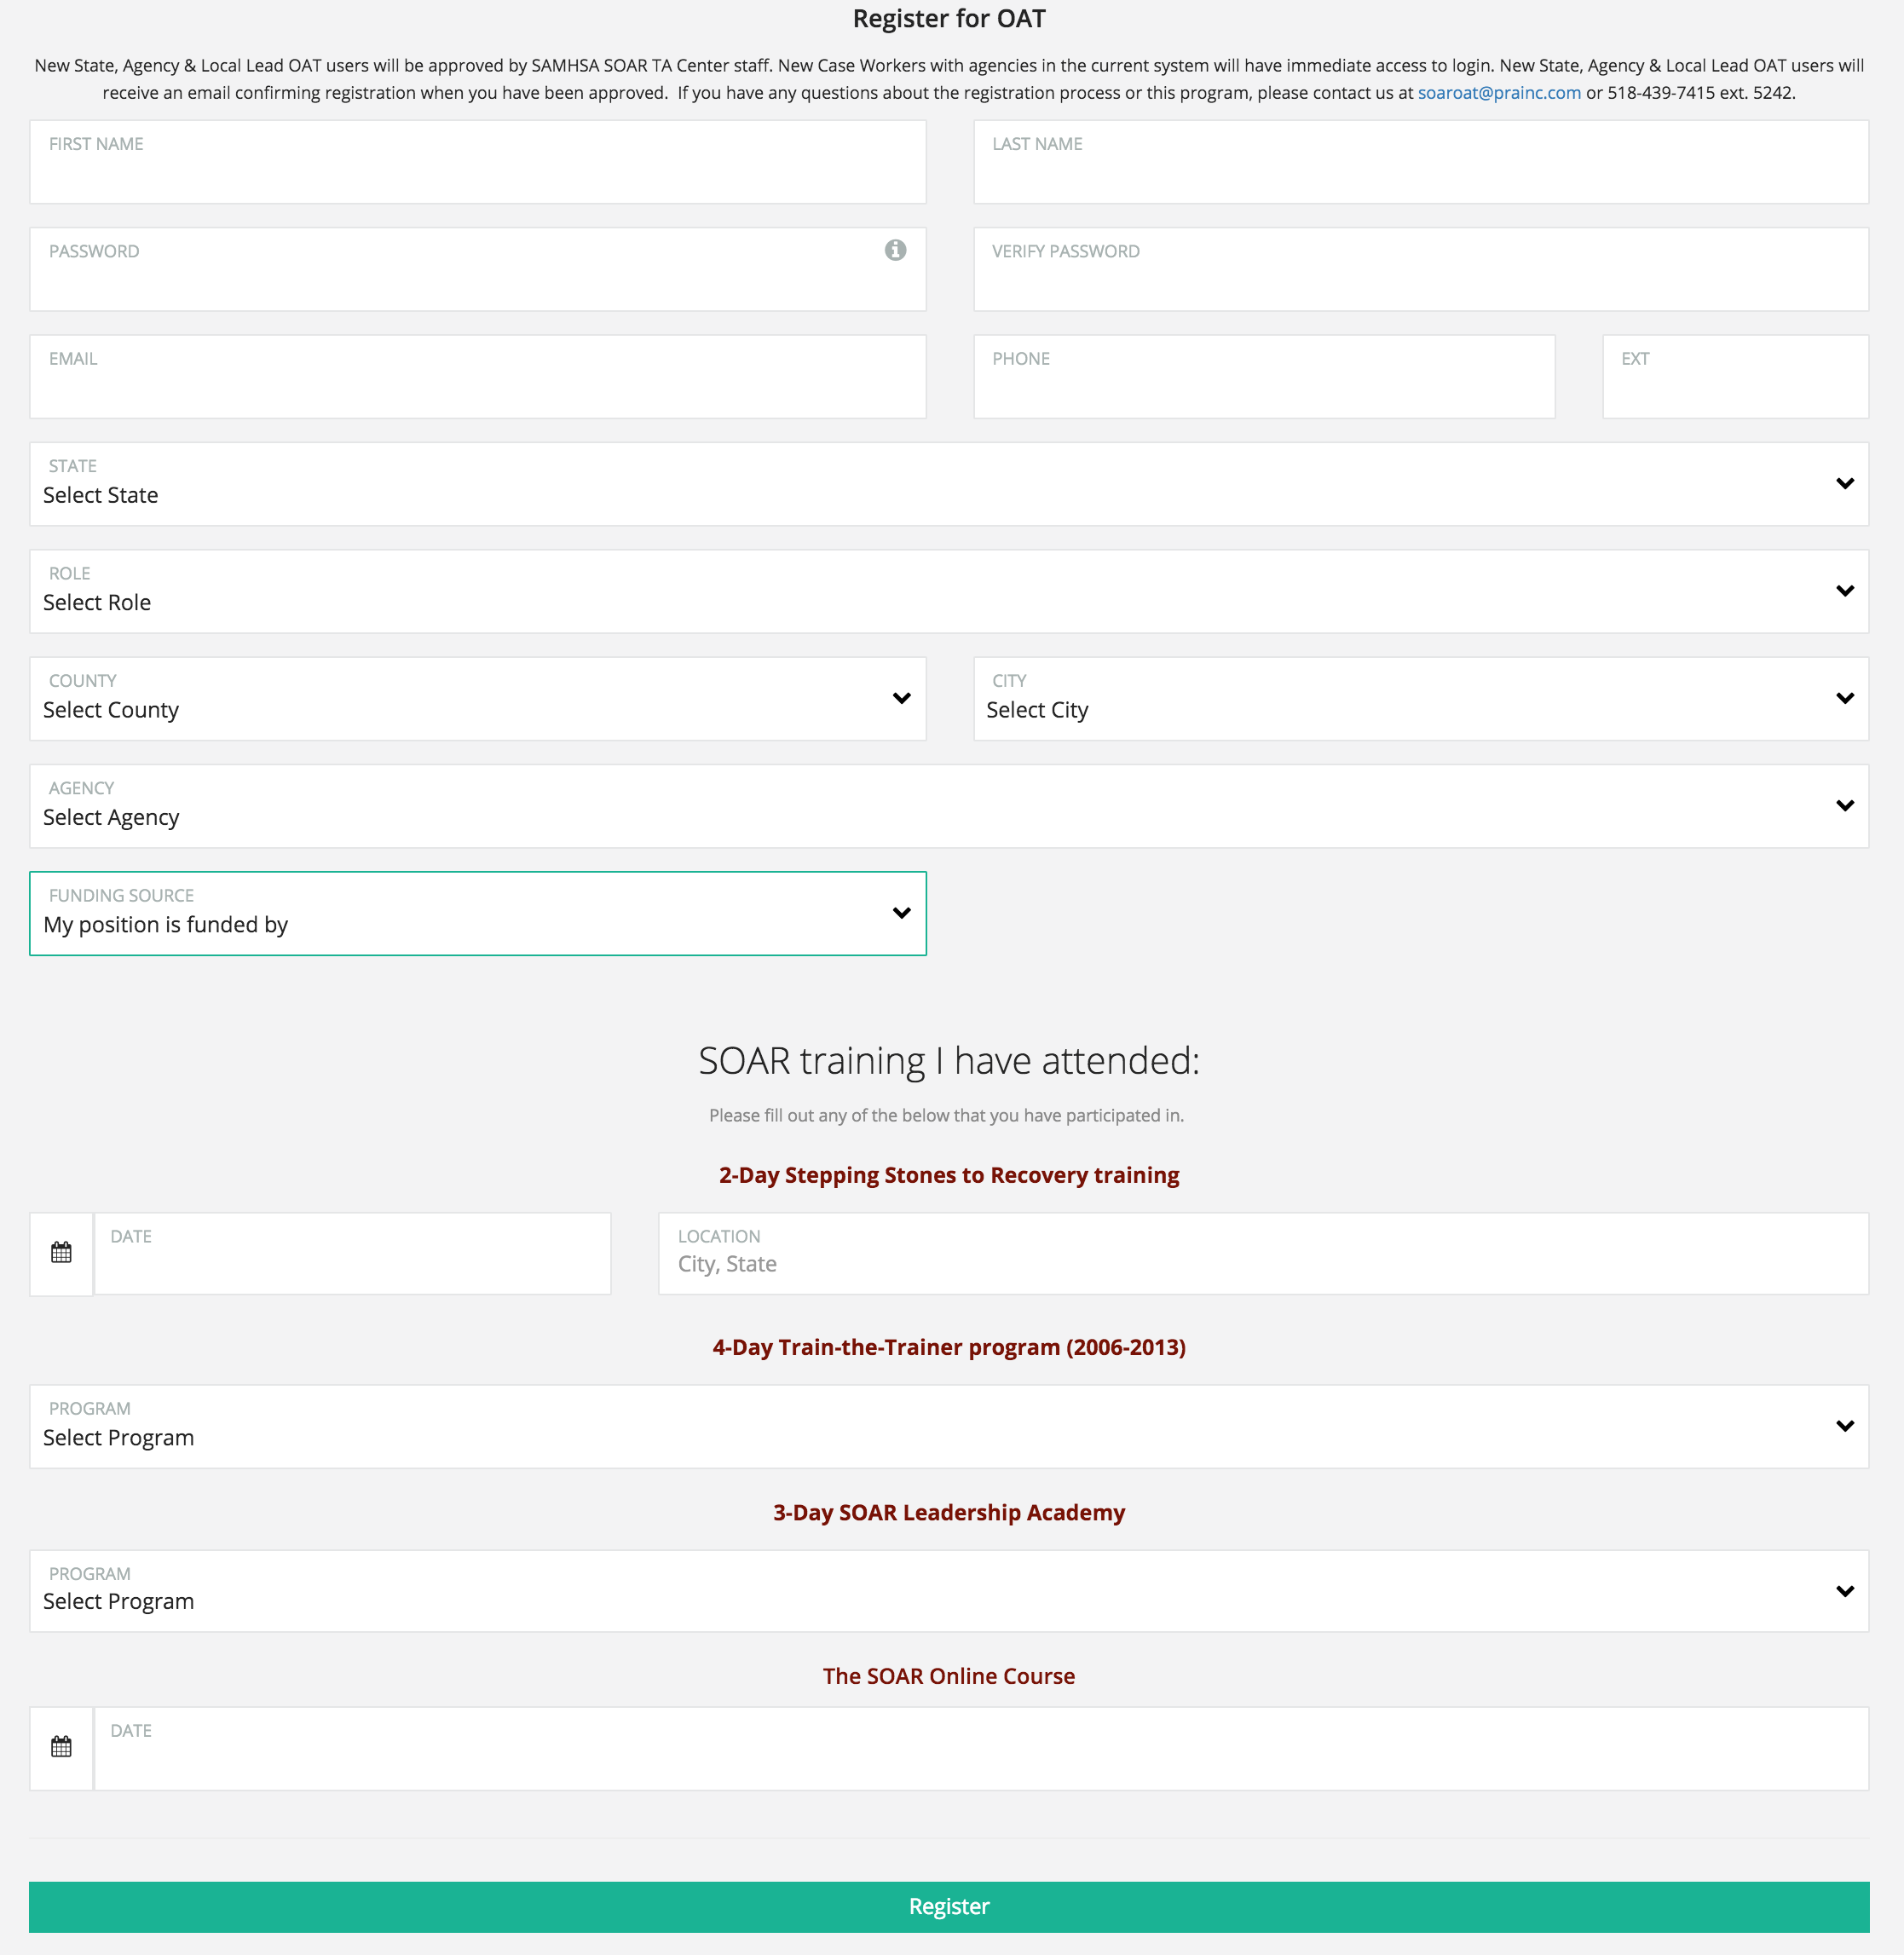

Demographic Information
The demographic information on each applicant is collected on this screen. Basic information including gender, age, military service, benefits received, employment status and housing status are included.

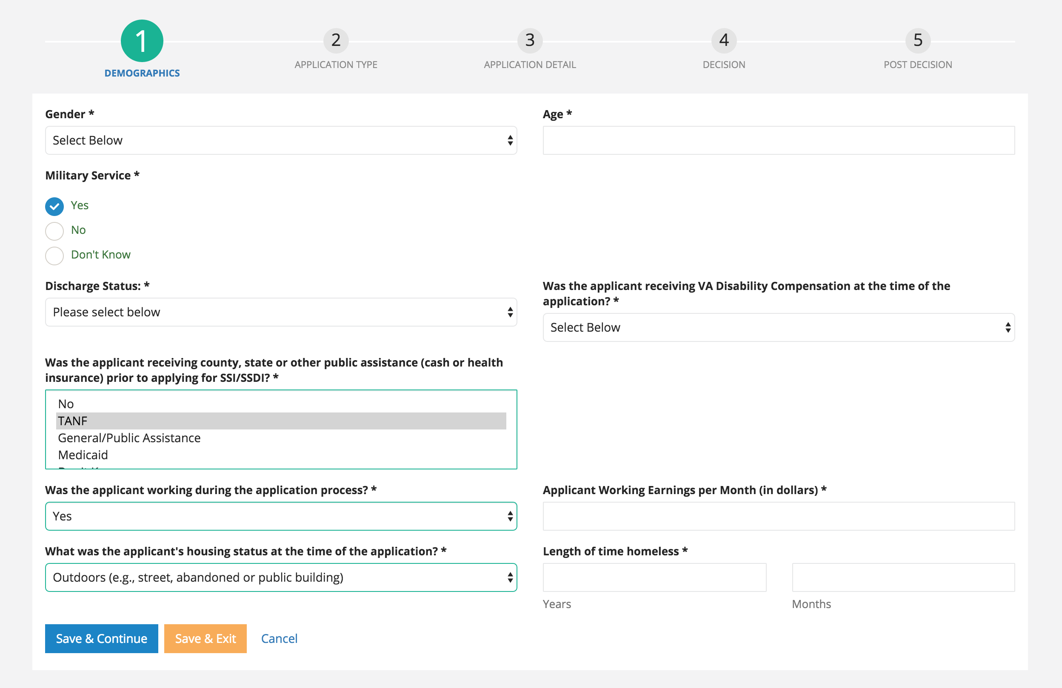

Application Type
The second section asks about the application type. There are four types: initial, reconsideration, ALJ hearing and non-SOAR claim.

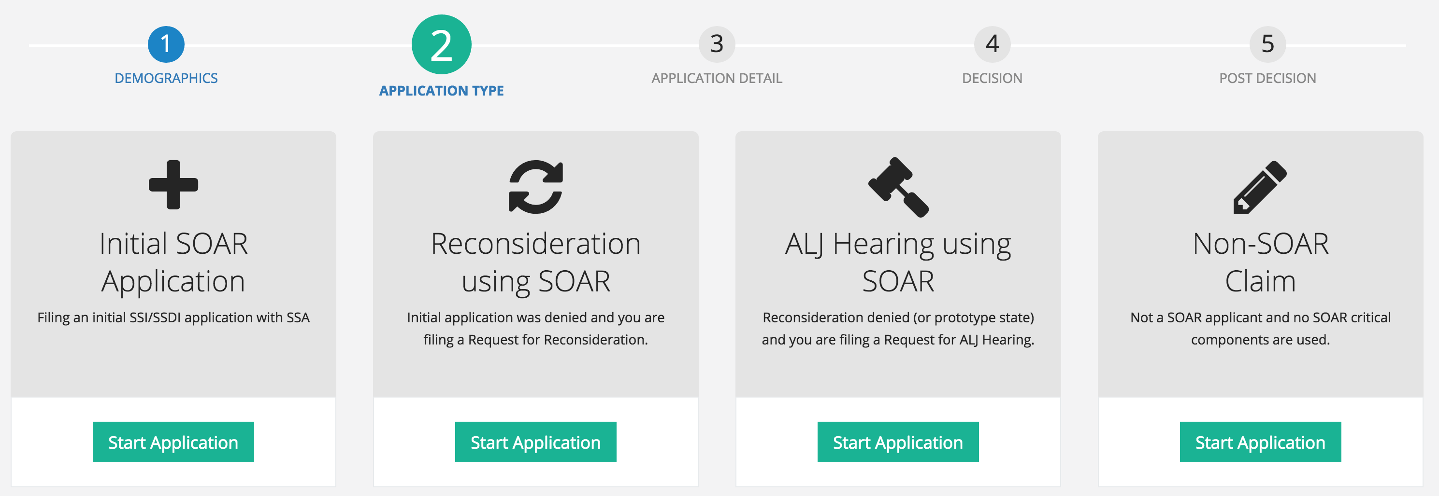

Application Detail
The third section asks a few questions about what SOAR critical components were used while assisting with the application. Questions include the protective filing date, forms and records that are submitted, whether quality review was done, if the applications is complete, if consultative exams were ordered and if so, the total number and the application date.
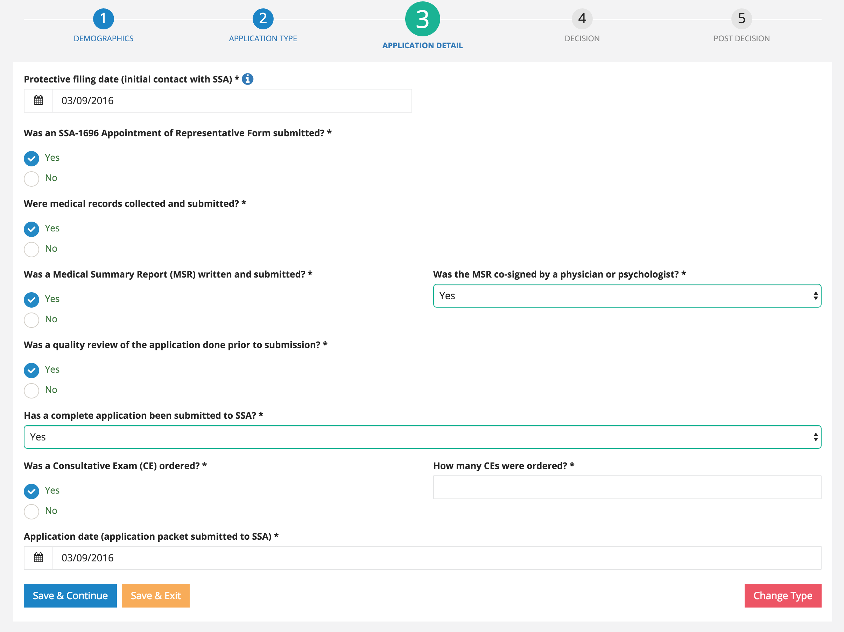

Decision
The questions ask if there has been notification of a decision, the date of the decision, and if denied, whether an appeal was filed.
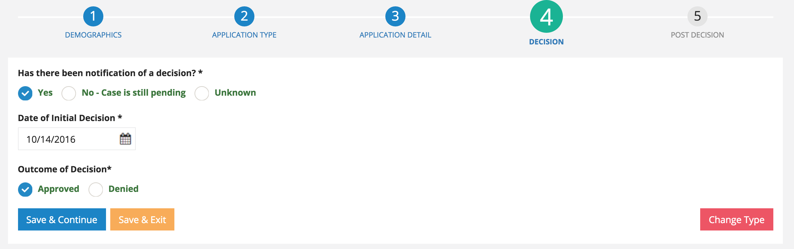

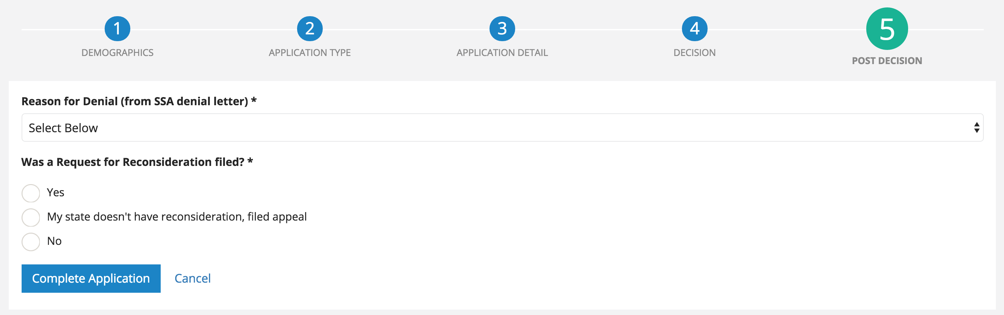

Post Decision
Most of the questions that are asked post-decision are optional for the user. They are asked to answer what programs the applicant was approved for and then can optionally track other reimbursement amounts and other more qualitative outcomes including housing status, employment status and hours to complete the claim.

